CHAROTAR UNIVERSITY OF SCIENCE AND TECHNOLOGY (CHARUSAT)
Chandubhai S. Patel Institute of Technology (CSPIT)
Department of Computer Science & Engineering
ITUE203 – Web Development Frameworks

PRACTICAL 11

Student Management CRUD Application with Search, Course Filter, Soft Delete and CSV Export
PHP 8 · MySQL (MariaDB) · MySQLi prepared statements
Student Name | Shreyas
Roll Number | 25CS023
Student ID | 25CS023
Email | 25cs023@charusat.edu.in
Course | ITUE203 – Web Development Frameworks
Programme | B.Tech Computer Science & Engineering
Semester / Academic Year | 3 / 2026-27
Date of Submission
Faculty Signature

1. Aim and Objectives
To implement a complete Student Management application with PHP, MySQL and MySQLi that performs all record operations safely and keeps every record, even after a student is removed from the active list.
- Display student records in a responsive table with a clear Active / Inactive status.
- Add and update students with browser and server-side validation, duplicate-email handling and clear messages.
- Search by name, email and course, filter by course (and status), and paginate the list.
- Soft delete a student after an explicit confirmation: the status changes from active to inactive and the row stays in MySQL.
- Export the selected records to a CSV file that opens correctly in Microsoft Excel and is protected against formula injection.
- Use MySQLi prepared statements for every database operation and protect the forms against CSRF, XSS and duplicate submissions.

2. Problem Definition
An institute's student list changes constantly: students join, change course or semester, and leave. Staff must be able to find a student quickly and export the list for spreadsheet work. At the same time a record must never be lost by a wrong click, so removing a student must be reversible at database level – a soft delete that only marks the student inactive. Every input comes from the browser and is therefore untrusted: it has to be validated on the server, sent to MySQL only through prepared statements, and escaped whenever it is shown again.
Starting point: the Practical-11 folder already contained a simple version (index.php, edit.php, auth.php, schema.sql). It used the shared student_db database, required the Practical 10 login database, deleted records permanently through a GET link and changed the status through GET links without CSRF protection. It was replaced by the application described here, which uses its own database studenthub_prac11 and has no permanent delete. The old files were backed up before the change and remain in the Git history.

3. Tools and Technologies
Tool | Use in this practical
PHP 8.2.12 (XAMPP) | Application pages, validation, sessions, CSV generation
MySQLi | All database access with prepared statements (prepare / bind_param / execute)
MariaDB 10.4.32 (XAMPP) | Database studenthub_prac11; export with mysqldump
HTML5, CSS3, JavaScript | Forms with HTML5 validation, responsive table (style.css), double-click guard (app.js)
Microsoft Edge | Running the application; headless Edge (Playwright) for the browser test and screenshots
Microsoft Excel | Opening the exported CSV file
Python 3 | tests/test_app.py – automated end-to-end tests (standard library only)

4. Database Design
The practical uses its own database, studenthub_prac11, so the databases of Practicals 8–10 and the main StudentHub application are never touched. It has one InnoDB table, students; a second table (for example courses) is not needed, so there are no foreign keys – the five allowed courses are checked by the application.
Column | Type | Notes
student_id | INT UNSIGNED AUTO_INCREMENT | Primary key
full_name | VARCHAR(100) NOT NULL | Index idx_students_full_name
email | VARCHAR(254) NOT NULL | UNIQUE uq_students_email (case-insensitive collation)
course | VARCHAR(60) NOT NULL | Index idx_students_course
semester | TINYINT UNSIGNED NOT NULL | CHECK semester BETWEEN 1 AND 8
status | ENUM('active','inactive') | Default 'active'; index idx_students_status
created_at | DATETIME | Default CURRENT_TIMESTAMP
updated_at | DATETIME | ON UPDATE CURRENT_TIMESTAMP – changes on every update
deleted_at | DATETIME NULL | Time of the soft delete; CHECK: NULL exactly when status = 'active'

studenthub_prac11.sql is the mysqldump export of this database: CREATE DATABASE, the table and 24 fictional students (example.com addresses) – 22 active and 2 inactive. It can be imported with phpMyAdmin or mysql -u root < studenthub_prac11.sql; importing it again resets the table to the seed data.
studenthub_prac11.sql (lines 45–62) – table structure from the dump
45 CREATE TABLE `students` (
46 `student_id` int(10) unsigned NOT NULL AUTO_INCREMENT,
47 `full_name` varchar(100) NOT NULL,
48 `email` varchar(254) NOT NULL,
49 `course` varchar(60) NOT NULL,
50 `semester` tinyint(3) unsigned NOT NULL,
51 `status` enum('active','inactive') NOT NULL DEFAULT 'active',
52 `created_at` datetime NOT NULL DEFAULT current_timestamp(),
53 `updated_at` datetime NOT NULL DEFAULT current_timestamp() ON UPDATE current_timestamp(),
54 `deleted_at` datetime DEFAULT NULL,
55 PRIMARY KEY (`student_id`),
56 UNIQUE KEY `uq_students_email` (`email`),
57 KEY `idx_students_course` (`course`),
58 KEY `idx_students_status` (`status`),
59 KEY `idx_students_full_name` (`full_name`),
60 CONSTRAINT `chk_students_semester` CHECK (`semester` between 1 and 8),
61 CONSTRAINT `chk_students_soft_delete` CHECK (`status` = 'active' and `deleted_at` is null or `status` = 'inactive' and `deleted_at` is not null)
62 ) ENGINE=InnoDB AUTO_INCREMENT=25 DEFAULT CHARSET=utf8mb4 COLLATE=utf8mb4_unicode_ci;

4.1 Setting up and running the application
Practical 11 is a standalone application without a login. It needs only XAMPP's PHP and MySQL:
- Start MySQL in the XAMPP Control Panel.
- Import the database: phpMyAdmin → Import → studenthub_prac11.sql, or C:\xampp\mysql\bin\mysql.exe -u root < studenthub_prac11.sql in the Practical-11 folder.
- Start the server: double-click start-server.bat, or run C:\xampp\php\php.exe -S 127.0.0.1:8611 router.php in the Practical-11 folder.
- Open http://127.0.0.1:8611/index.php in the browser.
- Run the tests: python tests\test_app.py (uses the temporary database studenthub_prac11_test).

5. Implementation
File | Purpose
index.php | READ – student table, search, course/status filter, pagination (10 per page), messages, Export button
add.php | CREATE – form, validation, duplicate-email check, prepared INSERT
edit.php | UPDATE – form filled from MySQL, validation, prepared UPDATE
delete.php | SOFT DELETE – confirmation page (GET) and status change to inactive (POST)
export.php | CSV export of all records matching the current search and filters
includes/functions.php | Session, security headers, one-time form tokens, messages, validation, search query, layout
db.php | Settings and MySQLi connection; errors are logged, never shown
style.css, app.js | Responsive layout (table becomes cards on phones); disables the button after submitting

5.1 Create and update with validation
Both forms share student_form(). The browser checks required, type="email", pattern and maxlength first, but only the server check in validate_student() is trusted: name 2–100 letters (spaces, dots, apostrophes and hyphens allowed), valid email (stored in lower case), a course from the list and a semester 1–8. The email must not belong to another student – inactive students included. If anything is wrong the form is shown again with HTTP 422, an error under each field and the typed values. A duplicate inserted at the same moment is also caught by the UNIQUE key (error 1062).
add.php (lines 11–34) – token check, validation and prepared INSERT
11 if ($_SERVER['REQUEST_METHOD'] === 'POST') {
12 if (!use_form_token($_POST['form_token'] ?? null)) {
13 reject_invalid_token();
14 }
15 [$values, $errors] = validate_student($_POST);
16 $db = get_db();
17 if (!$errors && email_taken($db, $values['email'])) {
18 $errors['email'] = 'This email is already registered to another student.';
19 }
20 if (!$errors) {
21 try {
22 $stmt = $db->prepare('INSERT INTO students (full_name, email, course, semester) VALUES (?, ?, ?, ?)');
23 $stmt->bind_param('sssi', $values['full_name'], $values['email'], $values['course'], $values['semester']);
24 $stmt->execute();
25 flash('success', 'Student “' . $values['full_name'] . '” was added successfully (ID ' . $stmt->insert_id . ').', $stmt->insert_id);
26 redirect('index.php');
27 } catch (mysqli_sql_exception $exception) {
28 if ($exception->getCode() !== 1062) { // 1062 = duplicate key (email added at the same moment)
29 throw $exception;
30 }
31 $errors['email'] = 'This email is already registered to another student.';
32 }
33 }
34 http_response_code(422);

5.2 Soft delete
The Deactivate button only opens delete.php?id=N, a confirmation page that shows the student and asks “Are you sure you want to deactivate …?”. A GET request never changes data. Only Yes, deactivate student sends a POST with a one-time token. The record is not deleted: one prepared UPDATE sets status = 'inactive' and deleted_at = NOW(), and AND status = 'active' makes a second attempt harmless ("already inactive"). The student stays in the list with a red Inactive badge, stays in the CSV export and keeps the email reserved. The application contains no DELETE statement.
delete.php (lines 11–25) – confirmed soft delete
11 if ($_SERVER['REQUEST_METHOD'] === 'POST') {
12 if (!use_form_token($_POST['form_token'] ?? null)) {
13 reject_invalid_token();
14 }
15 $id = positive_id($_POST['student_id'] ?? '');
16 $student = $id > 0 ? find_student($db, $id) : null;
17 $stmt = $db->prepare("UPDATE students SET status = 'inactive', deleted_at = NOW() WHERE student_id = ? AND status = 'active'");
18 $stmt->bind_param('i', $id);
19 $stmt->execute();
20 if ($stmt->affected_rows === 1) {
21 flash('success', 'Student “' . $student['full_name'] . '” was deactivated. The record is kept in the database with status Inactive.', $id);
22 } else {
23 flash('error', $student ? 'Student “' . $student['full_name'] . '” is already inactive.' : 'That student record was not found.');
24 }
25 redirect('index.php');

5.3 Search, course filter and pagination
The search text is matched against name, email and course with LIKE ?; % and _ typed by the user are escaped so they are searched literally. The course and status values are accepted only if they appear in the fixed lists, so they can never change the SQL. The same WHERE clause is used for counting, for the page of 10 records (LIMIT ? OFFSET ?) and for the CSV export; the most recently changed records are listed first.
includes/functions.php (lines 186–207) – WHERE clause with placeholders
186 function filter_sql(array $filters): array
187 {
188 $where = [];
189 $types = '';
190 $params = [];
191 if ($filters['q'] !== '') {
192 $like = '%' . addcslashes($filters['q'], '\\%_') . '%';
193 $where[] = '(full_name LIKE ? OR email LIKE ? OR course LIKE ?)';
194 $types .= 'sss';
195 array_push($params, $like, $like, $like);
196 }
197 if ($filters['course'] !== '') {
198 $where[] = 'course = ?';
199 $types .= 's';
200 $params[] = $filters['course'];
201 }
202 if ($filters['status'] !== '') {
203 $where[] = 'status = ?';
204 $types .= 's';
205 $params[] = $filters['status'];
206 }
207 return [$where ? ' WHERE ' . implode(' AND ', $where) : '', $types, $params];

5.4 CSV export
export.php reads the same filters and writes every matching record (all pages). Inactive records are included (Status Inactive and a Deactivated At time) unless the status filter is set to Active. A UTF-8 byte-order mark, commas and CRLF line endings make Excel open the file directly. Cells that start with =, +, -, @, tab or carriage return get a leading apostrophe, so a name such as =HYPERLINK(...) is shown as text instead of being run as a formula.
export.php (lines 13–36) – formula-injection protection and CSV output
13 function csv_safe(mixed $value): string
14 {
15 $text = (string) $value;
16 return $text !== '' && strpbrk($text[0], "=+-@\t\r") !== false ? "'" . $text : $text;
17 }
18
19 start_app();
20 $filters = list_filters($_GET);
21 $students = fetch_students(get_db(), $filters); // read everything before sending any CSV output
22
23 header('Content-Type: text/csv; charset=utf-8');
24 header('Content-Disposition: attachment; filename="students_' . date('Ymd_His') . '.csv"');
25
26 $out = fopen('php://output', 'w');
27 fwrite($out, "\xEF\xBB\xBF");
28 fputcsv($out, ['Student ID', 'Full Name', 'Email', 'Course', 'Semester', 'Status', 'Created At', 'Updated At', 'Deactivated At'],
29 ',', '"', '', "\r\n");
30 foreach ($students as $s) {
31 fputcsv($out, array_map('csv_safe', [
32 $s['student_id'], $s['full_name'], $s['email'], $s['course'], $s['semester'],
33 STATUSES[$s['status']] ?? $s['status'], $s['created_at'], $s['updated_at'], $s['deleted_at'] ?? '',
34 ]), ',', '"', '', "\r\n");
35 }
36 fclose($out);

5.5 Security measures
- SQL injection: every query uses prepare() with ? placeholders and bind_param(); the test suite also checks that the code contains no query() call.
- XSS: every value is printed through e() = htmlspecialchars(…, ENT_QUOTES, 'UTF-8'); a Content-Security-Policy allows only the site's own files.
- CSRF and duplicate submissions: each form gets a random 64-character token stored in the session. A POST is accepted only with a token this session issued and has not used yet, so another site cannot submit the forms and a form sent twice (double click, Back + resend) is refused the second time. Add, update and soft delete accept only POST and redirect afterwards (Post/Redirect/Get).
- Errors: MySQL errors throw exceptions; a global handler writes the details to the PHP error log and shows only “The student database is not available right now”.
- Configuration: the defaults are XAMPP's; local credentials go into the git-ignored config.local.php. includes/, tests/, the SQL dump and the config files are blocked with HTTP 403.
includes/functions.php (lines 60–77) – one-time form tokens
60 function form_token(): string
61 {
62 $token = bin2hex(random_bytes(32));
63 $_SESSION['form_tokens'][$token] = time();
64 if (count($_SESSION['form_tokens']) > 50) { // keep only the 50 newest open forms
65 $_SESSION['form_tokens'] = array_slice($_SESSION['form_tokens'], -50, null, true);
66 }
67 return $token;
68 }
69
70 function use_form_token(mixed $submitted): bool
71 {
72 if (!is_string($submitted) || !preg_match('/^[0-9a-f]{64}$/', $submitted)
73 || !isset($_SESSION['form_tokens'][$submitted])) {
74 return false;
75 }
76 unset($_SESSION['form_tokens'][$submitted]);
77 return true;

6. Output Screenshots
All screenshots are genuine captures of the running application (PHP built-in server, database studenthub_prac11 with the fictional seed data). Figures 1–11 were taken with Microsoft Edge during the browser test; Figure 12 is a normal Edge window after clicking Export CSV, and Figure 13 shows that downloaded file opened in Microsoft Excel (columns auto-fitted for readability, the file was closed without saving).
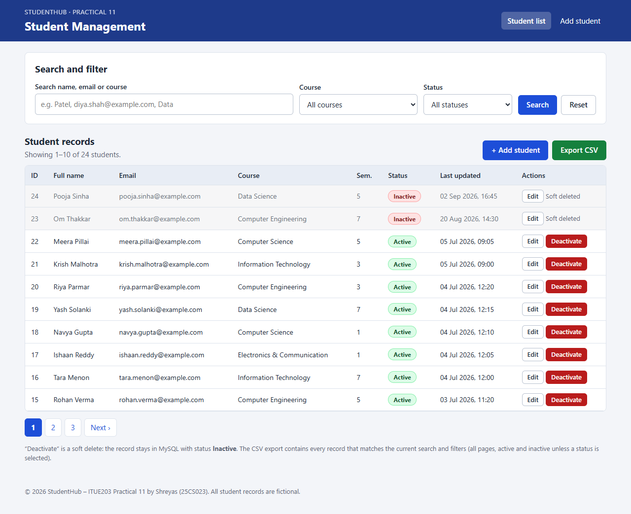
Figure 1: Student records in a table – 24 students, 10 per page, Active/Inactive badges, Edit and Deactivate actions (students-list.png)
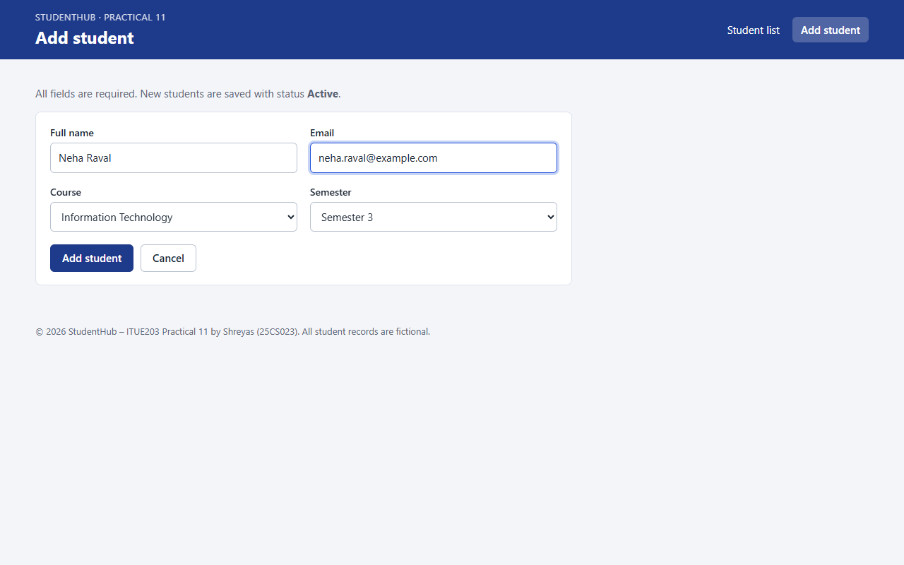
Figure 2: Add student form filled in (Neha Raval, Information Technology, semester 3) (add-student.png)
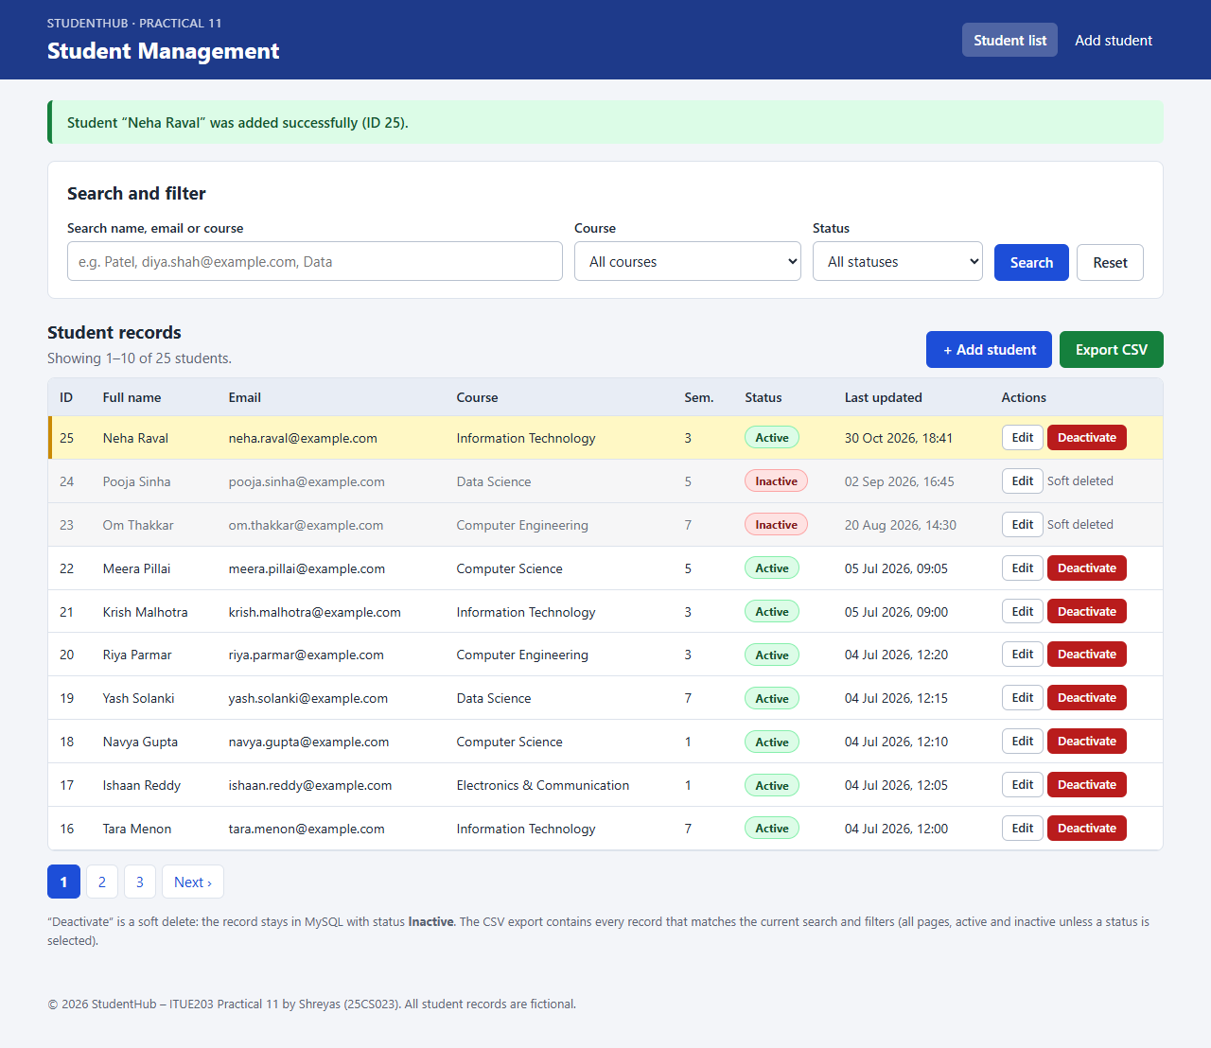
Figure 3: Successful addition – green message and the new student (ID 25) first and highlighted (successful-add.png)
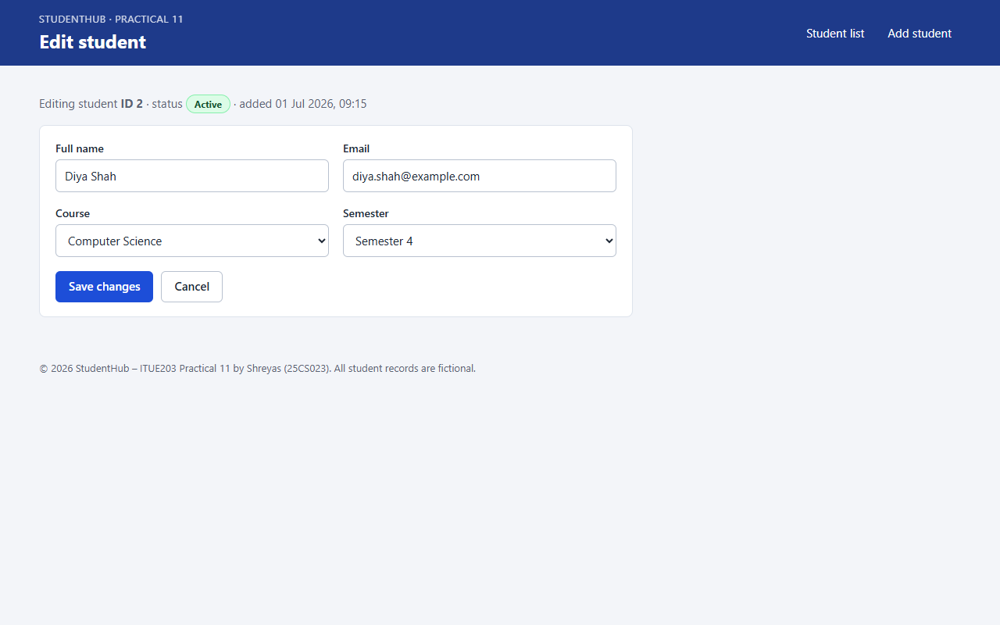
Figure 4: Edit form for Diya Shah (ID 2) – course changed to Computer Science, semester 4 (edit-student.png)
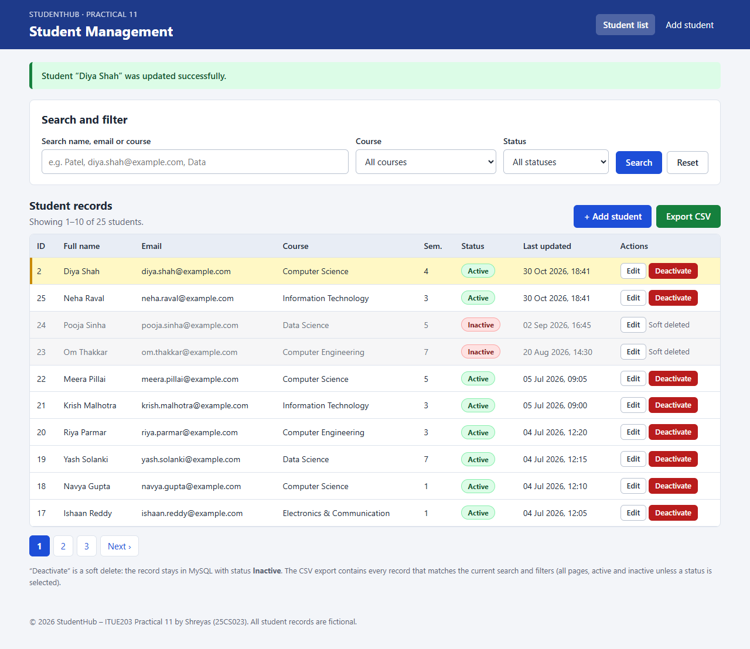
Figure 5: Successful update – message and the updated details at the top of the list (successful-update.png)
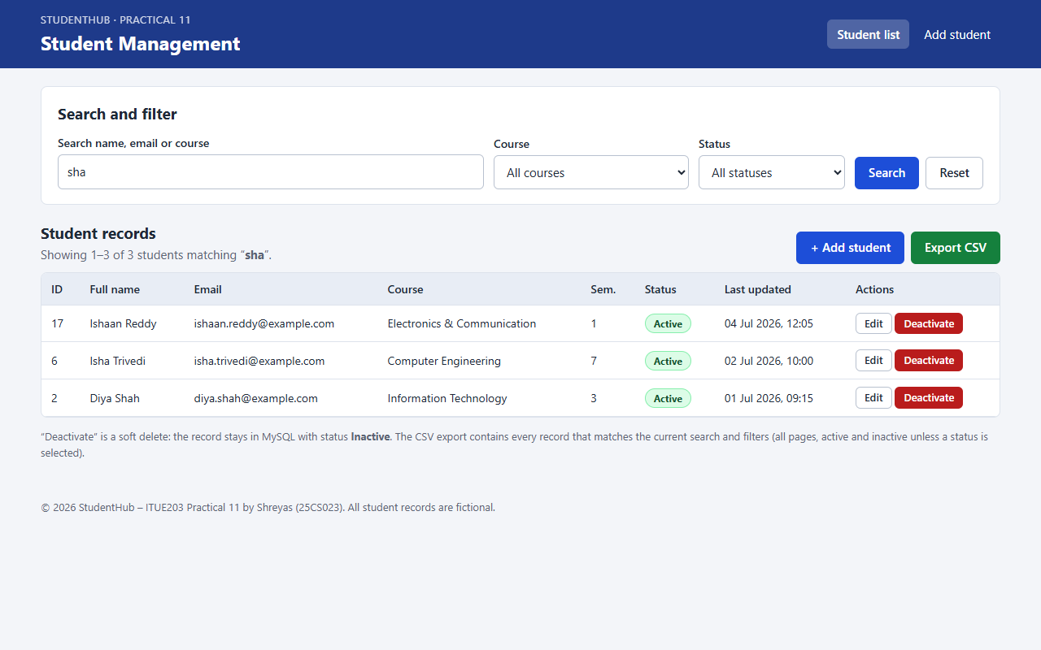
Figure 6: Search “sha” – matches Diya Shah, Isha Trivedi and Ishaan Reddy by name and email (search-result.png)
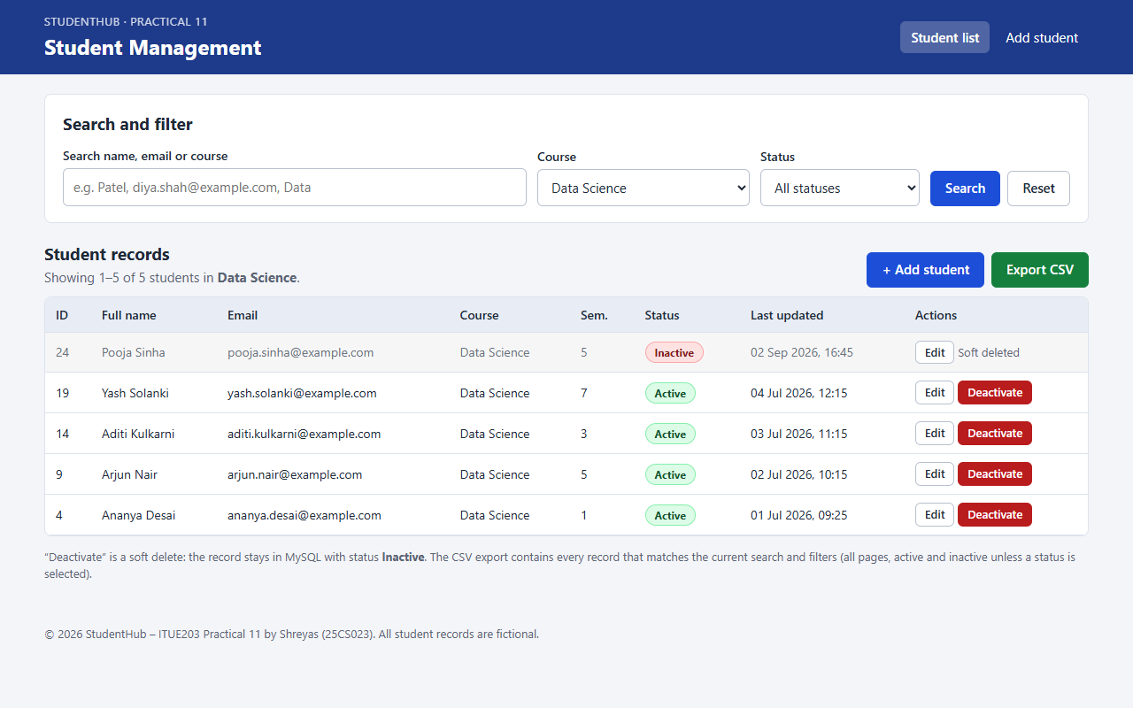
Figure 7: Course-wise filtering – only Data Science students (active and inactive) (course-filter.png)
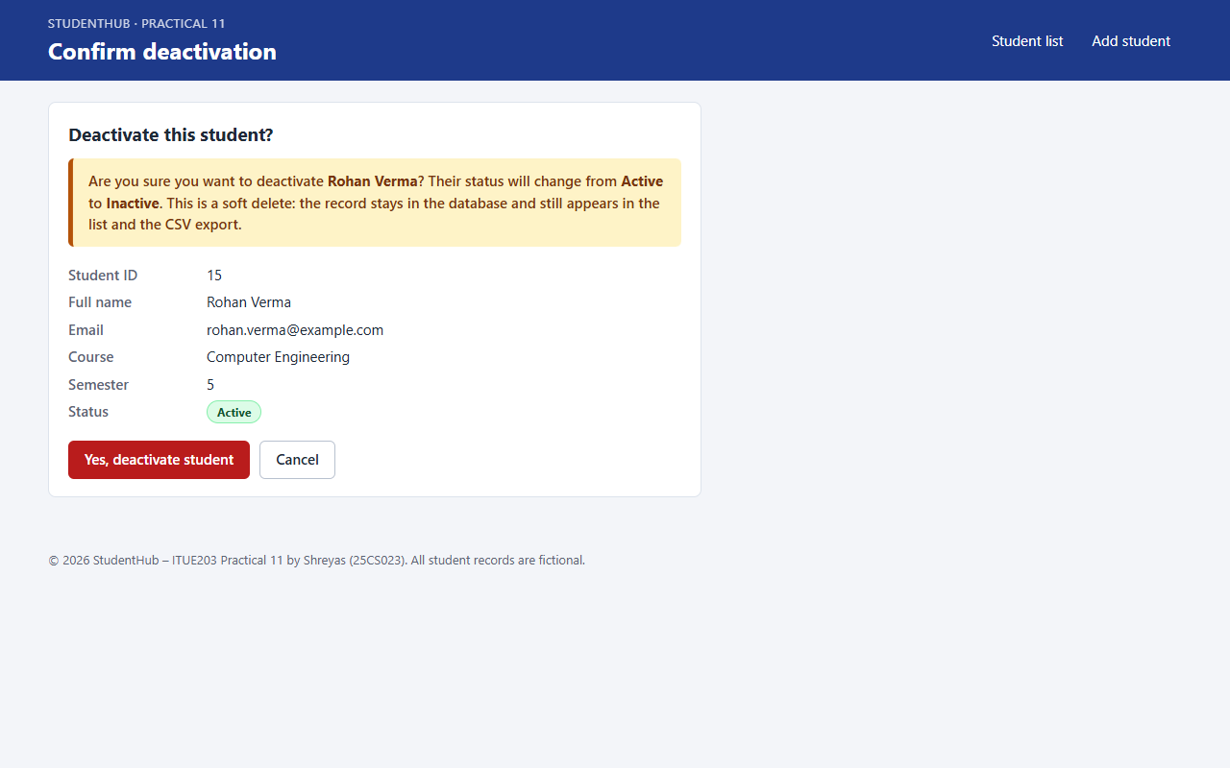
Figure 8: Confirmation before the soft delete of Rohan Verma (ID 15) (delete-confirmation.png)
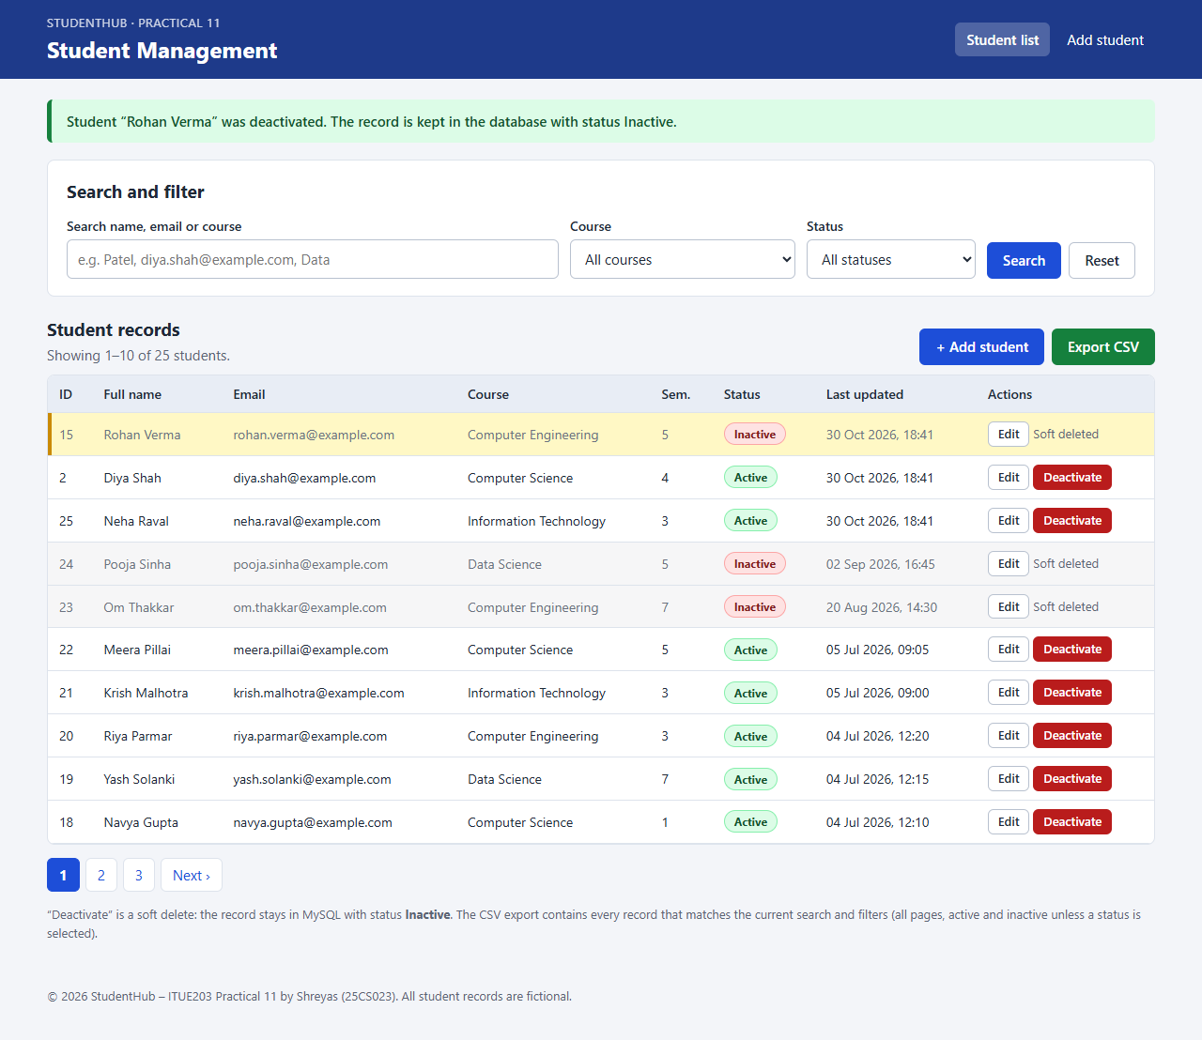
Figure 9: Successful soft delete – Rohan Verma kept in the list with status Inactive (successful-soft-delete.png)
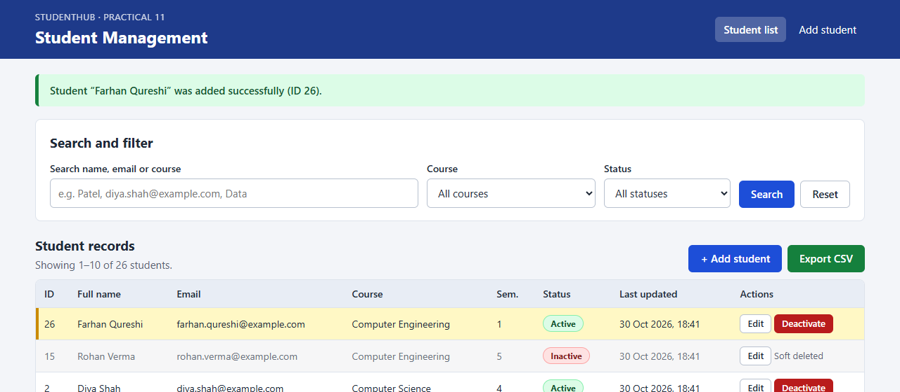
Figure 10: Success message after adding another student (Farhan Qureshi, ID 26) (success-message.png)
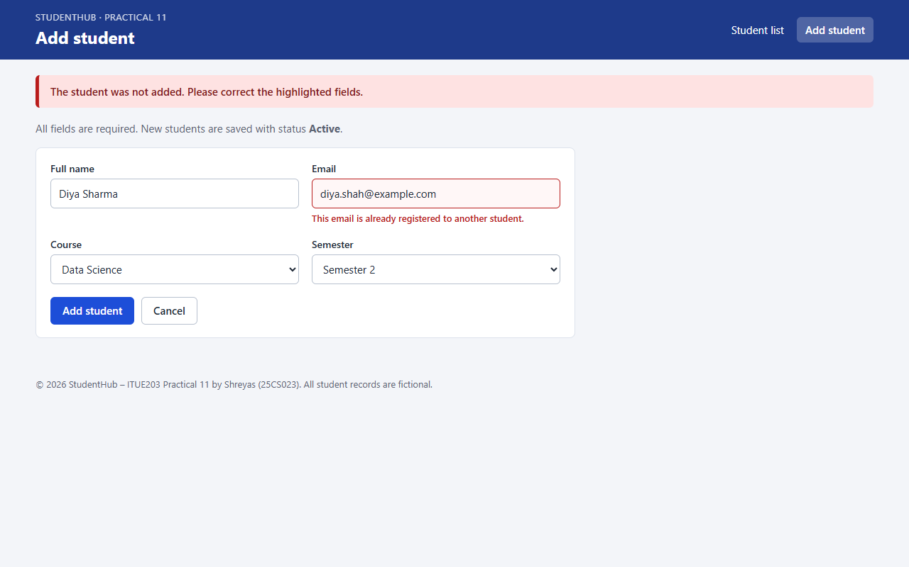
Figure 11: Error message – the server refuses a duplicate email (diya.shah@example.com) (error-message.png)
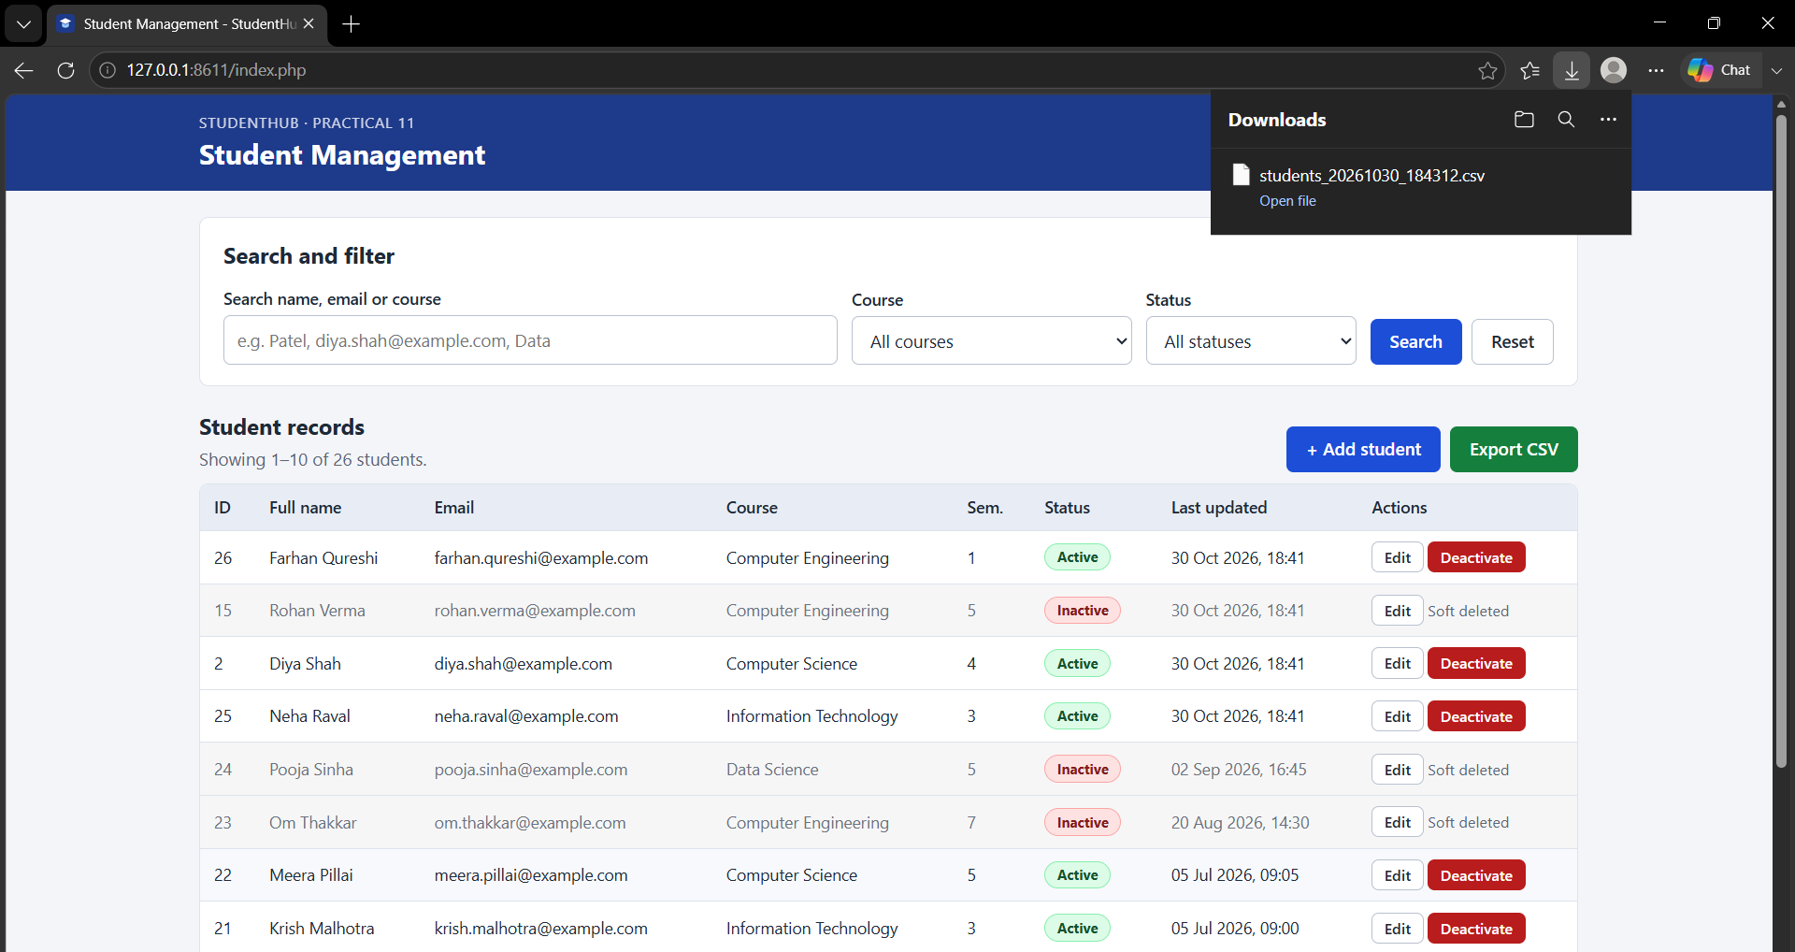
Figure 12: CSV export – Edge's Downloads panel shows students_20261030_184312.csv after clicking Export CSV (csv-export.png)
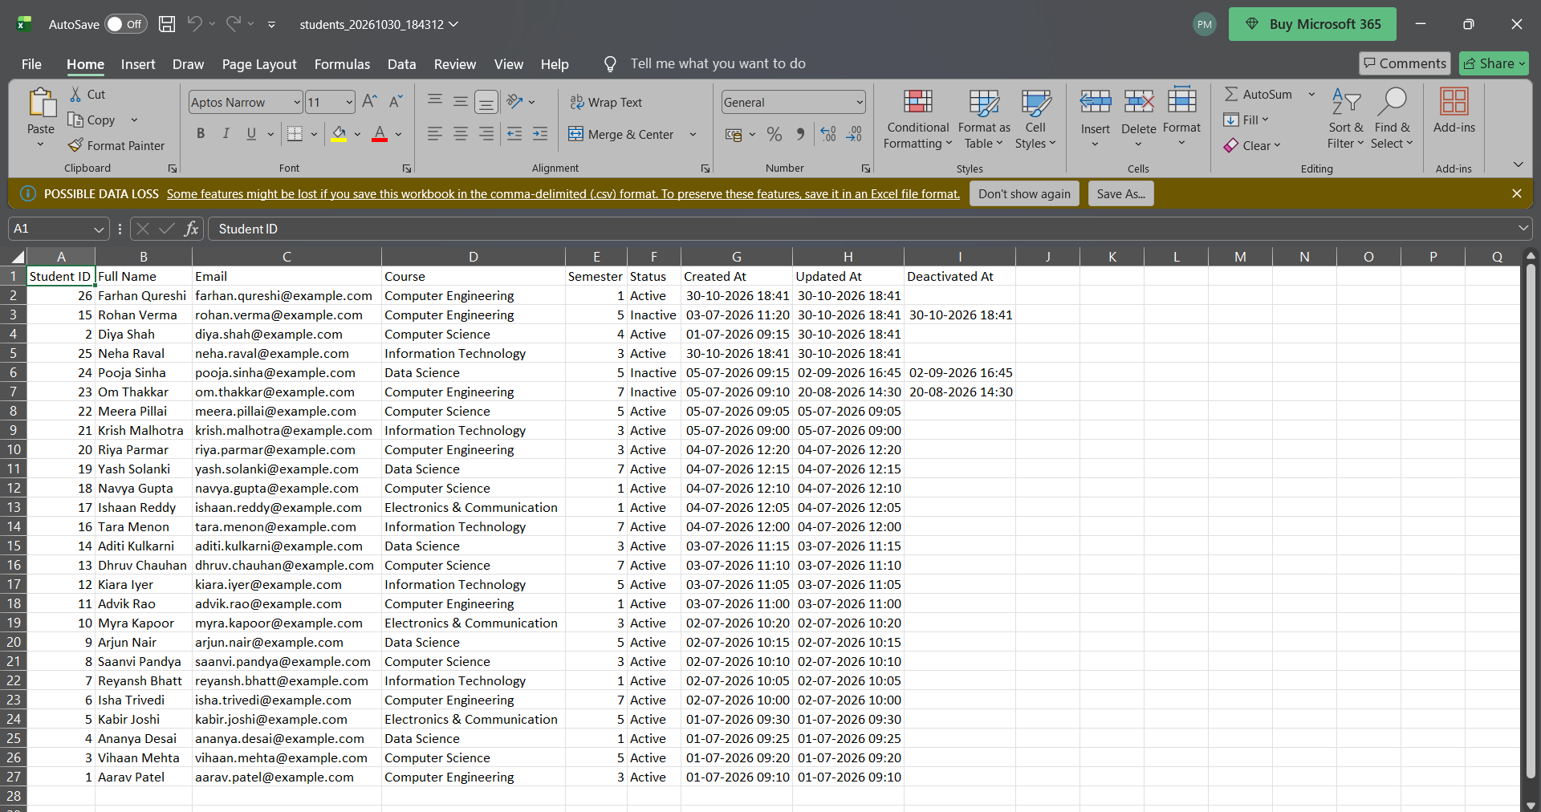
Figure 13: The exported CSV opened in Microsoft Excel – 26 students, 9 columns, inactive rows with Deactivated At (csv-opened-in-excel.png)

7. Test Cases and Results
tests/test_app.py (Python standard library) creates the disposable database studenthub_prac11_test from the SQL dump, starts two PHP servers (normal, and with MySQL unreachable), sends real HTTP requests and checks the pages and the database. It removes the test database at the end; studenthub_prac11 is not used.
Result: 106 of 106 automated checks passed, 0 failed. php -l found no syntax errors in the 9 PHP files. The browser test in Microsoft Edge passed 13 of 13 checks (including: the browser blocks an empty form, no JavaScript errors).
ID | Test case | Expected result | Result
TC01 | Database connection | page loads (HTTP 200) with data from studenthub_prac11_test | Pass
TC02 | Seed data | 24 records, 22 active, 2 inactive; UNIQUE email and CHECK constraints work | Pass
TC03 | Student list display | table with ID, name, email, course, semester, status badge, last updated, actions; "Showing 1–10 of 24 students" | Pass
TC04 | Successful addition | 303 → list, "Student “Neha Raval” was added successfully", row first and highlighted, email stored in lower case, status active | Pass
TC05 | Empty-field validation | HTTP 422, an error under each of the 4 fields, nothing inserted; in Edge the browser blocks the empty form | Pass
TC06 | Invalid email | "Enter a valid email address…", typed values kept, nothing inserted | Pass
TC07 | Duplicate email | "This email is already registered to another student.", nothing inserted | Pass
TC08 | Tampered values | all three refused by the server | Pass
TC09 | Successful update | "Student “Diya Shah” was updated successfully.", MySQL row changed, row first | Pass
TC10 | Update errors | error messages, nothing saved; unknown ID → "That student record was not found." | Pass
TC11 | Soft-delete confirmation | confirmation page "Are you sure you want to deactivate Rohan Verma?"; GET changes nothing | Pass
TC12 | Successful soft delete | "…was deactivated. The record is kept in the database with status Inactive." | Pass
TC13 | Status changed to inactive | status='inactive', deleted_at set; red Inactive badge, no Deactivate button | Pass
TC14 | Inactive record remains | row count unchanged; no DELETE FROM anywhere in the code | Pass
TC15 | Soft delete twice / unknown ID | "…is already inactive." / "record was not found", nothing changed | Pass
TC16 | Search by name | only Aarav Patel | Pass
TC17 | Search by email | only Kiara Iyer | Pass
TC18 | Search by course | all Data Science students (case-insensitive) | Pass
TC19 | Search edge cases | "No students found"; % searched literally | Pass
TC20 | Course filter | only that course; & escaped as &amp; | Pass
TC21 | Combined filters | result equals the matching SQL count | Pass
TC22 | Pagination | 10 + 10 + 4 rows, each student once; out-of-range pages clamped; page links keep the filter | Pass
TC23 | Success and error messages | green success or red error message; shown once only | Pass
TC24 | CSV export | text/csv attachment students_YYYYMMDD_HHMMSS.csv, UTF-8 BOM, CRLF, header + one row per student, 9 columns | Pass
TC25 | CSV contents and filters | only matching rows; inactive rows have Status Inactive and Deactivated At | Pass
TC26 | CSV formula injection | exported as '=HYPERLINK(…), '+1+1, … (text, not formulas) | Pass
TC27 | Excel compatibility | 27 rows × 9 columns, readable, & and dates correct (csv-opened-in-excel.png) | Pass
TC28 | CSRF validation | refused with "The form could not be processed…", nothing changed | Pass
TC29 | Duplicate submission | first accepted, second refused (one record) | Pass
TC30 | SQL injection | treated as text / refused; no extra rows, no change, table intact; O'Brien stored literally | Pass
TC31 | XSS output escaping | shown escaped (&lt;…&gt;) in the list, edit form, confirmation page and re-shown form | Pass
TC32 | Raw database errors hidden | HTTP 503 "The student database is not available right now", no technical details; real error in the PHP log | Pass
TC33 | Protected files | HTTP 403 | Pass

Checks per area (from tests/test_output.txt): static 4, database 8, list 6, pagination 6, add 5, validation 9, update 7, soft delete 9, search/filter 10, CSV 9, CSRF/duplicates 7, SQL injection 7, XSS 5, protected files 9, server log 1, MySQL unreachable + cleanup 4 = 106.

8. Problems Encountered and Fixes
- Sorting within one second: the list shows the most recently changed record first using updated_at, which has 1-second precision. In one test run an insert and an update happened in the same second and the updated student was not first. The order is still deterministic (ties by ID); the test now waits one second and the limitation is documented.
- Test expectations: the search “sha” also (correctly) matches Isha Trivedi, and a soft delete of an inactive student answers with a redirect; two checks were corrected to expect the real, correct behaviour.
- Error highlighting: the red border for invalid fields was overridden by a more specific CSS rule; the selector was fixed.
- CSV download evidence: with Playwright the download is intercepted and Edge shows a random file name, so Figure 12 was captured from a normal Edge window instead.
- router.php: a shell here-document turned '\\' into '\'; php -l reported the parse error and it was fixed.

9. Conclusion
The Student Management application fulfils all required functions: records are listed in a table, students are added and updated with validation and clear messages, the list can be searched by name, email and course, filtered by course and paged, and students are soft-deleted only after confirmation – their status becomes inactive while the record stays in MySQL. The CSV export respects the selected filters, includes inactive records and opens correctly in Excel. Prepared statements, output escaping, one-time form tokens and hidden error details protect the application, and all 106 automated checks and 13 browser checks passed. Possible extensions are a login (as in Practical 10) and a button to reactivate inactive students.

10. References
- PHP Manual – MySQLi prepared statements: https://www.php.net/manual/en/mysqli.quickstart.prepared-statements.php
- PHP Manual – htmlspecialchars: https://www.php.net/manual/en/function.htmlspecialchars.php
- PHP Manual – fputcsv: https://www.php.net/manual/en/function.fputcsv.php
- MariaDB Knowledge Base – CHECK constraints: https://mariadb.com/kb/en/constraint/
- OWASP – CSV Injection: https://owasp.org/www-community/attacks/CSV_Injection
- OWASP – Cross-Site Request Forgery Prevention Cheat Sheet: https://cheatsheetseries.owasp.org/cheatsheets/Cross-Site_Request_Forgery_Prevention_Cheat_Sheet.html
- OWASP – SQL Injection Prevention Cheat Sheet: https://cheatsheetseries.owasp.org/cheatsheets/SQL_Injection_Prevention_Cheat_Sheet.html
- Project repository: https://github.com/TheEmperor08/StudentHub-ITUE203-25CS023 (folder Practical-11)

