CHAROTAR UNIVERSITY OF SCIENCE AND TECHNOLOGY (CHARUSAT)
Chandubhai S. Patel Institute of Technology (CSPIT)
Department of Computer Science & Engineering
ITUE203 – Web Development Frameworks

PRACTICAL 12

Event Management CRUD with Poster Upload and File Validation
PHP 8 · MySQL (MariaDB) · MySQLi · Bootstrap 5
Student Name | Shreyas
Roll Number | 25CS023
Student ID | 25CS023
Email | 25cs023@charusat.edu.in
Course | ITUE203 – Web Development Frameworks
Programme | B.Tech Computer Science & Engineering
Semester / Academic Year | 3 / 2026-27
Date of Submission
Faculty Signature

1. Problem Definition
StudentHub needs an event module in which administrators publish events with a poster image. Uploading files is one of the most dangerous features of a web application: if the server trusts the file name, the extension or the browser's accept attribute, an attacker can upload a PHP script and run it, an SVG file with JavaScript, a disguised executable or a huge file. A carelessly built edit or delete function can also destroy the wrong file, follow a path such as ../db.php, or lose the old poster when an update fails. The module must therefore validate every poster on the server, store it safely, change files only after the database change succeeded, and let only authorised administrators manage events.
Starting point: the Practical-12 folder contained a simple teaching version that used the shared event_db database, a users table with a role column, checked only the extension and getimagesize(), had no CSRF protection and stored posters in a web-accessible folder. It was backed up and replaced by the application described here, which uses its own database studenthub_prac12 and its own administrator table.

2. Objectives
- Add, view, update and delete events (title, description, category, date, time, venue, poster, status).
- Upload event posters and validate the file type (JPEG, PNG, WebP) and file size (max 2 MB) on the server.
- Show clear success and failure messages for every action.
- Restrict event management to authorised administrators with a secure login, session handling and logout.
- Intermediate extension: event categories and Open/Closed status filtering.
- Use MySQLi prepared statements, output escaping and CSRF protection throughout.

3. Tools and Technologies
Tool | Use in this practical
PHP 8.2.12 (XAMPP) | Application pages, sessions, password_verify(), upload handling
MySQLi | All database access with prepared statements
PHP Fileinfo extension | Detects the real MIME type of an uploaded file from its content
MariaDB 10.4.32 (XAMPP) | Database studenthub_prac12; export with mysqldump
Bootstrap 5.3.3 | Responsive layout, forms, tables, alerts (stored locally, no CDN)
HTML5, CSS3, JavaScript | Forms with HTML5 validation; poster preview before upload (app.js)
Microsoft Edge | Running the application; headless Edge (Playwright) for the browser test and screenshots
Python 3 | tests/test_app.py – automated end-to-end tests (standard library only)

4. Database Design
The practical uses its own database, studenthub_prac12, with three InnoDB tables. No other practical's database is used.
Table / column | Type | Notes
events.event_id | INT UNSIGNED AUTO_INCREMENT | Primary key
events.event_title | VARCHAR(150) | CHECK at least 3 characters
events.description | TEXT | Required (10–2000 characters, checked by the application)
events.category | VARCHAR(40) | FOREIGN KEY → event_categories.category_name; index
events.event_date / event_time | DATE / TIME | Composite index idx_events_date
events.venue | VARCHAR(150) | Required
events.poster_filename | VARCHAR(64) | UNIQUE; CHECK REGEXP ^[a-f0-9]{32}[.](jpg|png|webp)$
events.status | ENUM('open','closed') | Default 'open'; index
events.created_at / updated_at | DATETIME | updated_at changes on every UPDATE
event_categories | category_name PK, description | Cultural, Hackathon, Seminar, Sports, Technical, Workshop
admins | admin_id, full_name, email UNIQUE, password_hash, created_at, last_login_at | CHECK: password_hash must be a bcrypt/Argon2 hash (no plaintext)

The foreign key keeps the category list in the database (the drop-downs are filled from event_categories). The UNIQUE key on poster_filename guarantees that two events can never share one file, so deleting one event can never remove another event's poster, and the CHECK constraint allows only the generated safe names – a value such as ../db.php cannot be stored at all.
studenthub_prac12.sql is the mysqldump export: 6 categories, 12 fictional events (8 open, 4 closed) whose poster files are in uploads/, and the fictional administrator admin.demo@example.com. Its password is stored only as a password_hash() hash of a random password that is not in the repository; the password is set locally with tools\set_admin_password.php.
studenthub_prac12.sql (lines 106–126) – events table from the dump
106 CREATE TABLE `events` (
107 `event_id` int(10) unsigned NOT NULL AUTO_INCREMENT,
108 `event_title` varchar(150) NOT NULL,
109 `description` text NOT NULL,
110 `category` varchar(40) NOT NULL,
111 `event_date` date NOT NULL,
112 `event_time` time NOT NULL,
113 `venue` varchar(150) NOT NULL,
114 `poster_filename` varchar(64) NOT NULL,
115 `status` enum('open','closed') NOT NULL DEFAULT 'open',
116 `created_at` datetime NOT NULL DEFAULT current_timestamp(),
117 `updated_at` datetime NOT NULL DEFAULT current_timestamp() ON UPDATE current_timestamp(),
118 PRIMARY KEY (`event_id`),
119 UNIQUE KEY `uq_events_poster_filename` (`poster_filename`),
120 KEY `idx_events_category` (`category`),
121 KEY `idx_events_status` (`status`),
122 KEY `idx_events_date` (`event_date`,`event_time`),
123 CONSTRAINT `fk_events_category` FOREIGN KEY (`category`) REFERENCES `event_categories` (`category_name`) ON UPDATE CASCADE,
124 CONSTRAINT `chk_events_poster_filename` CHECK (`poster_filename` regexp '^[a-f0-9]{32}[.](jpg|png|webp)$'),
125 CONSTRAINT `chk_events_title` CHECK (char_length(`event_title`) >= 3)
126 ) ENGINE=InnoDB AUTO_INCREMENT=13 DEFAULT CHARSET=utf8mb4 COLLATE=utf8mb4_unicode_ci;

4.1 Setting up and running the application
- Start MySQL in the XAMPP Control Panel.
- Import the database: phpMyAdmin → Import → studenthub_prac12.sql, or C:\xampp\mysql\bin\mysql.exe -u root < studenthub_prac12.sql in the Practical-12 folder.
- Set the demo password: C:\xampp\php\php.exe tools\set_admin_password.php admin.demo@example.com (type 8–72 characters).
- Start the server: double-click start-server.bat, or run C:\xampp\php\php.exe -S 127.0.0.1:8612 router.php in the Practical-12 folder.
- Open http://127.0.0.1:8612/login.php and log in with admin.demo@example.com.
- Optional settings (database, upload folder, timeout): copy config.example.php to the git-ignored config.local.php.

5. Application Implementation
File | Purpose
login.php / logout.php | Administrator login (password_verify, session ID regeneration) and POST-only logout
index.php | READ – event table with poster thumbnails, category and Open/Closed filters, messages
view.php | Event details with the full-size poster
add.php / edit.php | CREATE / UPDATE – validation, poster upload or replacement
delete.php | DELETE – confirmation page (GET) and deletion of the event and its poster (POST)
poster.php | The only way to view a poster: validated name, image Content-Type, admins only
includes/functions.php | Session, security headers, CSRF token, require_admin(), messages, validation, layout
includes/upload.php | Poster validation, random file names, safe file paths and deletion
tools/*.php | Command line: set the admin password; list/delete abandoned poster files
router.php, .htaccess, uploads/.htaccess | Block private files and the upload folder (HTTP 403)

5.1 Administrator authentication
The login form posts email, password and a CSRF token. The email is looked up with a prepared statement and the password is checked with password_verify(); an unknown email is checked against a dummy hash so that both failures take about the same time and show the same message, “Invalid email or password.” After a successful login session_regenerate_id(true) gives the session a new ID (protection against session fixation) and a new CSRF token. The session cookie P12SESSID is HttpOnly and SameSite=Strict, and a session ends after 30 minutes of inactivity.
login.php (lines 28–46) – password verification and session regeneration
28 $stmt = get_db()->prepare('SELECT admin_id, full_name, email, password_hash FROM admins WHERE email = ?');
29 $stmt->bind_param('s', $email);
30 $stmt->execute();
31 $row = $stmt->get_result()->fetch_assoc();
32 // An unknown email is checked against a dummy hash, so both failures take about the same time
33 $hash = $row['password_hash'] ?? '$2y$10$qAzAl/cRo1Zi1CMFWjkd6uXqfnlXMCb8ADDDWVXGEfMWXNVeKN7Pa';
34 $verified = password_verify($password, $hash); // always runs, also for an unknown email
35 if ($verified && $row !== null && $email !== '' && $password !== '') {
36 session_regenerate_id(true);
37 $_SESSION = [
38 'admin' => ['id' => (int) $row['admin_id'], 'name' => $row['full_name'], 'email' => $row['email']],
39 'last_activity' => time(),
40 'csrf_token' => bin2hex(random_bytes(32)), // new token for the new session
41 ];
42 $update = get_db()->prepare('UPDATE admins SET last_login_at = NOW() WHERE admin_id = ?');
43 $update->bind_param('i', $_SESSION['admin']['id']);
44 $update->execute();
45 flash('success', 'Welcome, ' . $row['full_name'] . '. You are logged in as administrator.');
46 redirect('index.php');

Every event page – including poster.php – starts with require_admin(). Without a valid administrator session the server answers HTTP 401 “Access denied” before any data is read or changed.
includes/functions.php (lines 100–122) – access control for all event pages
100 function require_admin(): array
101 {
102 start_app();
103 $admin = current_admin();
104 if ($admin !== null && time() - (int) ($_SESSION['last_activity'] ?? 0) > session_timeout_seconds()) {
105 end_session();
106 redirect('login.php?status=timeout');
107 }
108 if ($admin === null) {
109 http_response_code(401);
110 page_start('Access denied');
111 echo '<div class="card border-danger shadow-sm mx-auto access-card">', "\n",
112 ' <div class="card-body p-4">', "\n",
113 ' <h2 class="h4 text-danger mb-3">Access denied</h2>', "\n",
114 ' <p class="mb-2">Event management is restricted to authorized administrators. You are not logged in, so this page was refused by the server (HTTP 401).</p>', "\n",
115 ' <p class="text-secondary small mb-4">No event data was shown or changed.</p>', "\n",
116 ' <a class="btn btn-primary" href="login.php">Go to administrator login</a>', "\n",
117 ' </div>', "\n", '</div>', "\n";
118 page_end();
119 exit;
120 }
121 $_SESSION['last_activity'] = time();
122 return $admin;

6. CRUD Functionality

6.1 Create and read
add.php validates all fields (validate_event(): required values, lengths, a category from the table, a real date, a time HH:MM, status open/closed) and the poster (Section 7). Only when everything is valid is the poster stored under a random name and the event inserted with a prepared INSERT; if the INSERT fails, the stored file is removed again. index.php lists all events with a poster thumbnail, title, category, date and time, venue and an Open (green) or Closed (grey) badge; the new event is highlighted after adding.
The category and status filters accept only values from the category table and the two statuses; the WHERE clause is built from fixed pieces with ? placeholders.
index.php (lines 13–33) – category and Open/Closed filter
13 // WHERE clause from fixed pieces with ? placeholders; the values were checked against the allowed lists above
14 $where = [];
15 $types = '';
16 $params = [];
17 if ($category !== '') {
18 $where[] = 'category = ?';
19 $types .= 's';
20 $params[] = $category;
21 }
22 if ($status !== '') {
23 $where[] = 'status = ?';
24 $types .= 's';
25 $params[] = $status;
26 }
27 $stmt = $db->prepare('SELECT event_id, event_title, category, event_date, event_time, venue, poster_filename, status FROM events'
28 . ($where ? ' WHERE ' . implode(' AND ', $where) : '') . ' ORDER BY event_date, event_time, event_id');
29 if ($types !== '') {
30 $stmt->bind_param($types, ...$params);
31 }
32 $stmt->execute();
33 $events = $stmt->get_result()->fetch_all(MYSQLI_ASSOC);

6.2 Update with poster replacement
Without a new file the existing poster is kept. A replacement is validated first and stored under a new random name; then the UPDATE runs, and only after it succeeded is the old file deleted. If the UPDATE fails, the new file is removed and the old poster stays in MySQL and on disk. A rejected replacement changes nothing at all.
edit.php (lines 43–63) – safe poster replacement
43 $new_name = $replace ? store_poster($poster) : null;
44 if ($replace && $new_name === null) {
45 $errors['poster'] = 'The new poster could not be saved on the server. The current poster was kept.';
46 } else {
47 $poster_name = $new_name ?? $stored['poster_filename'];
48 try {
49 $stmt = $db->prepare('UPDATE events SET event_title = ?, description = ?, category = ?, event_date = ?, event_time = ?,
50 venue = ?, poster_filename = ?, status = ? WHERE event_id = ?');
51 $stmt->bind_param('ssssssssi', $event['event_title'], $event['description'], $event['category'], $event['event_date'],
52 $event['event_time'], $event['venue'], $poster_name, $event['status'], $id);
53 $stmt->execute();
54 } catch (Throwable $exception) {
55 discard_new_poster($new_name);
56 throw $exception;
57 }
58 if ($new_name !== null) {
59 delete_poster_file($db, $stored['poster_filename']); // the old file is no longer used by any event
60 }
61 flash('success', 'Event “' . $event['event_title'] . '” was updated successfully'
62 . ($new_name !== null ? ' and its poster was replaced.' : '; the existing poster was kept.'), $id);
63 redirect('index.php');

6.3 Delete with confirmation
Delete opens delete.php?id=N, which shows the poster and details and asks “Are you sure you want to delete …?”. Only the POST from Yes, delete event (with the CSRF token) deletes the row; afterwards its poster file is removed through delete_poster_file().
delete.php (lines 22–29) – delete the row, then its poster
22 $stmt = $db->prepare('DELETE FROM events WHERE event_id = ?');
23 $stmt->bind_param('i', $id);
24 $stmt->execute();
25 if ($stmt->affected_rows !== 1) {
26 flash('error', 'The event could not be deleted. Please try again.');
27 redirect('index.php');
28 }
29 $file_removed = delete_poster_file($db, $event['poster_filename']);

7. Poster Upload and Validation
All checks run on the server in validate_poster(); the accept attribute of the file field is only a convenience. Accepted are JPEG, PNG and WebP images up to 2 MB (and up to 6000 × 6000 px):
Step | Check | Rejects for example
1 | PHP upload error code | partial upload, file above the server limit, missing temp folder
2 | is_uploaded_file() | a path that was not uploaded in this request
3 | size 1 byte – 2 MB | empty files, files over 2 MB
4 | extension .jpg/.jpeg/.png/.webp | .gif, .svg, .php, .exe
5 | Fileinfo MIME type of the content, matching the extension | PHP script named .jpg, SVG named .png, PNG named .jpg
6 | getimagesize: same image type, 1–6000 px | fake images, gigantic dimensions
7 | complete structure (PNG chunks + CRC to IEND, JPEG end marker, WebP RIFF length) | truncated or damaged images
8 | no <?php inside the file | a valid JPEG with appended PHP code

includes/upload.php (lines 59–92) – content-based checks
59 $extension = strtolower(pathinfo((string) ($file['name'] ?? ''), PATHINFO_EXTENSION));
60 if (!isset(POSTER_EXTENSIONS[$extension])) {
61 return ['ok' => false, 'error' => 'Invalid file type. Only JPEG, PNG and WebP images (.jpg, .jpeg, .png, .webp) are allowed.'];
62 }
63
64 // The file is read once and every content check works on these bytes. Reading can fail when security software
65 // on the server blocks a malicious upload; that file is simply rejected.
66 $content = @file_get_contents($tmp);
67 if ($content === false || strlen($content) !== $size) {
68 error_log('Practical 12: an uploaded file could not be read (blocked or removed)');
69 return ['ok' => false, 'error' => 'Invalid file type. The file could not be read as an image.'];
70 }
71
72 $mime = (new finfo(FILEINFO_MIME_TYPE))->buffer($content);
73 if (!in_array($mime, POSTER_EXTENSIONS, true)) {
74 return ['ok' => false, 'error' => 'Invalid file type. The file content is not a JPEG, PNG or WebP image.'];
75 }
76 if ($mime !== POSTER_EXTENSIONS[$extension]) {
77 return ['ok' => false, 'error' => 'The file extension does not match its content (.' . $extension . ' file containing ' . $mime . ').'];
78 }
79
80 $info = @getimagesizefromstring($content);
81 if ($info === false || !isset(POSTER_IMAGE_TYPES[$info[2]]) || image_type_to_mime_type($info[2]) !== $mime
82 || !image_structure_ok($content, POSTER_IMAGE_TYPES[$info[2]])) {
83 return ['ok' => false, 'error' => 'The poster is not a valid image or is damaged.'];
84 }
85 if ($info[0] < 1 || $info[1] < 1 || $info[0] > POSTER_MAX_PIXELS || $info[1] > POSTER_MAX_PIXELS) {
86 return ['ok' => false, 'error' => 'The poster must be between 1 and ' . POSTER_MAX_PIXELS . ' pixels wide and high.'];
87 }
88
89 if (stripos($content, '<?php') !== false) {
90 return ['ok' => false, 'error' => 'The poster was rejected because it contains embedded code.'];
91 }
92 return ['ok' => true, 'tmp' => $tmp, 'ext' => POSTER_IMAGE_TYPES[$info[2]]];

Safe storage. The original name is never used: store_poster() names the file with 32 random hexadecimal characters (random_bytes(16)) plus the extension of the detected type and moves it with move_uploaded_file(). Only this name is stored in MySQL. The uploads/ folder is not reachable over HTTP – the router and uploads/.htaccess answer 403, switch the PHP engine off and remove script handlers – so even a file that contained code could never run. Posters are delivered by poster.php, which accepts only names matching ^[a-f0-9]{32}\.(jpg|png|webp)$ inside the upload folder and sends them as images with nosniff and a sandbox CSP.
includes/upload.php (lines 151–177) – no path traversal, no deleting other events' posters
151 function poster_path(string $name): ?string
152 {
153 if (!preg_match(POSTER_NAME_PATTERN, $name)) {
154 return null;
155 }
156 $dir = realpath(upload_dir());
157 $path = $dir === false ? false : realpath($dir . DIRECTORY_SEPARATOR . $name);
158 if ($path === false || dirname($path) !== $dir || !is_file($path)) {
159 return null;
160 }
161 return $path;
162 }
163
164 // Deletes a poster file, but only a valid name inside the upload folder that no event uses any more
165 // (poster_filename is also UNIQUE in MySQL, so two events can never share one file).
166 function delete_poster_file(mysqli $db, ?string $name): bool
167 {
168 if ($name === null || ($path = poster_path($name)) === null) {
169 return false;
170 }
171 $stmt = $db->prepare('SELECT COUNT(*) FROM events WHERE poster_filename = ?');
172 $stmt->bind_param('s', $name);
173 $stmt->execute();
174 if ((int) $stmt->get_result()->fetch_row()[0] > 0) {
175 return false;
176 }
177 return @unlink($path);

No abandoned files. Rejected uploads are never moved out of PHP's temporary folder (PHP deletes them after the request); a stored file is removed again when the INSERT or UPDATE fails; tools\cleanup_orphan_posters.php lists and (with --delete) removes valid-named files that no event uses and that are older than one hour.

8. Security Measures
- SQL injection: every query uses prepare() with placeholders and bind_param(); the tests confirm there is no query() call.
- XSS: every value is printed through e() = htmlspecialchars(…, ENT_QUOTES, 'UTF-8'); Content-Security-Policy default-src 'self', X-Frame-Options: DENY, X-Content-Type-Options: nosniff.
- CSRF: a random 64-character token per session in every form, checked with hash_equals(); add, edit, delete and logout accept only POST.
- Sessions: strict mode, HttpOnly + SameSite=Strict cookie, ID regenerated at login, 30-minute timeout, logout destroys the session and the cookie, Cache-Control: no-store on protected pages.
- Uploads: Section 7 – server-side validation, random names, non-public and non-executable folder, safe replacement and deletion.
- Errors and configuration: MySQL errors are logged and replaced by “The event database is not available right now.”; credentials belong in the git-ignored config.local.php; db.php, includes/, tools/, tests/, uploads/, the SQL dump and documents return HTTP 403.

9. Output Screenshots
All screenshots are genuine captures of the running application in Microsoft Edge (headless, 1280 px wide) taken during the browser test, with the demo database studenthub_prac12 and fictional data.
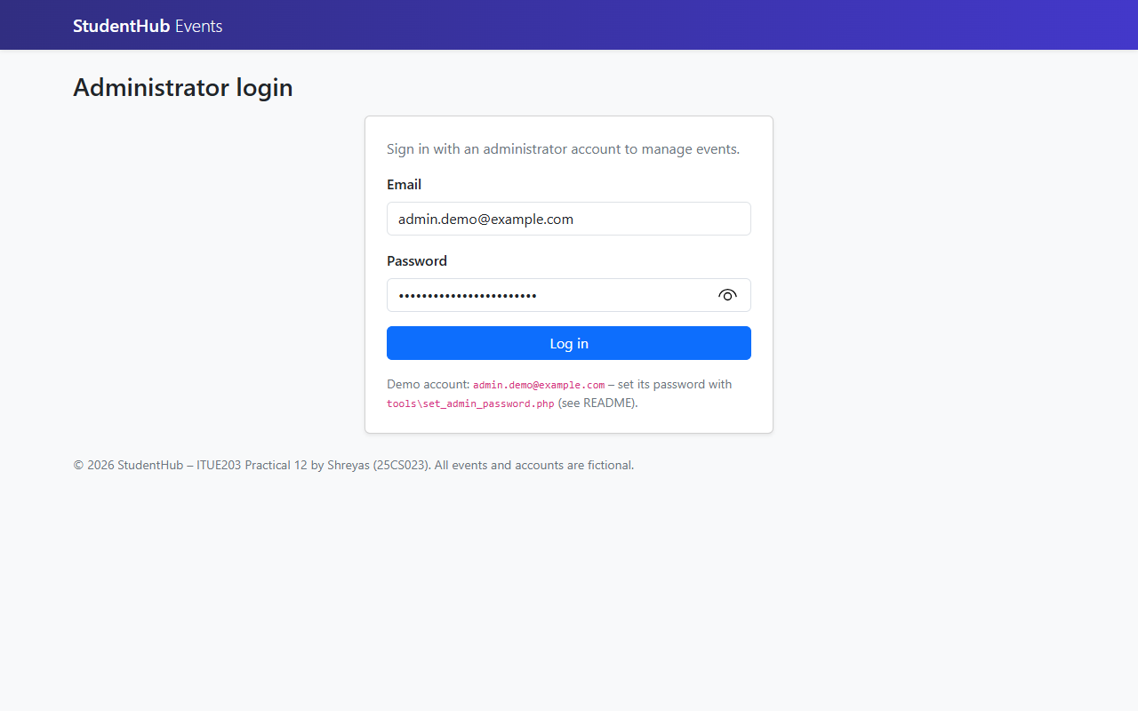
Figure 1: Administrator login page (email and password entered) (admin-login.png)
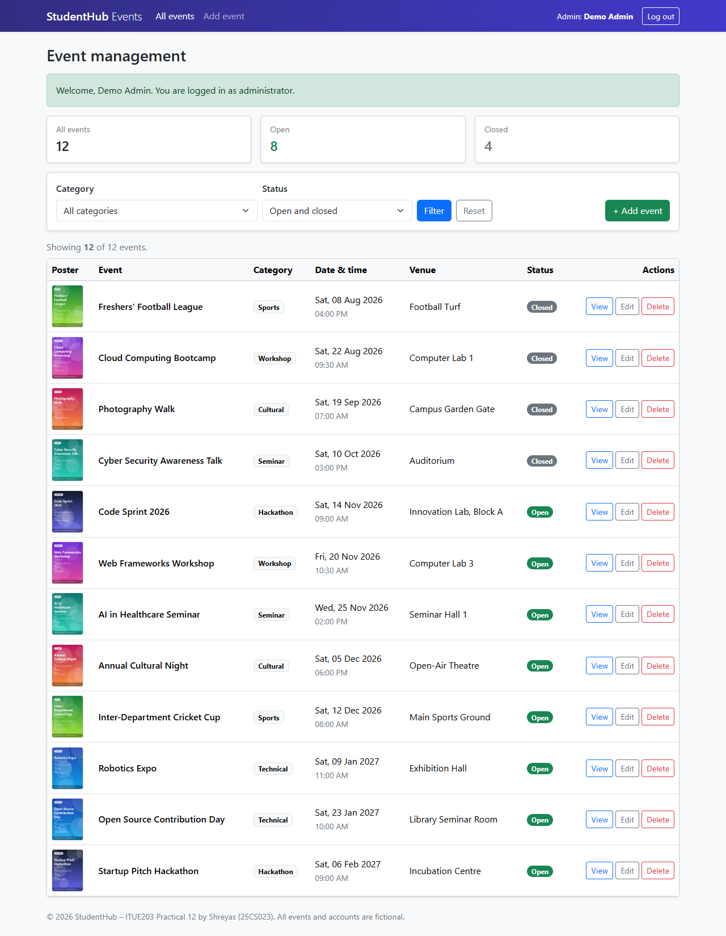
Figure 2: Event list after login – 12 events with poster thumbnails, category, date, venue and Open/Closed status (events-list.png)
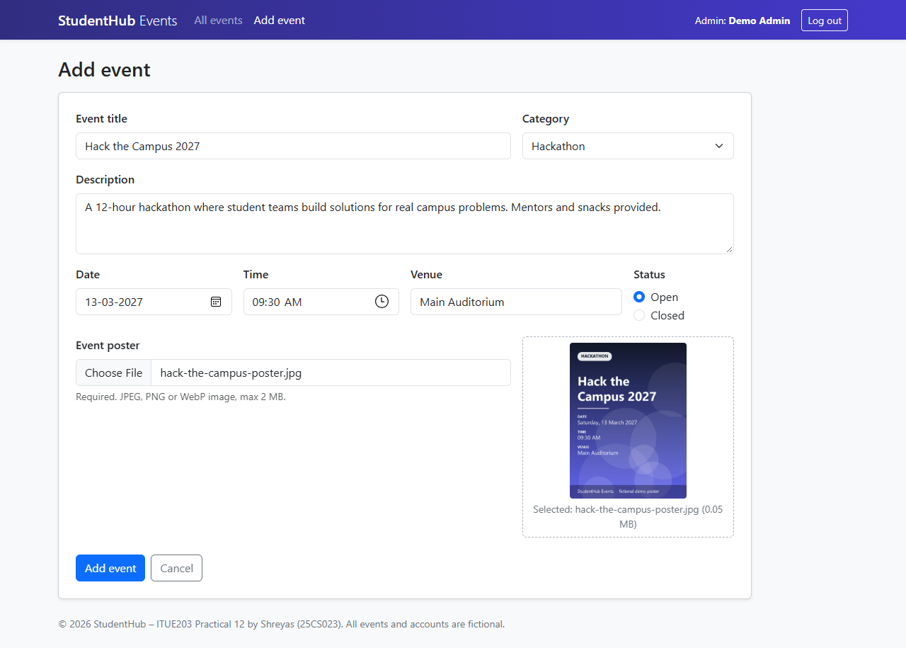
Figure 3: Add event form – all fields filled and a JPEG poster selected (preview shown before upload) (add-event-form.png)
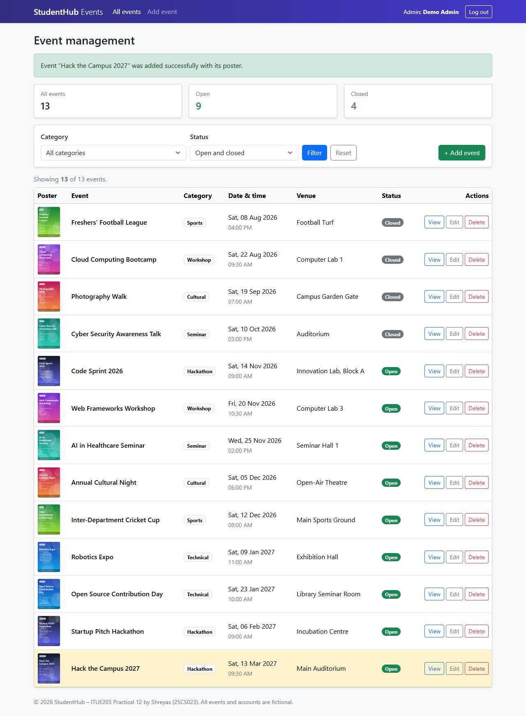
Figure 4: Successful addition – message and the new event “Hack the Campus 2027” highlighted with its poster (successful-event-add.png)
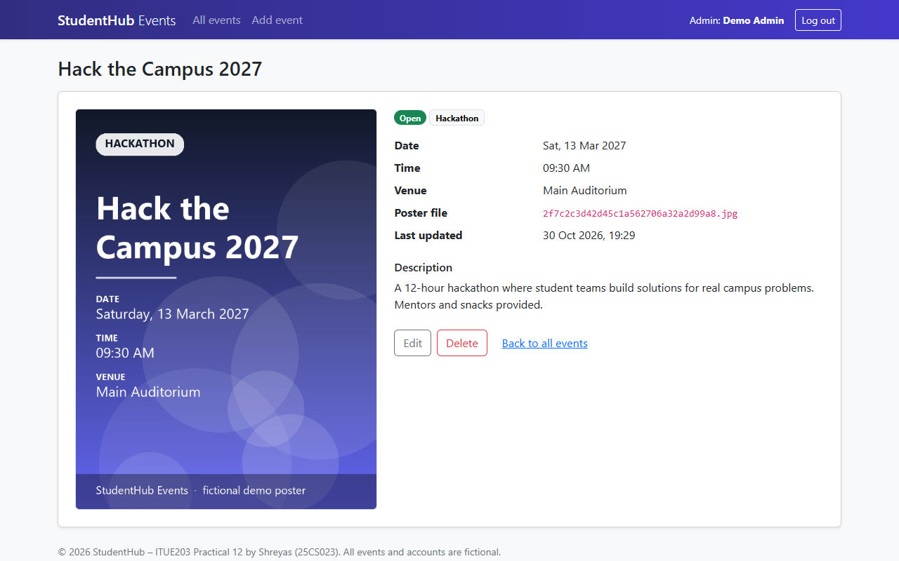
Figure 5: Uploaded poster displayed on the event page, stored under a random 32-character name (event-poster-preview.png)
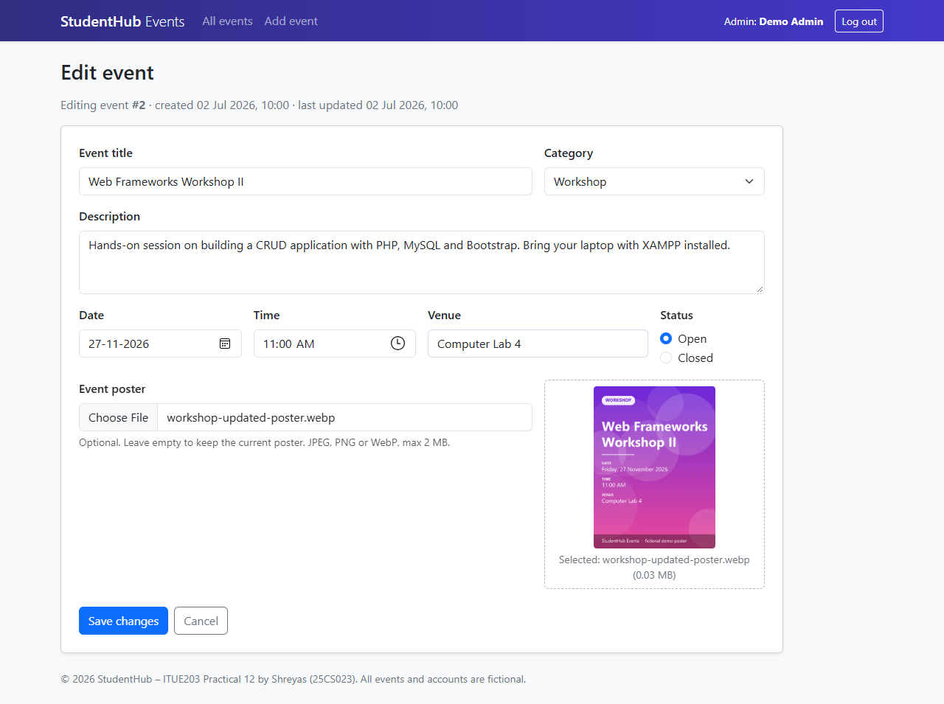
Figure 6: Editing event #2 – new title, date, time and venue and a replacement WebP poster (edit-event-form.png)
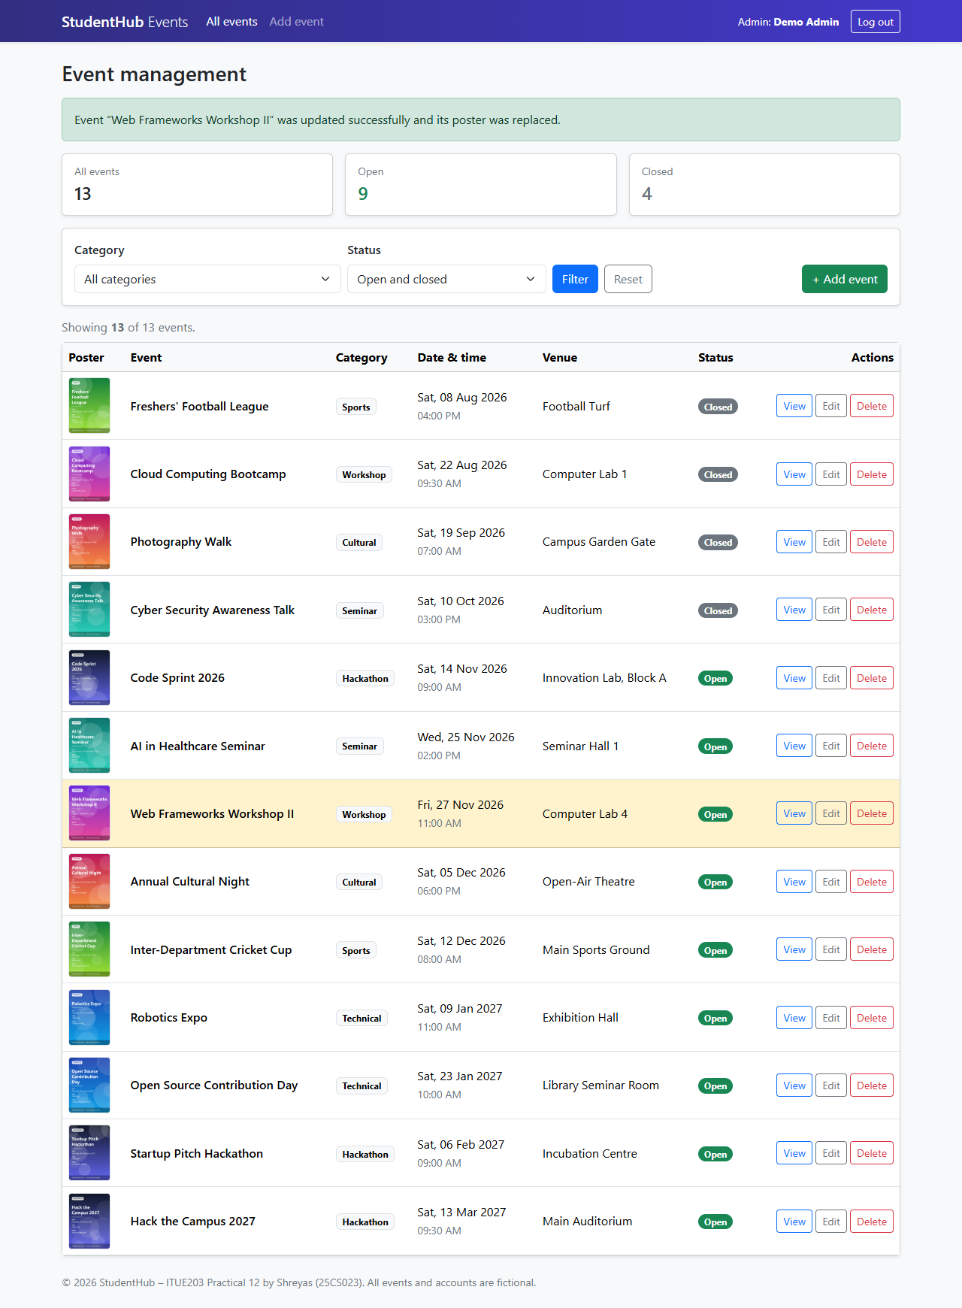
Figure 7: Successful update – “…updated successfully and its poster was replaced” (successful-event-update.png)
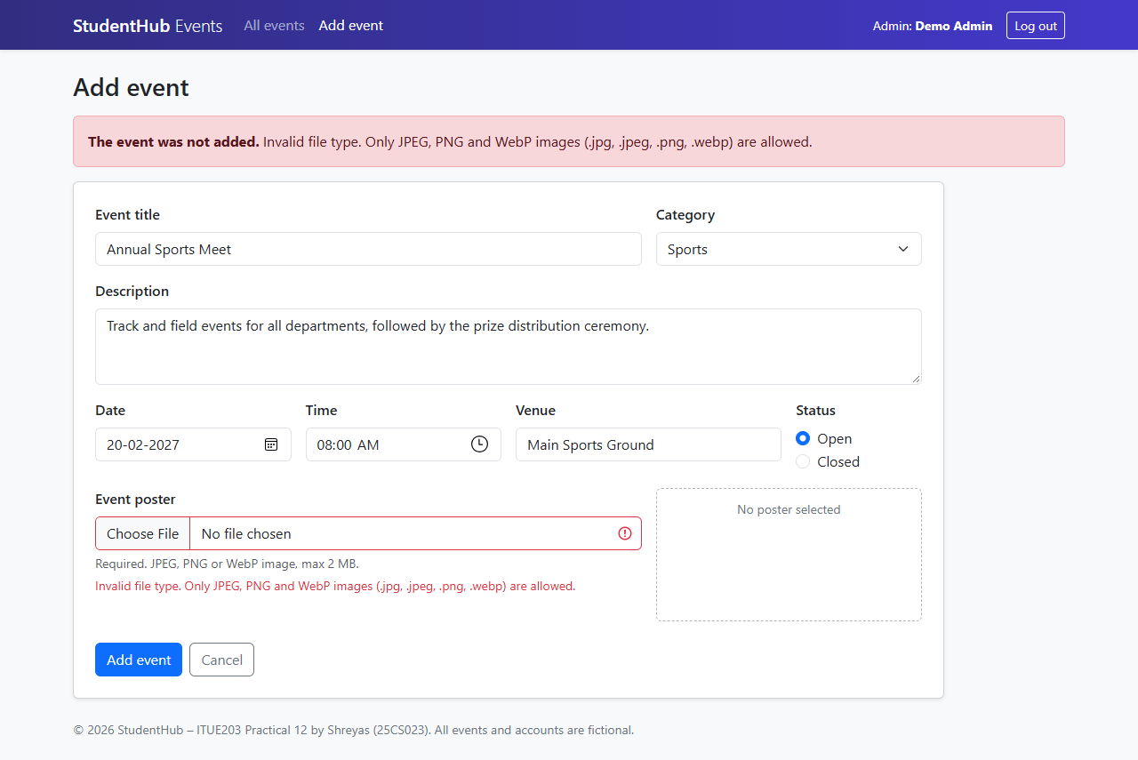
Figure 8: Invalid file type – an SVG file is rejected by the server (invalid-file-type.png)
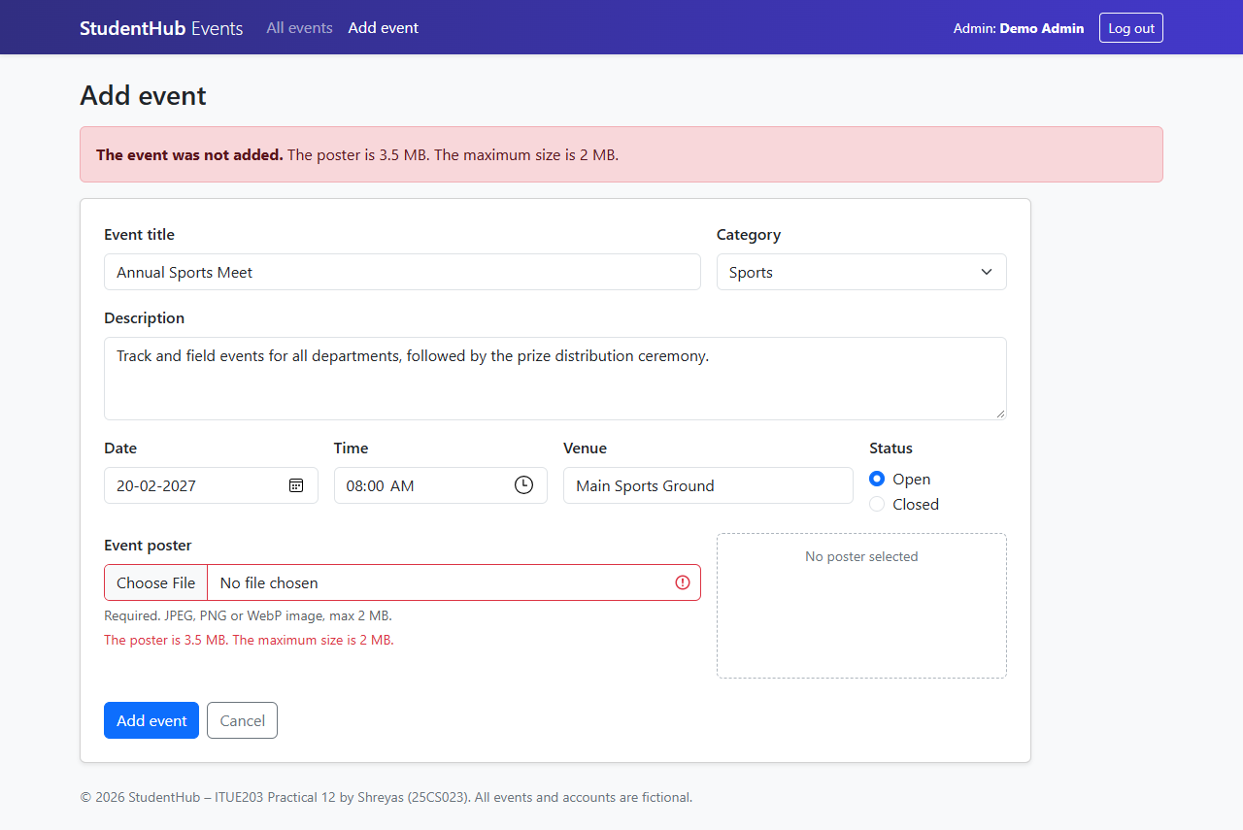
Figure 9: File size rejection – a 3.5 MB poster is rejected (maximum 2 MB) (file-size-rejection.png)
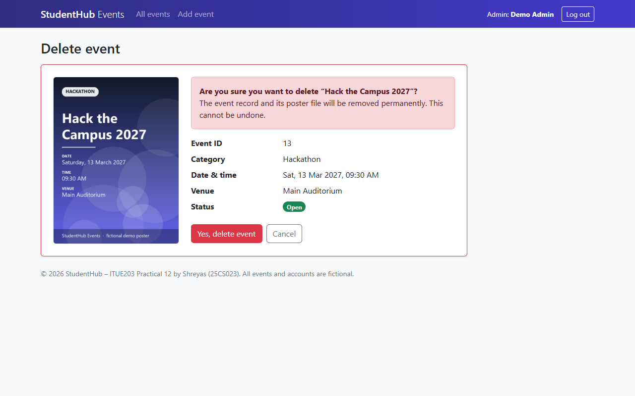
Figure 10: Confirmation before deleting “Hack the Campus 2027” (delete-confirmation.png)
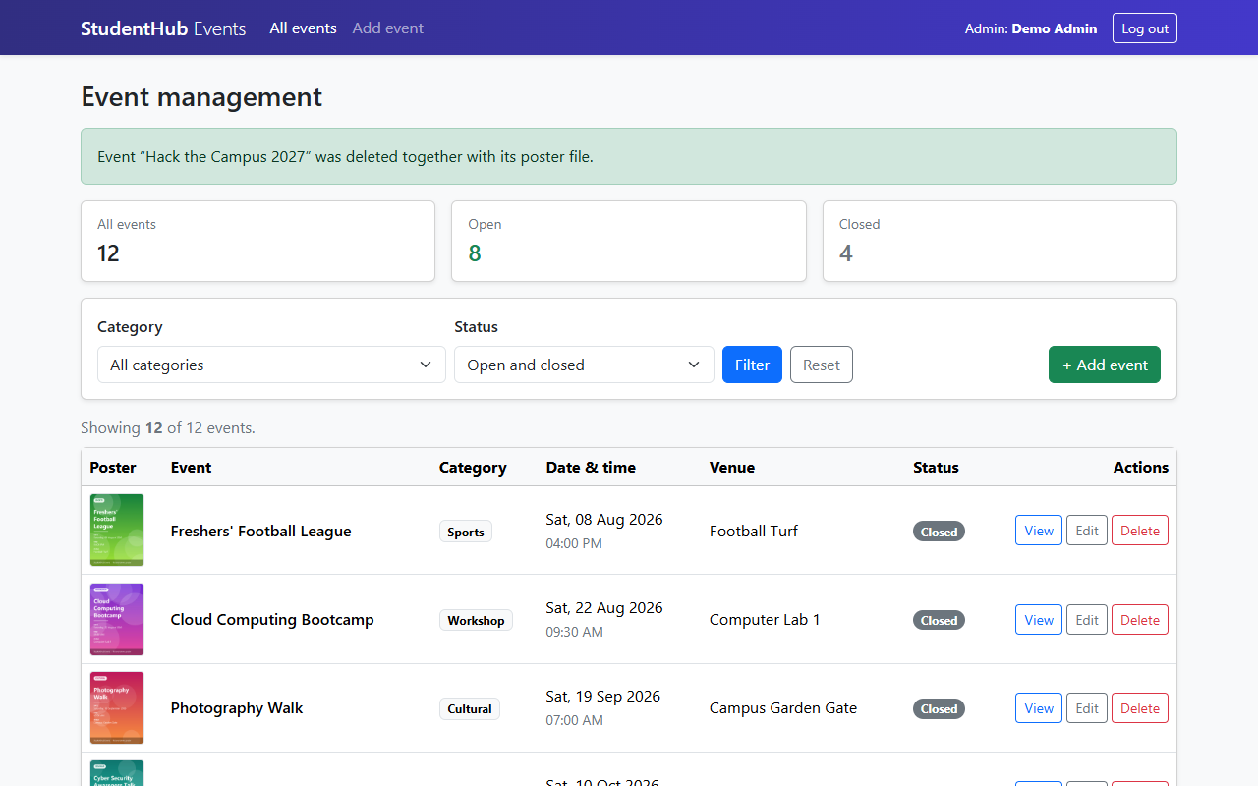
Figure 11: Successful deletion – “…was deleted together with its poster file” (successful-event-delete.png)
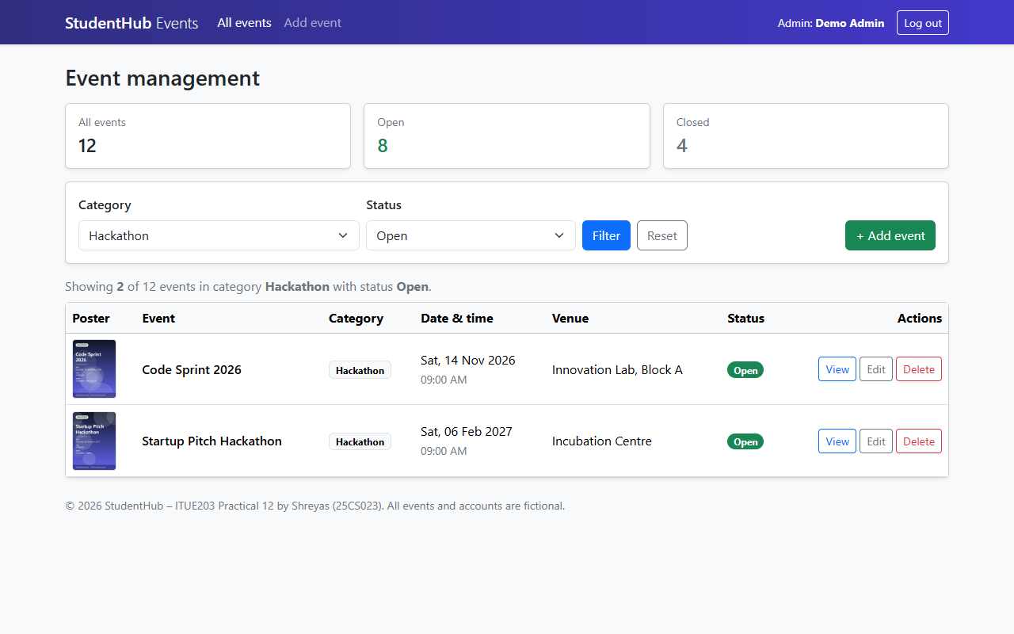
Figure 12: Category and status filters – Hackathon + Open shows 2 of 12 events (category-status-filter.png)
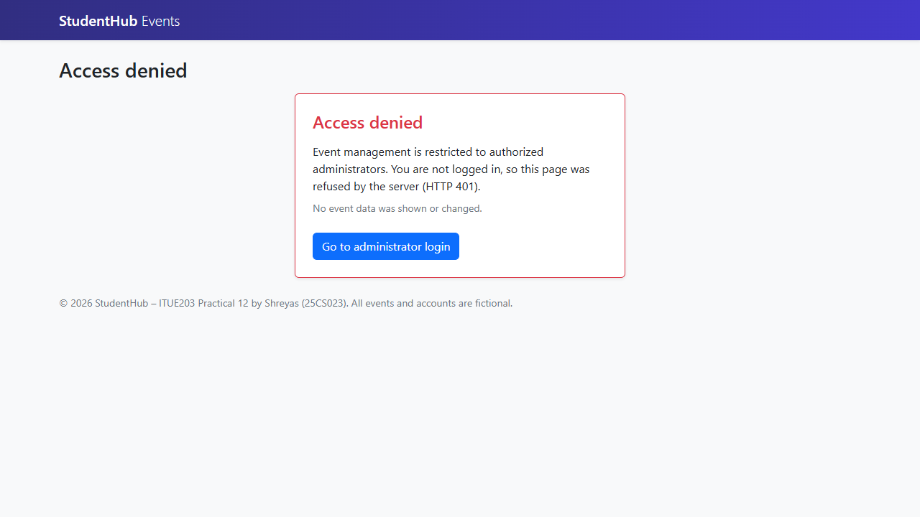
Figure 13: Not logged in – index.php refused with HTTP 401 “Access denied” (unauthorized-access-denied.png)

10. Test Cases and Results
tests/test_app.py (Python standard library) creates the disposable database studenthub_prac12_test and a temporary upload folder, sets a random admin password, starts three PHP servers (normal; 2-second timeout with small upload limits; MySQL unreachable), sends real HTTP and multipart upload requests and checks the pages, the database and the files. Test triggers in the test database force an INSERT and an UPDATE to fail after a poster was stored, to prove that no file is left behind and no old poster is lost. Everything is removed at the end; studenthub_prac12 and uploads/ are not changed.
Result: 153 of 153 automated checks passed, 0 failed. php -l found no syntax errors in the 15 PHP files. The browser test in Microsoft Edge passed 13 of 13 checks.
ID | Test case | Expected result | Result
TC01 | Database connection and seed data | 12 events (8 open, 4 closed), 6 categories, 1 hashed admin; page loads | Pass
TC02 | Constraints | refused by FK, CHECK, UNIQUE and CHECK constraints | Pass
TC03 | Admin login | 303 → event list, “Welcome, Demo Admin”, session ID changed, old ID useless | Pass
TC04 | Failed login | HTTP 401 “Invalid email or password.” / “login form expired”; no session | Pass
TC05 | Unauthorized access | HTTP 401 “Access denied”, no event data, nothing changed | Pass
TC06 | Logout | only the valid POST logs out; afterwards 401, old cookie useless | Pass
TC07 | Session timeout | redirect to login “Your session expired…”, session gone | Pass
TC08 | Event listing | 12 rows with poster thumbnails, title, category, date & time, venue, Open/Closed badge | Pass
TC09 | Poster delivery | exact image bytes, image Content-Type, nosniff, sandbox CSP | Pass
TC10 | Create with valid JPEG / PNG / WebP | 303, success message, new row, file stored under <32 hex>.<ext> with identical bytes | Pass
TC11 | Random file names | three different random names; nothing written outside uploads/ | Pass
TC12 | Required-field validation | HTTP 422, error for title, description, category, date, time, venue and poster | Pass
TC13 | Tampered values | all refused | Pass
TC14 | Invalid extension | “Invalid file type. Only JPEG, PNG and WebP…” | Pass
TC15 | Disguised files | rejected (content is not a JPEG, PNG or WebP image) | Pass
TC16 | MIME mismatch | “The file extension does not match its content” | Pass
TC17 | Corrupted images | “The poster is not a valid image or is damaged.” | Pass
TC18 | Embedded code | “rejected because it contains embedded code” | Pass
TC19 | Oversized file | “The poster is … MB. The maximum size is 2 MB.”; exactly 2 MB is accepted | Pass
TC20 | Server limits | clear “too large” messages, not a CSRF error | Pass
TC21 | Image dimensions; empty file | rejected | Pass
TC22 | No abandoned files | no new row and no new file in uploads/ | Pass
TC23 | Edit without new poster | “existing poster was kept”, same file name and file | Pass
TC24 | Poster replacement | new random name stored, new file present, old file deleted after the update | Pass
TC25 | Rejected replacement | HTTP 422, “current poster was kept”, nothing changed, no new file | Pass
TC26 | Failed update | 503 general message; new file removed; old poster still in MySQL and on disk | Pass
TC27 | Delete confirmation | “Are you sure you want to delete …?”, nothing deleted yet | Pass
TC28 | Delete and poster clean-up | refused without token; confirmed: row and only its poster file removed | Pass
TC29 | Delete edge cases | “not found”, nothing deleted | Pass
TC30 | Category filter | only Workshop events | Pass
TC31 | Open/Closed filter | only matching events; filters stay selected | Pass
TC32 | Filter tampering | ignored, all events listed | Pass
TC33 | SQL injection | stored literally, table intact; not found | Pass
TC34 | XSS escaping | escaped in list, view, edit and delete pages | Pass
TC35 | CSRF protection | refused, nothing changed | Pass
TC36 | Path traversal | HTTP 404, no file content revealed | Pass
TC37 | Upload-folder execution protection | HTTP 403; planted code delivered as raw bytes, never executed | Pass
TC38 | Protected files | HTTP 403 | Pass
TC39 | Abandoned-file clean-up tool | list mode lists it; --delete removes only that file | Pass
TC40 | Raw database errors hidden | 503 “The event database is not available right now”, details only in the PHP log | Pass

11. Problems Encountered and Fixes
- Truncated images: the first test run accepted a PNG cut after its header, because getimagesize() reads only the header. GD (which could re-encode the image) is not enabled in this XAMPP, so a structure check was added (PNG chunks with CRC up to IEND, JPEG end marker, WebP RIFF length) together with tests for truncated JPEG, PNG and WebP files.
- Unreadable malicious upload: for the test file containing a PHP web-shell line, finfo::file() logged a PHP warning – the file could not even be opened (most likely blocked by the security software). The upload is now read once; an unreadable file is rejected cleanly and all checks work on the read bytes.
- Login timing: the dummy-hash comparison was skipped for unknown emails because of short-circuit evaluation; password_verify() now always runs.
- Content-Security-Policy: the Edge test showed that img-src 'self' blocked Bootstrap's built-in data: icons (select arrows, radio dots); data: images are now allowed. Lazy-loaded thumbnails were removed so every poster loads at once.
- SQL CHECK constraint: the backslash in the poster-name REGEXP was lost, so . matched any character; it is now [.].
- Demo data: the screenshot run replaced a seed poster; uploads/ was restored and the dump re-imported afterwards.

12. Conclusion
The event management module lets authorised administrators add, view, update and delete events, filter them by category and Open/Closed status, and see clear success and error messages. Posters are accepted only after eight server-side checks – upload status, size, extension, Fileinfo MIME type, image type and dimensions, file structure and embedded code – are stored under random names in a folder that cannot be opened or executed, and are replaced or deleted only after the database change succeeded. Prepared statements, output escaping, CSRF tokens and a hardened session protect the application; all 153 automated checks and 13 browser checks passed. Possible extensions are a login-attempt limit, administrator management in the interface and image re-encoding once GD is available.

13. References
- PHP Manual – Handling file uploads: https://www.php.net/manual/en/features.file-upload.php
- PHP Manual – Fileinfo (finfo): https://www.php.net/manual/en/book.fileinfo.php
- PHP Manual – getimagesize: https://www.php.net/manual/en/function.getimagesize.php
- PHP Manual – password_verify: https://www.php.net/manual/en/function.password-verify.php
- PHP Manual – MySQLi prepared statements: https://www.php.net/manual/en/mysqli.quickstart.prepared-statements.php
- OWASP – File Upload Cheat Sheet: https://cheatsheetseries.owasp.org/cheatsheets/File_Upload_Cheat_Sheet.html
- OWASP – Cross-Site Request Forgery Prevention Cheat Sheet: https://cheatsheetseries.owasp.org/cheatsheets/Cross-Site_Request_Forgery_Prevention_Cheat_Sheet.html
- Bootstrap 5.3 documentation: https://getbootstrap.com/docs/5.3/
- Project repository: https://github.com/TheEmperor08/StudentHub-ITUE203-25CS023 (folder Practical-12)

