**Pre-Lab 02**

Emre Can Şen - 21902516

*Department of Electrical and Electronics Engineering, Bilkent University, 06800 Ankara, Turkey*

1. **Introduction**

In this lab, the bode plot of a transfer function will be found. In the first, part this is done directly with the given sample code. This part will be used as a reference for the second part. In the second part, cosine signals with varying frequencies will be applied to the system. Then the differences between these outputs and inputs will be used for generation of the bode plot of the system.

1. **Laboratory Content**

**Part 1**

Using the given signal and the code, the bode plot was obtained.

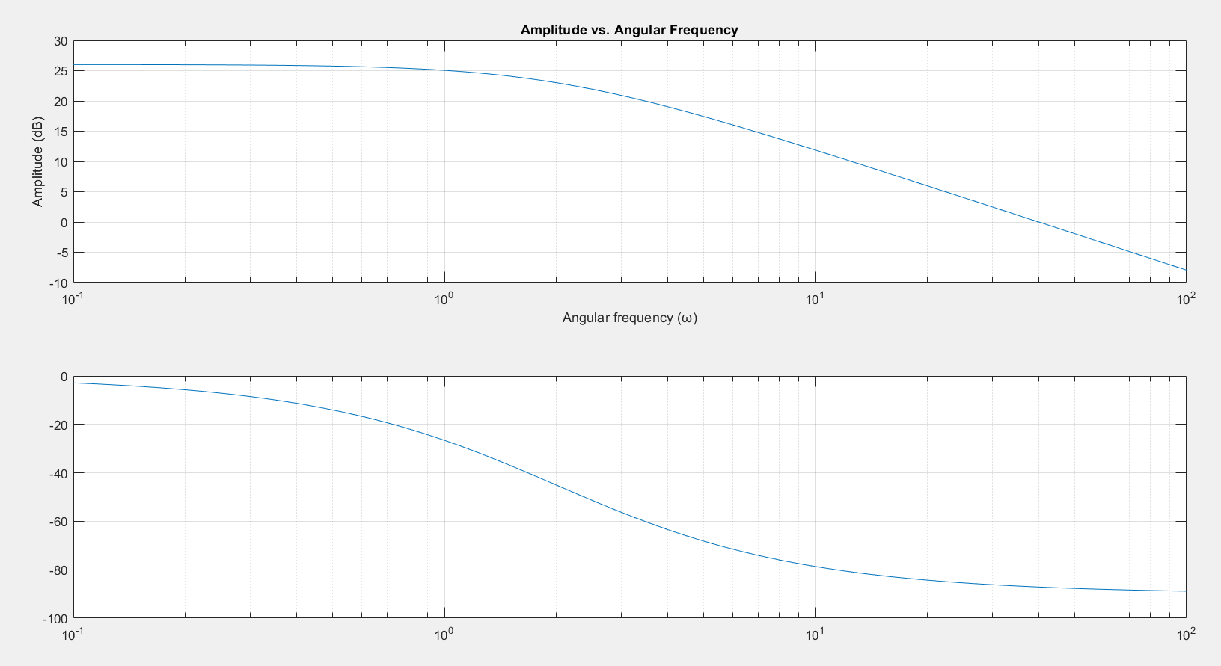

Figure 1- Bode Plot for the Given Function

This part will be used for comparison in the second part.

**Part 2**

The characteristics of LTI system when a cosine signal is applied will be determined firstly so that the bode plot can be plotted. The transfer function of an LTI system is as follows:

$$G\left(s\right)=\frac{A}{(s*τ+1)}$$

The Laplace transform of the cosine function is also as follows:

$$U\left(s\right)= L\{cos⁡(ωt)\}=\frac{s}{(s^{2}+ω^{2})}$$

The product of these two functions will result in the output function:

$$Y\left(s\right)=\frac{A}{(s*τ+1)}*\frac{s}{(s^{2}+ω^{2})}$$

Partial fraction expansion will be applied and then inverse Laplace transform will be taken so that the time domain form is obtained:

$$Y\left(s\right)=\frac{k_{1}}{(0.5*s+1)}+\frac{k_{2}}{s-jω}+\frac{k_{2}'}{s+jω}$$

$$y\left(t\right)=k_{1}e^{\frac{-t}{0.5}}+k_{2}e^{jωt}+k_{2}'e^{-jωt}$$

In the steady-state response the first term will converge to zero as t goes to infinity.

$$y\left(t\right)=k_{2}e^{jωt}+k_{2}'e^{-jωt}$$

When Euler expansion is performed the imaginary parts will cancel out so the following simplification is performed:

$$y\left(t\right)=2Re\{k_{2}e^{jωt}\}$$

$$y\left(t\right)=2Re\left\{\left|k_{2}\right|*e^{j\left(ωt+∡k_{2}\right)}\right\}=2\left|k_{2}\right|cos⁡(ωt+∡k_{2})$$

Then the coefficient $k_{2}$ needs to be calculated:

$$Y\left(s\right)\left(s-jω\right)|_{s=jω}=\frac{A}{(jω*τ+1)}*\frac{1}{2}=\frac{G\left(jω\right)}{2}$$

$${|k}_{2}|=\frac{G\left(jω\right)}{2}$$

$$∡k_{2}= ∡G\left(jω\right)$$

Putting these all together it is obtained that:

$$y\left(t\right)=\left|G\left(jω\right)\right|*cos⁡(ωt+∡G\left(jω\right))$$

From this equation it is observed that when a cosine input output is applied to the system, the output of the system will also be in the cosine form. Also the difference in the magnitude of input and the output signals will show the magnitude of the transfer function. Likewise, the difference in the phase will show the phase of transfer function. These values are obtained for different values of angular frequency. Combining all of these will result in bode plot of the transfer function.

$$\left|G\left(jω\right)\right|=\frac{20}{\sqrt{{(0.5ω)}^{2}+1^{2}}}$$

$$y\left(t\right)=\frac{20}{\sqrt{{(0.5ω)}^{2}+1^{2}}}*cos⁡(ωt-arctan⁡(0.5ω))$$

The angular frequencies are selected between 0.1 and 100 rad with logarithmic distribution. Then using the “fft” method, the difference between input and output signals are computed. These findings are plotted together with the part 1 and following plot is obtained:

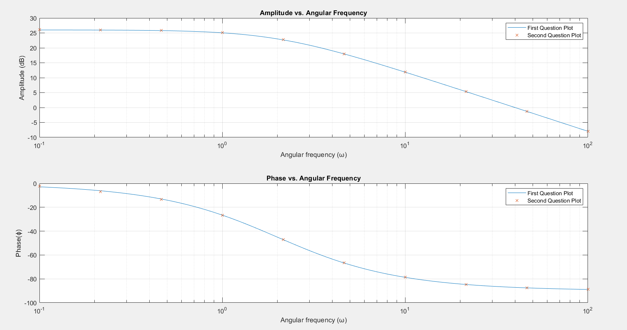

Figure 2- Bode Plot of First Part and Second Part

Since the x marks are in line with the findings of the second part, it can be concluded that this method was applied successfully.

1. **Conclusion**

In this lab firstly, the generation of bode plot of a system is learned. This part is then used as a reference for the second part. In the second part, a cosine signal is applied to the system. It is seen that the output is also in the form of a cosine signal and, magnitude and phase of the transfer functions at certain frequencies can be found by applying cosine function with the said frequency. In the end, this technique was verified with the final plot.

**Appendix**

%q1

w = logspace(-1,2,100);

for k = 1:100

s = 1i * w(k);

G(k) = 20 / (0.5*s+1);

end

subplot(2,1,1)

semilogx(w,20*log10(abs(G)));

grid on

ylabel('Amplitude (dB)');

xlabel('Angular frequency (?)');

title('Amplitude vs. Angular Frequency');

subplot(2,1,2)

ylabel('Phase(?)');

xlabel('Angular frequency (?)');

title('Phase vs. Angular Frequency');

semilogx(w,angle(G)*180/pi)

grid on

%q2

t = 0:0.01:100;

Amplitude = zeros(10, 1);

Phase = zeros(10, 1);

cosine_freq = logspace(-1,2,10);

for n=1:10

x = cos(t*cosine_freq(n));

y=(cos(-atan(0.5*cosine_freq(n)/1)+cosine_freq(n).*t)*20/sqrt((0.5*cosine_freq(n))^2+1^2));

lap_x=fft(x);

[x_max,max_x_loc] = max(abs(lap_x));

lap_y= fft(y);

[y_max,max_y_loc] = max(abs(lap_y));

Phase(n)=angle(lap_y(max_y_loc))-angle(lap_x(max_x_loc));

Amplitude(n)=y_max/x_max;

end

figure(2)

subplot(2,1,1)

semilogx(w,20*log10(abs(G)));

hold on;

semilogx(cosine_freq,20*log10(Amplitude),'x');

ylabel('Amplitude (dB)');

xlabel('Angular frequency (?)');

title('Amplitude vs. Angular Frequency');

legend('First Question Plot',"Second Question Plot");

grid on

hold off;

subplot(2,1,2)

semilogx(w,angle(G)*180/pi);

hold on;

semilogx(cosine_freq,Phase*180/pi,'x');

ylabel('Phase(?)');

xlabel('Angular frequency (?)');

title('Phase vs. Angular Frequency');

legend('First Question Plot',"Second Question Plot");

grid on;

hold off;