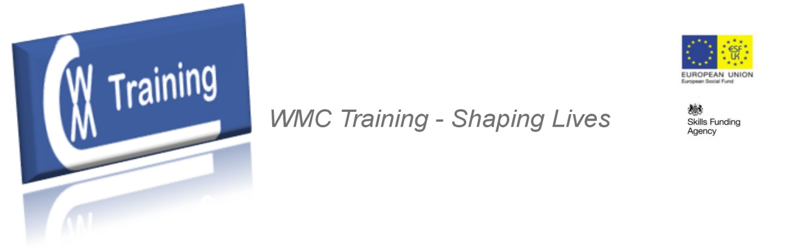

WMC Training

Management Qualifications content outline:

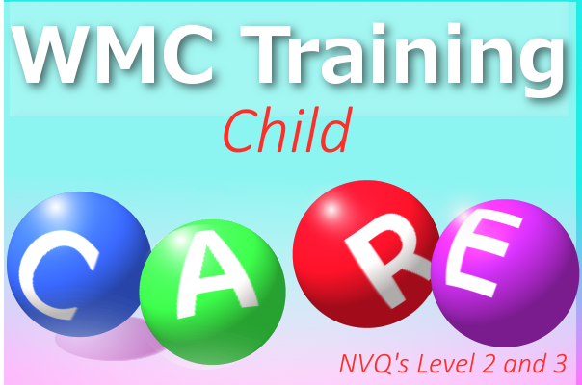

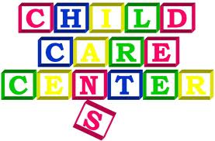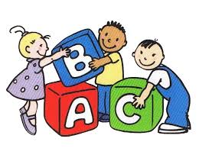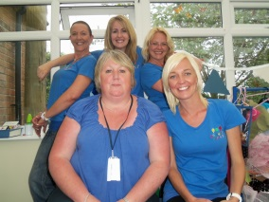

Thank you for considering WMC Training for your CCLD and your room leader and management training needs.

With Ofsted putting more and more focus on strategic leadership and management it’s time to put your staff onto our funded programmes.

We hope you will find the units within this brochure relevant and valuable.

Please contact us on: 02920 647 610 for more information or to get started…

Kindest regards,



Paul Rees

Managing Director

WMC Training

**ROOM LEADING LEVEL 2 QUALIFICATION**

Qualification framework – all components shown below are mandatory unless already achieved

|  |  |
| --- | --- |
| **Qualification component** | **Assessment method** |
| Employment Rights & Responsibilities (ERR) | Workbook |
| Team Leading Principles Level 2 | Written Assignments & Answers |
| Team Leading NVQ Level 2 | Observations, Discussions, Question & Answers, Case Studies, Reflective Accounts, Witness Testimony |
| Functional Skill – Maths Min Level 1 | Online exam |
| Functional Skill – English Min Level 1:  Reading  Writing  Speaking, Listening & Communicating | Online exam  Online exam  Observations |
| Functional Skill – ICT Min Level 1 | Online exam |

**NVQ Mandatory & Optional Units**

|  |  |  |  |
| --- | --- | --- | --- |
| **Title: ICQ Level 2 NVQ Certificate in Team Leading** |  | Total Credits | **17** |
| **Mandatory Units (Group A) All 3 components needed (minimum 10 credits)** | **Unit Level** | **GLH** | **Credit Value** |
| Manage personal development | 2 | 20 | 4 |
| Develop working relationships with colleagues | 2 | 15 | 3 |
| Communicate information and knowledge | 2 | 10 | 3 |
|  |  |  |  |
| **Optional Units (Group B) Learners may select units from this optional group. A minimum of 5 Credits (1 unit) must be attained from Group B** | **Unit Level** | **GLH** | **Credit Value** |
| Plan, allocate and monitor work of a team | 3 | 25 | 5 |
| Set objectives and provide support for team members | 3 | 35 | 5 |
|  |  |  |  |
| **Optional Units (Group C) Learners may select units from this optional group. A maximum of 1 unit (minimum of 2 Credits) may be attained from Group C** | **Unit Level** | **GLH** | **Credit Value** |
| Manage or support equality of opportunity, diversity and inclusion in own area of responsibility | 3 | 20 | 4 |
| Support team members in identifying, developing and implementing new ideas | 3 | 20 | 4 |
| Manage conflict in a team | 3 | 20 | 3 |
| Lead and manage meetings | 3 | 20 | 4 |
| Participate in meetings | 2 | 10 | 2 |
| Make effective decisions | 3 | 10 | 3 |
| Manage knowledge in own area of responsibility | 3 | 15 | 4 |
| Procure supplies | 3 | 20 | 2 |
| Manage customer service in own area of responsibility | 3 | 25 | 4 |

**MANAGEMENT LEVEL 3 QUALIFICATION**

Qualification framework – all components shown below are mandatory unless already achieved

|  |  |
| --- | --- |
| **Qualification component** | **Assessment method** |
| Employment Rights & Responsibilities (ERR) | Workbook |
| Management Principles Level 3 | Written Assignments & Answers |
| Management NVQ Level 3 | Observations, Discussions, Question & Answers, Case Studies, Reflective Accounts, Witness Testimony |
| Functional Skill – Maths Min Level 2 | Online exam |
| Functional Skill – English Min Level 2:  Reading  Writing  Speaking, Listening & Communicating | Online exam  Online exam  Observations |
| Functional Skill – ICT Min Level 2 | Online exam |

**NVQ Mandatory & Optional Units**

|  |  |  |  |
| --- | --- | --- | --- |
| **Title: ICQ Level 3 NVQ Certificate in Management** (QCF) |  | Total Credits | **25** |
| **Mandatory Units (Group A) Learners must achieve all three mandatory units in Group A (14 credits)** | **Unit Level** | **GLH** | **Credit Value** |
| Manage own professional development within an organisation | 3 | 20 | 4 |
| Set objectives and provide support for team members | 3 | 35 | 5 |
| Plan, allocate and monitor work of a team | 3 | 25 | 5 |
|  |  |  |  |
| **Optional Units (Group B – Optional Units) Learners must attain a minimum of 11 credits from the optional units in Group B.** | **Unit Level** | **GLH** | **Credit Value** |
| Make effective decisions | 3 | 10 | 3 |
| Support team members in identifying, developing and implementing new ideas | 3 | 20 | 4 |
| Procure supplies | 3 | 20 | 2 |
| Manage or support equality of opportunity, diversity and inclusion in own area of responsibility | 3 | 20 | 4 |
| Manage conflict in a team | 3 | 20 | 3 |
| Manage knowledge in own area of responsibility | 3 | 15 | 4 |
| Lead and manage meetings | 3 | 20 | 4 |
| Manage customer service in own area of responsibility | 3 | 25 | 4 |
| Communicate information and knowledge | 2 | 10 | 3 |
| Manage the achievement of customer satisfaction | 4 | 25 | 5 |
| Support individuals to develop and take responsibility for their performance | 4 | 20 | 4 |
| Address performance problems affecting team members | 4 | 20 | 3 |
| Build, support and manage a team | 4 | 20 | 4 |
| Ensure compliance with legal, regulatory, ethical and social requirements | 4 | 25 | 5 |
| Plan, allocate and monitor work in own area of responsibility | 4 | 25 | 5 |
| Know how to follow disciplinary procedures | 4 | 20 | 4 |
| Manage a tendering process | 4 | 20 | 4 |
| Plan and manage a project | 4 | 30 | 8 |
| Develop working relationships with colleagues and stakeholders | 4 | 20 | 4 |
| Managing grievance procedures | 4 | 10 | 3 |
| Manage physical resources | 4 | 25 | 3 |
| Develop and implement marketing plans | 4 | 25 | 6 |
| Manage risk in own area of responsibility | 4 | 25 | 4 |
| Review risk management processes in own area of responsibility | 4 | 20 | 3 |
| Develop and implement a risk assessment plan in own area of responsibility | 4 | 20 | 6 |
| Implement change in own area of responsibility | 4 | 25 | 6 |
| Support learning and development within own area of responsibility | 4 | 25 | 5 |
| Support the management of redundancies in own area of responsibility | 4 | 15 | 3 |
| Manage the environmental impact of work activities | 4 | 10 | 5 |
| Analyse the market in which your organisation operates | 4 | 25 | 5 |
| Develop, maintain and review personal networks | 4 | 25 | 4 |
| Provide leadership and direction for own area of responsibility | 4 | 30 | 5 |
| Prepare for and support quality audits | 4 | 20 | 4 |
| Manage personal development | 2 | 20 | 4 |
| Recruit staff in own area of responsibility | 5 | 25 | 4 |
| Develop working relationships with colleagues | 2 | 15 | 3 |
| Participate in meetings | 2 | 10 | 2 |

We also deliver the industry standard NVQ level two and three Childcare, Learning and development:

**Childcare Apprenticeships Qualification (formerly NVQ Level 2 in Childcare)**

* Develop your skills and learn new ones
* Covers key work skills such as communication, first aid and employment rights and responsibilities
* Build knowledge through work experience
* Includes the Level 2 Children and Young People’s Workforce qualification and key work skills

**Who is this course for?**

If you’re employed in a childcare setting and have recently started a career in the Early Years, the Level 2 Certificate for the Children and Young People’s Workforce is ideal.

If this course doesn’t sound right for you, [look at other courses](http://www.parenta.com/getting-qualified/finding-the-right-course/).

**How will it help you?**

The Level 2 qualification allows you to work with children under supervision and to count in staff ratios.

**Main subject areas for Level 2 Childcare qualification include:**

* Communication
* Health and safety
* Partnership
* Equality and inclusion
* Child development
* Creative development
* Personal development
* Safeguarding

**Studying and assessment**

It’s important to us that you are motivated and enthusiastic about your course. Your assessor will provide full support and feedback and visit you on-site, so your workplace observation is in a familiar setting.

You will have access to [e-learning tutorials](http://www.parenta.com/getting-qualified/online-childcare-courses/) and resources so you’re able to easily fit studying around your work, social and family commitments.

If you’d like to earn while you learn, Level 2 can be taken as an [apprenticeship](http://www.parenta.com/getting-qualified/apprenticeships/). Childcare [apprenticeships](http://www.parenta.com/getting-qualified/apprenticeships/) are fully funded for learners, meaning that you can develop your career in childcare for free with WMC Training Care.

**Advanced Childcare Apprenticeships Qualification (formerly NVQ Level 3 in Childcare)**

* Develop your skills and learn new ones
* Covers key work skills such as communication, first aid and employment rights and responsibilities
* Build knowledge through work experience
* Includes the Level 3 Children and Young People’s Workforce qualification and functional skills

**Who is this course for?**

If you are employed in a childcare setting and have experience within an Early Years environment, this qualification will be ideal. You will be in a great position for this course if you have achieved the [Level 2 Childcare Certificate](http://www.parenta.com/getting-qualified/courses/level-2-childcare/).

If this course doesn’t sound right for you, [look at other courses](http://www.parenta.com/getting-qualified/finding-the-right-course/).

**How will it help?**

By the end of the course, you will be able to demonstrate proficient knowledge and understanding of working with children.

The Level 3 Diploma for the Children and Young People’s Workforce allows you to supervise other members of staff and work unsupervised with children.

**Main subject areas for Level 3 Childcare qualification include:**

* Communication
* Health And Safety
* Partnership
* Equality And Inclusion
* Child Development
* Creative Development
* Personal Development
* Safeguarding

**Studying and assessment**

It’s important to us that you are motivated and enthusiastic about your course. Your assessor will provide full support and feedback and visit you on-site so you that your workplace observation is in a familiar setting.

You will have access to e-learning tutorials and resources so you’re able to easily fit studying around your work, social and family commitments.

If you’d like to earn while you learn, Level 3 can be taken as an [apprenticeship](http://www.parenta.com/getting-qualified/apprenticeships/). Childcare [apprenticeships](http://www.parenta.com/getting-qualified/apprenticeships/) are fully funded for learners, meaning that you can develop your career in childcare for free with WMC Training.

Please dial 02920 647610 for details on how to access funding today…