**DIODE CHARACTERISTICS**

**Christopher Brant, ECE 3110(4), September 18th, 2017**

**Proposal**: It is proposed in this experiment that using a curve tracer to on a diode can obtain characteristics that can be used to determine parameters of a diode. These include the dynamic resistance, diode forward resistance, the cut-in voltage, the forward diode ideality factor, and the breakdown voltage. It is also proposed that these parameters will depend on the current at which they are measured.

**Experimental:** In this experiment the values in Table 1.1 or 1.2 will either be calculated or found experimentally. The values already filled in were part of the pre-calculations. We will need either a 1N4004 diode or a 1N4744 diode, a curve tracer, the NI ELVIS II workstation, a lab kit, and LTSpice for simulations.

**Anticipated Results:** We anticipate results to be consistent with the equations that are given throughout the explanation and introductory sections of Lab 1 of the Lab Manual.

Table 1.1: Table of Current, Voltage, Forward resistance, dynamic resistance

|  |  |  |  |  |
| --- | --- | --- | --- | --- |
| ID (A) | Your Value of ID (A) | VD (volts) | RF (Ω) = VD/ID | rd (Ω) = nVT/ID |
| 30µA | “” | 453 mV | 15100 | 1348 |
| 100µA | “” | 503 mV | 5030 | 404.5 |
| 200 µA | “” | 531 mV | 2655 | 202.3 |
| 400 µA | “” | 559 mV | 1397.5 | 101.1 |
| 1mA | “” | 596 mV | 596 | 40.45 |
| 2mA | “” | 626 mV | 313 | 20.23 |
| 6mA | “” | 671 mV | 111.8 | 6.742 |
| 14mA | “” | 707 mV | 50.5 | 2.890 |
| 30mA | “” | 739 mV | 24.6 | 1.348 |
| 60mA | “” | 767 mV | 12.8 | 0.674 |
| 100mA | “” | 794 mV | 7.94 | 0.405 |

*For Table 1.1, n is calculated to be equal to ~1.568

The cut in voltage Vy should be about the same for all variances and will be at ~ 0.7 volts or 700 mV

|  |  |  |  |
| --- | --- | --- | --- |
| Vin (V) | V0 at 100 Ohms | V0 at 1000 Ohms | V0 at 10000 Ohms |
| 0.0 | 0 | 0 | 0 |
| 0.5 | ~ 46 mV | ~ 250 mV | ~ 432 mV |
| 1.0 | ~ 90 mV | ~ 476 mV | ~ 556 mV |
| 1.5 | ~ 137 mV | ~ 554 mV | ~ 584 mV |
| 2.0 | ~ 183 mV | ~ 590 mV | ~ 609 mV |
| 2.5 | ~ 225 mV | ~ 605 mV | ~ 619 mV |
| 3.0 | ~ 272 mV | ~ 619 mV | ~ 632 mV |
| 3.5 | ~ 313 mV | ~ 632 mV | ~ 638 mV |
| 4.0 | ~ 358 mV | ~ 636 mV | ~ 647 mV |
| 4.5 | ~ 403 mV | ~ 643 mV | ~ 649 mV |
| 5.0 | ~ 450 mV | ~ 649 mV | ~ 653 mV |

Table 1.2: Measured V0 for circuit in the bottom of Figure 1.2

Figure 1.1

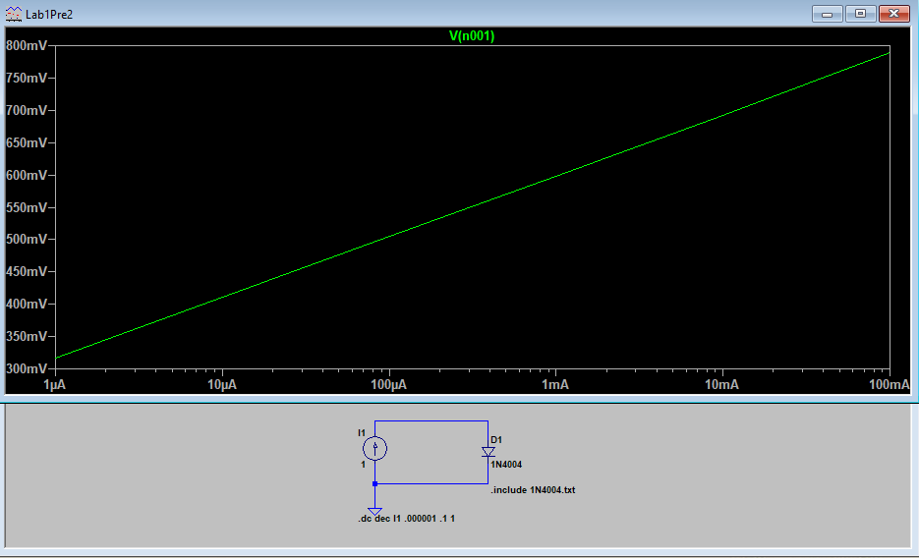

Figure 1.2

