**Power Supply Design**

**Christopher Brant, ECE 3110(4), September 25th, 2017**

**Proposal**

In this experiment we will be working with rectifiers, both half and full wave. We will be testing both half wave and full wave rectifier circuits and observing both similarities and differences between the two.

**Experimental**

In this experiment we will build both a half wave and a full wave rectifier. The half wave rectifier is made up of a voltage source and a diode in series, connected to a resistor and a capacitor in parallel. When you simulate with an AC voltage source, you end up with Figure 1. The second circuit is the full wave rectifier, and it is made up of 4 diodes, a capacitor and two resistors that will make both the positive and negative halves of the wave seem positive and will seem almost like a DC voltage as in Figure 2.

**Expected Results**

I expect my experimental results to be very similar to those in figures 1 and 2 as it is known that a half wave rectifier will have a positive sine wave that the contains a large ripple voltage. Then the full wave rectifier will also have a positive wave with exactly half the ripple voltage of a half wave rectifier of the same diode.

**Figures**

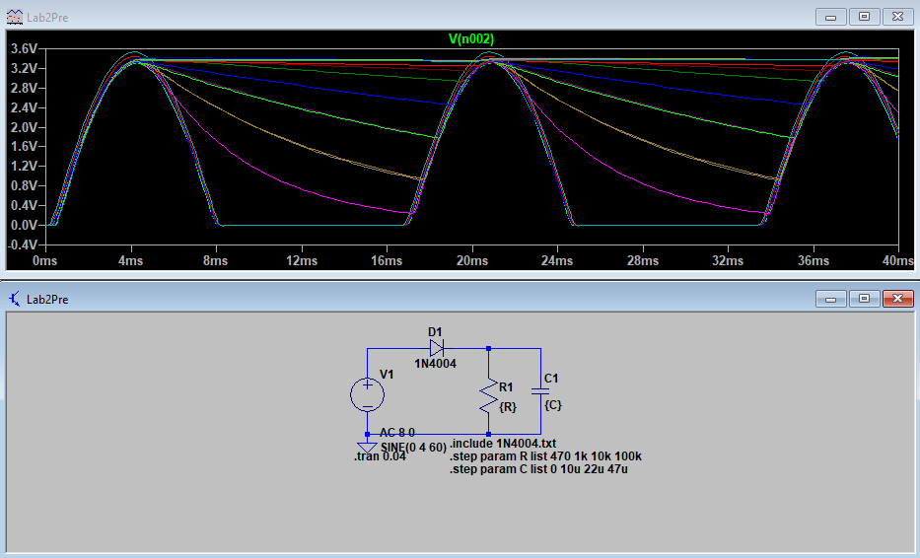

Figure 1: Half-wave rectifier with step functions through resistances and capacitances

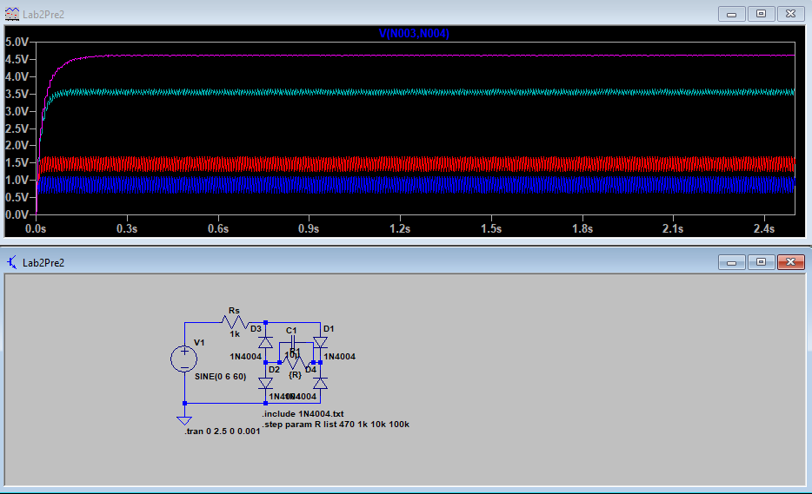

Figure 2: Full wave rectifier with only steps through resistances