**Power Supply Design**

**Christopher Brant, ECE 3110(4), October 2nd, 2017**

**Proposal**

In this experiment we will be designing a full-wave bridge rectifier circuit as a power supply. Using either a 22 or 47 micro Farad capacitor, a circuit will be constructed to serve as a power supply that will act as a DC power supply. This will be calculated based on the given information in Lab 3’s Design Problem Statement.

**Experimental**

In this experiment we will build a power supply circuit using a full-wave bridge rectifier either a 22 or 47 micro Farad capacitor, and the maximum output voltage must be at least Vin-2Vy, with a ripple factor less than 0.05. The equation that is used to calculate the values necessary for this design lab is as follows:

$$R_{L}= \frac{1+(\sqrt{3}*RF)}{2\sqrt{3}*RF*f_{p}*C}$$

**Expected Results**

I expect my experimental results to be extremely similar to what is simulated as this circuit is designed by myself and therefore the results should be similar to exactly what I have designed and simulated. We will be using a Vs voltage of 10Vpp, 120 Hz frequency, and a 1000 Ohm Rs resistance in this circuit as well. The design will be implementing a 47 micro Farad capacitor and a load resistance of around 1100 Ohms. The simulated values for Vin are a sinusoidal signal that has a value of roughly 4.8 Vpp or an absolute value of around 2.4V. This is calculated to fit well into the design standards as it is calculated at a ripple factor of 0.05. As seen in Figure 2, the values given here should allow values between around ~500 to 1100 Ohms for RL.

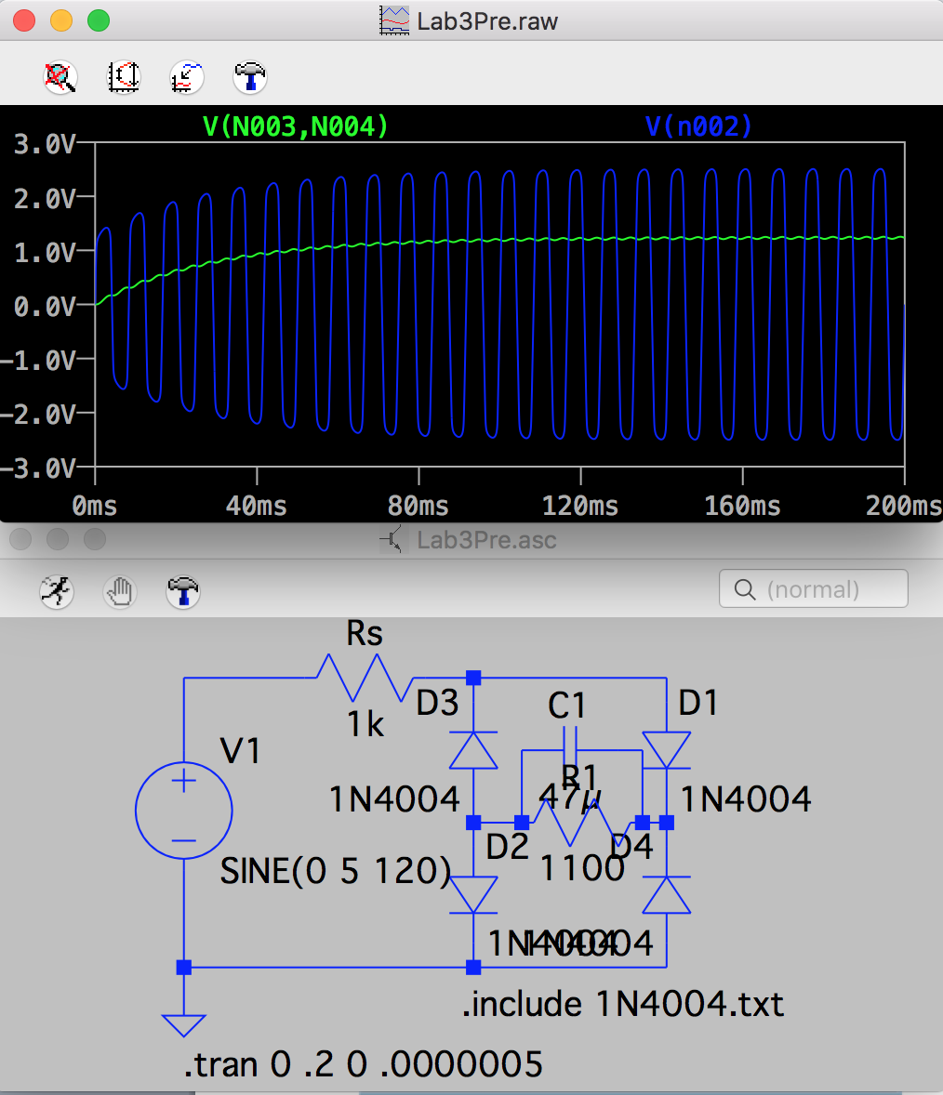**Figures**

Figure 1: Voltages Vin and Vm in blue and green, respectively.

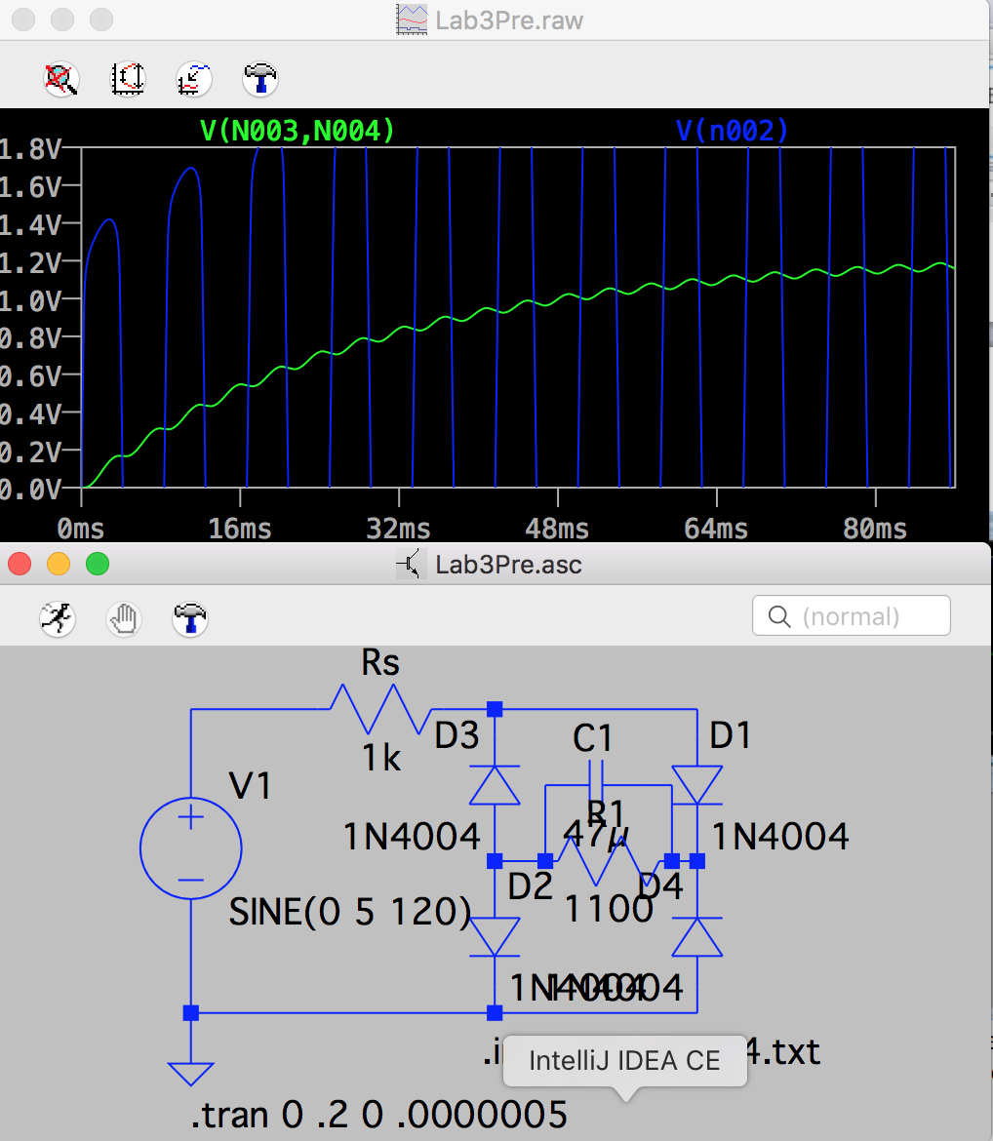

Figure 2: Zoomed in version of Voltages Vin and Vm in blue and green, respectively

*It is seen here that the ripple voltage is very low, and within the necessary values.