**Diode Clippers and Clampers**

**Christopher Brant, ECE 3110(4), October 9th, 2017**

**Proposal**

The purpose of this experiment is to study how diodes can be used in circuits to shape and shift an input voltage’s waveform to a specific form for its output voltage. The two specific types we will be working with in this lab will be the clipper and clamper circuits. These two circuits shape a wave or shift a wave, respectively for clipper and clamper circuits.

**Experimental**

In this experiment. we will build four circuits, with a few variations of each, and those four circuits are included in the Figures below, including three clipper circuits and a clamper circuit, and their behavior and waveforms will be recorded based on the voltage inputs and the diode directions that are given.

**Expected Results**

The results to be expected will be similar to almost identical to the results that are seen in the following six circuits, as these simulations should be almost spot on to their tangible counterparts in the lab.

**Actual Results**

Actual results proved to be extremely similar to the expected results, although there were some unexpected hiccups along the way as a result of some hardware inconsistencies.

**Pre-Lab Figures**

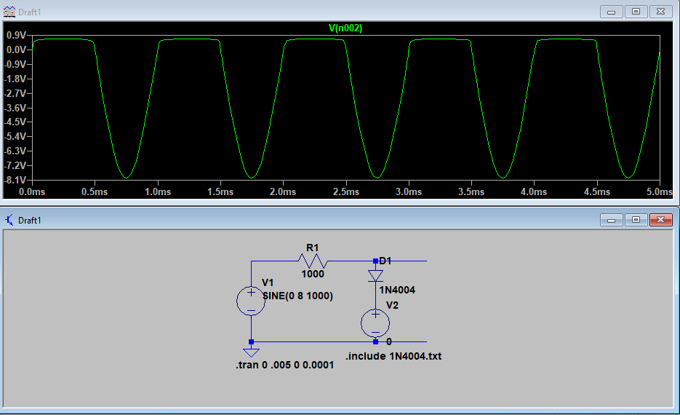

Figure 1: Circuit 4.5(a) with VB = 0 V

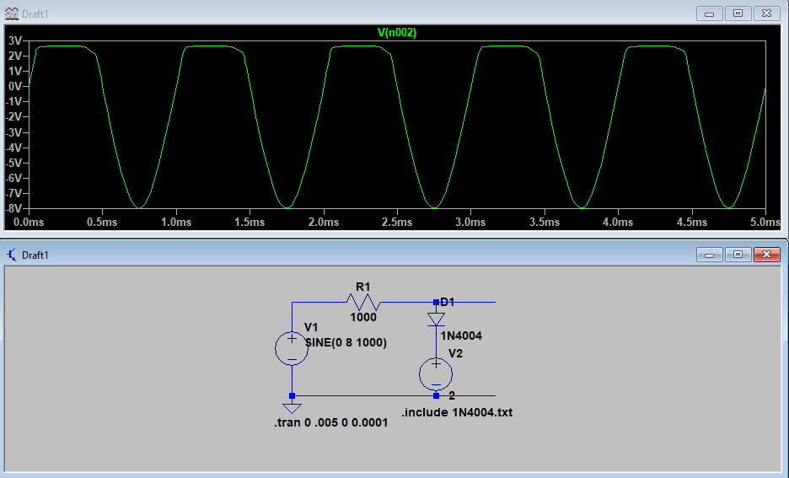

Figure 2: Circuit 4.5(a) with VB = 2 V

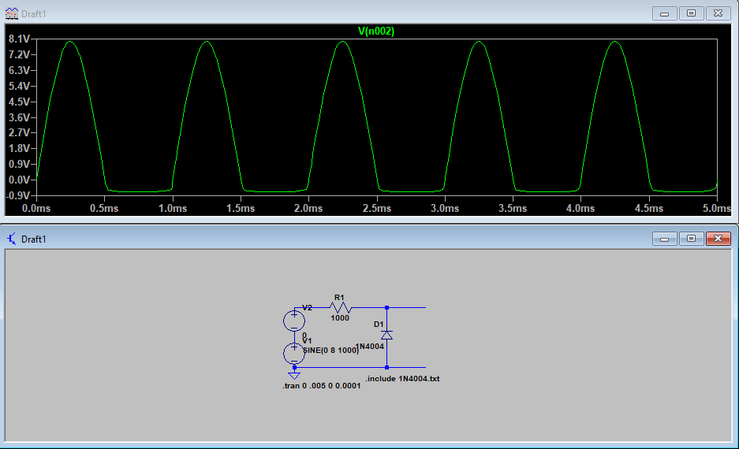

Figure 3: Circuit 4.6(a) with VB = 0 V

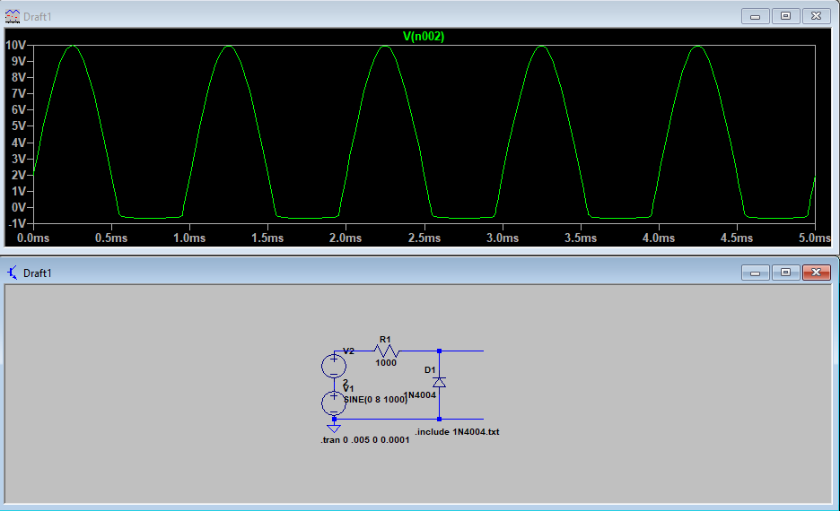

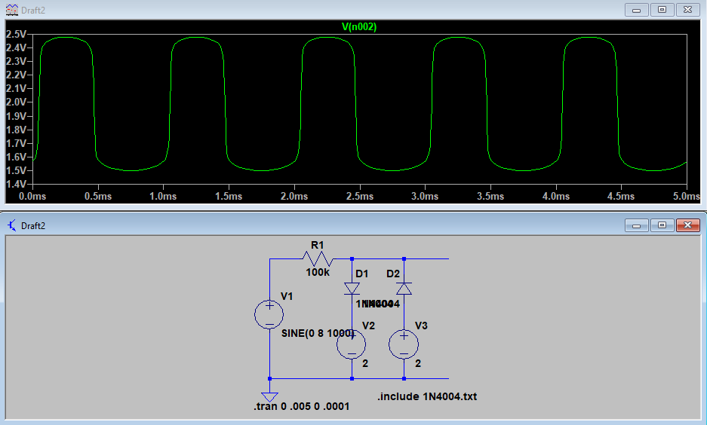Figure 4: Circuit 4.6(a) with VB = 2 V

Figure 5: Circuit 4.7 Parallel Clipper Circuit

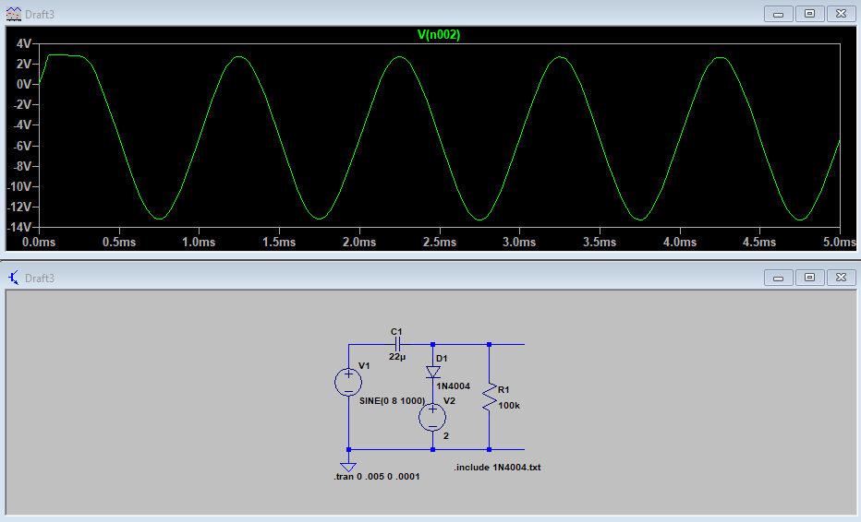

Figure 6: Circuit 4.8 Clamper Circuit