**BJT Common-Emitter Circuit Bias**

**Christopher Brant, ECE 3110(4), October 30th, 2017**

**Proposal**

The purpose of this experiment is to study how a BJT transistor circuit can be biased to be used in a DC circuit however it needs to be. How the BJT is biased determines the Q-point of the transistor circuit, which in turn determines the relationship between the input and output waveforms. We will test and observe how moving the Q-point will change the shape of the output waveform.

**Experimental**

In this experiment. we will build the circuits seen in Figure 6.1 and Figure 6.2 in the lab manual. The curve tracer will be used to measure the beta of both of the given transistors at certain current values.

**Expected Results**

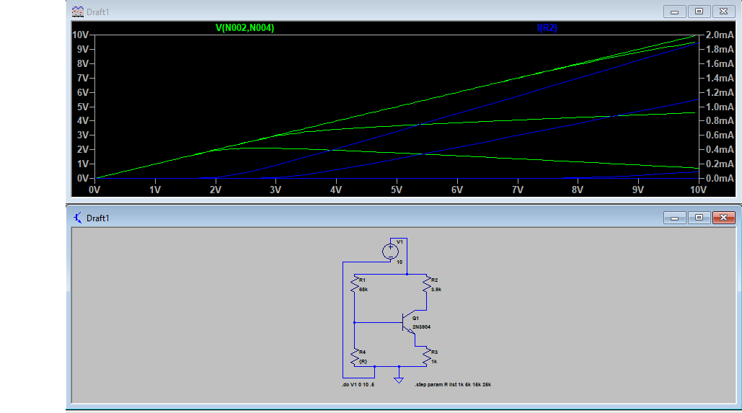 The results will be expected to be similar to those in the pre-lab simulations which are included below:

Figure 1: Simulating Figure 6.2 and stepping through R values

*The closest to have Vce = 5V and Ic = 1mA is for R2 = 25 kiloOhms*

*Values for Vceq, Icq, and Ieq, can be seen on the given graph for Figure 1*

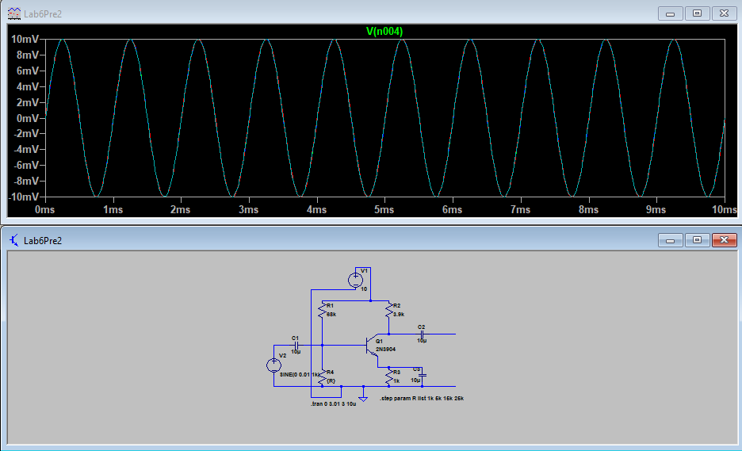Figure 2: Figure 6.1 simulated with the waveform for Vs shown above

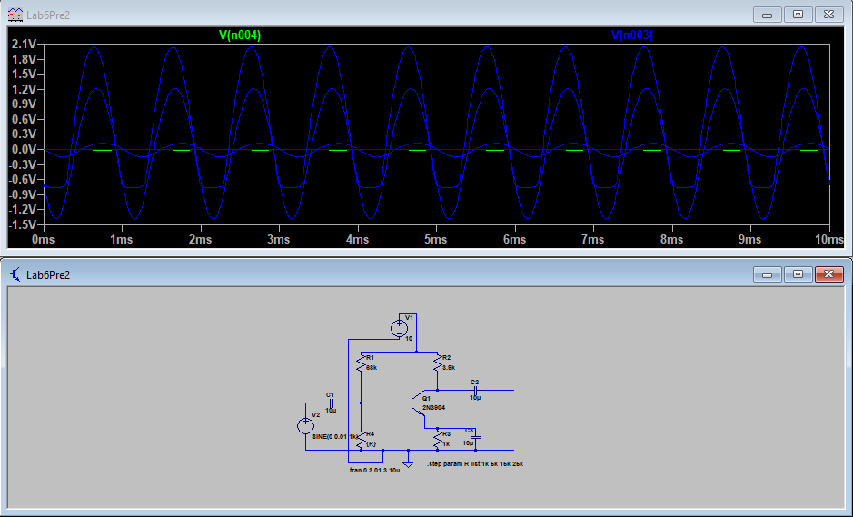

Figure 3: Figure 6.1 simulated with the waveforms of Vo shown for all values of R