**BJT Common-Emitter Design I**

**Christopher Brant, ECE 3110(4), November 13th, 2017**

**Proposal**

The purpose of this experiment is to visually experience and observe the effects of the BJT Common-Emitter Circuit that we have designed using the design procedure outlined in the Lab Manual. The process of designing this amplifier ourselves is supposed to instill in us a deeper understanding of how the amplifier’s different components and their corresponding values can vary the output voltages and characteristics of the amplifier.

**Experimental**

In this experiment we will be designing a common emitter amplifier using a BJT with already known characteristics. The design procedure goes as follows. First you begin by estimated what you believe Re should be as you can assume that Hib+Re~Re for a non-bypassed amplifier. Then calculate Rac and Rdc for whether Re is bypassed or not using the equations in the lab manual and included as Equations 1 and 2 below. Then the values of Icq and Vceq will be calculated from equations 3 and 4 below. Then the value of hie or the pi resistance is calculated along with hib in equations 5 and 6 below. Then a standard resistor will be chosen for Re, and the Thevenin equivalent input resistance and voltage are calculated based on equations 7 and 8 below, but will be calculated last as R1 and R2 should be unknown yet. For good bias stability, we will choose a value of Rb that is close to Rth and is close to 0.1*beta*Re. Then from equation 9 we will calculate Vbb, and finally R1 and R2 are calculated from the voltage value calculated previously, using equations 11 and 10 from below. Once the circuit has been designed, the circuit will be built and measurements will be taken from in. DC measurements will be taken by measuring Vc0 and Ve0 will be measured using the DMM and then Vceq and Icq will be calculated from those values. Then the ac input voltage will be connected to the amplifier along with the load resistor and the coupling capacitors, and Vo will be measured using the oscilloscope and using the measured peak to peak Vo value, the voltage gain, Av, will be measured and recorded in Table 8.1. Then a large emitter-bypass capacitor will be placed across Re and the AC analysis will be repeated, then they will be repeated again for values of RL that are 0.1Rc and 10Rc.

**Equations**



Equations 1 and 2: AC and DC resistances

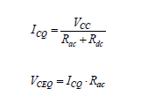

Equations 3 and 4: Q-point values



Equations 5 and 6: hie and hib



Equations 7 and 8: Thevenin equivalent values



Equation 9: Base supply voltage equation

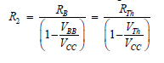

Equation 10: R2 value for voltage divider bias resistance

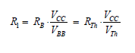

Equation 11: R1 value for voltage divider bias resistance

**Simulations for Expected Results**

*Using the values below, all simulations were done as the lab manual has stated

$β=205, V_{BE}=0.68 V$

*

* Emitter resistance has been calculated to be $R_{E }=215.45 Ω≈220 Ω$
* $R_{ac}=$ 2585 Ω and $R_{dc}=4935 Ω$
* $I_{CQ}=1.330 mA$ and $V_{CEQ}=3.4375 V$
* $h_{ie}=4007.5 Ω$ and $h_{ib}=r_{π}=19.55 Ω$
$R_{B}=R_{Th}=4817.5 Ω$

$V_{BB}=V_{Th}=1.024 V$

$R_{2}=5367 Ω$

$R_{1}=47046 Ω$

* Although the above mentioned values are all mathematically correct and derived, assuming Rc is 4.7kiloOhms and RL is also 4.7 kiloOhms, the corresponding simulations that are shown below do not reflect what is expected from a voltage gain of -10. 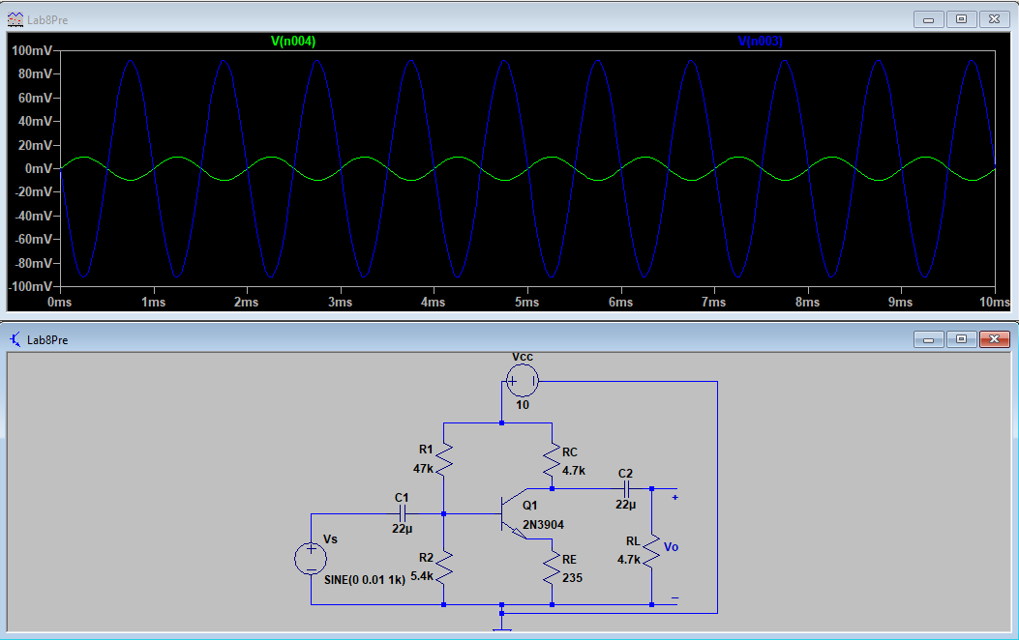

Figure 1: Simulation for Values Above for RL = RC (Green is Vs, Blue is Vo)

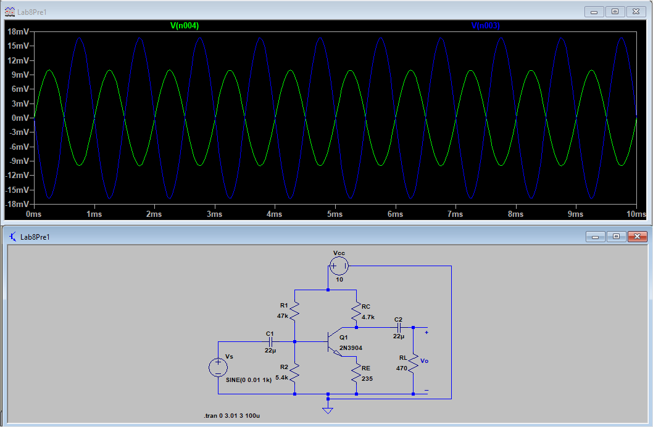

Figure 2: Simulation for Values Above for RL = 0.1RC (Green is Vs, Blue is Vo)

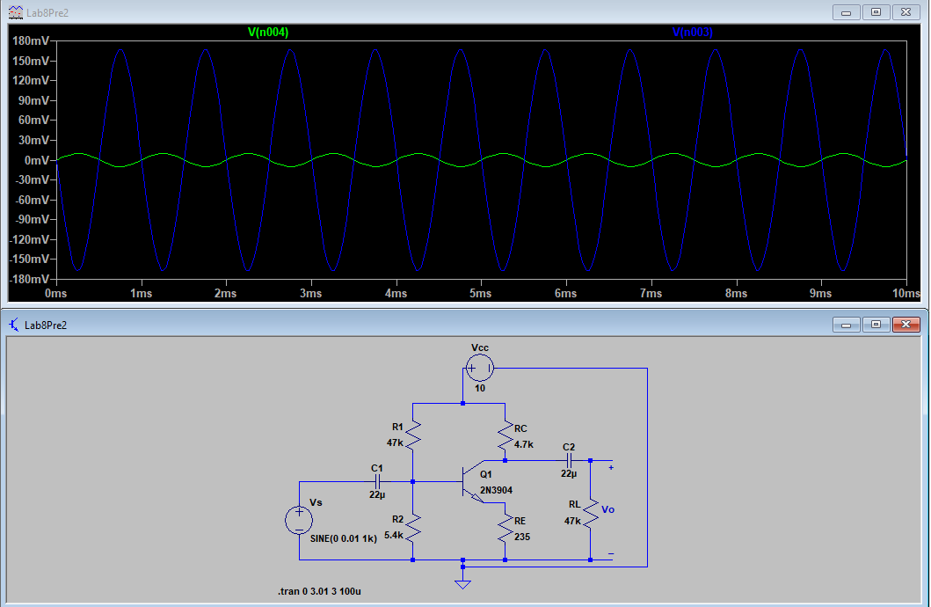

Figure 3: Simulation for Values Above for RL = 10RC (Green is Vs, Blue is Vo)