**BJT Common-Emitter Design II**

**Christopher Brant, ECE 3110(4), November 27th, 2017**

**Equations**



Equation 1: Rac resistance

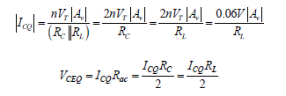

Equations 2 and 3: Q-point values



Equations 4 and 5: hie and hib

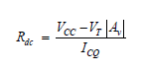

Equation 6: Rdc resistance



Equation 7: Emitter Resistor value



Equation 8: Base Resistor value



Equation 9: Base Voltage Calculation

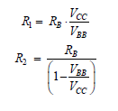

Equations 10 and 11: Voltage Divider Biasing Resistor Values

**Simulations for Expected Results**

*Using the values below, all simulations were done as the lab manual has stated

$β=205, V_{BE}=0.68 V A_{V}= -100$



$R_{C}=R_{L}=4.7 kΩ V_{CC}=10 V$



$R_{ac}=$*

* 2350 Ω and $R_{dc}=5795 Ω$
* $I_{CQ}=1.277 mA$ and $V_{CEQ}=3 V$
* $h_{ie}=r_{π}=4173.84 Ω$ and $h_{ib}=20.36 Ω$
$R_{E}=1095 Ω$

$R_{B}=22444 Ω$

$V_{BB}=2.218 V$

$R_{1}=101185 Ω$

$R_{2}=28840 Ω$

* Assuming a Vi-pp of ~0.02 V, with a voltage gain of -100, the Vo-pp should be ~2V
* Although the above mentioned values are all mathematically correct and derived, assuming Rc is 4.7kiloOhms and RL is also 4.7 kiloOhms, the corresponding simulations that are shown below do not reflect what is expected from a voltage gain of -100.

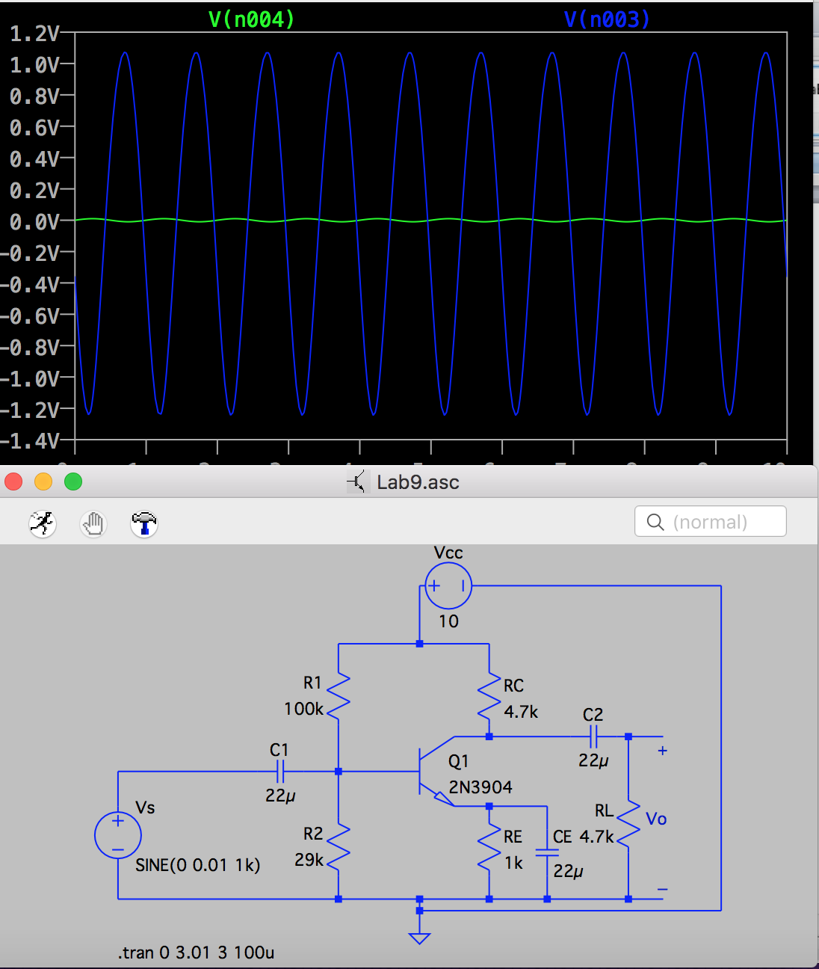

Figure 1: Simulation for Figure 9.1 with the above calculated values (Vs in green and Vo in blue)