**Serial Peripheral Interface (SPI) -** Full Duplex

**Inter Integrated Circuits (I^2C) -** Half Duplex

**MOSI –** Master Out Slave In (Data out)

**MISO –** Master In Slave Out (Data in)

**SCK –** Serial clock

**SS#** - Slave Select

PIC32 has **2 SPI** peripherals available

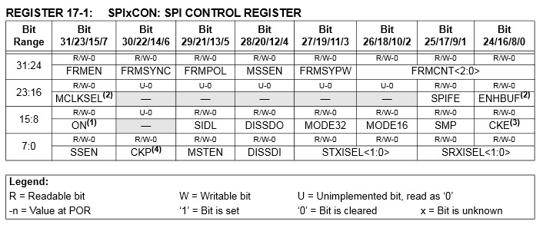

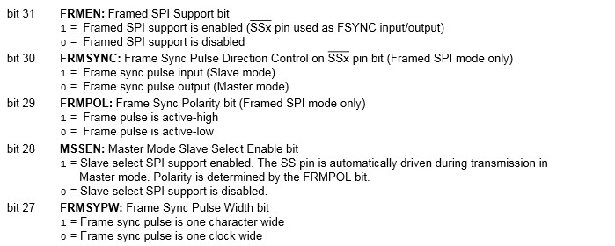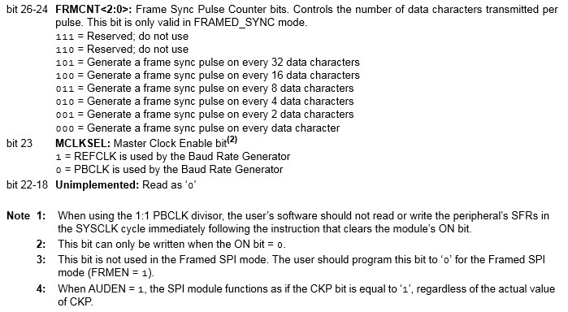

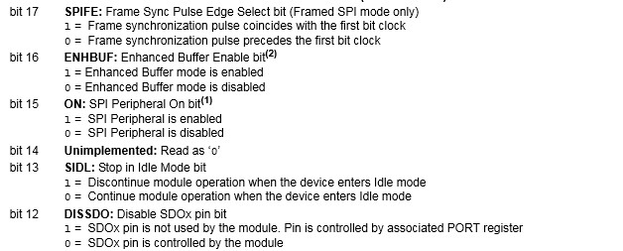

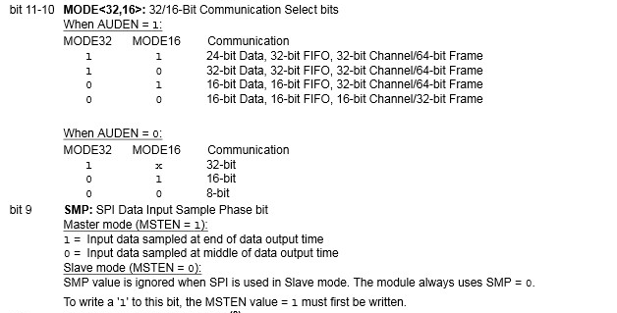

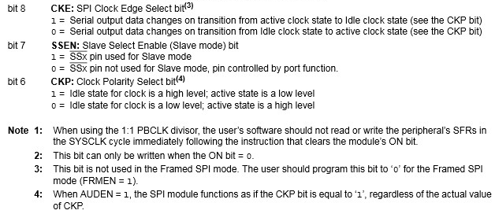

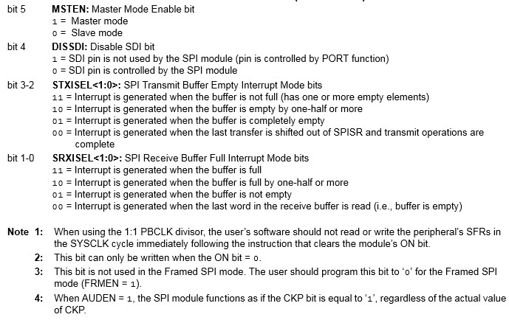

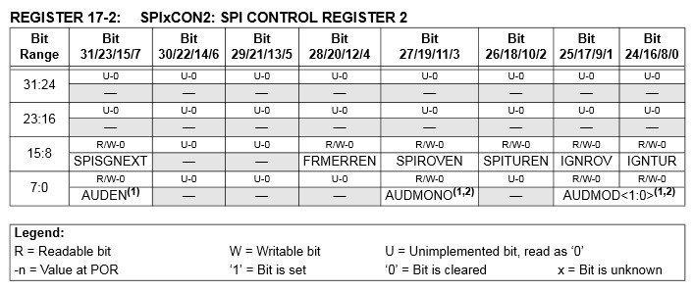

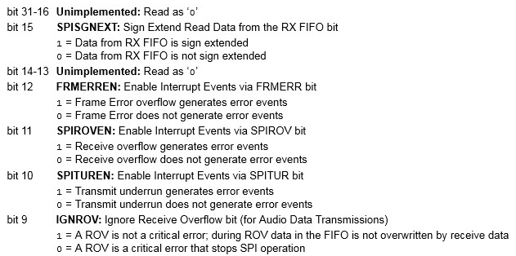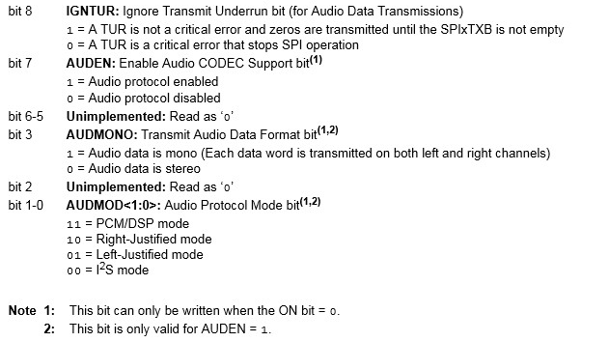

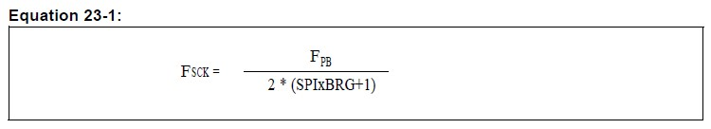

- **SPIxBRG<0:8>** - Baud rate register

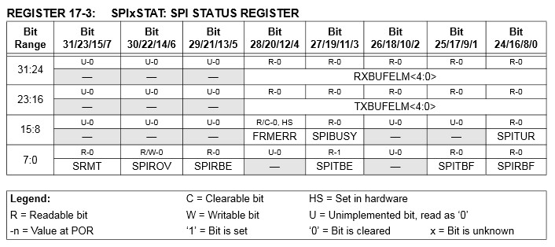

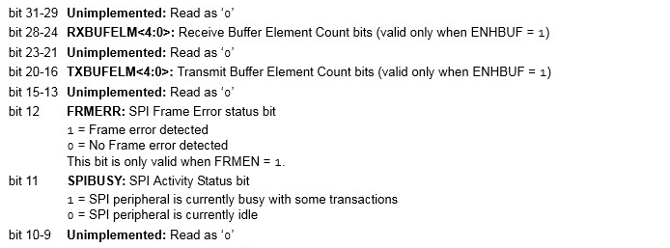

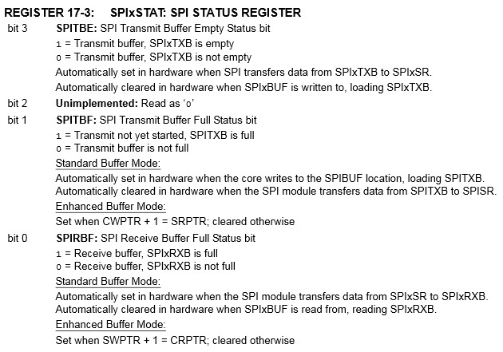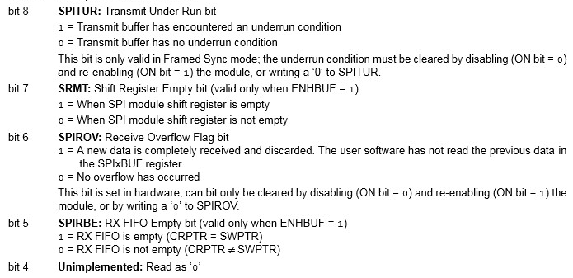

# PIC32 has 3 comparators

# CVRCON

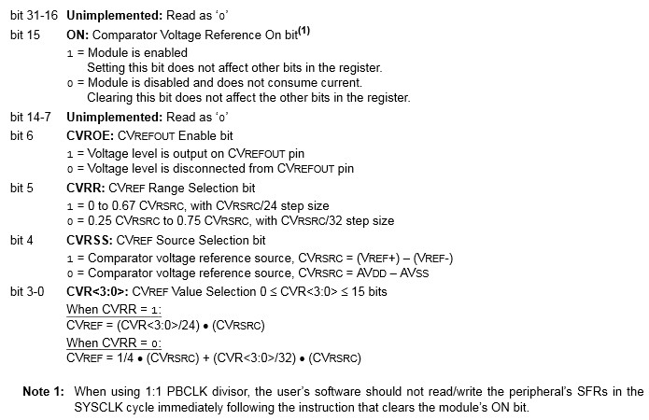

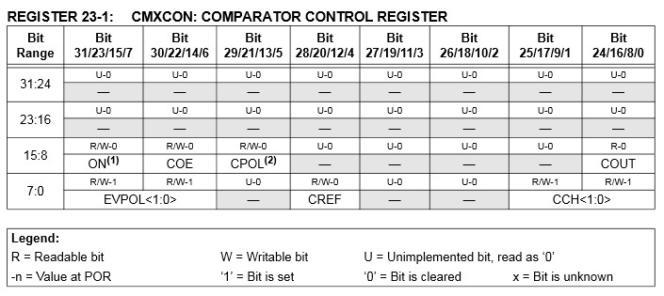

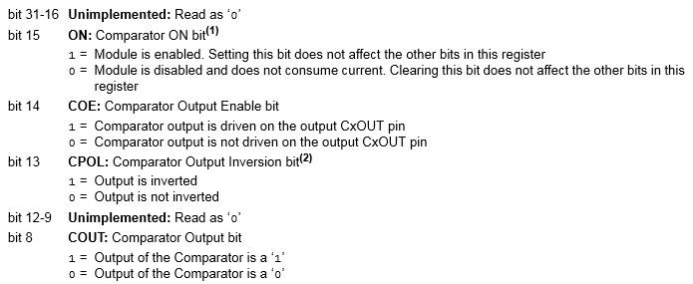

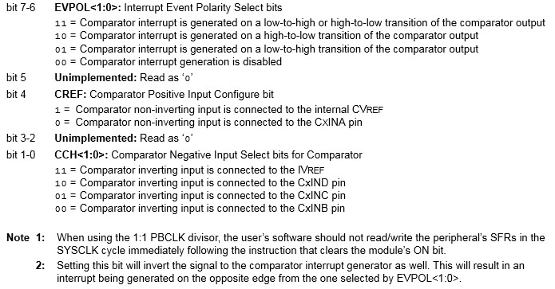

D to A:

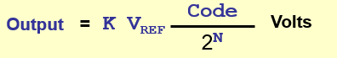

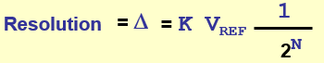

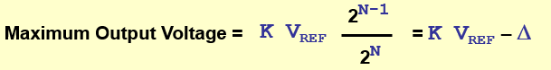

**Zero Error –** error when input = 0

**Full-Scale Error -** error when input is the maximum

**Relative Accuracy Error –** error between actual and the line from output_max and output_min.

**Monotonicity -** outputalways increasing as input increases

**Settling Time -** The required for the output to reach with a D/2 of the stable output when the input changes from 0 to 2N-1, or 2N-1 to 0.

A-to-D:

**Offset Error** - Error of analog transition point nearest 0 Volts.

**Full Scale (Gain) Error** - Error of analog transition point farthest from 0 Volts.

**Differential Nonlinearity Error** - The maximum difference between a step D and the constant ideal D.

**DNLE = Maximum |Dk – D|**

**A *Successive Approximation Register* (SAR)** is an ADC where each output bit is determined sequentially, starting with the most significant bit (MSB) working down to the least significant bit (LSB) in a binary search algorithm.

**Dual-Ramp ADCs use an RC Operational Amplifier Circuit coupled with a timer to measure the value of an input.**

* Slower but more precise because it needs to charge and discharge a capacitor.

**PIC32 A-to-D:**

* 10 bit, up to 16 analog inputs, internal VREF, multiple channel scan, 16-word buffer, 8 conversion formats and can run during idle/sleep mode.

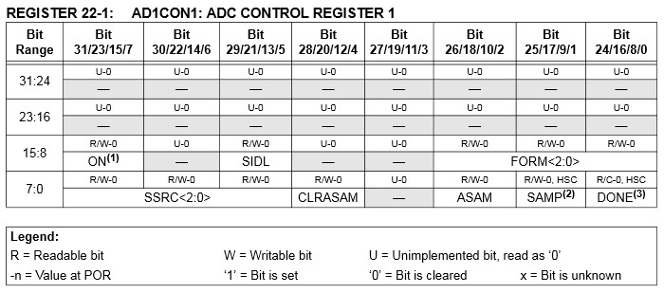

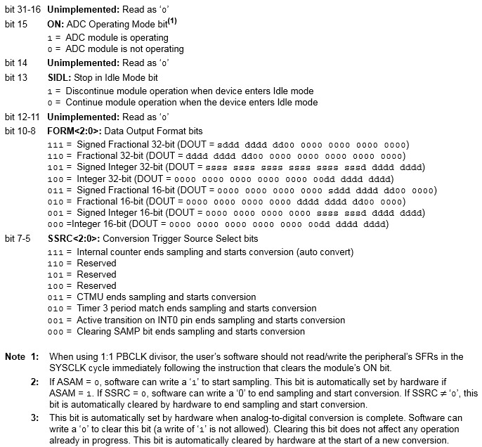

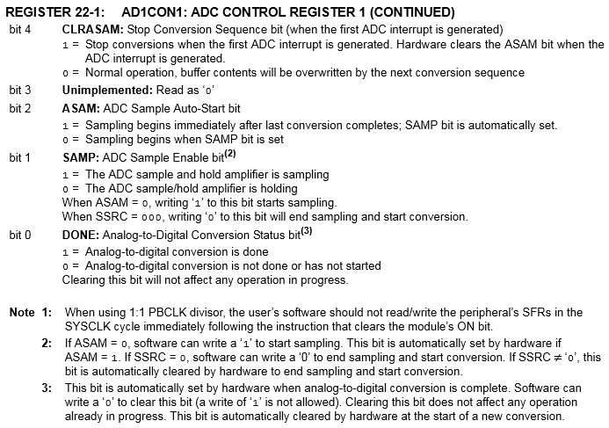

* Signed voltages: Vad = ( # / 1024 ) * VREF+
  + (VREF+ **-** VREF-) / 2 + Vad
  + For fractions add 1 if POSITIVE

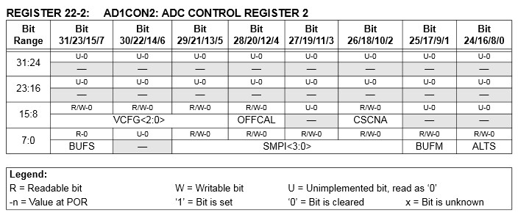

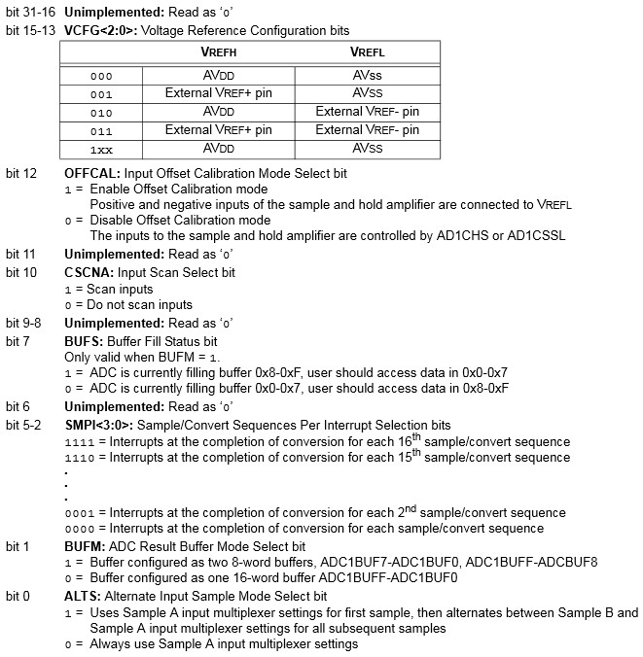

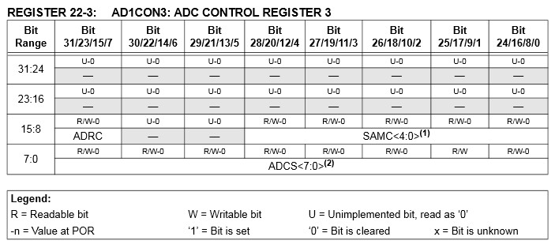

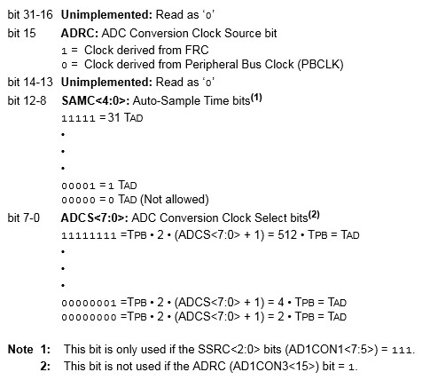

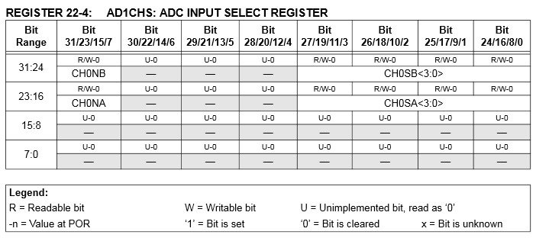

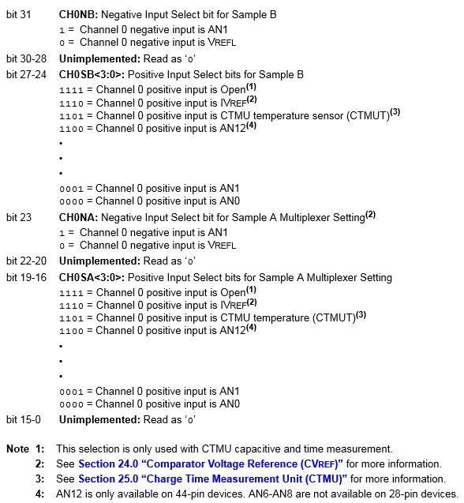

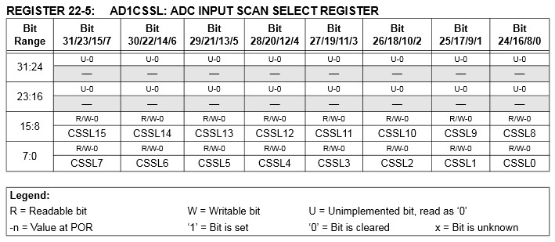

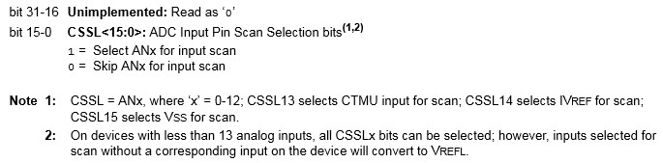

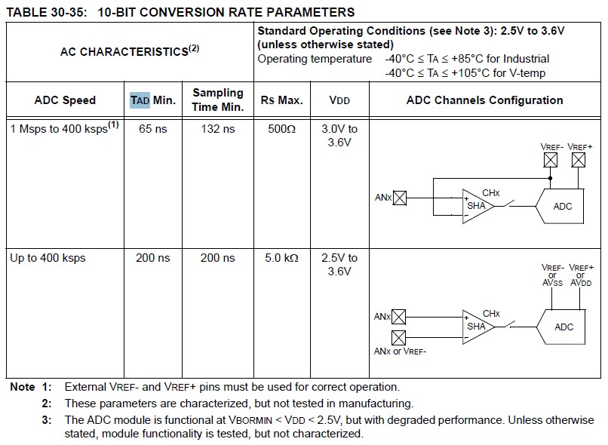

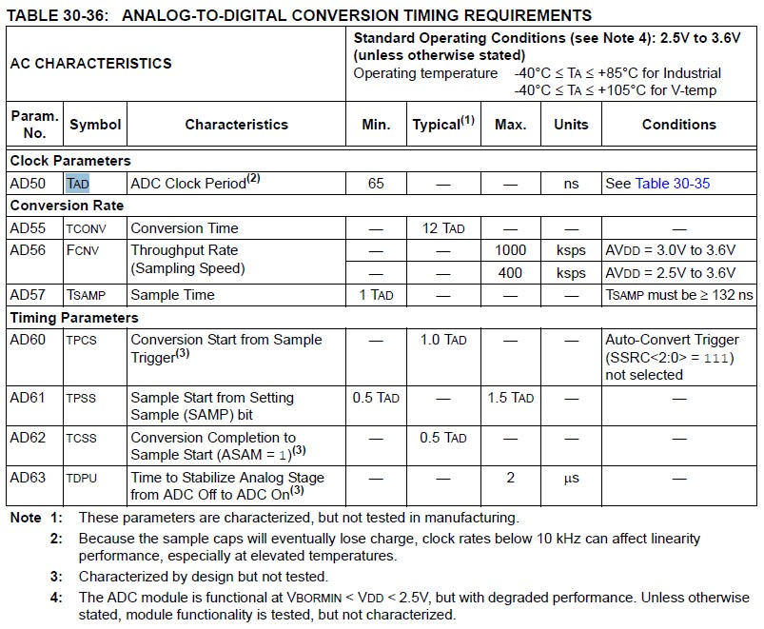

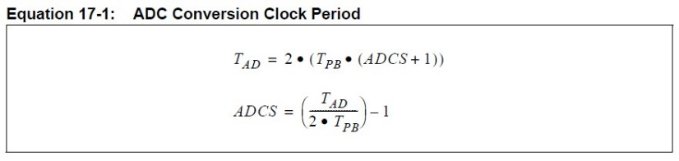

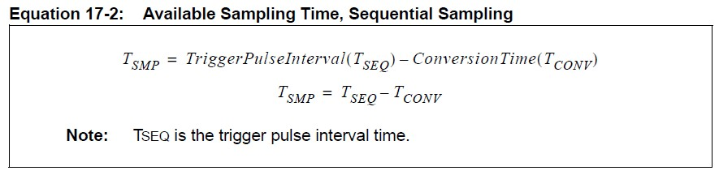

**UARTS:**

**Overrun Error –** A new character has arrived before previous character has been read.

**Underrun Condition –** The UART’s transmit buffer is empty while communication has been taking place.

**Framing Error –** Start and/or stop bits are in error. That is, the line is not low where a start bit should be, or it is not high where the stop bit(s) should be located.

**Parity Error –** The parity bit (if present) is not the value should be for the transmitted data bits.

**Break Condition –** A certain number of consecutive 0’s (generally more than a complete character) have been received. Can be sent intentionally to tell the receiver communication is finished.

**Baud Rate:** Symbols per second

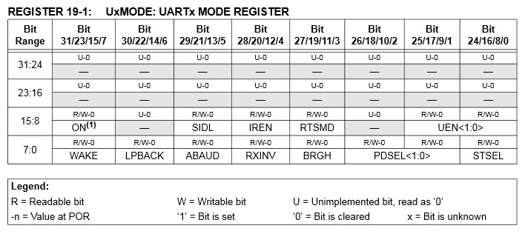

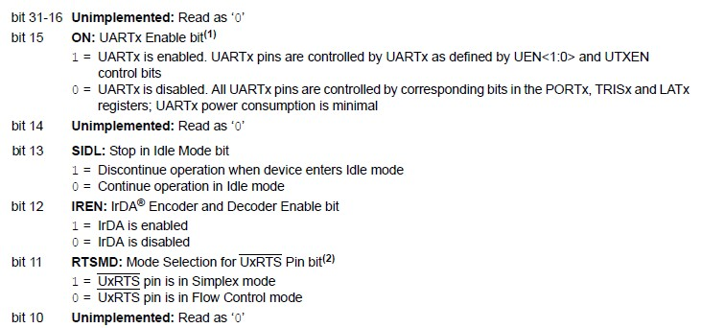

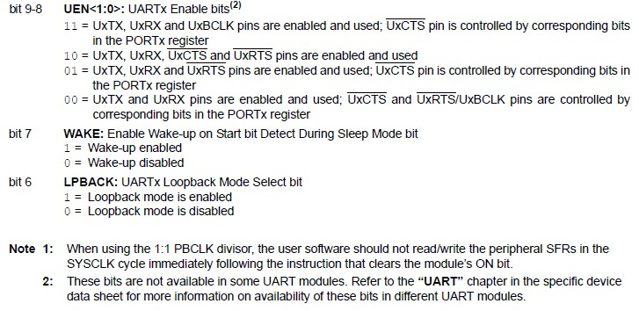

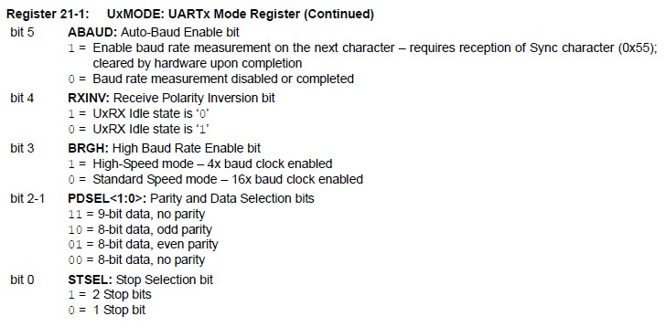

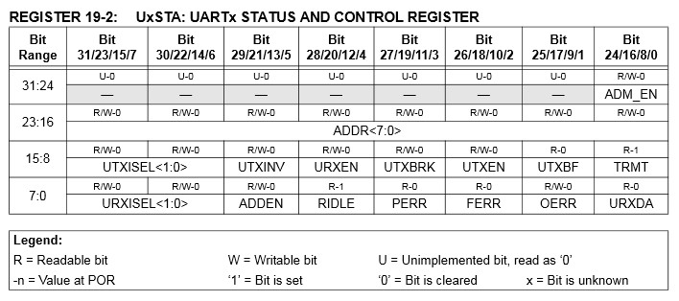

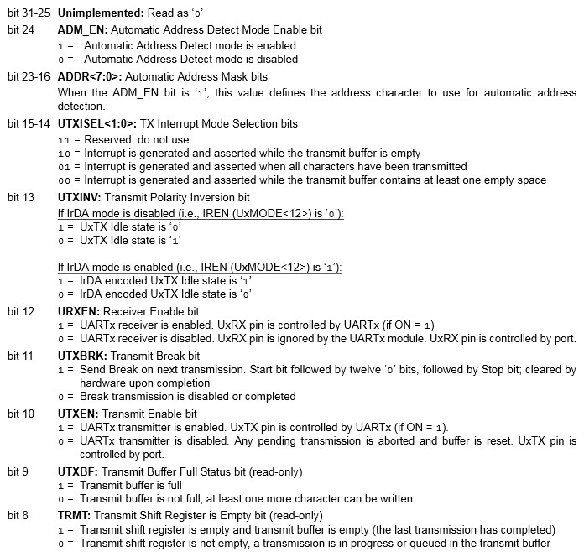

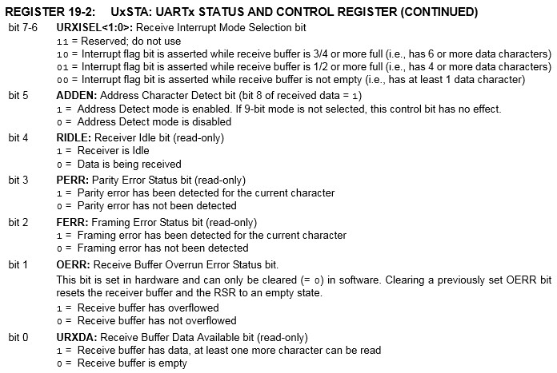

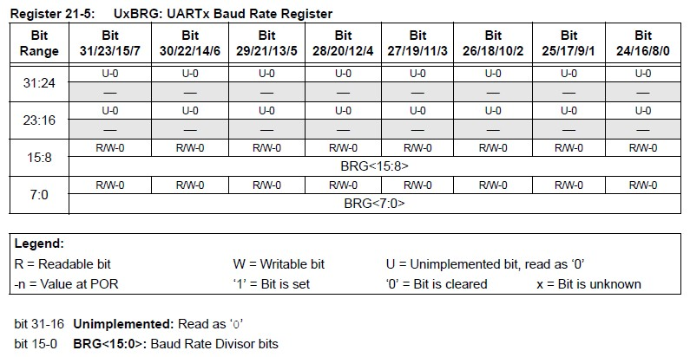

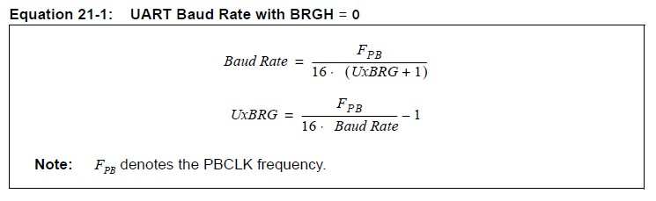

If BRGH = 1 then replace 16 with 4 ^.

**Stepper Motors:**

- Unlike many motors, they have full torque at stand-still and have excellent response to starting, stopping, and reversing.

- They don’t need brushes for commutation, so they have a longer motor life depending primarily on bearing and coil life.

- They can achieve very low speeds and only require open-loop control

- Furthermore, their speed is determined by the period of these pulses, not by their voltage.

- **Disadvantages:**Resonance can be a problem if not controlled.

Do not perform as well for high-speed applications.

**Stepping Modes:**

**Wave Drive Mode:** one by one A – B – A’ – B’

**Full Step Drive:** 2 at a time AB – BA’ – A’B’ – B’A

**Half Step Drive:** combo of above two AB-A-BA’-A’-A’B’-B’-B’A-A

**Micro Stepping:** smaller step sizes

**Stator** – Stationary (generally) part of the motor held in place by the outer casing of the motor.

**Rotor** – Inner part that rotates in response to changes in the activation pattern. It is supported at each end by bearings and includes a projecting shaft for the connection of the load.

**Stator Teeth** – Radial projections on the stator which provide a more precise path for the magnetic flux to flow between the stator and the rotor and produce the motor’s movement.

**Rotor Teeth** – Radial projections on the rotor which are also used to provide a path for the magnetic field that produces the motor’s movement.

**Multi-Stack Variable Reluctance:** rotor teeth lose to (not equal) stator is multiple of phases.



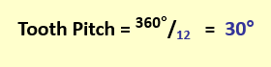12 = rotor teeth

**Hybrid:** Rotor teeth > Stator Teeth (still multiple of poles)



