## Kiwi Database Consultants

10/09/2018

Mr. Guillaume Muzumbo

Director

The Refugee Orientation Centre Trust

63 Kent St Frankton, Hamilton

Dear Mr Muzumbo:

Per our previous discussion, enclosed is our Structured Requirements for our proposal to provide consulting services for ROC.

In our evaluation of ROC, we have identified that organization of your proposed driving course will be challenging with the current system you have in place. The organization of the event will be more successful by:

* Having a database to keep track of clients and appointments
* Having a user interface to easily manipulate the database.

Kiwi Database consultants can assist ROC in overcoming the challenges. Our experience includes:

* Knowledge of SQL
* Knowledge of C#

Please review this proposal that details our plan to assist ROC.

Sincerely,

Kiwi Database Consultants

Team Members:

Luke McDowall

Peter Allen

Bryan Ong

Vineet Tyagi

Simon Wu

Dilip Thapa

Kiwi Database Consultants Driving Course Scheduler Structured Requirements for The Refugee Orientation Centre Trust

## Table of contents

**Kiwi Database Consultants**1

**Table of contents**3

**Executive summary**4

**Background and Problem Definition**5

**Current System**5

**Proposed System**5

Benefits 6

Tangible 6

Intangible 6

**Use Cases**7

Users 7

Actors 7

Cases 7

Use Case Diagram 11

**Constraints & Non-Functional Requirements**12

**Conclusion**12

**Appendices**13

Appendix 1: ROC Profile 13

**Meeting minutes**14

## Executive summary

ROC (The Refugee Orientation Centre Trust) was formed and is still run by former refugees to advocate, inform, and educate individuals and families who are from a refugee background. ROC is a Hamilton based organisation and it is the open gate of new home country for refugee families. ROC wants to help become more knowledgeable, get skills, and an attitude that will enable them to accelerate their living conditions and have a bright future in New Zealand. ROC runs different programs by targeted toward people from a refugee background. In current time, ROC has decided that they would like to run a driving instruction course over 4 weeks for refugees (ages 15 – 24) and young people in the youth at risk program. In terms of organization and scheduling, they are currently planning on using an excel spreadsheet. And KDC (Kiwi Database Consultants) is offering them to build a database system for their driving program.

Currently they don’t have any proper database system to store their data and manage all requirements of the course. Instead, they were thinking to use excel spreadsheet to manage all required data for driving program. As they can store or use excel spreadsheet to manage their data but excel spreadsheet is not actually developed for proper database system. So our group KDC has proposed them to replace that excel spreadsheet to proper database system which would help ROC to manage and run their driving program easily with proper system. The areas of developments involve interface design, database design, and a prototype built based off the design.

Mainly, our proposed system for ROC is only a prototype which is not going to be a fully functioning information system at this point but could be further developed based on the design offered by KDC. KDC has described the problems of the project and its solutions. The main problems are, ROC doesn’t have a proper database system to store their data and information related to driving program of a client. They are a big organization and they do run different programs every year. Without a proper database system, they are having a problem to look after the old data. So the database system that is going to be designed by KDC will help them a lot.

There would be numerous benefits to ROC from the proposed database system by KDC, and KDC has divided the benefit into two categories which are Tangible benefit and Intangible benefit. For example Tangible benefits are: saving time, saving money etc. and Intangible benefit are reducing errors and appearing more professional to potential investors. As well as KDC described the User interface of the system including actors, users, and their relation and workflow between them. In this proposed system clients, instructors, administrator, and car are the users where administrator and instructor are actors. KDC has listed more things about the proposed system such ROC profile, constraints and non-functional requirement, meeting time in between group members as well as with ROC.

## Background and Problem Definition

ROC wants to run a driving course for young refugees and youth at risk. The first time they want to run it over a four week period over summer. They want to have as much day time as possible to instruct as many students as possible. If the event is successful they would like to run the event in the future and possibly expanding it.

The problem that ROC is currently facing is they do not have an efficient way of scheduling the event. They have no staff trained in event organisation and the current system they have in place will be time consuming and has potential for errors.

## Current System

The current system they have in place for signing up course participants and scheduling the course is done on an Excel spreadsheet by a staff member. Excel is a flexible piece of software that allows users to do numerous jobs with it, but it is not specifically designed for organizing and scheduling a driving course. With a user interface designed for easy use and a database to keep track of data, ROC would save time in organization and allow for more focus to be put into the content of the course.

## Proposed System

The proposed system is a prototype which will not be a fully functioning information system but has the potential to be further developed based on the design offered by KDC. The system will give the administrator the ability to add cars, instructors and clients to the database. The instructors will then be able to signal times that they are available, and then the administrator will be able to book in clients with a car to make the appointment. The system will then send confirmation emails to the client and the instructor letting them know the details of the appointment. Mainly the areas of development involve interface design, database design, and a prototype built based off the design. The system is will use an SQL database and the user interface will be developed in C#. The proposed system will give a proper database to manage client’s information, appointment for instructor and car, time scheduling and store all data in professional way. It is more efficient and more beneficial system for a big company like ROC.

### Benefits

#### Tangible

Employee time

A database system can save time for refugees. It takes on average 10 minutes for an appointment to be setup. With up to 6 appointments a day, that is one hour a day. A database will halve the time it takes to make these appointments because it will be a streamlined processes with the sole purpose of making scheduling efficient. The refugees can make an appointment with ROC. ROC staff can quickly arrange car driving lesson for them. As we know they may not have a car, therefore is not convenient for them to come to ROC. We can provide the platform for them to make an appointment anywhere by letting them make appointments over the phone.

The potential for growth

Excel spreadsheets are not specifically designed for scheduling this means as the database grows if becomes less and less efficient to work with the spreadsheet. It is easier to make an appointment by using software that is explicitly designed to schedule and as the database grows it will not get cluttered like an Excel spreadsheet would. The time it takes to make an appointment would stay constant throughout the driving courses life as opposed to increasing.

Reduce error

Computers rarely make mistakes, unlike humans. As we know when we write down our email address or phone number, sometimes our handwriting is not clear or we miss type something. The next person will make an error, for example, someone will switch 1 to 7 or I to 1. It usually happens every day. However, if we use the computer, the errors will be significantly reduced. People just need to copy and paste the information. There will be fewer errors if we use a digital database. One problem of a data entry error could be booking an incorrect time, making the instructor and client expect different times leading to the lesson not happening.

#### Intangible

More professional to customers

The digital database is more professional for customers. The instructor can record learner’s learning into the database. The instructor can easily manage their process, knowing which part of driving skill need improving. It can provide efficiency for every student and instructor. For example Tom is very nervous when he is driving. He usually forgets to do a shoulder check when he is going to turn left or right. The instructor can record his problem into the database. The instructor can then help to improve this part.

Employee satisfaction

Reducing the appointment burden for an employee, the database is very useful. An employee can have more time to focus on their own job. The ROC is a non-profit organization, it does not have enough money to hire a staff for an appointment, and therefore the database can do the job for the appointment. It can replace the appointment staff. The ROC will have money to support refugees.

Employer satisfaction

Improving efficiency can make an employer be more relaxed at work. He doesn’t need to worry about making the error, labor cost, and time cost. He just needs to focus on running the ROC. The database system can bring many benefits to ROC. I think many refugees and employer will get benefit from the database.

## Use Cases

### Users

Clients - Clients are the students. They will be the ones who are using the course to learn to drive. Clients will either call ROC or go to ROC and the administrator will add them to the course and make appointments for them.

Instructors - Instructors are members of ROC staff. They will teach the students how to drive.

Administrators- Administrators are members of ROC staff. They will be in charge of organizing and scheduling the driving course.

Car - The car will be the vehicle the client uses for the driving course. They will either bring their own or, alternatively, ROC has a vehicle the client can use.

### Actors

Administrator - the administrator will be the main actor for the software. They will be in charge of adding clients to the database, making appointments, changing appointments and they will also be in charge of printing the certificates for clients who have completed the driving course.

Instructor - The instructor will select what time they are available to instruct. If need be they will change the time slots they are available for as well.

### Cases

Use Case: Instructor selects available time slots

Primary Actor: Instructor

Secondary Actors: None

Main Flow:

1. The Instructor selects the time slots on the calendar that they will be available to do.
2. The instructors’ selections are saved.

Alternate Flows:

2. If time slot has already been filled, saving is cancelled.

Use Case: Change available time slots

Primary Actor: Instructor

Secondary Actor: None

Pre Condition: An instructor would like the change what time they are available to teach

Main Flow:

1. The instructor selects the time slot/s they have selected that they want to change.
2. The instructor deletes their selection of the time slot/s.
3. The instructor chooses a new time slot/s
4. The new selected time slot is saved to the system

Alternate Flow:

1. If the time slot has already been deleted, a message pops up informing the instructor.

2. If the new time slot is already full, saving is cancelled

Use Case: Adding A client

Primary Actor: Administrator

Secondary Actors: None

Pre Condition: A client wants to be added to the system.

Main Flow:

1. The administrator obtains the clients details
2. The administrator creates a new client in the system
3. A digital copy of the clients Identification will be saved to a separate folder on the computer.
4. The clients details are added to the system
5. The client is saved to the system
6. If client wants to register a car, [extend with use case “Register Car”

Alternate flows:

3. If client has no identification, no digital copy will be saved.

4. If client already exists in the system, saving is cancelled.

Use Case: Register a car

Primary actor: Administrator

Secondary Actors: None

Pre Condition: A client wants to register their own car.

Main Flow:

1. The Administrator obtains the details of the clients car.
2. The administrator adds the details of the car to the client in the system
3. The new details about the client are saved to the system.

Alternate Flows:

3. If the car has already been registered, saving is cancelled.

Use Case: Register an Instructor/Admin

Primary actor: Administrator

Secondary Actors: None

Pre Condition: An administrator wants to add a new instructor/admin.

Main Flow:

1. The Administrator obtains the details of the new instructor/admin.
2. The administrator adds the details of the new instructor/admin to the client in the system.
3. The new details about the new instructor/admin are saved to the system.

Alternate Flows:

3. If the new instructor/admin has already been registered, saving is cancelled.

Use Case: Remove an Instructor/Admin/Car/Client

Primary actor: Administrator

Secondary Actors: None

Pre Condition: An administrator wants to remove a new instructor/admin/car/client.

Main Flow:

1. The Administrator obtains the details of the instructor/admin/car/client.
2. The Administrator removes the instructor/admin/car/client.
3. The instructor/admin/car/client is removed from the system

Alternate Flows:

3. If the admin cancels removing, removing is cancelled.

Use Case: Make an appointment

Primary Actor: Administrator

Secondary Actor: None

Pre-Condition: The client has requested to make an appointment

Main Flow:

1. The administrator informs the client about which time slots are available
2. The administrator selects the time slot the client chooses.
3. The client selects whether they want to use ROC’s car or their own.
4. The appointment is saved to the system.
5. The client receives an email confirming the date and time of appointment and with which instructor the appointment will take place.

Alternate Flow: The appointment is not available, saving is cancelled.

Use Case: Change appointment

Primary Actor: Administrator

Secondary Actor: None

Pre-Condition: The client has requested to change the time of an appointment.

Main Flow:

1. The administrator removes the incorrect appointment time from the system.
2. The administrator changes the appointment time slot to the preferred time slot that the client has indicated.
3. The appointment is saved to the system.

Alternate Flow:

1. If the client just wants to cancel the appointment, no further action is necessary after step 1 of main flow.

Use Case: Finish driving course

Primary Actor: Administrator

Secondary Actor: Instructor

Main Flow:

1. The administrator receives confirmation that the client has finished the driving course from the instructor
2. The administrator prints off certificate for the client
3. The administrator confirms completion of course, which removes any appointments the client has made that have not yet been carried out.
4. A copy of certificate is saved to file on ROC’s computers.

Alternate Flow:

1. If the course has already been completed and a certificate has been printed and saved, an error message occurs saying “Course has already been completed” and the administrator is redirected to the main page.

### Use Case Diagram

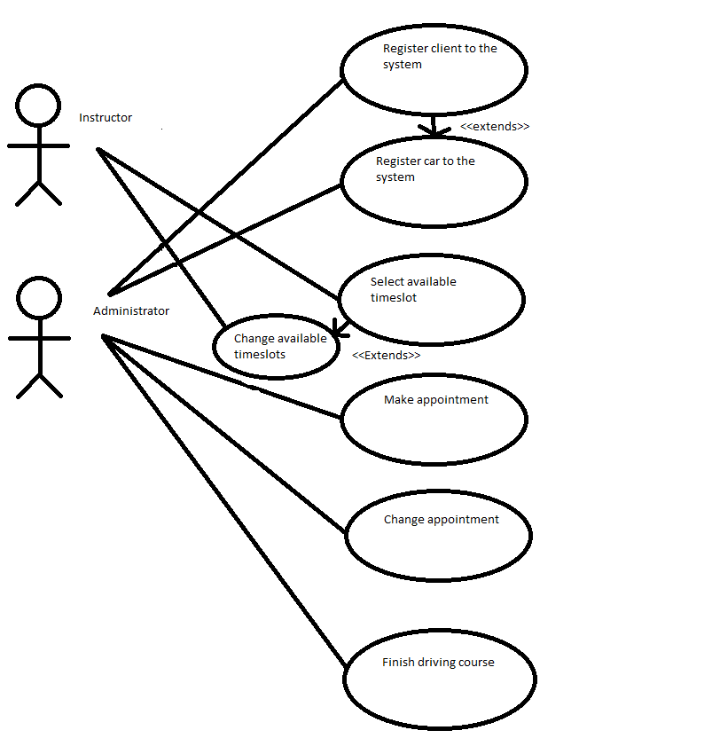

Remove admin/instructor/car/client

Register admin/instructor

## Constraints & Non-Functional Requirements

Types of user

The type of user to use the system will be a staff at ROC; they will be the only type of user using the system. The user will not need much training as the software will have an intuitive design but the user will be expected to be computer literate.

The system will be implemented on the ROC staff. The customers phone ROC and the staff will use the database system to make an appointment for them. Therefore the staff should be trained how to operate the booking system.

Documentation and Output

The documentation required are certificates that are presented to the driving student after they have completed their driving course. There are also emails sent out to the instructor and client reminding them of the appointment.

The outputs are the emails, text messages and message boxes. The email can be sent to different systems such as Windows, MacOS, iOS and so on. If the appointment is done, administrator will receive a confirmation email from the system.

Hardware Considerations

The software should have a good interface for users, therefore the memory requirements should be about 200mb, and it would include MySQL database, the C #program and some pictures. There are only a few users to use the booking system; therefore I think it does not need too much memory. But as the database grows so would the memory required.

The main hardware is the personal computer with Windows 7 system, due to the ROC is using the PC in the computer room. We should keep it has a stable environment to run the software.

Reporting input errors

If the user tries to input invalid data, the system will let the user know where the invalid data input and give them a chance to change it. In extreme conditions the system will let the user know and let them fix their input error.

If there are extreme conditions, it will display the error on message box. The textbox will delete the messages on the textbox. For example, if the age is less than 16 years old, the system should display an error message.

## Conclusion

Our system will be able to add and remove clients, cars, instructors and admins. It will be able to make bookings and send confirmation emails and congratulation certificates. The driving course that ROC want to run will be benefited by our system, by saving time on making appointments and confusion by reducing error. It will allow for the driving course to grow without cluttering a spreadsheet. It will increase employer and employee satisfaction by decrease the time done doing data entry and increase the quality of work. We have taken the technology and ROC has available into account, how to handle errors, who will be using the system and what sort of documentation and out there will be.

## Appendices

### Appendix 1: ROC Profile

ROC is a non-profit organisation focused on educating and informing refugees here in Hamilton. The education and information that ROC provides has helped, and will continue to help, refugees integrate and assimilate into New Zealand society and gain social and economic independence. ROC has been operating since June of 2005 and only offered two programs; Using Computers and English classes. There are 5 full time workers, 10 part time and as many volunteers as they can get. There will be 4 instructors to start off with but as the course gets underway ROC plans to increase the size of the course. The courses will include a lesson, a restricted licence test and a full licence test.

The programs ROC offers include:

* **Advocacy services:** Legal support and offering support when refugees have to communicate with the bank, landlords etc. When there is a language barrier or little knowledge of New Zealand culture, this support can be invaluable.
* **After School program (Study support centre):** Twice a week for 3 hours, ROC runs a study support centre for children aged 5 -13 years. The focus is to help children with English and their homework so as to promote a positive attitude towards study.
* **Budgeting Services:** Helping refugees learn about working effectively with money.
* **Catch up with homework program:** This program is focused towards high school and ESOL students to help stay on top of homework.
* **Computer Training:** A qualified basic computer training tutor is available at ROC 3 hours a weeks for refugees with no or limited experience using a computer. The participants learn typing, email and other useful software for the workplace, such word and PowerPoint.
* **Conversational English:** For adult refugees, this program is about building confidence in spoken English so refugees can better connect with the community.
* **Driver Education:** To help refugees with converting international drivers license to a NZ license and teaching drivers the road code book.
* **Girls2Girls Connection:** The idea of this program is to pair refugee girls aged 12-15 with women studying at university to provide them with a role model to promote finishing school and moving on to tertiary study.
* **Holiday Program:** For 5-13 year old refugee children to give a supportive environment to be in over the school holidays.
* **Parenting Program:** The objective of the parenting program is to provide a support structure for refugees who are parents. It includes home visits from staff of ROC and a monthly meeting where the participants can share their experiences.
* **Youth Mentoring Program:** Aims to provide individuals with the support to reach their full potential and develop a vision for where their future may take them.

## Meeting Minutes

*First meeting with client*

**Date**: 27th July 2018,

**Time**: 2.00pm

**Location**: Refugee Orientation Centre

**Present:** All members of Kiwi Database Consultants and representative of ROC

**Absent:** -

**Meeting Objective:**

* To introduce our team and our purpose.
* To understand Refugee Orientation Centre aimed.
* To listen and understand the problems that ROC are currently encounter.
* To know what kind of outcome that ROC are expecting.

**Meeting Outcome:**

ROC is currently preparing a driving lesson courses for the refugees at the end of September. ROC is looking forward for a program that allows refugees, driving instructors, and client to access which allow them to schedule the driving lesson. All information gathered is noted.

*Group meeting*

**Date:** 3rd August 2018

**Time:** 2.00pm

**Location:** University of Waikato

**Present:**

**Absent:**

**Meeting Objective:**

* To discuss the information gathered from ROC and create assumption of solutions.
* To divide the workload for every group members to carry out ISP.

**Meeting Outcome:**

* A numbers of solutions were carried out according to the problems that we gathered,
* A numbers of benefits were assumed from the solution.
* Workloads were divided evenly to every group member to carry out a proposal.

*Group meeting*

**Date:** 20th August 2018

**Time:** 2.00pm

**Location:** University of Waikato

**Present:** All members of KDC

**Absent: -**

**Meeting Objective:**

* To create a use case diagram
* To divide the workload for every group members to carry out for the structured Requirements deliverable

**Meeting Outcome:**

* A draft use case diagram was created
* Each member of the group was delegated different use cases to work on

*Second Meeting with client*

**Date:** 10th September 2018

**Time:** 12.00pm

**Location:** Refugee Orientation Centre

**Present:** Dilip, Simon, Luke, Vineet

**Absent:** Bryan, Peter

**Meeting Objective:**

* To get more information about the project.
* To understand the current machine and type of database they are using
* To find out who is going to operate the software.

**Meeting Outcome:**

From this meeting we confirmed that this scheduling program will be used by ROC staff only. Refugee or customers will need to walk in to the centre to register their interest. Staff members will then record their interest into the program. At the end of the lessons, the program will generate a certificate to the refugees/customers. All personal information like identification Card, passport etc. will be store in a private folder instead of database.