Facility Sense: Student Lead Facilities Feedback Web Application
Design Document
10/16/2017
Version 1.0



Team Best Team
Joseph Guerrero
Chanse Cramer
Luke Clancy

Course: CptS 322 - Software Engineering Principles I
Instructor: Sakire Arslan Ay

Note:
Length = 3-4 pages text+ appendixes as needed. Cover page, table of contents, pictures, images, use-case UML diagrams do not count for the 3 pages text.
Posted as a PDF file.
Typed single‐spaced.
Typed with black text.
Typed with #11 font size.
Typed using Calibri font.
Typed with one inch margins on sides, top and bottom.
(Please erase this page in your final document.

TABLE OF CONTENTS
I. Introduction 3
II. Architecture Design 3
II.1. Overview 3
III. Design Details 3
III.1. Subsystem Design 3
III.1.1. [Subsystem Name] 4
III.1.2. [Subsystem Name] 4
III.2. Data design 4
III.3. User Interface Design 4
IV. Testing Plan 4
V. References 5
VI. Appendix: Grading Rubric (for iteration-1) 5

Introduction
Explain the purpose for providing this design document If this is a revision of an earlier document, please make sure to summarize what changes have been made during the revision (keep this discussion brief).
This design document will be the first of several, detailing out progress so far with the project. We are still hoping to create a proof of concept regarding real time feedback regarding the student’s thoughts, suggestions, and opinions of a specific building.

Document Revision History
Rev 0 10/16/17 Design Doc 1st iteration

Architecture Design

Overview
This section should describe the high-level architecture of your software: i.e., the major subsystems and how they fit together.
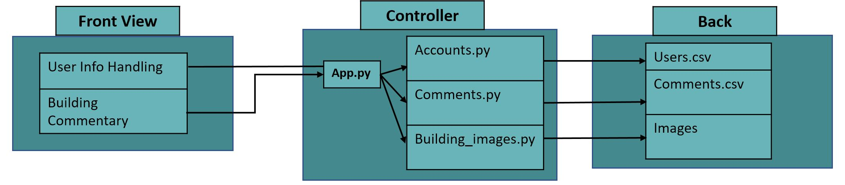
Front View:
User Info Handling: Sign people in/up, gather user info.
Building Commentary: View a building’s floors and access and provide commentary.

Controller:
App.py: Main function that handles backend. Should run on Heroku. Handles accounts, comments, and images.
Accounts.py: Contains functions for account handling. Read/writes to csv files for storage across sessions.
Comments.py: Contains functions related to comments. Loads/stores comments from a csv.
Bulding_images.py: Loads the appropriate building floorplan from a database.

Back:
Users.csv: Contains a user account at every line. Contains essential user information.
Comments.csv: Archive of comments posted to the website.
Images: Collection of images to be accessed by various functions and programs.

Design Details

Subsystem Design
This section provides more detail about each subsystem in your architecture. For each subsystem, include a sub-section and explain:
- The important features internal to the subsystem such as descriptions of critical algorithms used, protocols, and key invariants. Also, wherever possible items should be linked back to your requirements specification.
If there are messages sent between clients and servers, you should identify what messages and what data they contain, and in what format, and in what order they should be sent.
(Note: We expect to see a more refined design for the features to be included in the current iteration, and perhaps a more rough design for the features to be implemented in future iterations. )
- (in iteration -2) Provide your class level design. You should include a UML class diagram visualizing your class level design. In addition, explain each class in detail, specify and explain their methods.
If you have considered alternative designs, please describe briefly your reasons for choosing the final design.

[Front View]
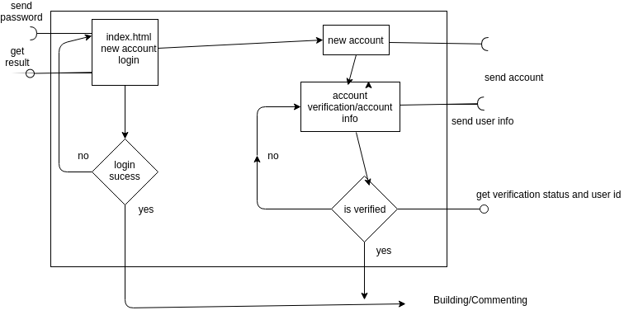

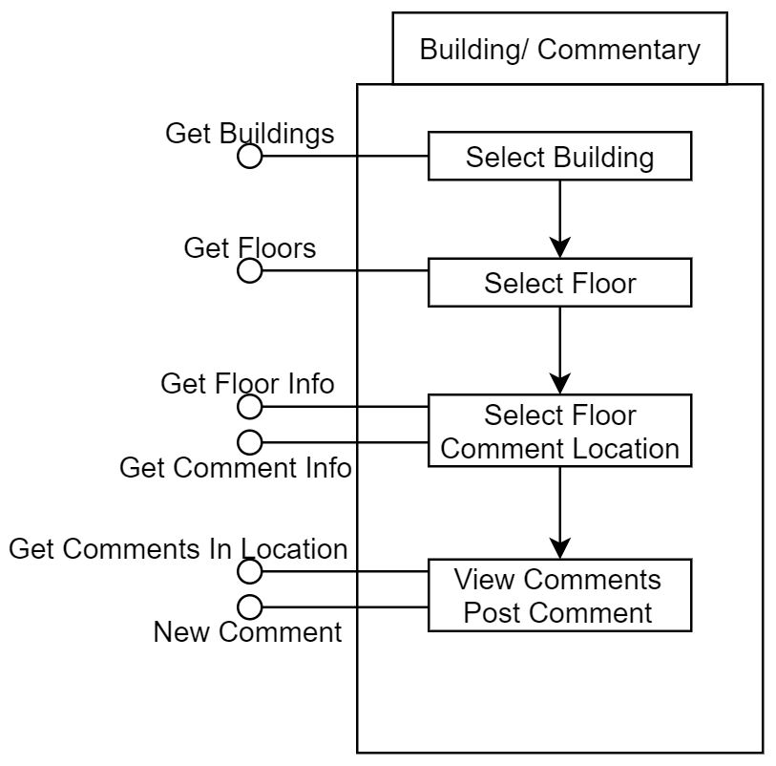
[Controller]

[Back]
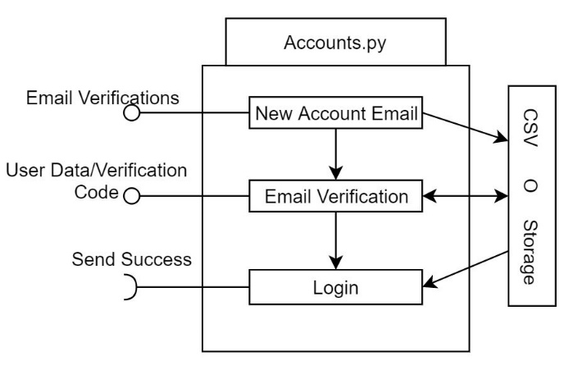

Data design
Describe all data structures (including the internal and temporary data structures), and the database tables created as part of the application. Provide the schemas (attributes) of the tables.

User Interface Design
Provide a detailed description of user interface you have built so far. The information in this section should be accompanied with proper images of your screenshots. Make sure to mention which use-cases in your “Requirements Specification” document will utilize these interfaces for user interaction.

Testing Plan
(starting iteration 2)
In this section goes a brief description of how you plan to test the system. Thought should be given to how mostly automatic testing can be carried out, so as to maximize the limited number of human hours you will have for testing your system. The effort you put early on automated testing will pay off when you have to ensure that you are not breaking existing functionality in future iterations.
Consider the following kinds of testing:
- Unit Testing: Explain for what modules you plan to write unit tests, and what framework you plan to use.
- Functional Testing: What routes and APIs does your server support that you plan to test? How will you test them? What tools you will use? Will you write mocks?
- UI Testing: How do you plan to test the user interface?

References
Cite your references here.
For the papers you cite give the authors, the title of the article, the journal name, journal volume number, date of publication and inclusive page numbers. Giving only the URL for the journal is not appropriate.
For the websites, give the title, author (if applicable) and the website URL.

