**Improving Sentiment Analysis with Multi-task Learning of Negation**

October 19th, 2020

**By**

**Team Members**

Akshaya Nagarajan

Pooja Patil

Sivaranjani Kumar

Vigneshkumar Thangarajan

**Abstract:**

Sentiment Analysis is a process where one can mine people’s opinions from a piece of text. At first glance, this task may look like a simple text classification problem, but once deep dived, one can find out challenges which can affect the sentiment analysis accuracy. For instance, predicting sentiment just using the words in a sentence can lead to major pitfalls such as detecting sarcasm, irony, word ambiguity, use of negating words, also multipolarity. Out of all these phenomena, negation is the most prevalent. Any sentiment analysis model must be able to identify negation and try to remove the effect that its scope has on the final sentiment of a text. In this project, we propose to use Multi-task learning approach, using a cascading and hierarchical neural architecture of LSTM layers. This architecture will explicitly train the model with negation as an auxiliary task and eventually help in improving the main task of sentiment analysis.

**Introduction:**

In this project, we propose to model sentiment prediction along with negation detection in a multi-task learning set-up. [1], annotates prediction tasks on same dataset with same output units, we propose to take auxiliary data from different dataset and domains with different units of classification across tasks. Also, as an auxiliary task, we will experiment learning sequence-labeling of negation cues and scopes based on two negation datasets, whereas our main task will be sentence and tweet level classification of sentiments.

Multi-task learning (MTL), a subfield of machine learning, solves related tasks simultaneously allowing a ML algorithm to include a useful inductive bias by restricting the search space of possible representations to those that are predictive for both tasks. We plan to incorporate negation information as a cascading architecture for sentiment prediction, where the intermediate representations learned for predicting negation is fed into subsequent layers along with skip-connections. The lower layers of the network are shared as well as supervised by both auxiliary and main task. The final layer is committed for the sentiment prediction task.

**Architecture Diagram:**

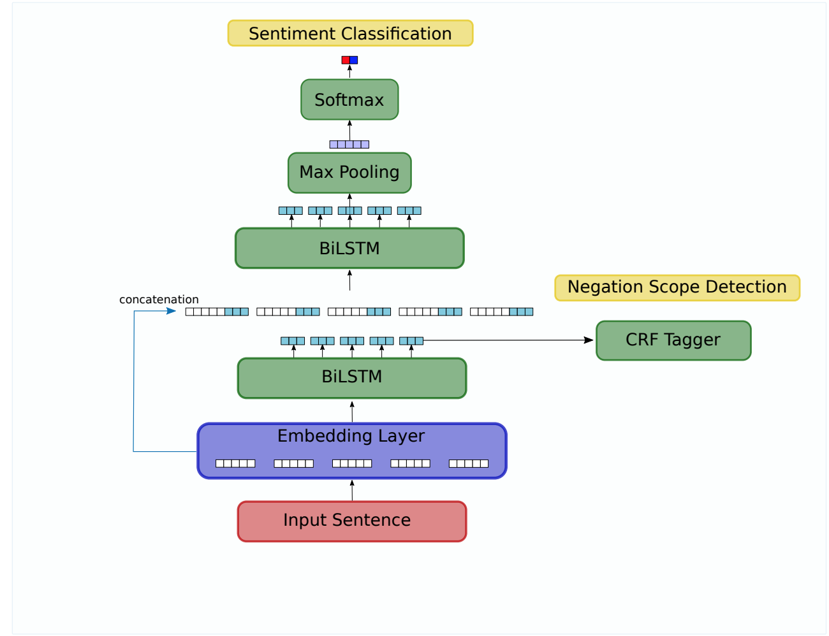

Figure 1. Architecture diagram.

**Reference:**

[1] Bingel, J. and Søgaard, A. (2017). Identifying beneficial task relations for multi-task learning in deep neural networks. In Proceedings of the 15th Conference of the European Chapter of the Association for Computational Linguistics, pages 164–169, Valencia, Spain.

[2] Improving Sentiment Analysis with Multi-task Learning of Negation J E R EM Y B A R N E S , E R I K V E L L D A L , and L I L J A Ø V R E L I D Language Technology Group, University of Oslo email: {jeremycb,erikve,liljao}@ifi.uio.no