**ASSIGNMENT**

**Q. Create a local git repository in your local machine first. Commit the initial code.**

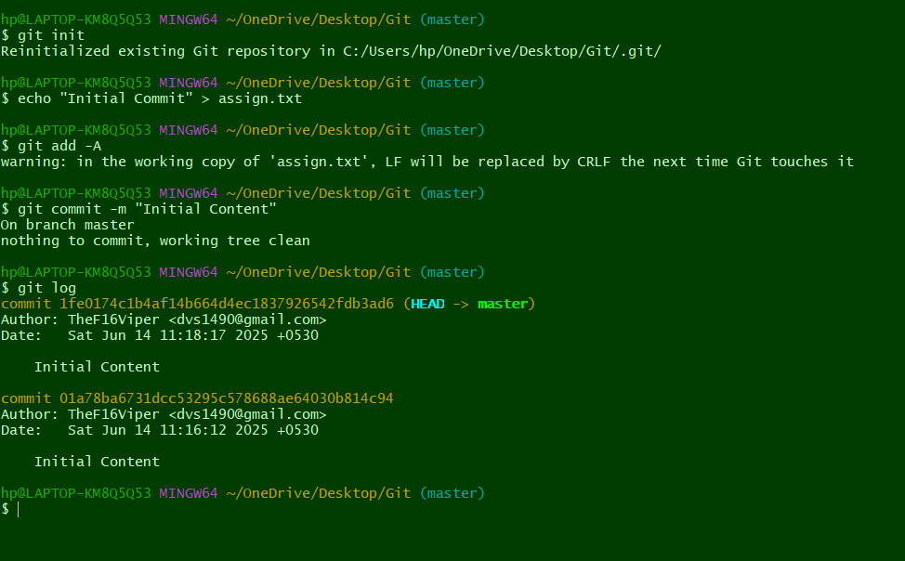

Q. Update the code on the remote server. Also perform some changes on remote n reflect the same on local. [push/pull operations]

Q. Create g1 branch on the github..................Add 1 txt file .................Raise a pull request on remote from g1 towards main........................... and merge without conflicts.

Local git: Use git commands to

o Get the updated files

o Perform reset

o List the changes

o Create local branches main>>>b1, update........b1>>>>b2, update b2>>>>>b3

and update them as well.

o List the changes [via diff and via ls]

Demonstrate diff between local branches

Perform LOCAL merging operation and after that delete the unnecessary ones

locally as well as remote

Perform fork operations on your repository as well.