**ASSIGNMENT**

**GIT COMMANDS**

**Q. Create a local git repository in your local machine first.**

**Commit the initial code**

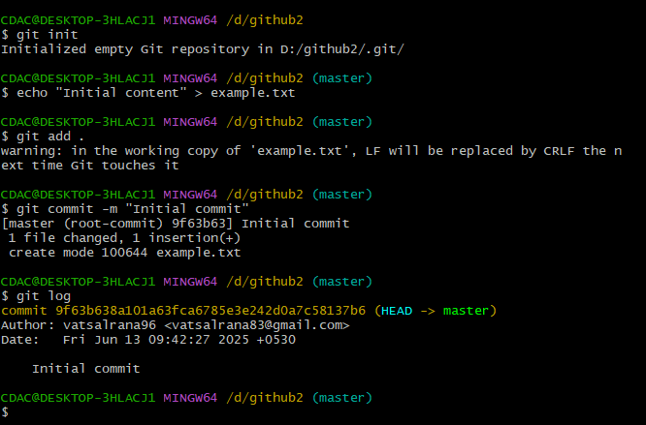

**Q. Update the code on the remote server . Also perform some changes on remote n reflect the same on local.[push/pull operations]**

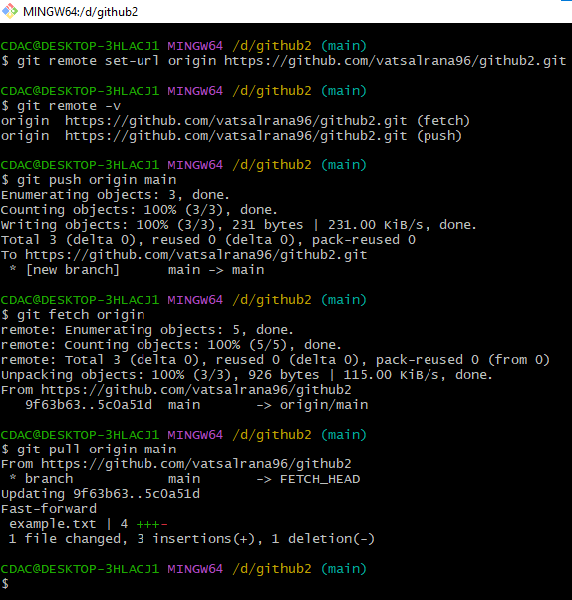

**Q. Create g1 branch on the github..................Add 1 txt file .................Raise a pull request on remote from g1 towards main........................... and merge without conflicts.**

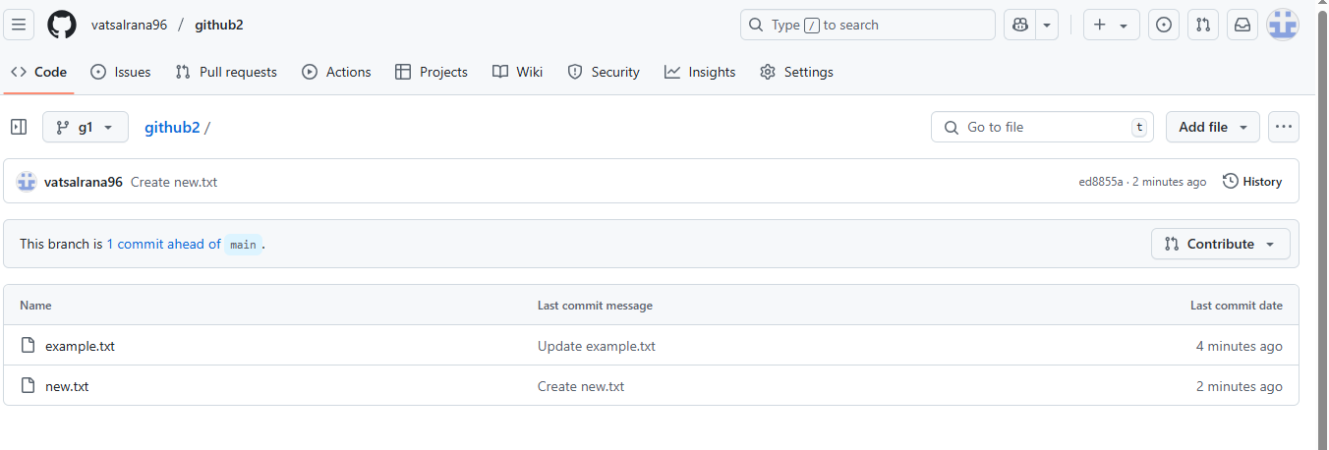

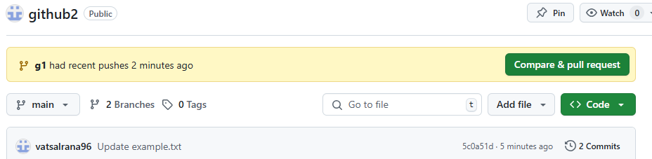

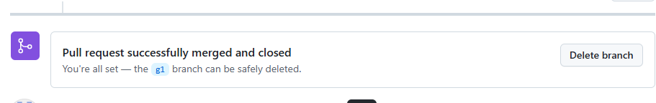

**Local git: Use git commands to**

**o Get the updated files**

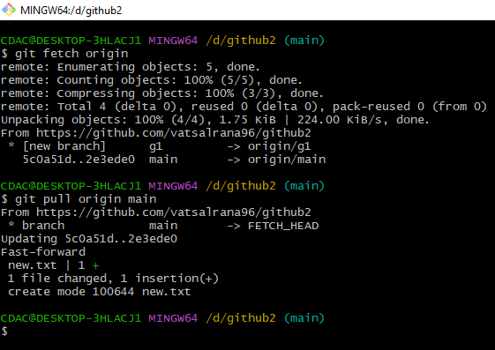

**o Perform reset**

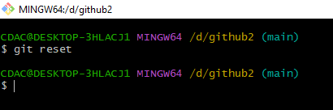

**o List the changes**

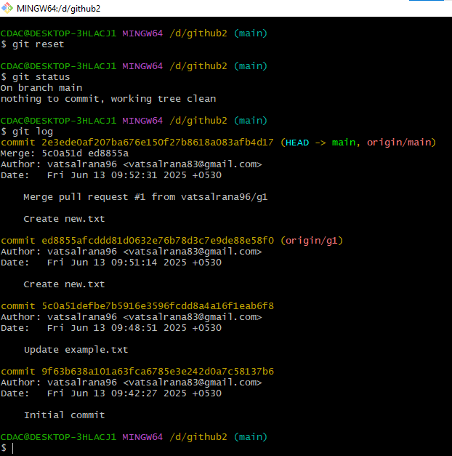

**o Create local branches main>>>b1,update........b1>>>>b2,update b2>>>>>b3 and update them as well.**

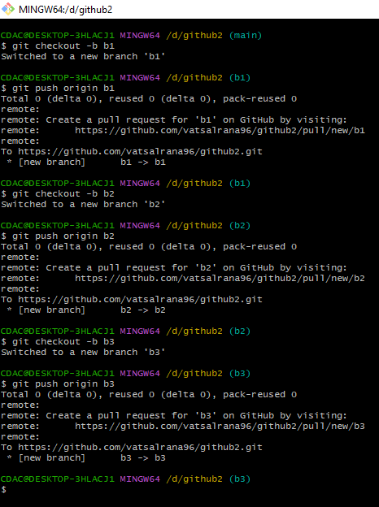

All three branches (b1, b2, b3) exist both locally and on the remote repository.

**o List the changes [via diff and via ls]**

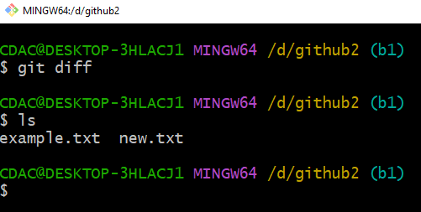

**Demonstrate diff between local branches**

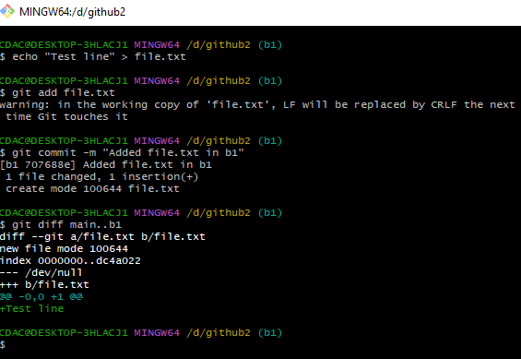

**Perform LOCAL merging operation and after that delete the unnecessary ones locally as well as remote**

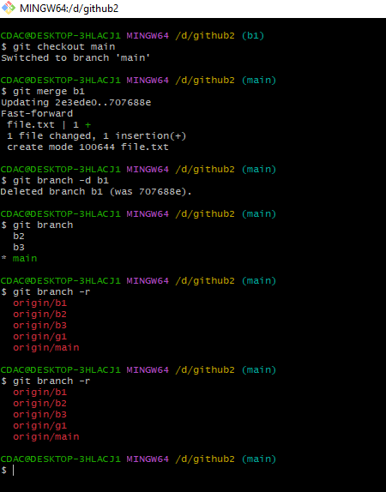

Perform fork operations on your repository as well.

