# Student Name:Khushwant Singh Rathore UID:19bcs464

**Branch: BE-CSE(IOT1) Section/Group:IOT1-A**

**Semester: 5 Date of Performance:16-08-2021 Subject Name: WIRELESS SENSOR NETWORKS AND IOT STANDARDS LAB**

**Subject Code: CSD-331**

1. **Experiment Title/Problem Statement:** To Study Arduino Uno Board in detail and familiarization to Arduino IDE.
2. **Requirements:** Arduino IDE, Arduino Uno

# Description Arduino Uno:

The Arduino Uno is a microcontroller board based on the ATmega328 (datasheet). It has 14 digital input/output pins (of which 6 can be used as PWM outputs), 6 analog inputs, a 16 MHz crystal oscillator, a USB connection, a power jack, an ICSP header, and a reset button. It contains everything needed to support the microcontroller; simply connect it to a computer with a USB cable or power it with a AC-to-DC adapter or battery to get started. The Uno differs from all preceding boards in that it does not use the FTDI USB-to-serial driver chip. Instead, it features the Atmega8U2 programmed as a USB-to-serial converter. "Uno" means "One" in Italian and is named to mark the upcoming release of Arduino 1.0. The Uno and version 1.0 will be the reference versions of Arduino, moving forward. The Uno is the latest in a series of USB Arduino boards, and the reference model for the Arduino platform.

# Technical Specifications

Microcontroller: ATmega328

Operating Voltage 5V

Supply Voltage (recommended) 7-12V

Maximum supply voltage (not recommended) 20V

Digital I/O Pins 14 (of which 6 provide PWM output)

Analog Input Pins 6

DC Current per I/O Pin 40 mA

DC Current for 3.3V Pin 50 mA

Flash Memory 32 KB (ATmega328) of which 0.5 KB used by bootloader

SRAM 2 KB (ATmega328)

EEPROM (1 KB (ATmega328)

Clock Speed 16 MHz

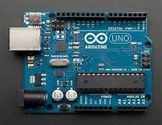

# Pin Description:

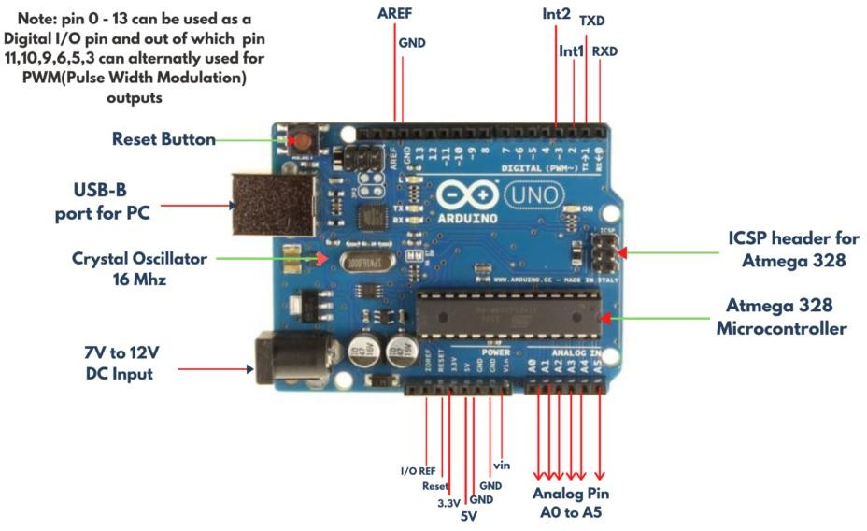

**Software:**

**Arduino IDE:**

Introduction to Arduino IDE

Arduino IDE is an open source software that is mainly used for writing and compiling the code into the Arduino Module.It is an official Arduino software, making code compilation too easy that even a common person with no prior technical knowledge can get theirifeet wet with the learning process.It is easily available for operating systems like MAC, Windows, Linux and runs on the Java Platform that comes with inbuilt functions and commands that play a vital role for debugging, editing and compiling the code in the environment.A range ofiArduino modules av ailable including Arduino Uno, Arduino Mega, Arduino Leonardo, Arduino Micro and many more.Each ofithem contains a microcontroller on the board that is actually programmed and accepts the information in the form oficode.The main code, also known as a sketch, created on the IDE platform will ultimately generate a Hex File which is then transferred and uploaded in th e controller on the board.The IDE environment mainly contains two basic parts: Editor and Compiler where former is used for writing the required code and later is used for compiling and u ploading the code into the given Arduino Module.This environmentsupport both C and C++ languages.



How to Download **Arduino IDE and install**

Software is available for common operating systems like Linux, Windows, and MAC, so make sure you are downloading the correct software version that is easily compatible with your operating system.Ifiyou aim to download Windows app version, make sure you have Windows 8.1 or Windows 10, as app version is not compatible with Windows 7 or olderiversion ofithis operating system. **Introduction to Arduino IDE** where IDE stands for Integrated Development Environment An official software introduced by Arduino.cc, that is mainly used for writing, compiling and uploading the code in the Arduino Device. Almost all Arduino modules are compatible with this software that is an open source and is readily available to install and start compiling the code on the go.

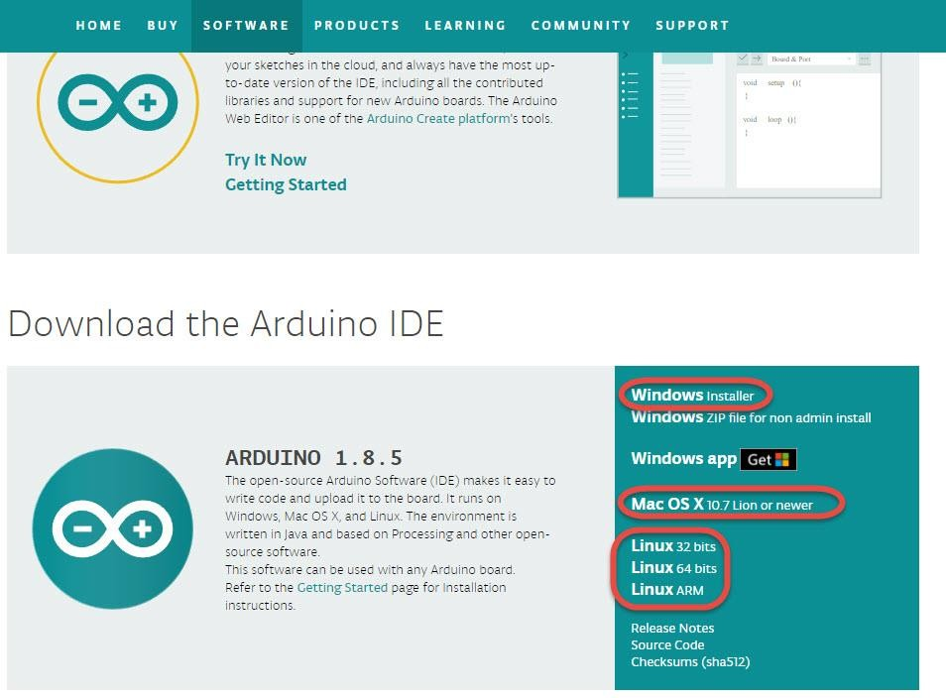

The IDE environment is divided into three sections:

# Menu Bar

1. **Text Editor**
2. **Output Panel**

The bar appearing on the top is called **Menu Bar** that comes with five different options as follow

* + **File** : You can open a new window for writing the code or open an existing one. Following table shows the number ofifurther subdivisions the file option is categorized into.
  + **Edit** :Used for copying and pasting the code with furtherimodification for font
  + **Sketch**: For compiling and programming
  + **Tools** :Mainly used for testing projects. The Programmer section in this panel is used for burning a bootloader to the new microcontroller.
  + **Help** : In case you are feeling skeptical about software, complete help is available from getting started to troubleshooting.

The **Six Buttons** appearing under the Menu tab are connected with the running program as follow.

The check mark appearing in the circular button is used to verify the code. Click this once written the code.

* + The arrow key will upload and transfer the required code to the Arduino board.
  + A dotted paper s used for creating a new file.
  + The upward arrow is reserved for opening an existing Arduino project.
  + The downward arrow is used to save the current running code.

# Steps for experiment/practical:

1. **Snapshots of Above steps**

BEFAhTME9T0F



Discover. Leo rn. Empower.

NAAC A«

GRADE ¥^WI"

ACCREDITED UNIVERSITY

ICMP header for Atmego 328

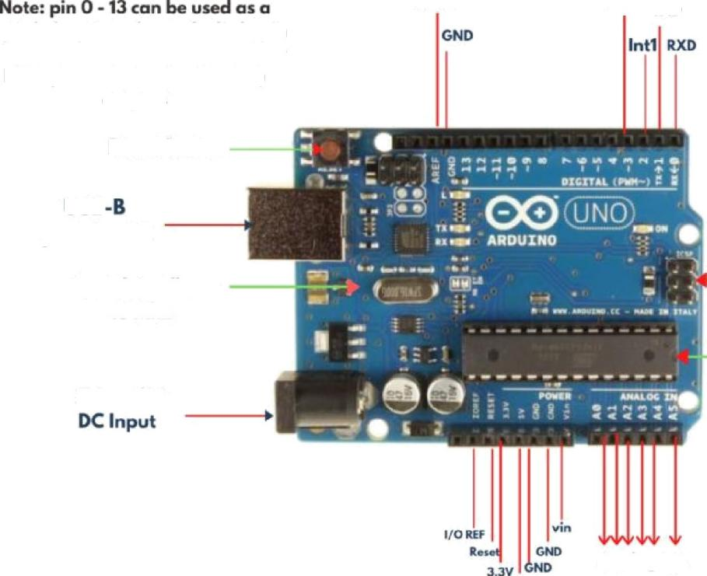

AREF

Digital l/O pin and out of which pin fit10,9,6,5,3 con ohernotly uBed for PWM(Pulcc Width tuition)

Reset Button

USB

Crystal Oscillator 16 hthz

AO so AS

Atmego 328

Microcontroller

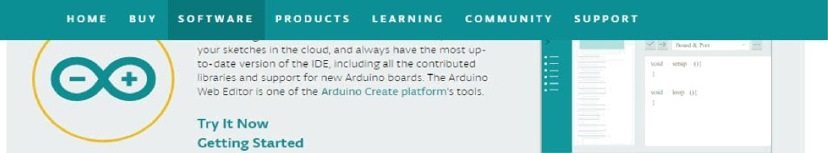

Down load the Arduino IDE



ARDUINO 1 . 8 . 5

The open -source Arduina SoWvare (IDE A makes it easy to

write code ari d upl oad it to the Doard. lt ru ns on

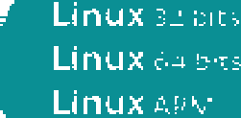\°Vindo\< s, Mac Of X, and Linux. 7h e environment is written in java an d based on Processing an a ate er open- source software.

This software can be useci •.with any Arduino board.

Refer ro the GeLcing Startert page for Installation instructions.



# Result/Output/Writing Summary:

Learned about the specifications and pin configuration of Arduino uno.

Learned about the Arduino IDE used for compiling and uploading the code on Arduino uno. Learned about how to compile and upload on Arduino uno board.

# Graphs (If Any): Image /Soft copy of graph paper to be attached here