**Experiment no. 2**

**Student Name:** Akshit Gupta **UID:** 19BCS4503

**Branch:** CSE-IOT **Section/Group:** 1-A

**Semester:** 6th  **Date of Performance:** 21-02-2022

**Subject Name:** CCIOT-Lab **Subject Code:** CSD-387

**1. Aim/Overview of the practical:**

Deploying Node.js Application using Bluemix Cloud

**2. Task to be done:**

Have to make a cloudfoundry sample app to change the image and text written over the web app.

**3. Steps for experiment/practical:**

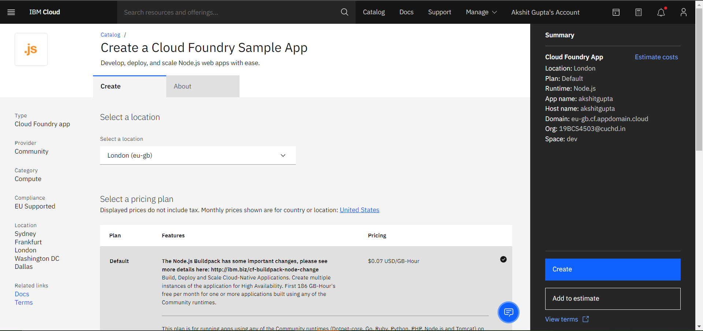

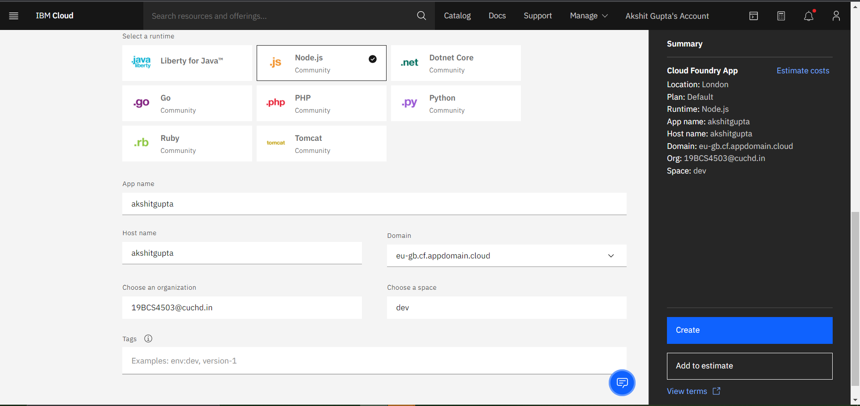

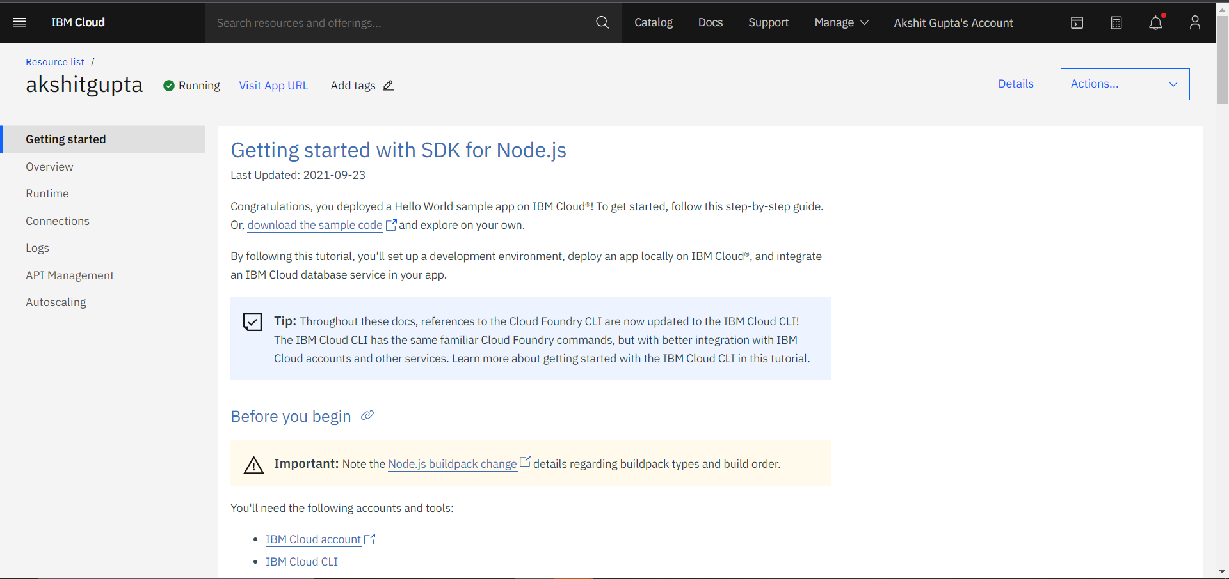

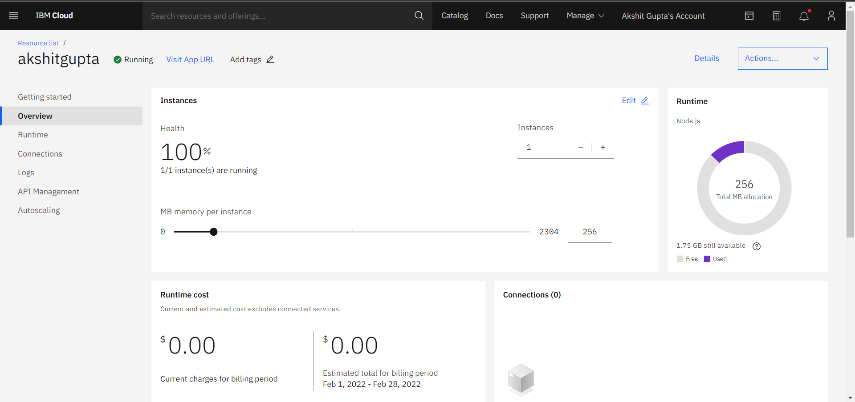

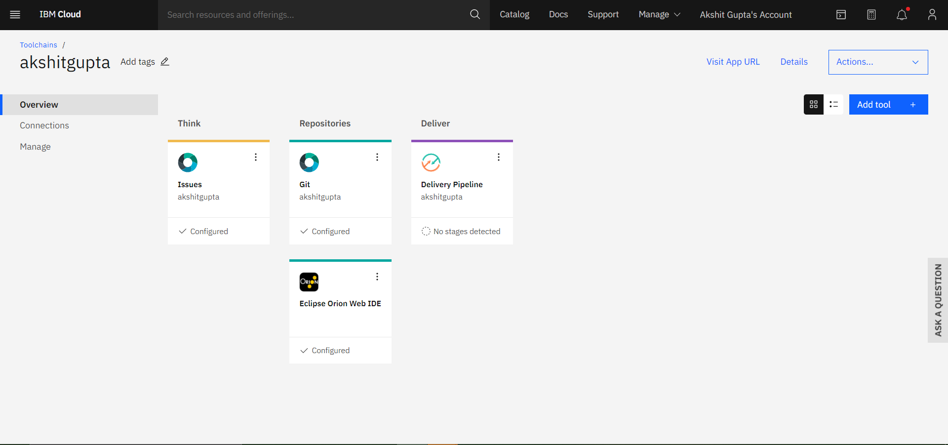

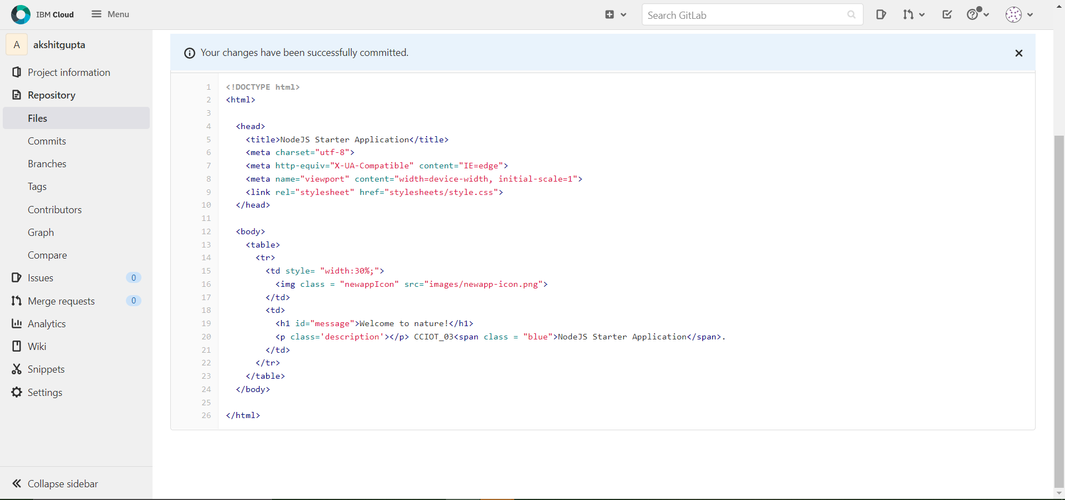

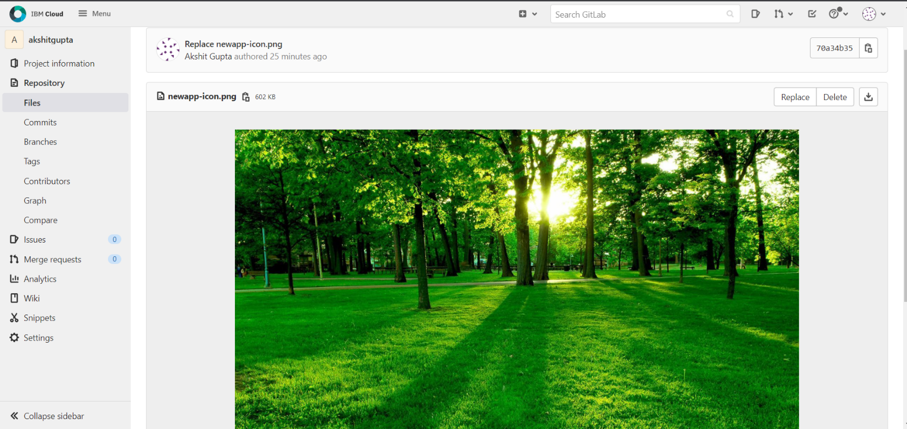

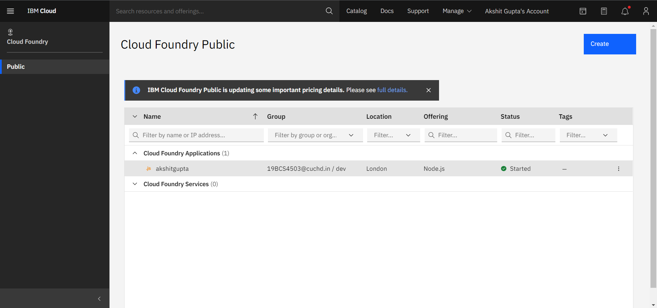

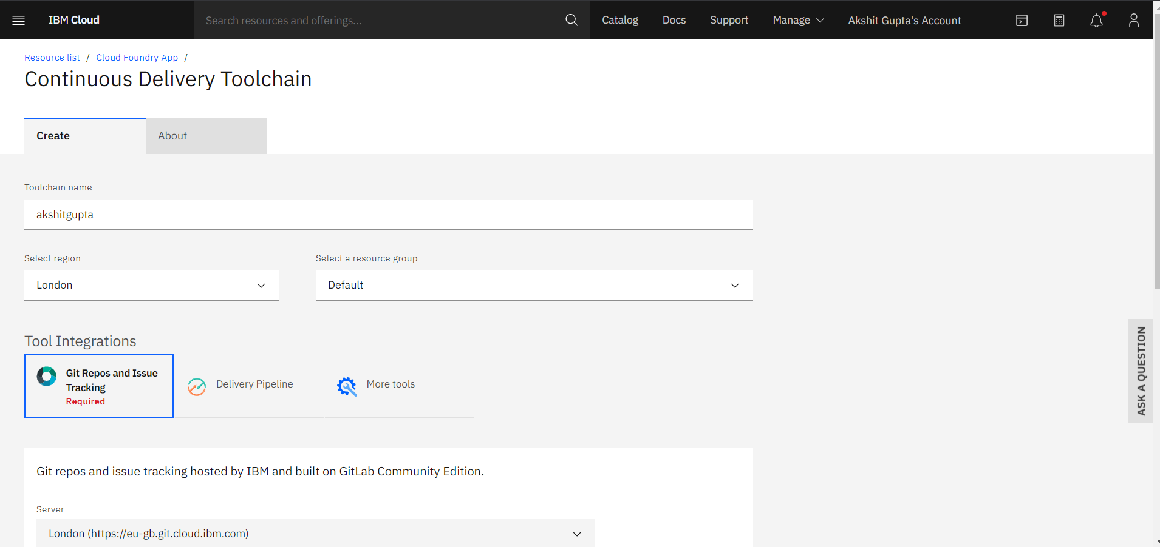

**5. Output: Image of sample output to be attached here**

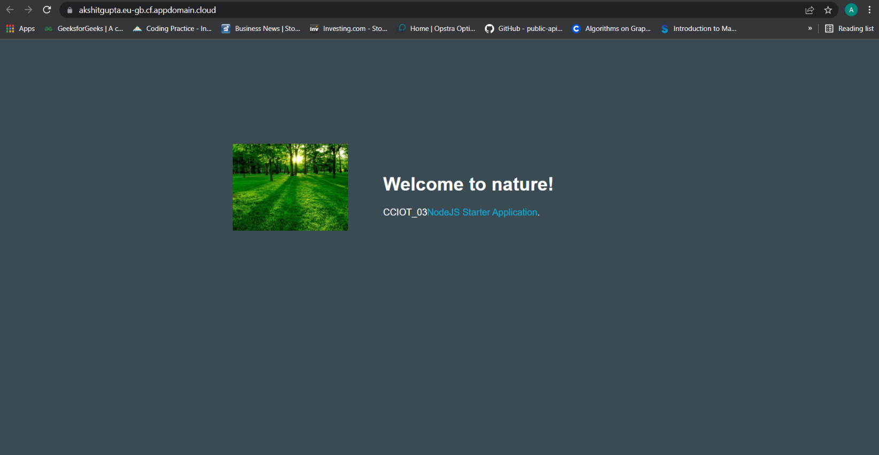

**Learning outcomes (What I have learnt):**

**1.** About cloudfoundry and its various features.

**2.** Modifying and creating web applications using node Js. Feature.

**3.** CLI method of launching application.

**Evaluation Grid (To be created as per the SOP and Assessment guidelines by the faculty):**

|  |  |  |  |
| --- | --- | --- | --- |
| Sr. No. | Parameters | Marks Obtained | Maximum Marks |
| 1. |  |  |  |
| 2. |  |  |  |
| 3. |  |  |  |
|  |  |  |  |