**Experiment no. 5**

**Student Name:** Akshit Gupta **UID:** 19BCS4503

**Branch:** CSE-IOT **Section/Group:** 1/A

**Semester:** 6th  **Date of Performance:** 02-04-2022

**Subject Name:** CCIOT Lab **Subject Code:** CSD-387

**1. Aim/Overview of the practical:** Deploy an Natural Language Understanding service app on IBM Cloud CLI.

**2. Steps for experiment/practical:**

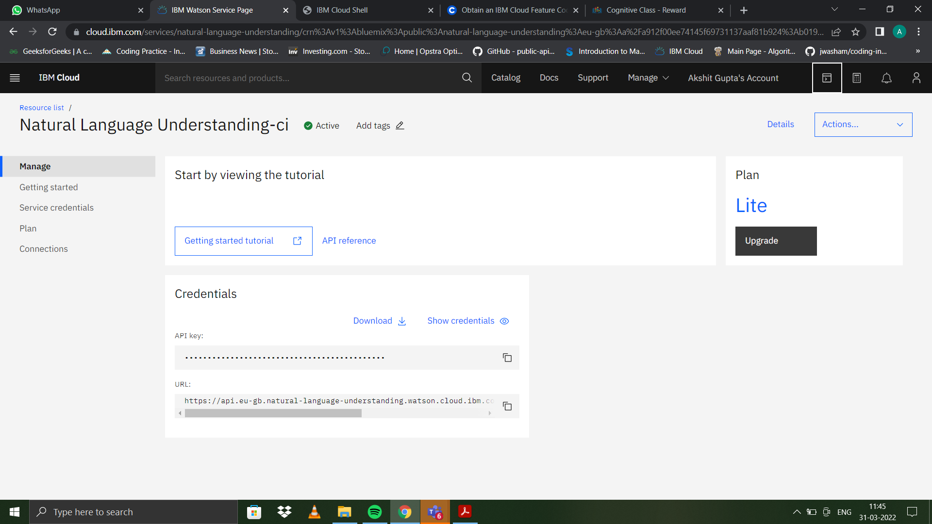

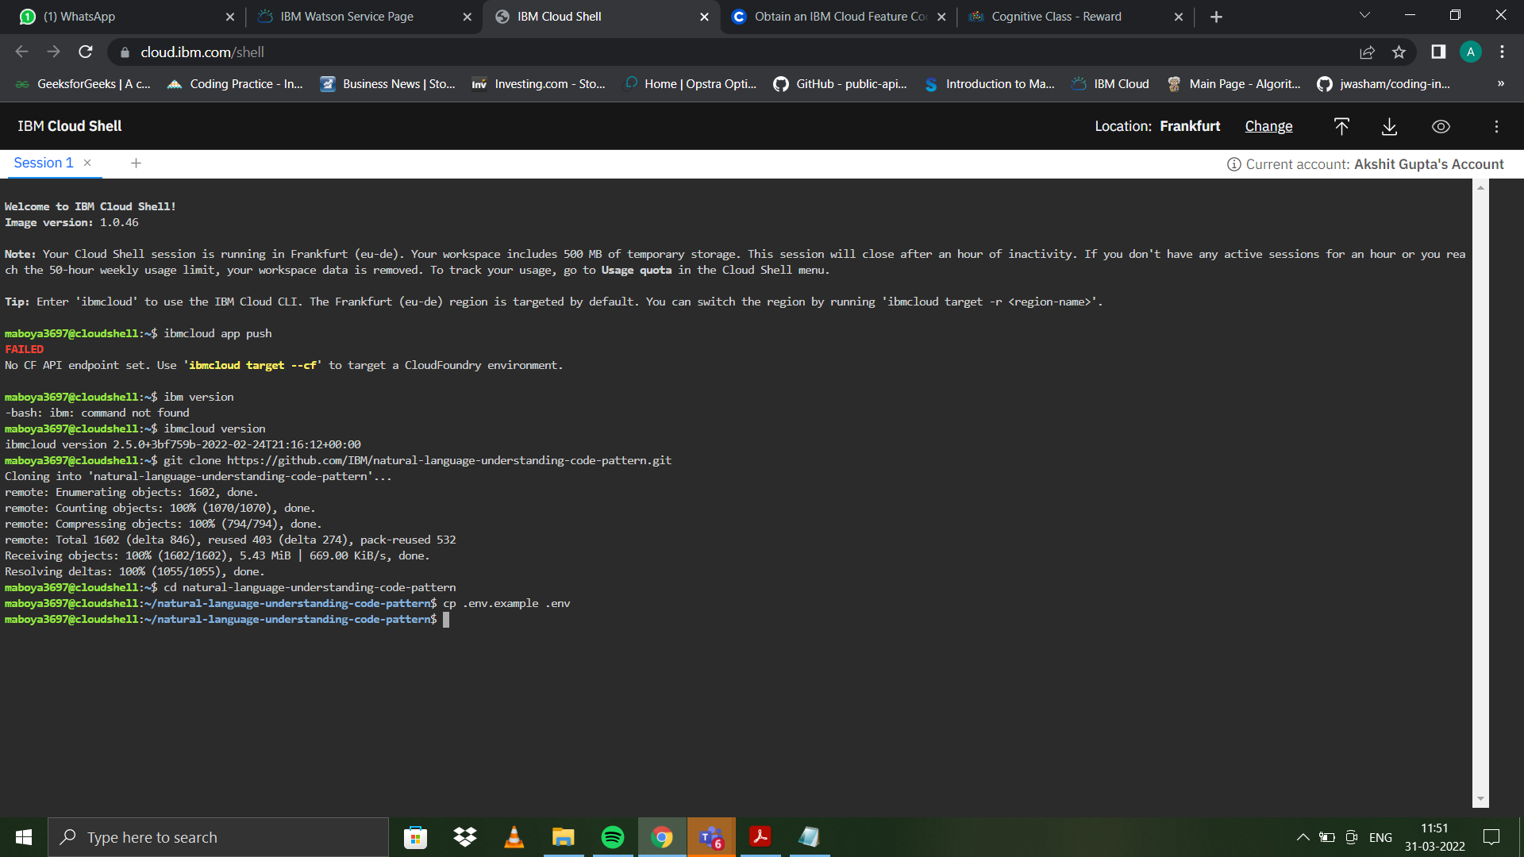

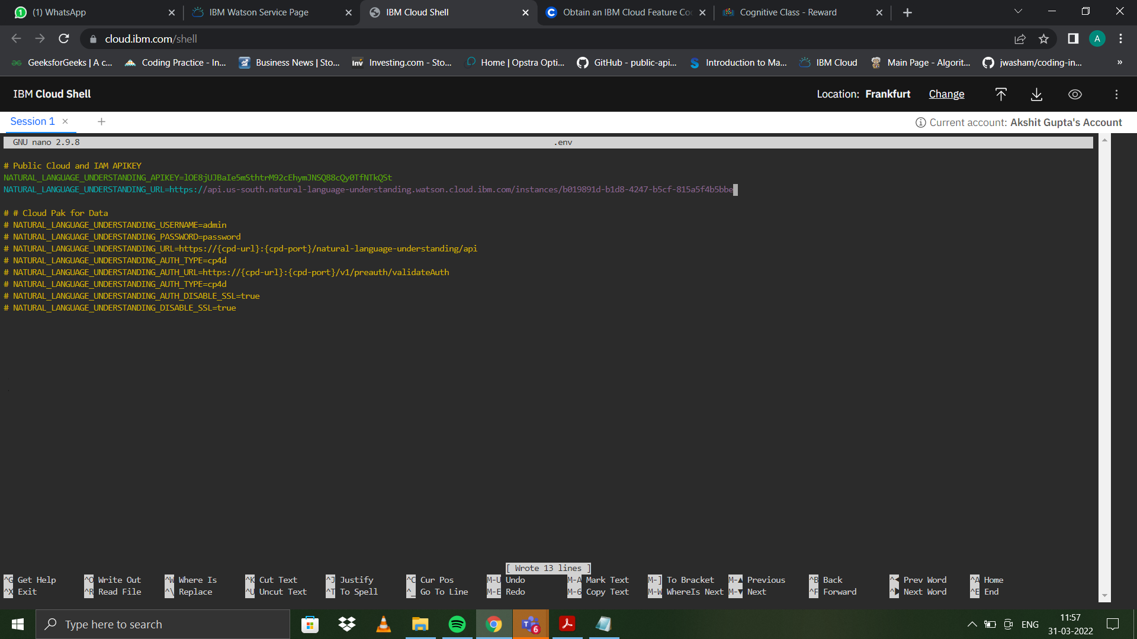

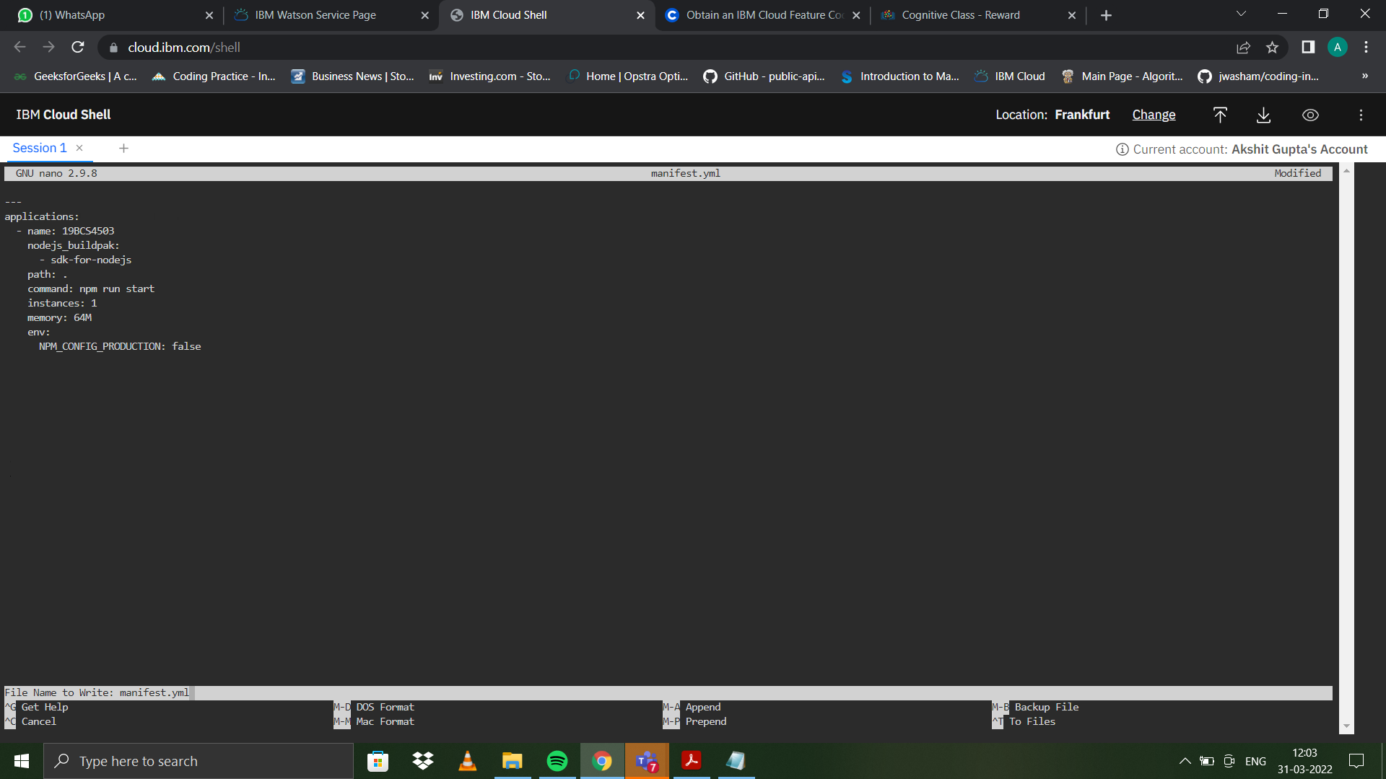

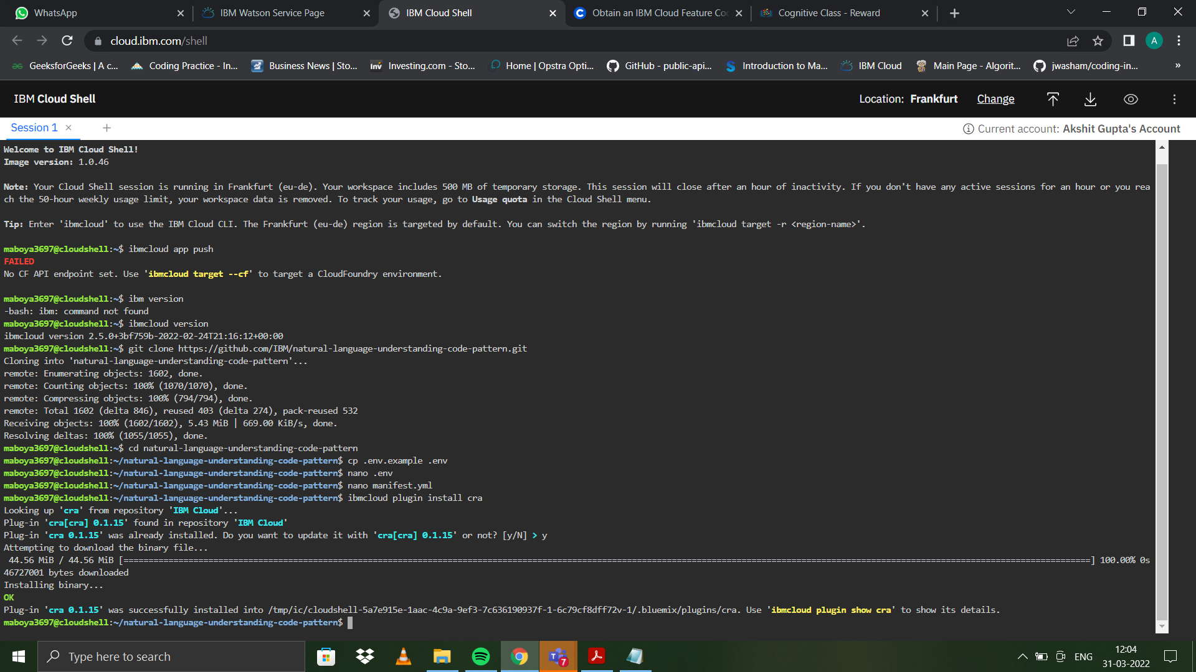

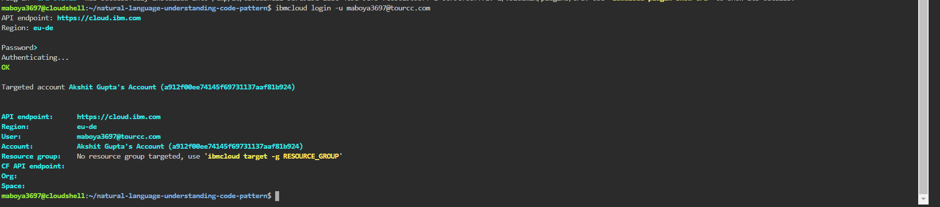

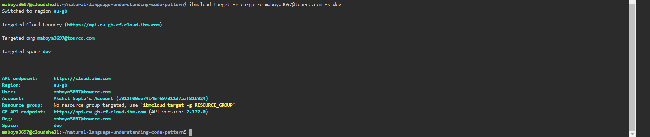

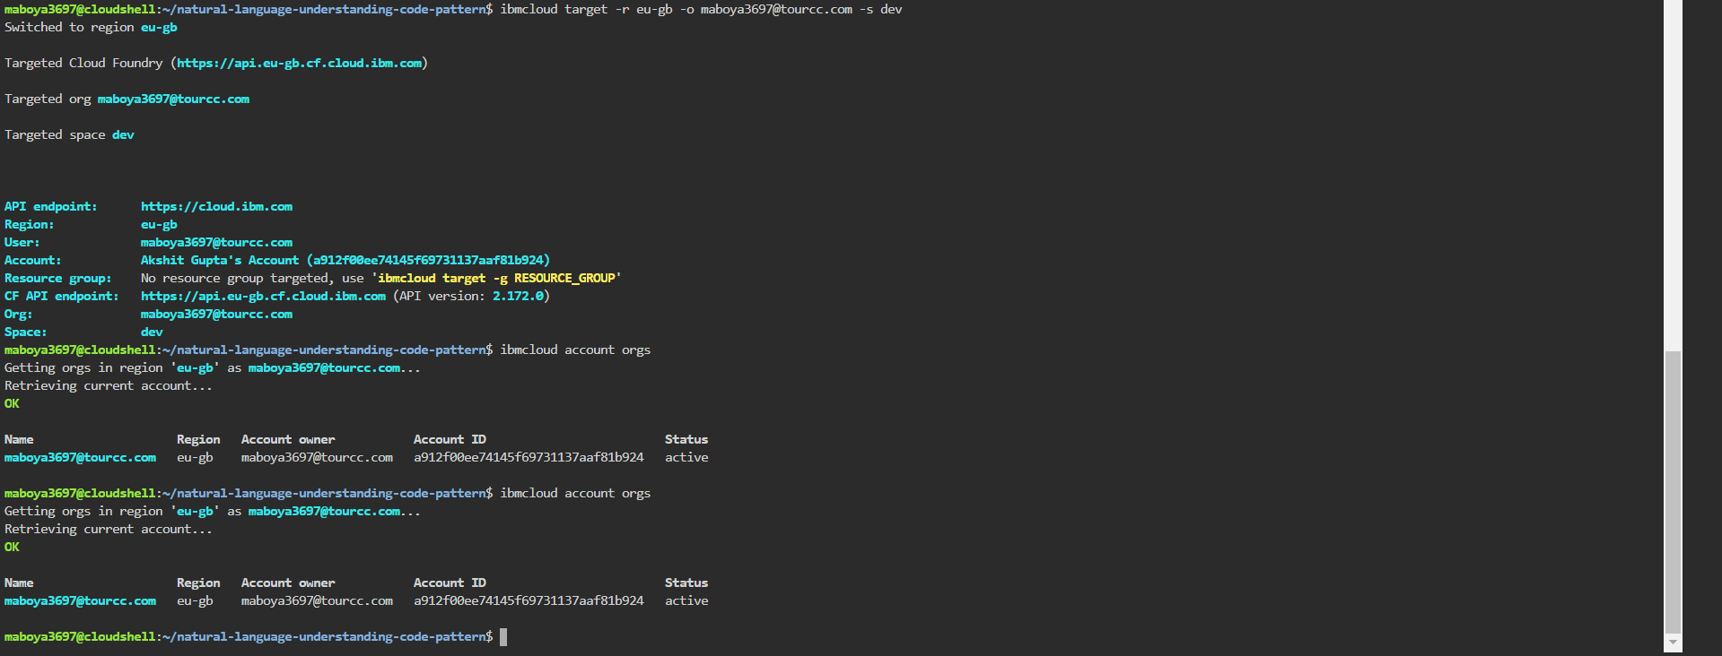

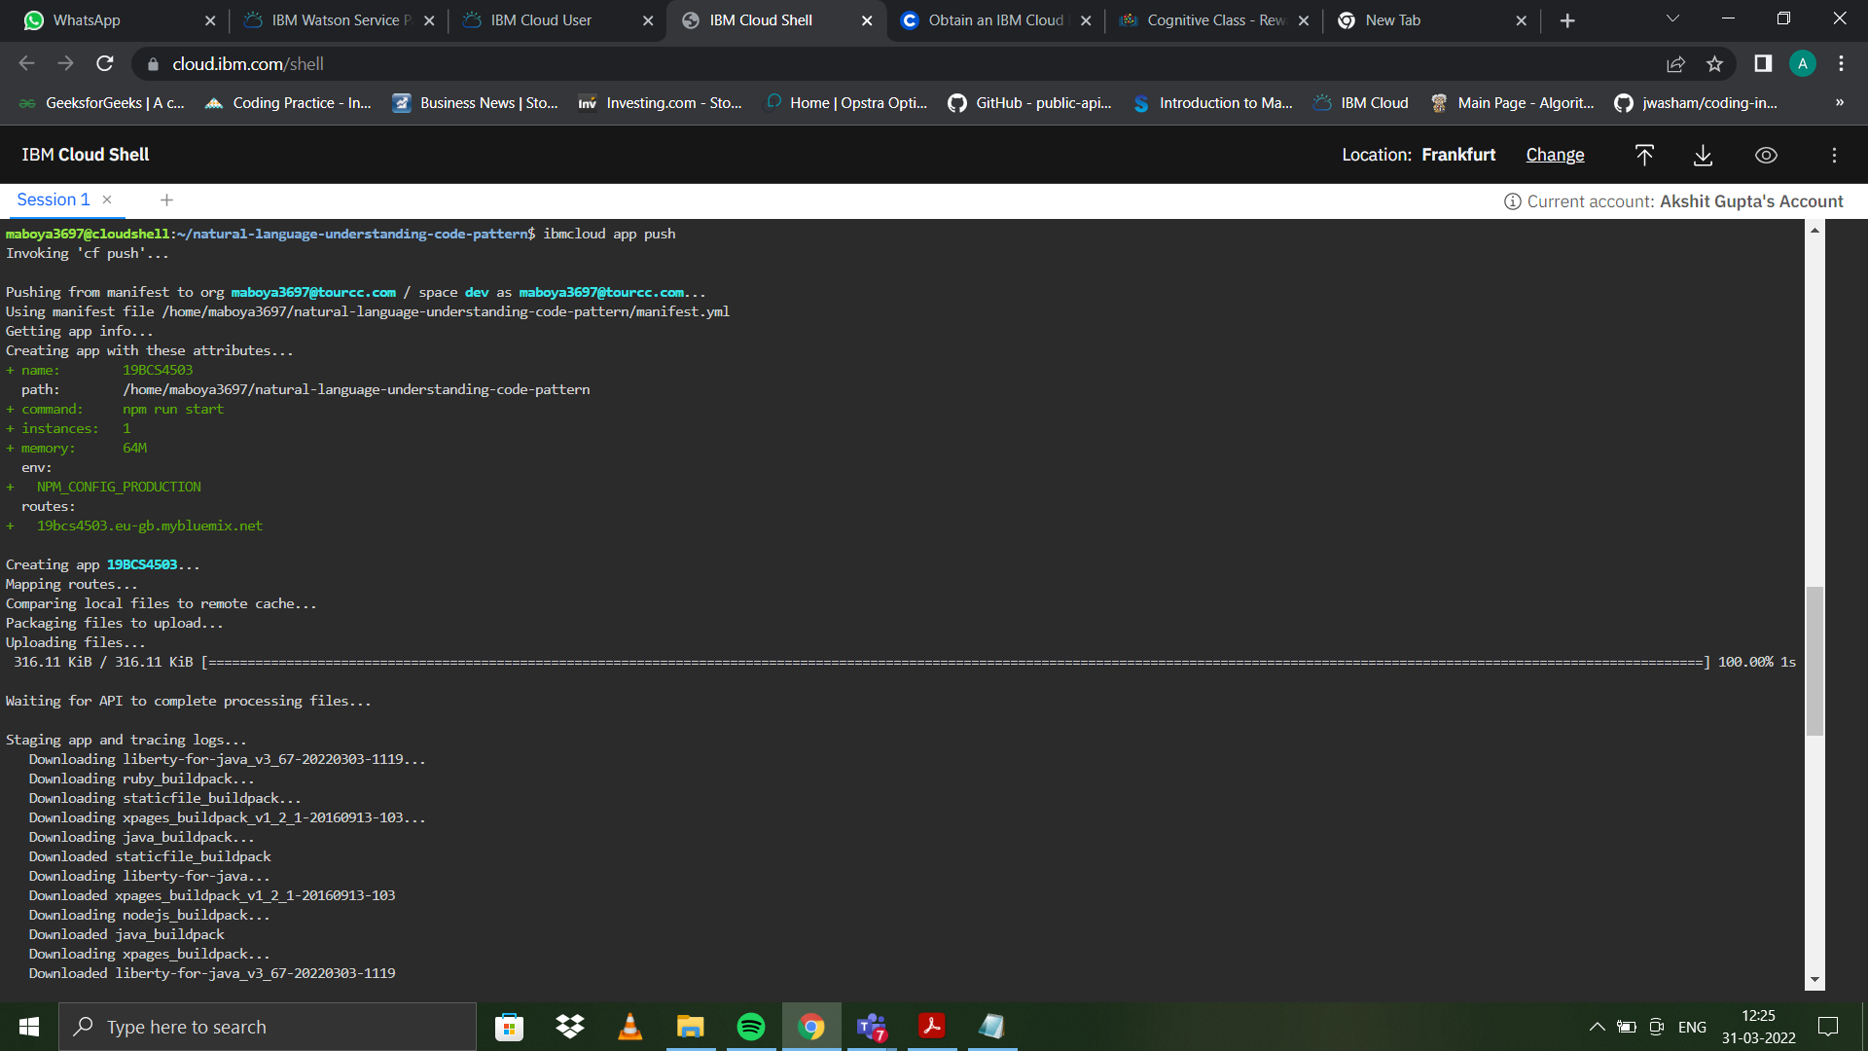

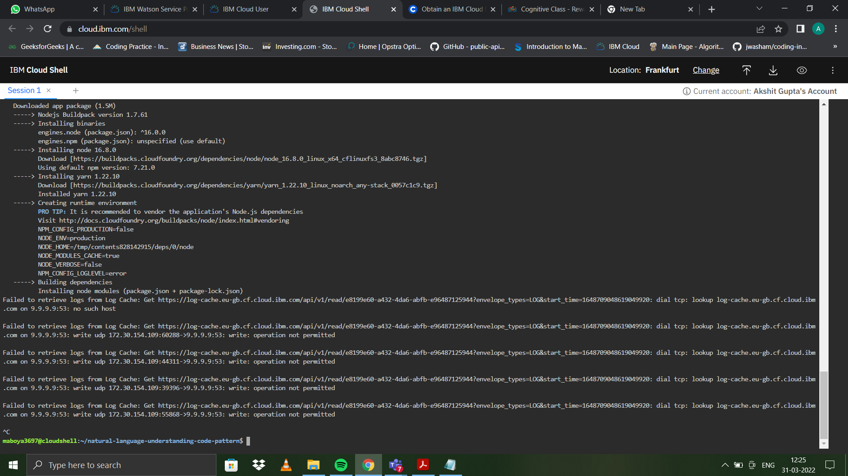

**3. Output: Image of sample output to be attached here**

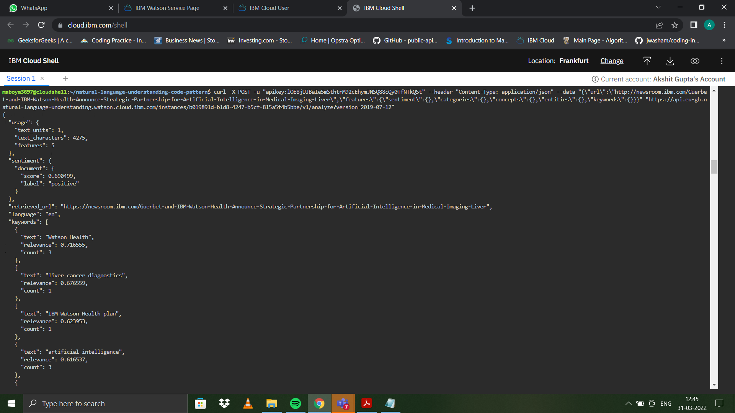

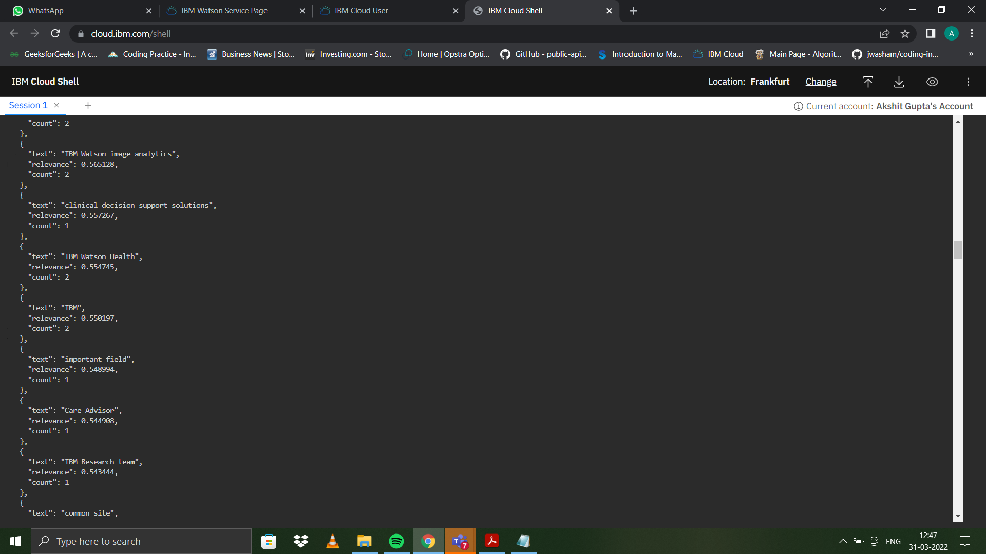

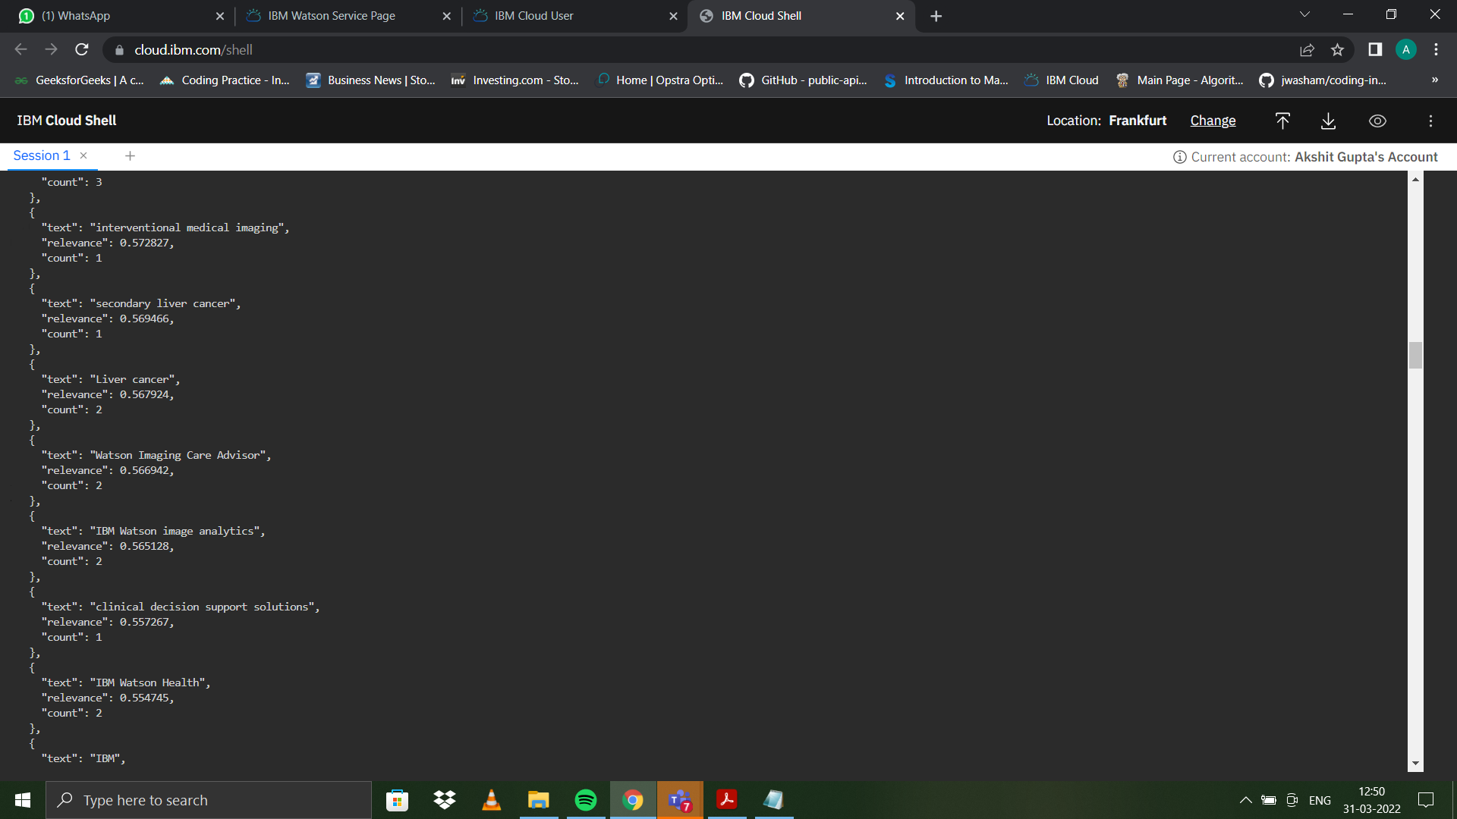

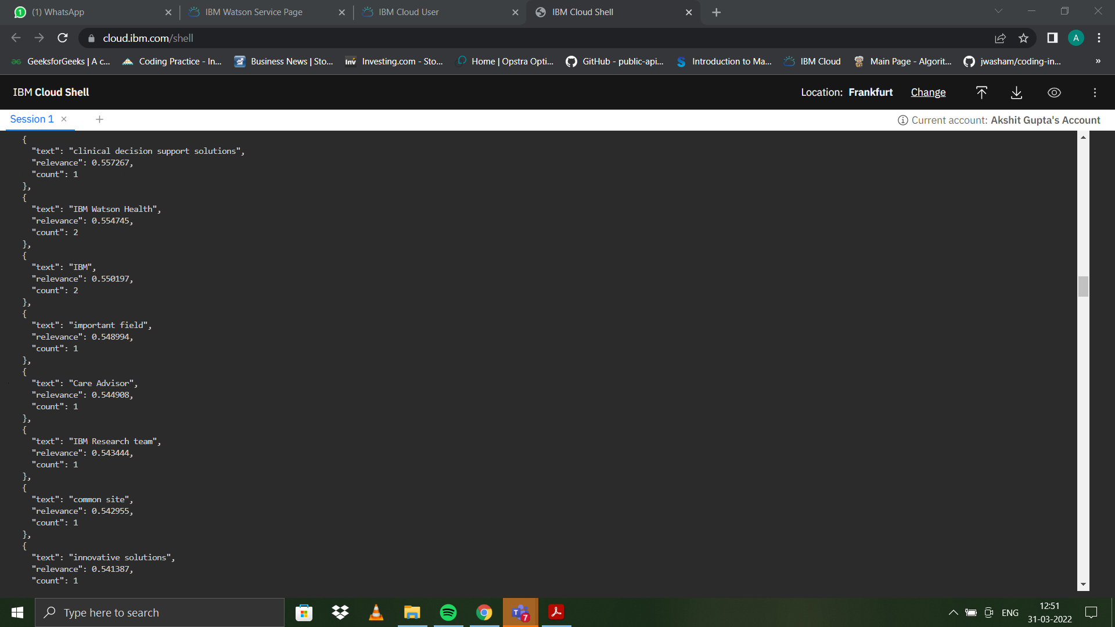

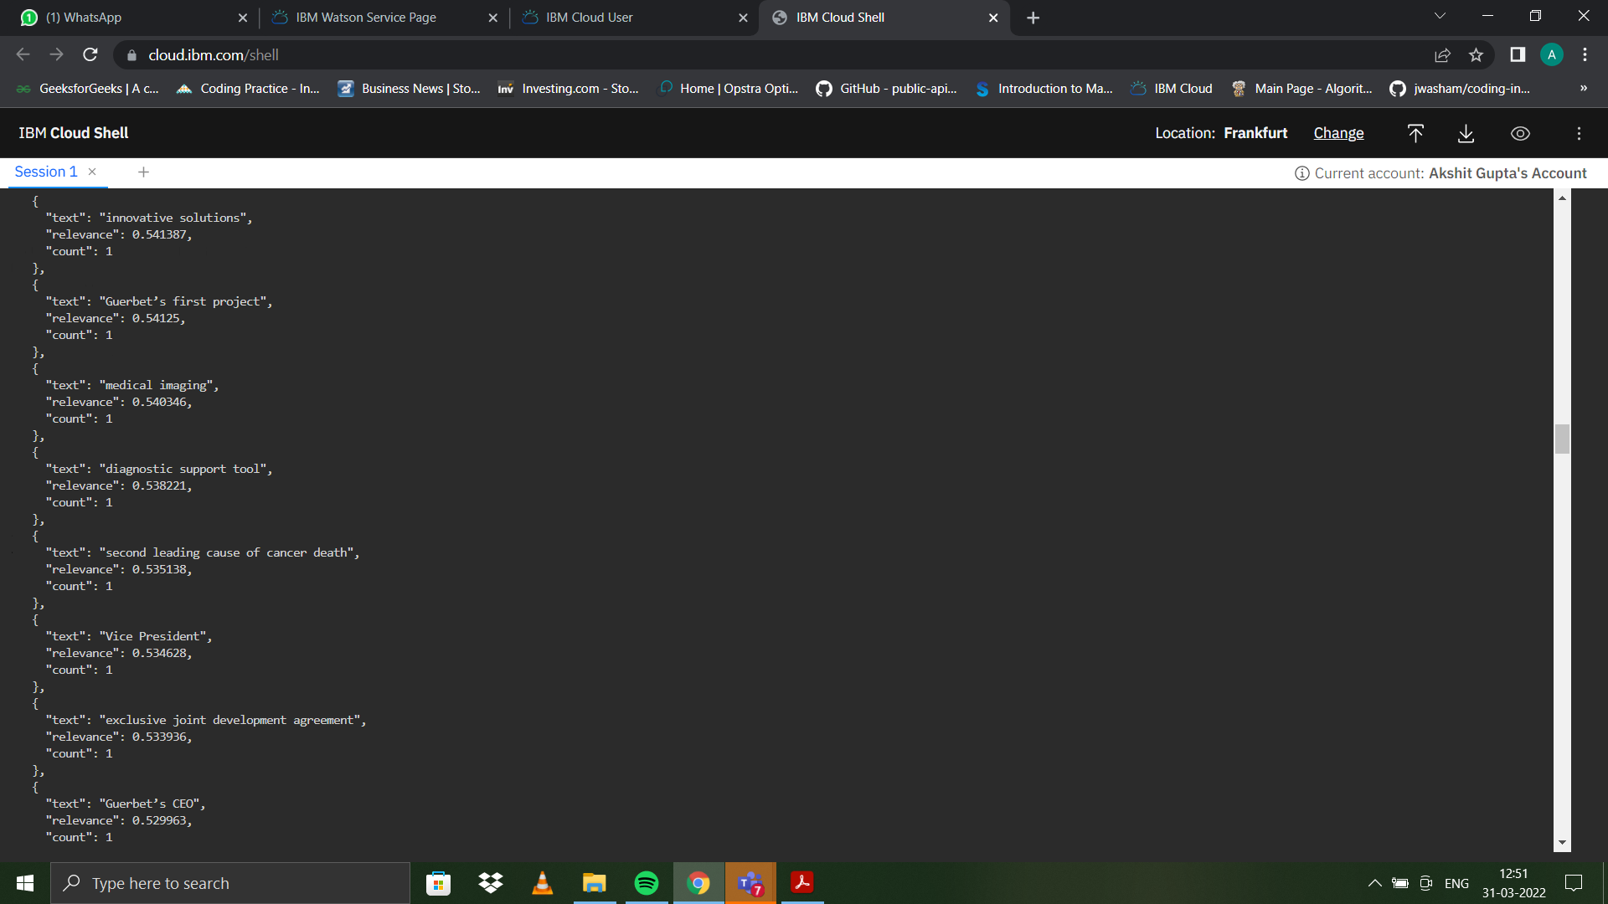

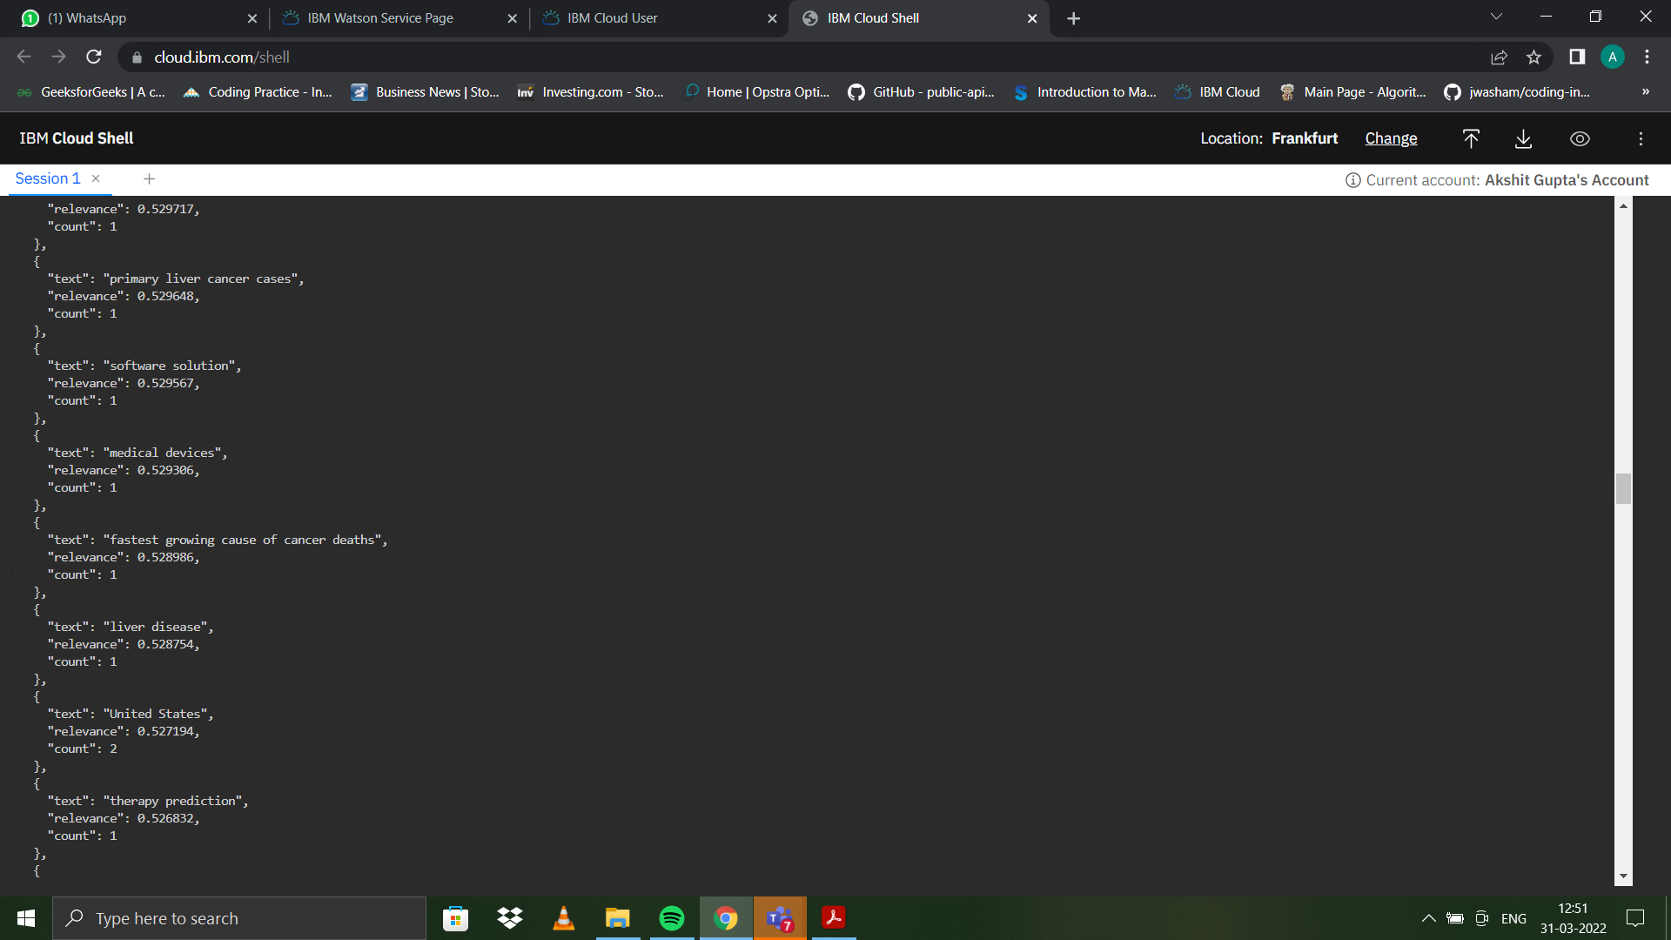

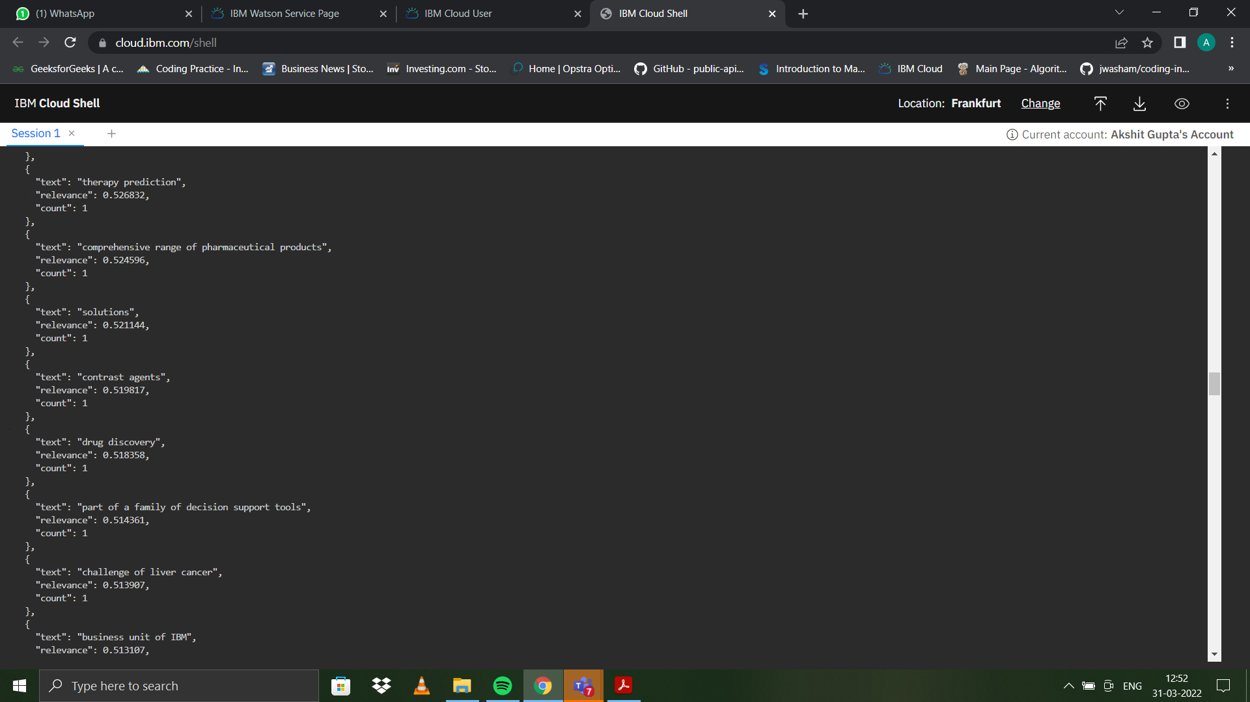

**Learning outcomes (What I have learnt):**

**1.** Use of cli in IBM Cloud to deploy apps.

**2.** Learnt to deploy Natural Language Understanding App using IBM Cloud.

**Evaluation Grid (To be created as per the SOP and Assessment guidelines by the faculty):**

|  |  |  |  |
| --- | --- | --- | --- |
| Sr. No. | Parameters | Marks Obtained | Maximum Marks |
| 1. |  |  |  |
| 2. |  |  |  |
| 3. |  |  |  |
|  |  |  |  |