**EXPERIMENT TITLE-2**

|  |
| --- |
| **To implement the linear regression models on the given data set. Also, calculate the errors.**  **A. Simple linear regression**  **B. Multi linear Regression** |

**Student Name:** Akshit Gupta **UID:** 19BCS4503

**Branch:** CSE IOT **Section/Group:** 1/A

**Semester:** 6  **Date of Performance:** 24/02/2022

**Subject Name:** ML Lab  **Subject Code:** CSD 386

**1 Aim/Overview of the practical:** To understand the Linear Regression model, and to implement the linear regression models on the given data set. Also, calculate the errors.

A. Simple linear regression

B. Multi linear Regression

**2. Task to be done:**

Develop a python code to implement Linear Regression Model on dataset given in the statement.

**3. Code:**

* **Linear Regression:**

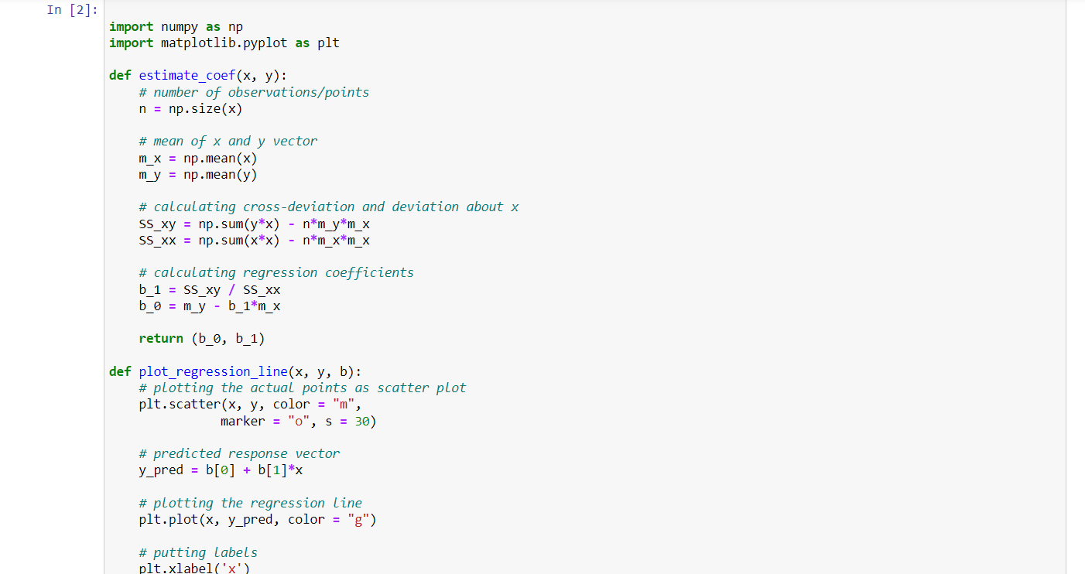

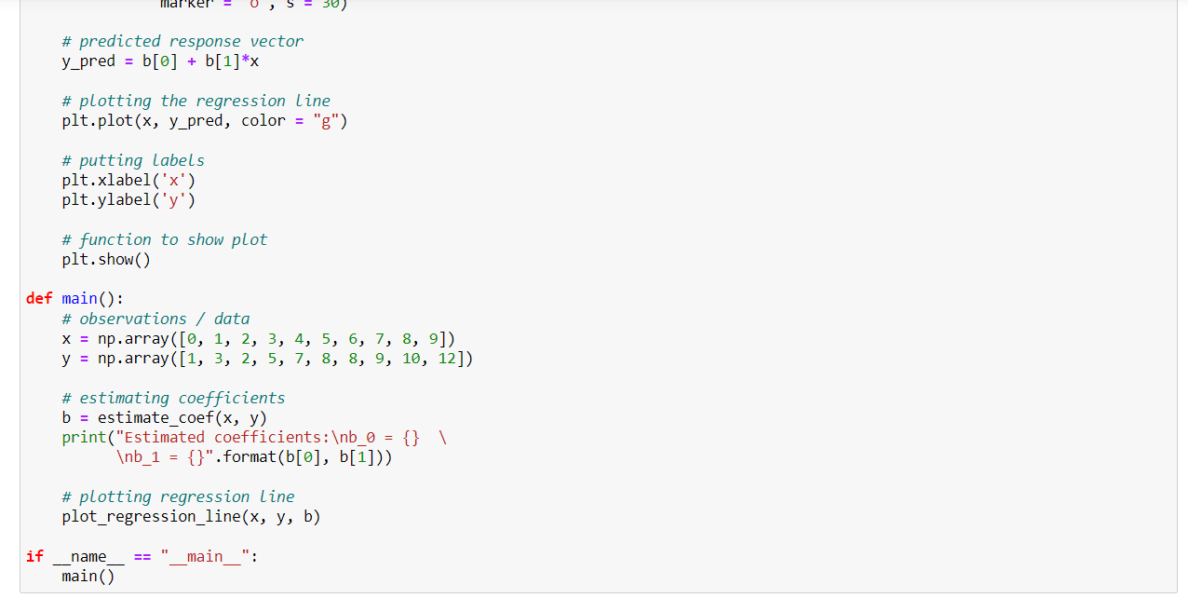

* **Multi Linear Regression:**

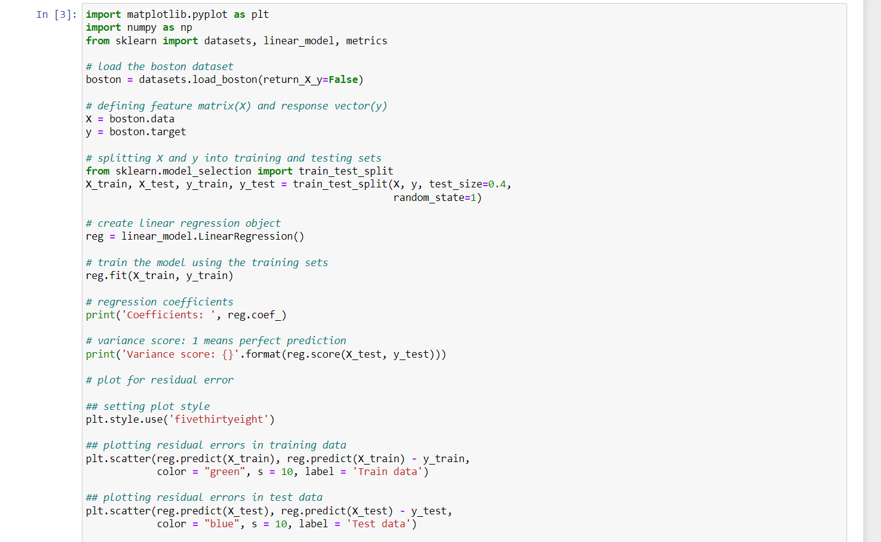

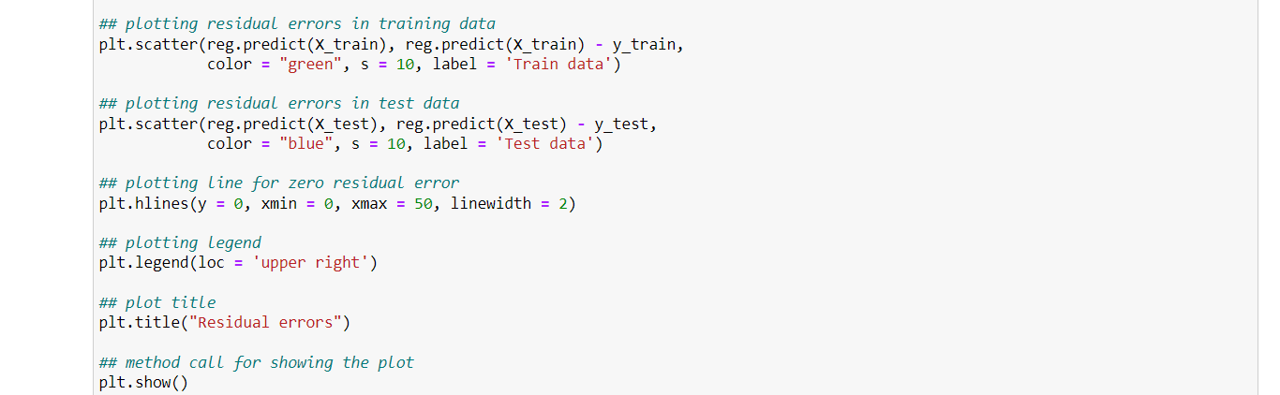

**4. Results:**

* **Linear Regression:**

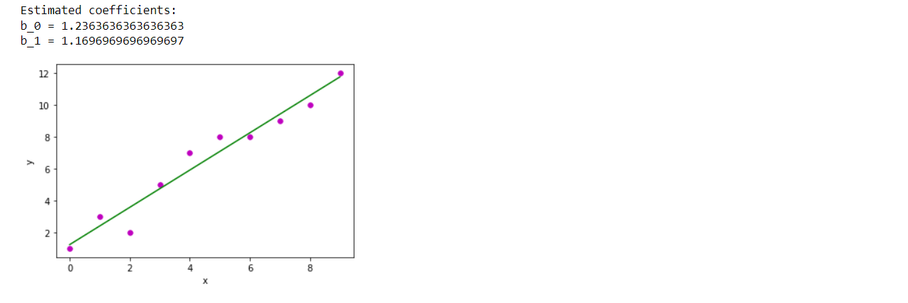

* **Multi Linear Regression:**

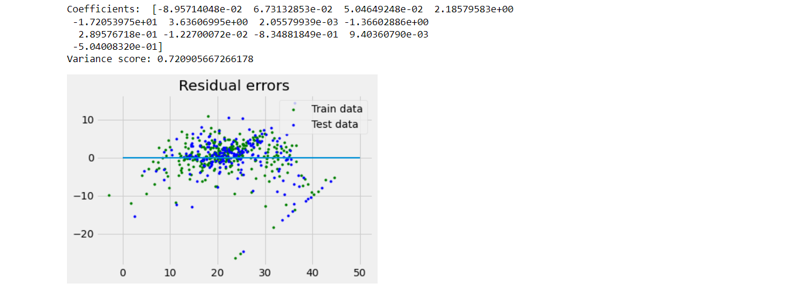

**5. Graphs (If Any): Image /Soft copy of graph paper to be attached here**

NA

**Learning outcomes (What I have learnt):**

1. Learnt about NumPy and pandas.
2. Learnt about Matplotlib.
3. Learnt about Linear Regression.
4. Learnt about Multi Linear Regression.

**Evaluation Grid (To be created as per the SOP and Assessment guidelines by the faculty):**

|  |  |  |  |
| --- | --- | --- | --- |
| Sr. No. | Parameters | Marks Obtained | Maximum Marks |
| 1. |  |  |  |
| 2. |  |  |  |
| 3. |  |  |  |
|  |  |  |  |