**Experiment 6. To implement SVM Technique using Python programming Language.**

**Student Name:** Akshit Gupta **UID:** 19BCS4503

**Branch:** CSE-IOT **Section/Group:** 1-A

**Semester:** 6th **Date of Performance:** 03/04/2022

**Subject Name:** ML Lab **Subject Code:** CSD-386

1. **Aim/Overview of the practical:** To implement SVM Technique using Python programming Language

**2. Task to be done:**

* Install the prerequisite Python
* Load the dataset.
* Apply **SVM** **Technique**
* Analyse results/output.

**3. Steps for experiment/practical:**

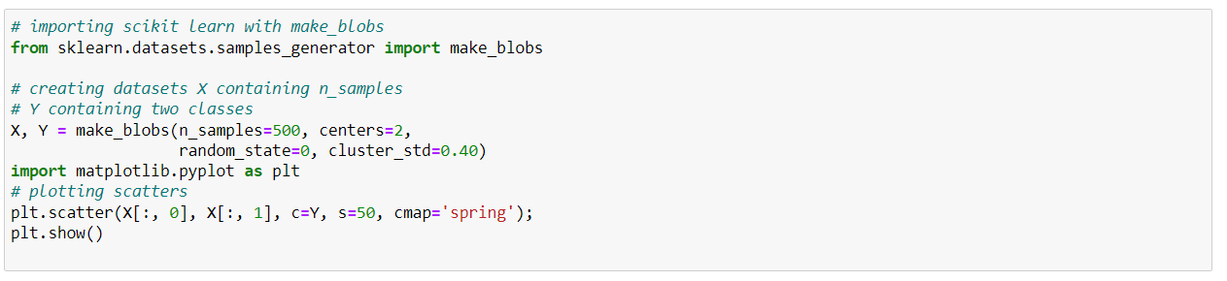

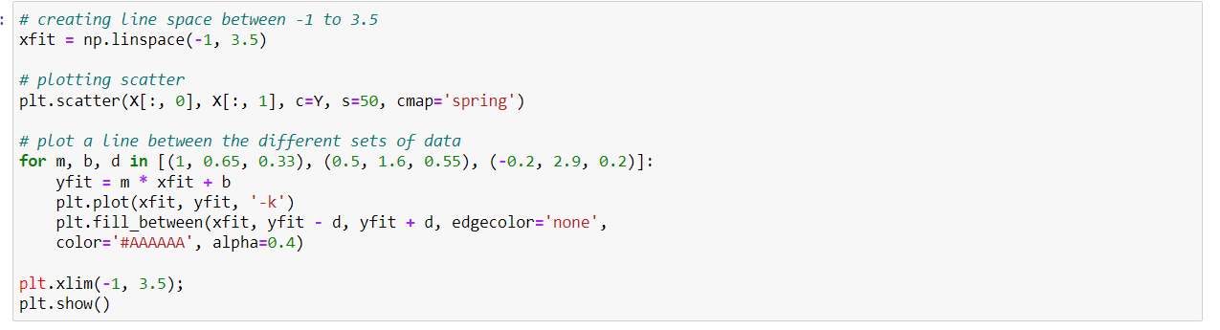

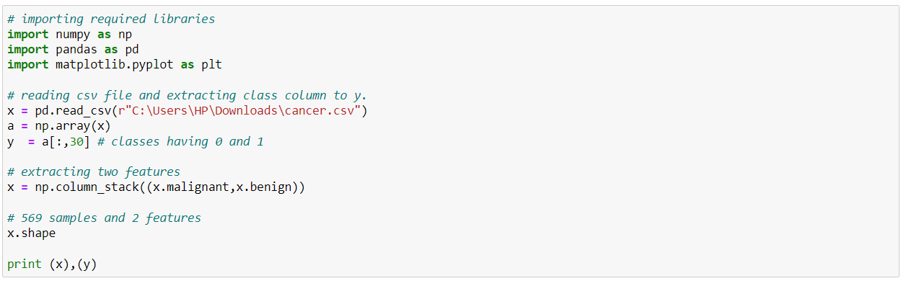

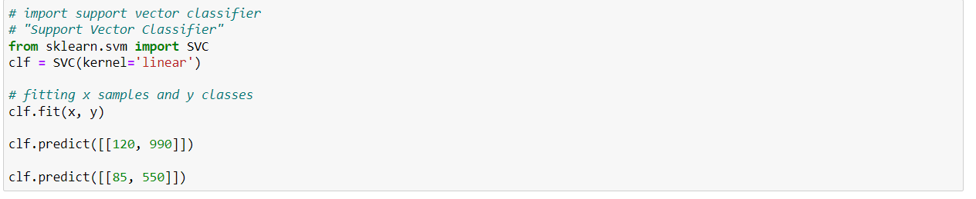

**5. Result/Output/Writing Summary:**

[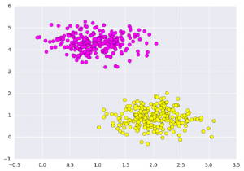](https://media.geeksforgeeks.org/wp-content/uploads/g22.png)

[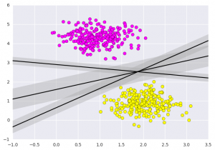](https://media.geeksforgeeks.org/wp-content/uploads/g31.png)

[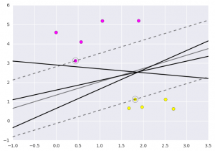](https://media.geeksforgeeks.org/wp-content/uploads/g11.png)

**Learning outcomes (What I have learnt):**

1. Learnt to implement support vector machine algorithm.