**Experiment 8.** To implement Decision tree learning Technique using Python programming Language.

**Student Name:** Akshit Gupta **UID:** 19BCS4503

**Branch:** CSE-IOT **Section/Group:** 1-A

**Semester:** 6th **Date of Performance:** 20/04/2022

**Subject Name:** ML Lab **Subject Code:** CSD-386

1. **Aim/Overview of the practical:**

To implement Decision Tree technique.

**2. Task to be done:**

* Install the prerequisite Python
* Load the dataset.
* Apply **Decision tree learning Technique**
* Analyse results/output.

**3. Steps for experiment/practical:**

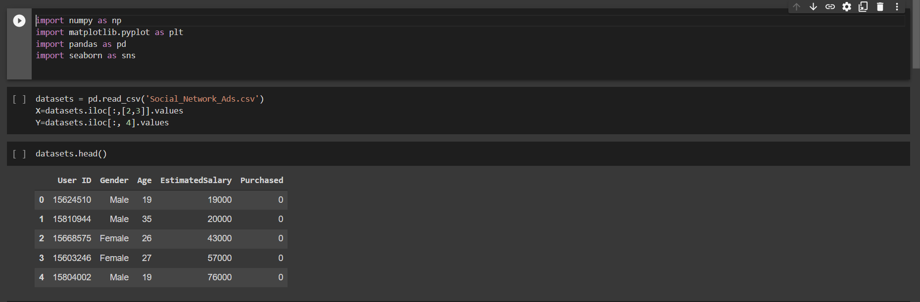

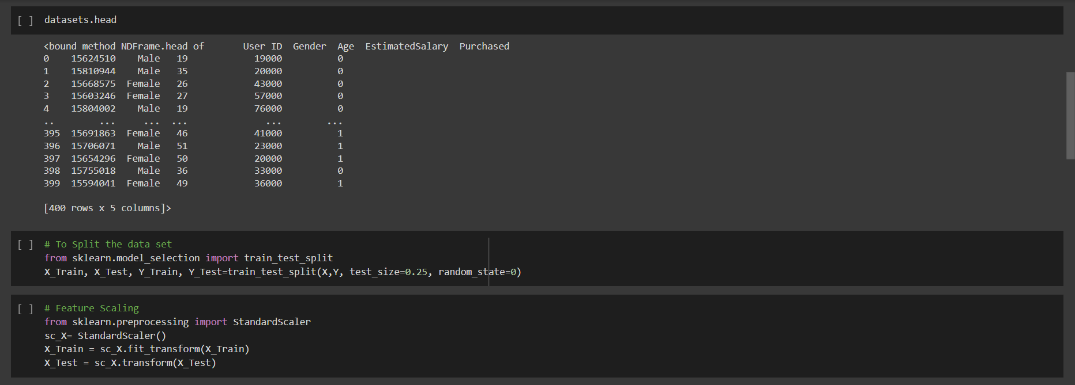

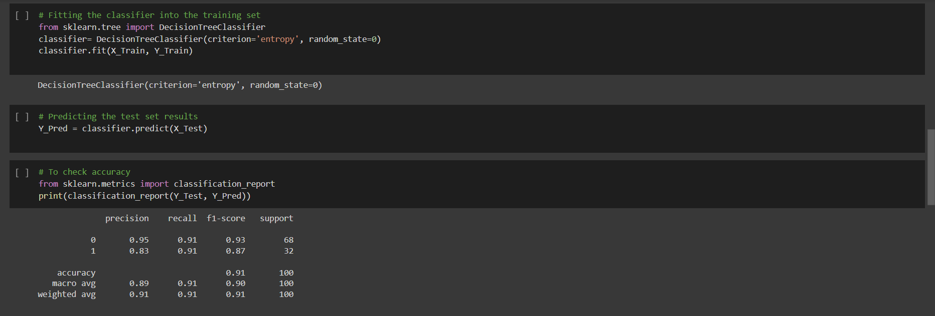

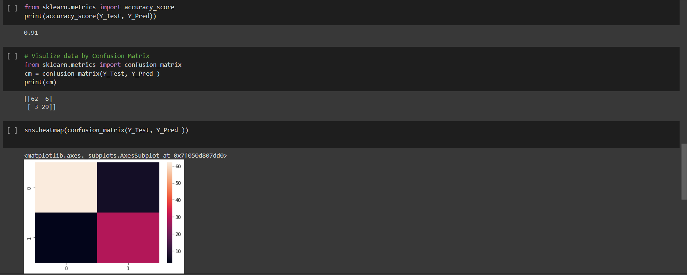

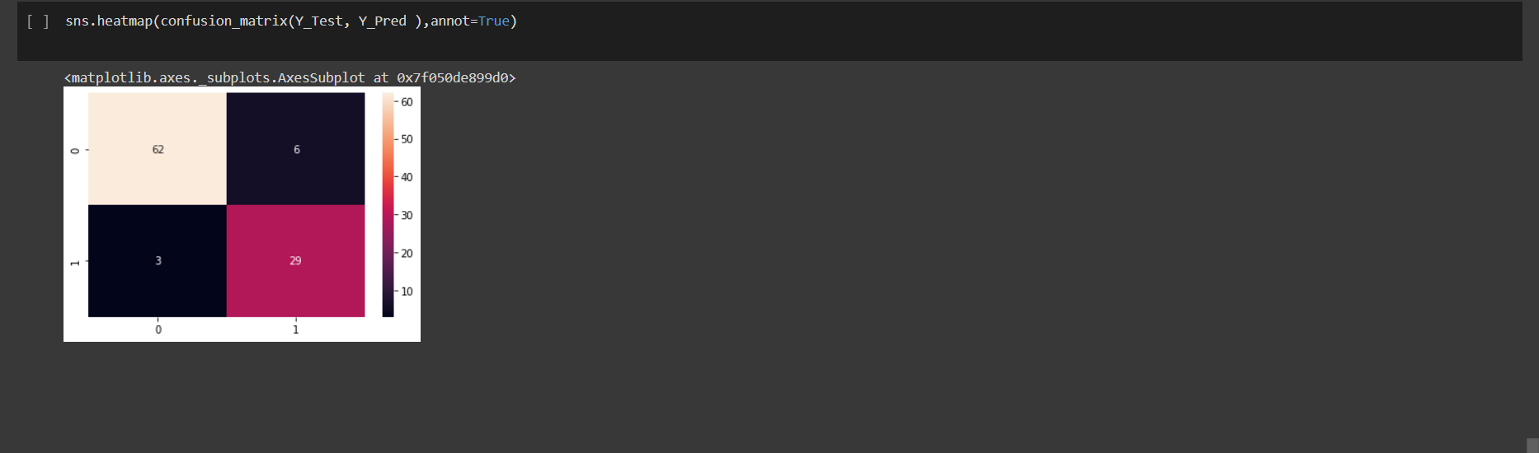

**Learning outcomes (What I have learnt):**

1. Learnt to implement decision tree using python