Experiment-1
. To Implement DNS in Complex Network developed

Student Name: Akshit Gupta UID: 19BCS4503
Branch: CSE-IOT Section/Group: 1-A
Semester: 6th Date of Performance: 07/04/2022
Subject Name: NOS Lab Subject Code: CSP-396

- Task to be done:

To Implement DNS in Complex Network developed

2. Steps for experiment/practical:

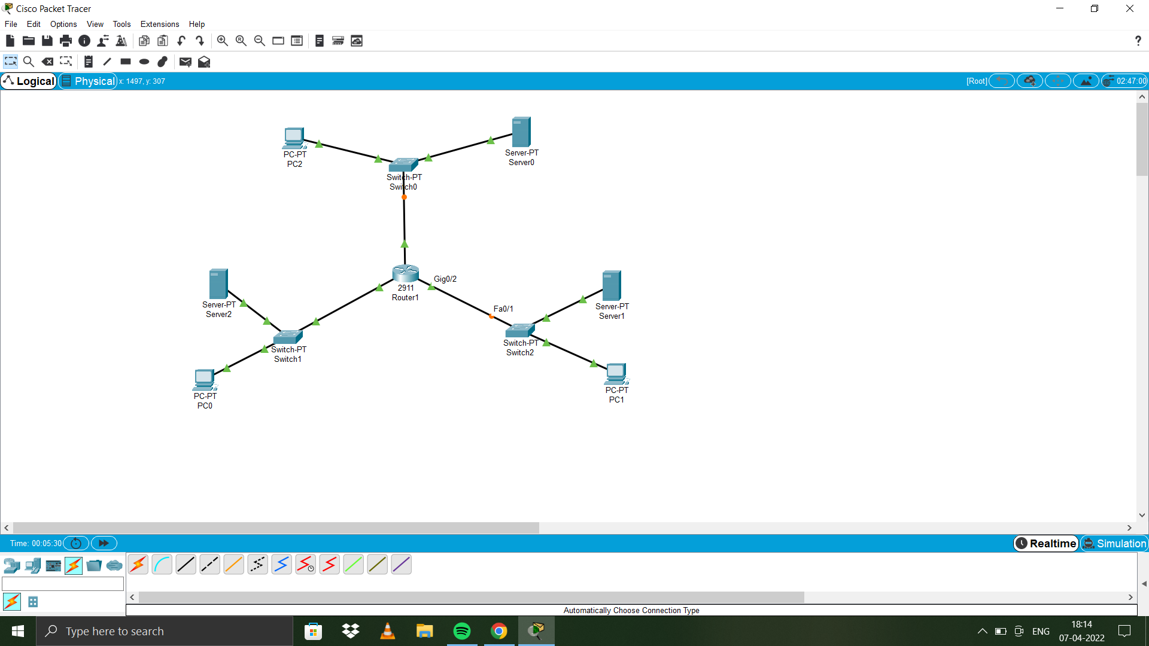
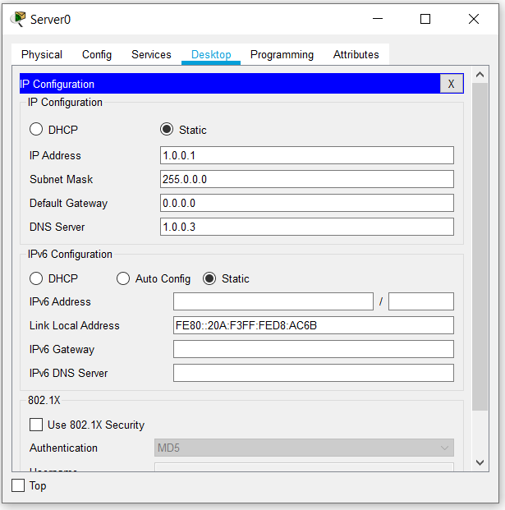

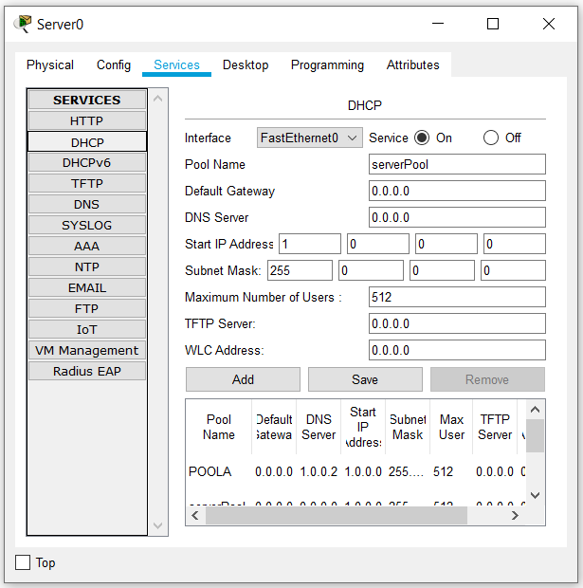
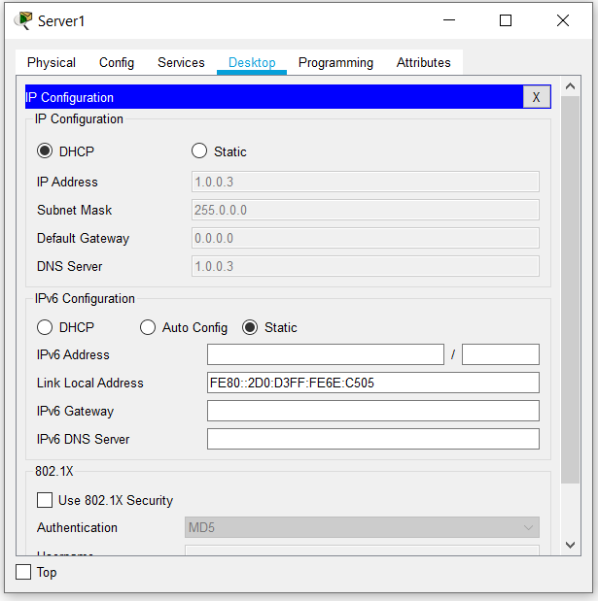
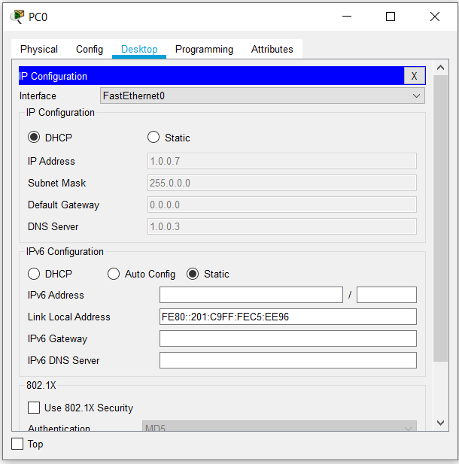
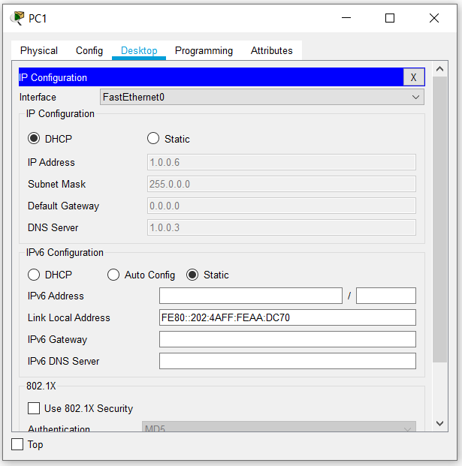

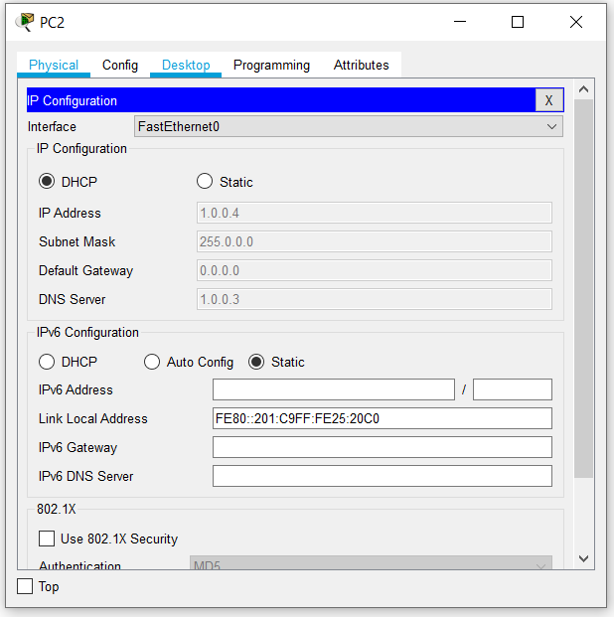

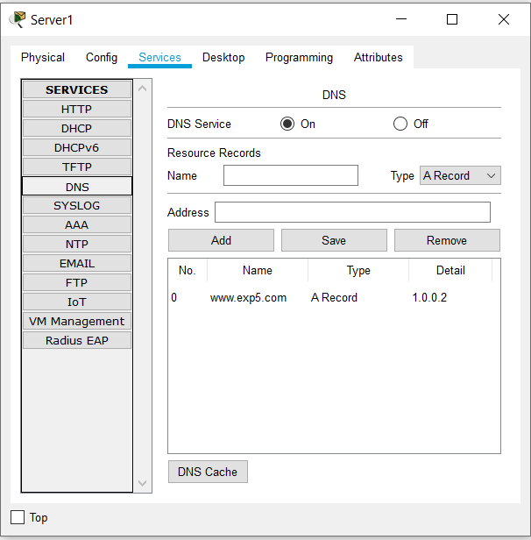

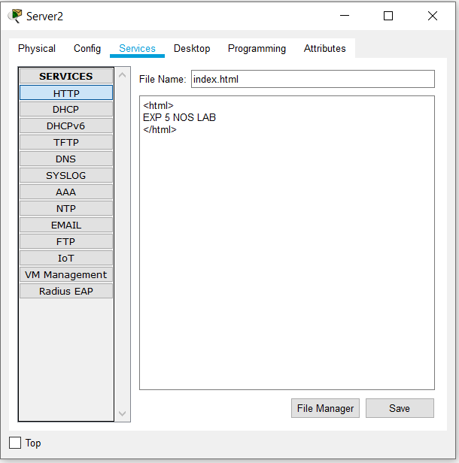

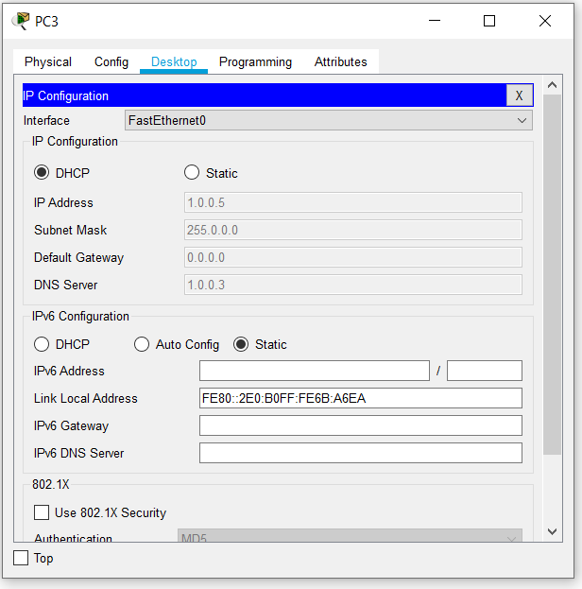

3. Result/Output/Writing Summary:
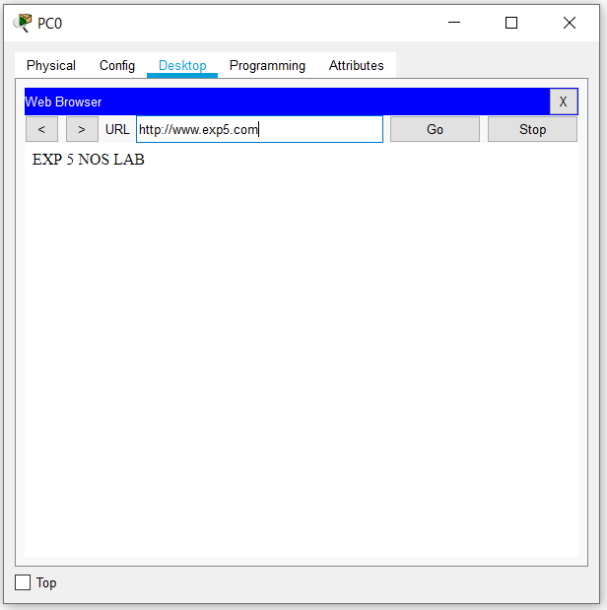
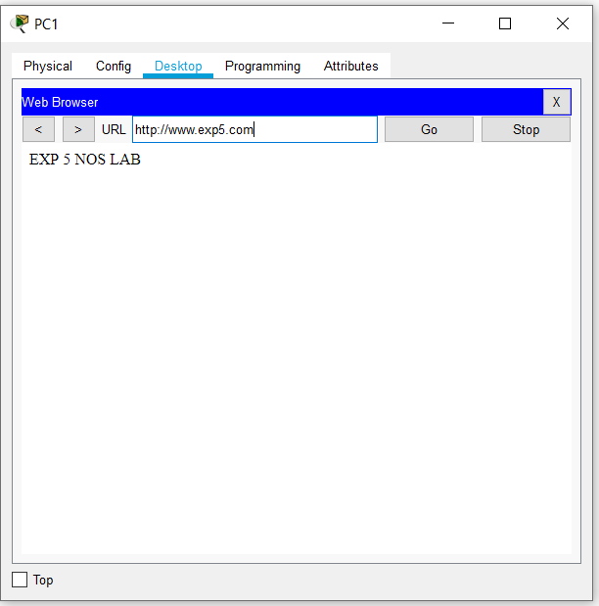
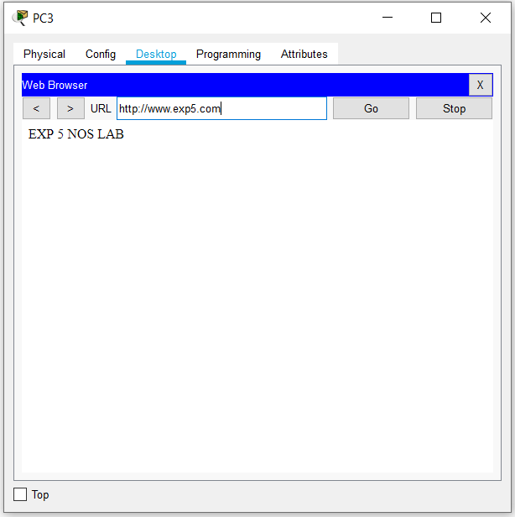
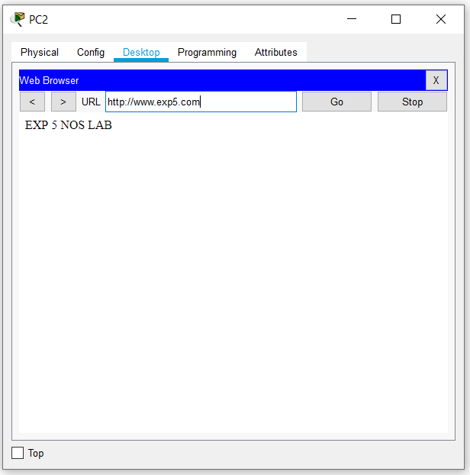
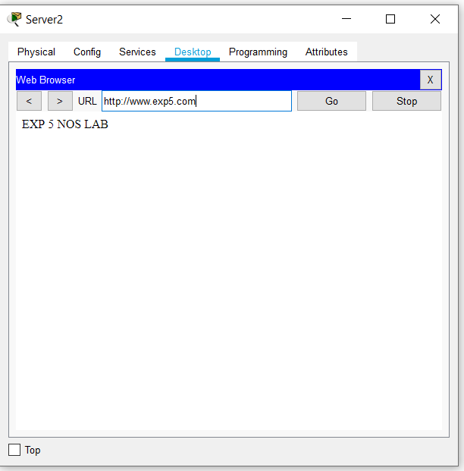

Learning outcomes (What I have learnt):
- DNS in complex network.

Evaluation Grid (To be created as per the SOP and Assessment guidelines by the faculty):
Sr. No. | Parameters | Marks Obtained | Maximum Marks
1.
2.
3.

