Experiment-9
Student Name: Akshit Gupta UID: 19BCS4503
Branch: CSE-IOT Section/Group: 1/A
Semester: 6th Date of Performance:1/05/2022
Subject Name : NOS Lab Subject Code: CSP-396

- Aim/Overview of the practical:

Installation and Exploring basic features of Hyper-V.

- Task to be done:

Install and explore the Hyper V and create a Virtual Machine in the Hyper V.

3. Apparatus(For applied/experimental sciences/materials based labs):

Laptop, Window 10/11 Pro , Hyper V

4. Algorithm/Flowchart (For programming based labs):

NA

5. Steps for experiment/practical:

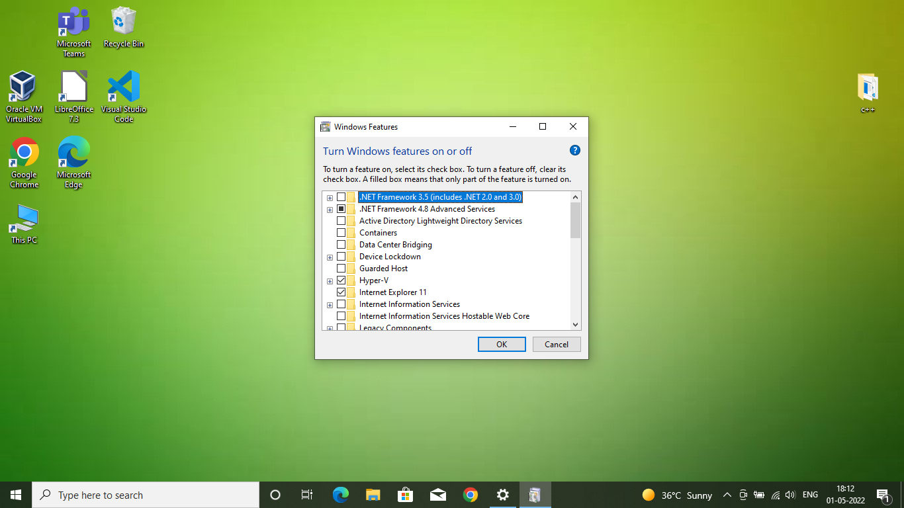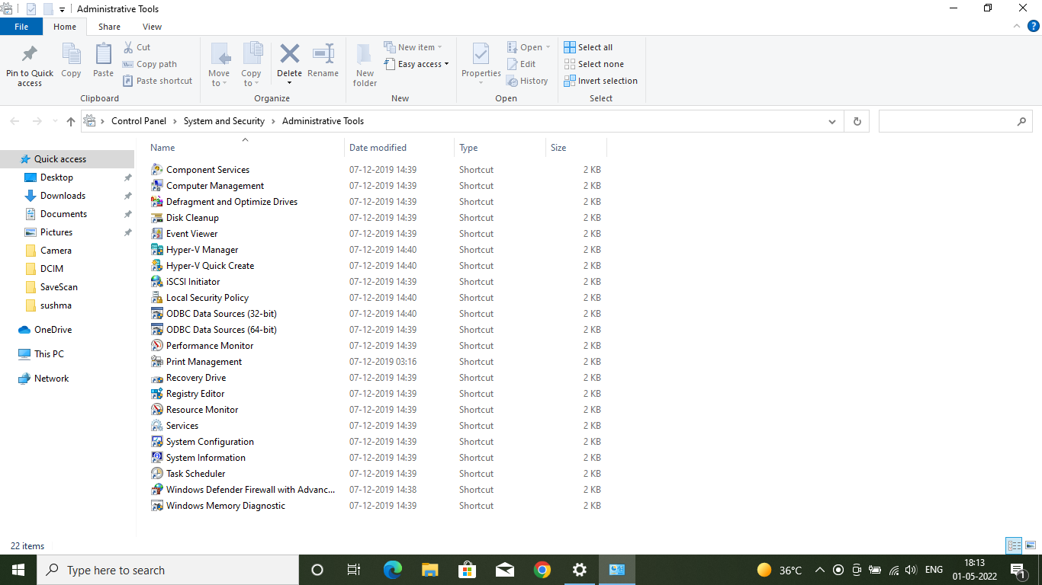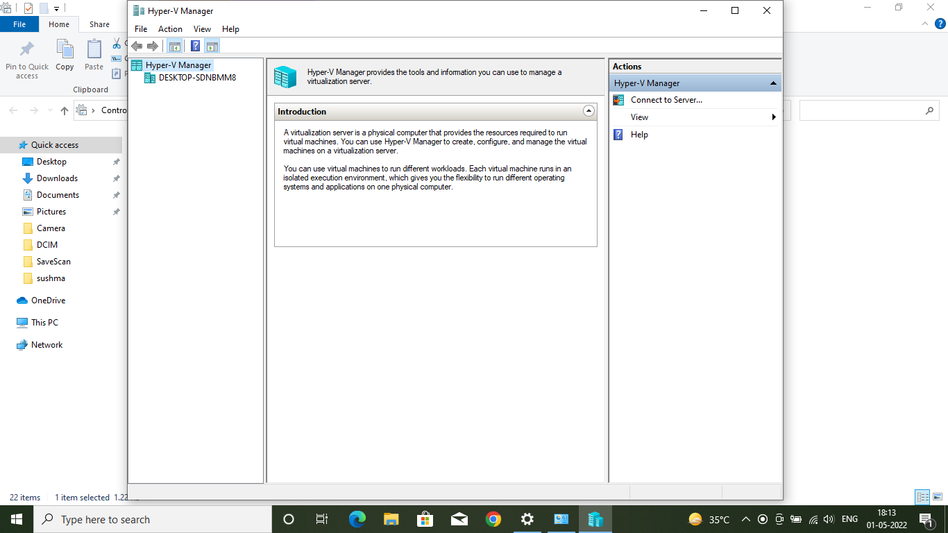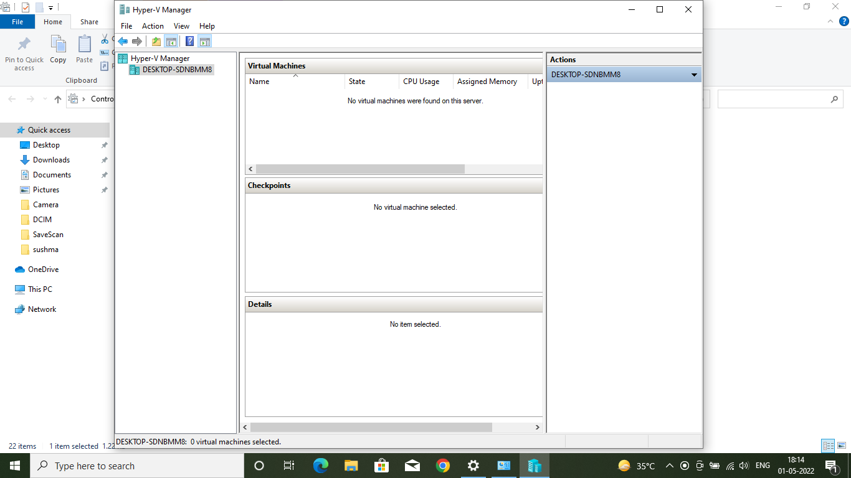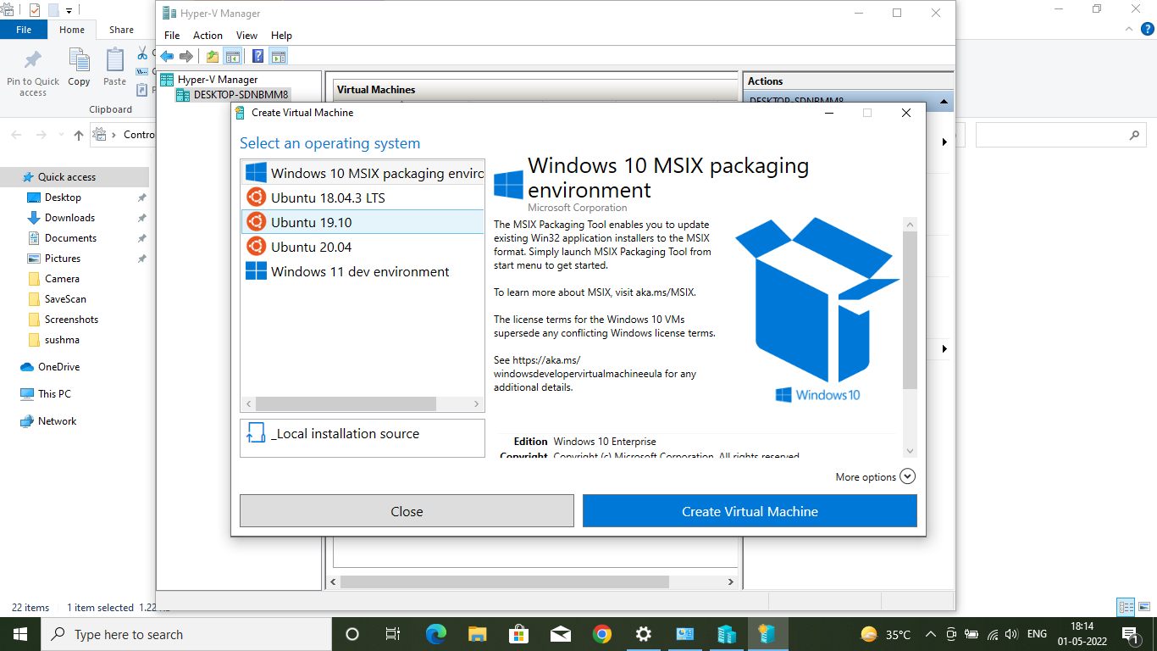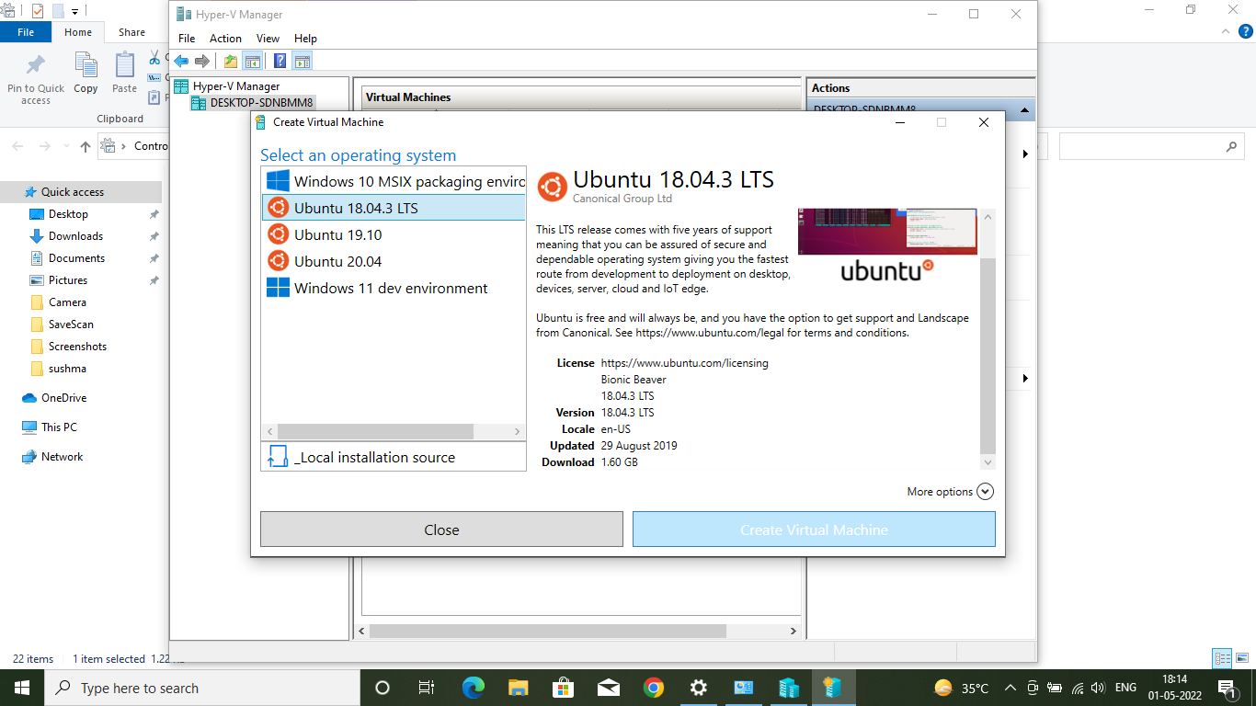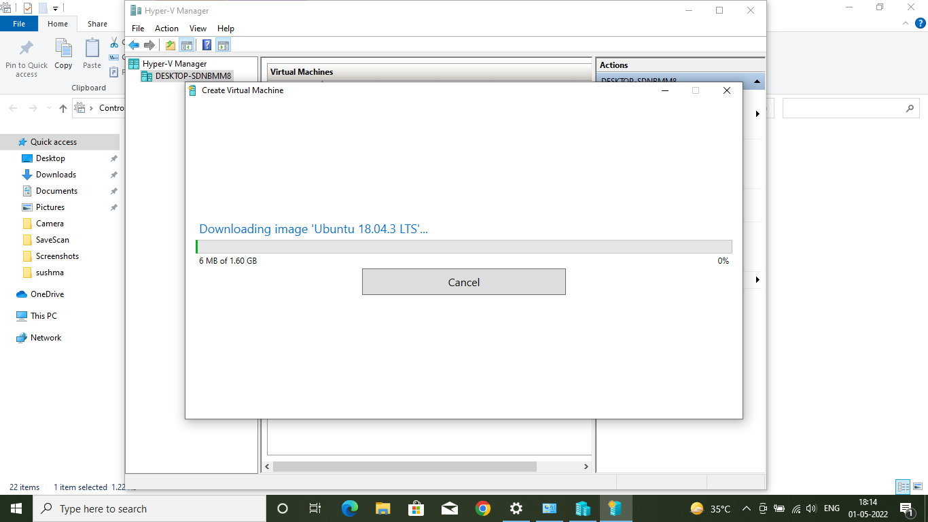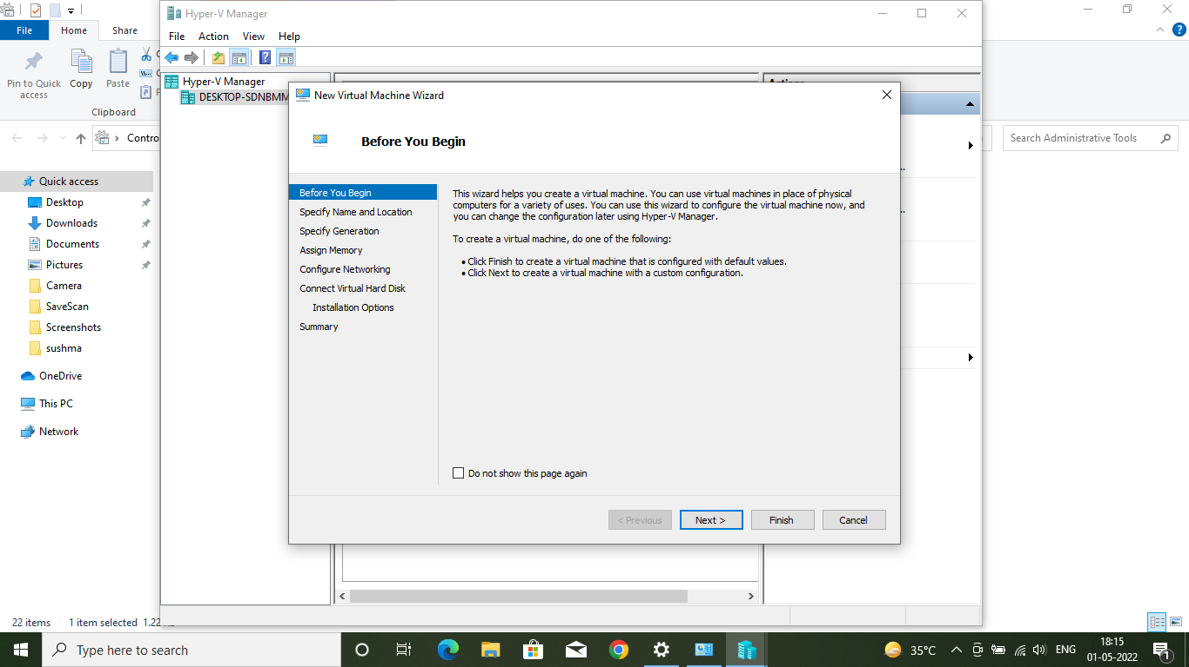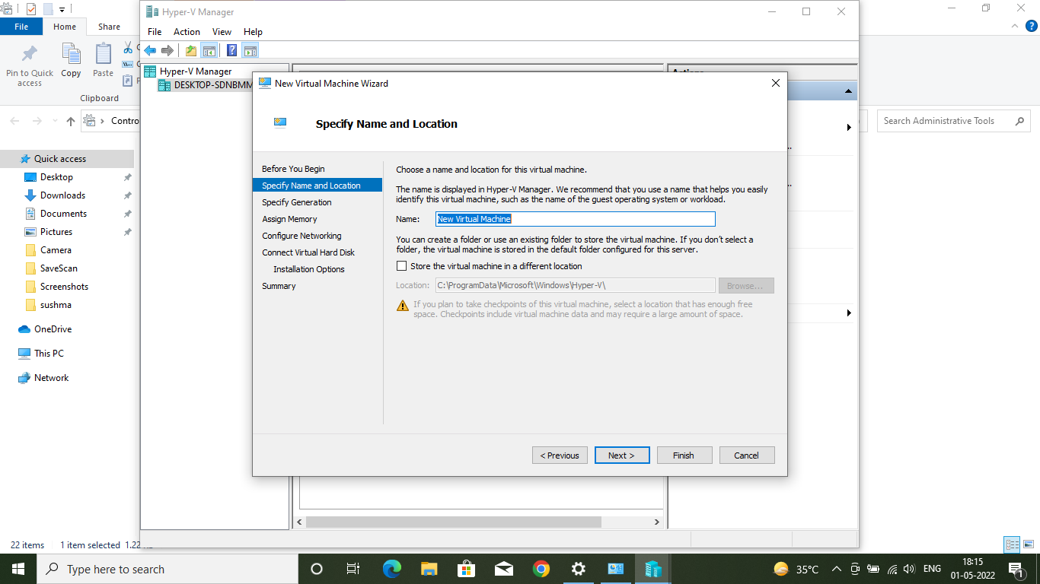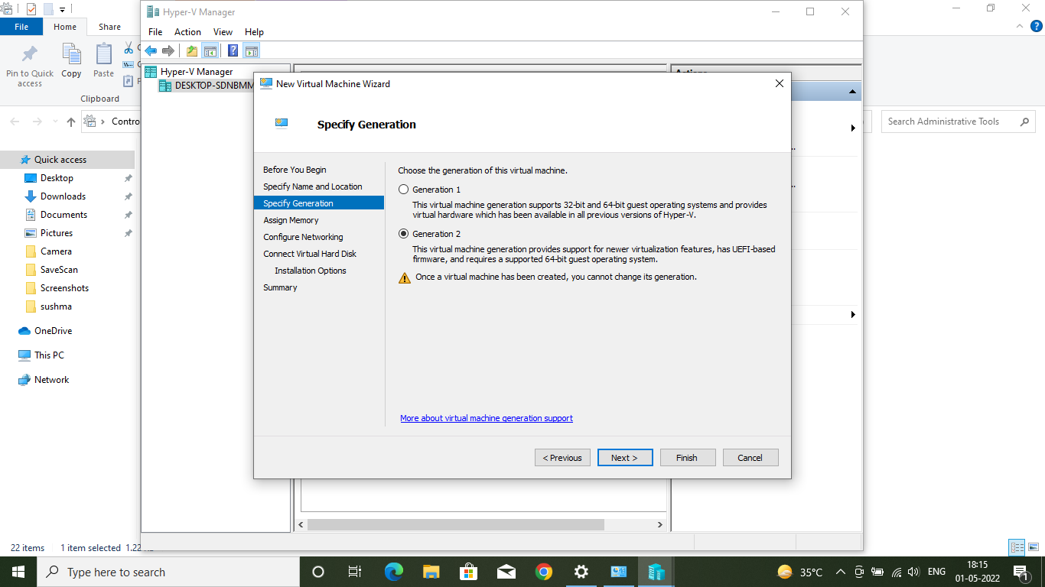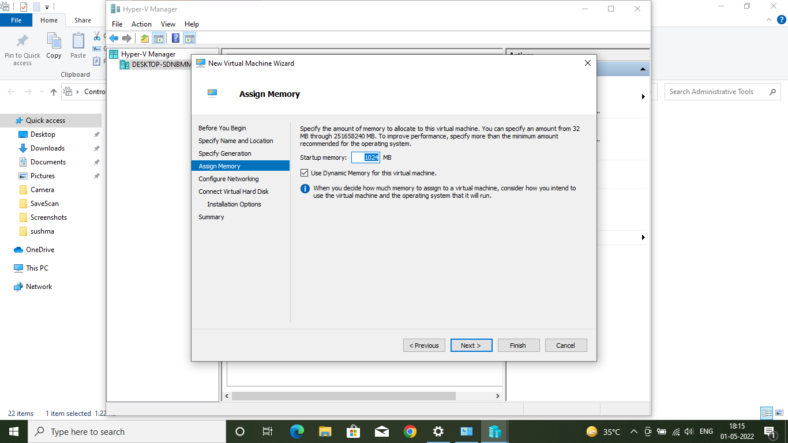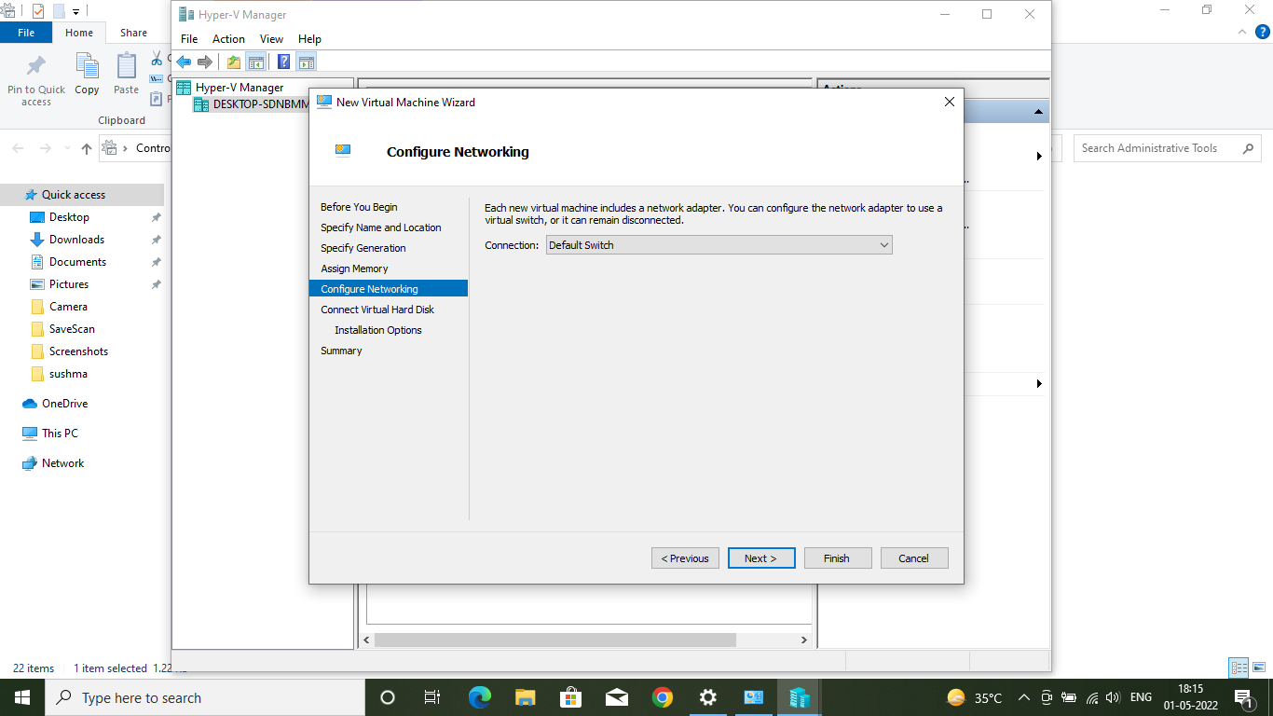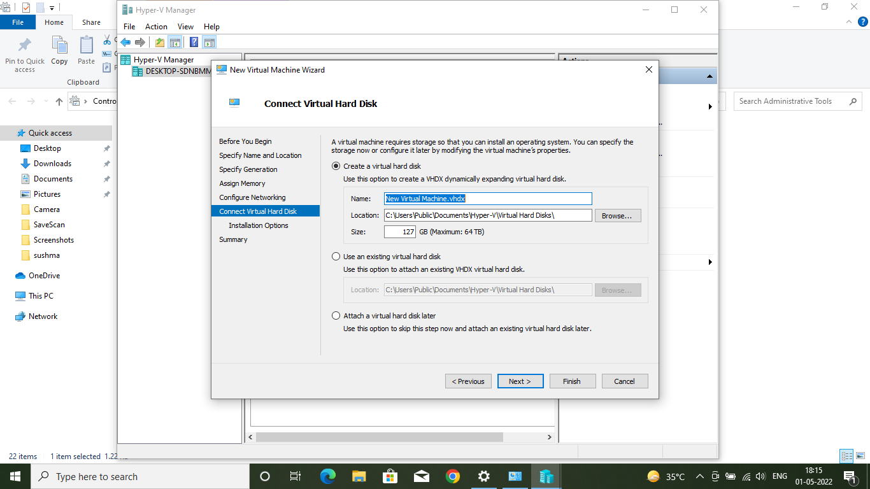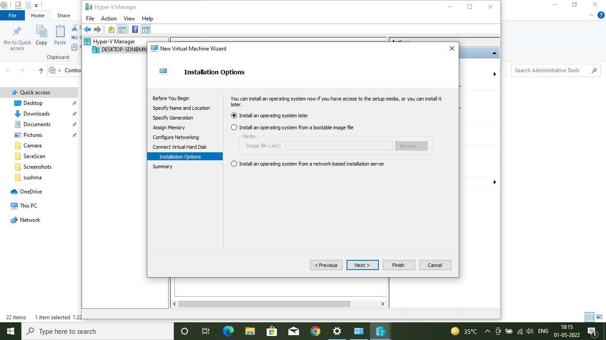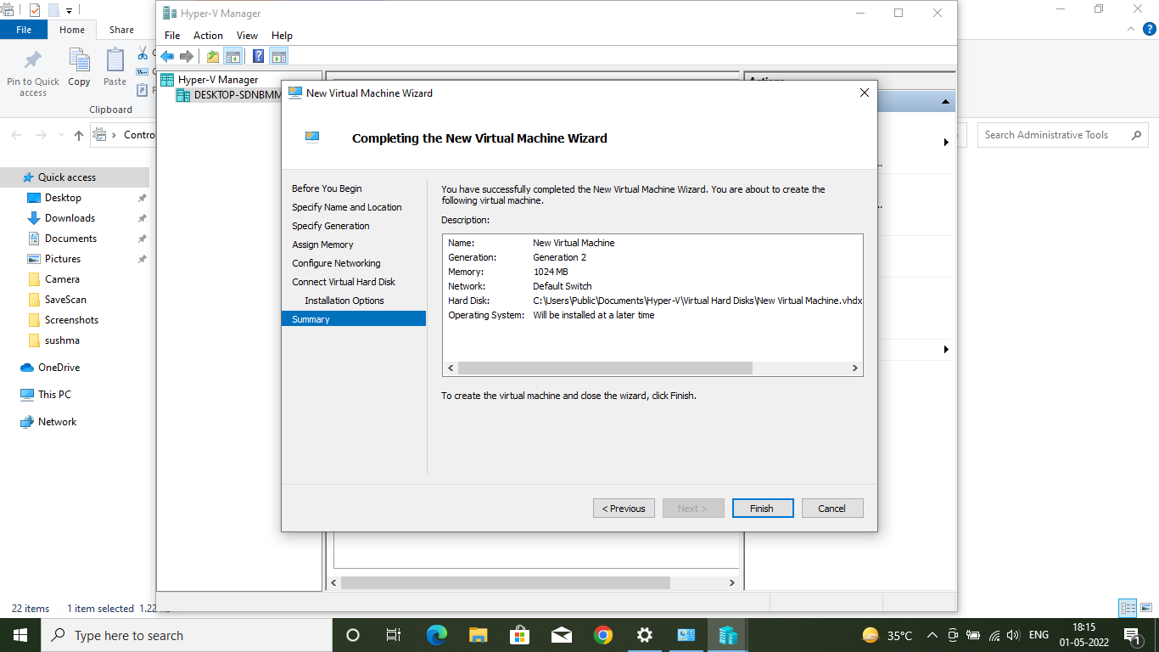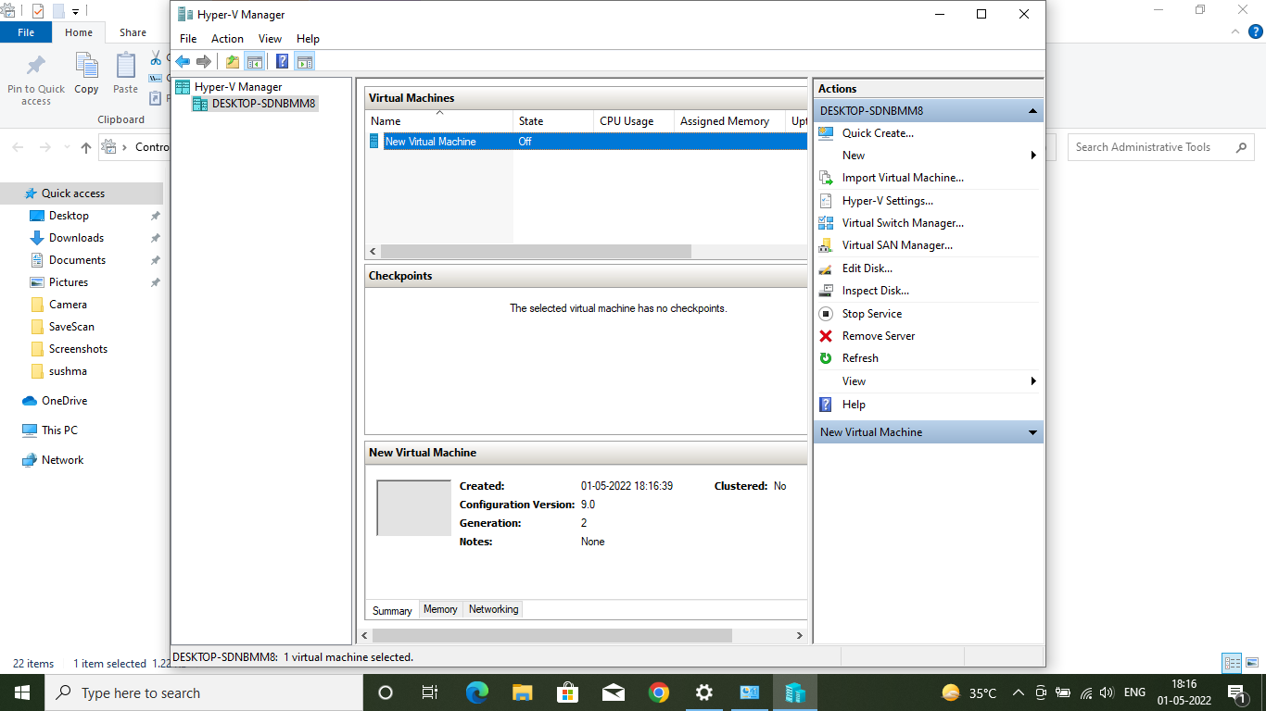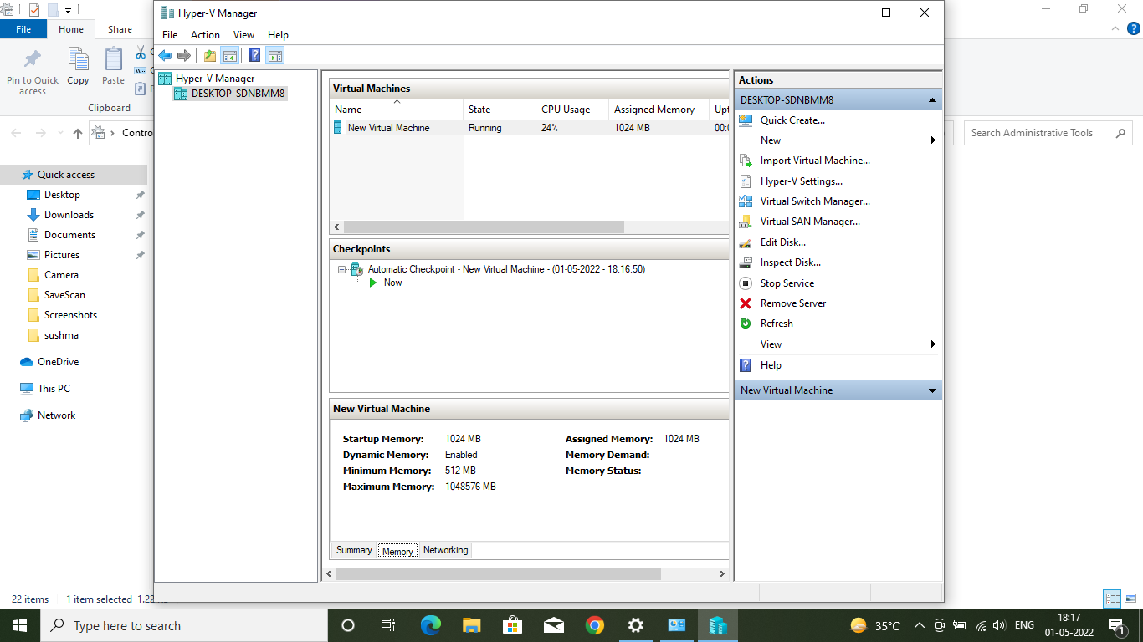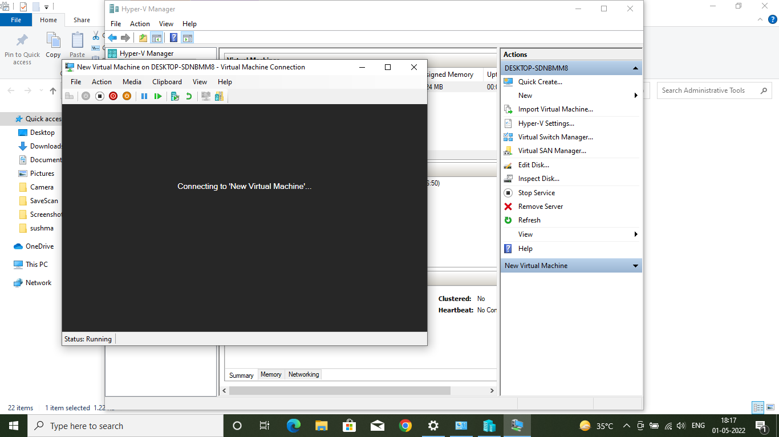

6. Result/Output/Writing Summary:

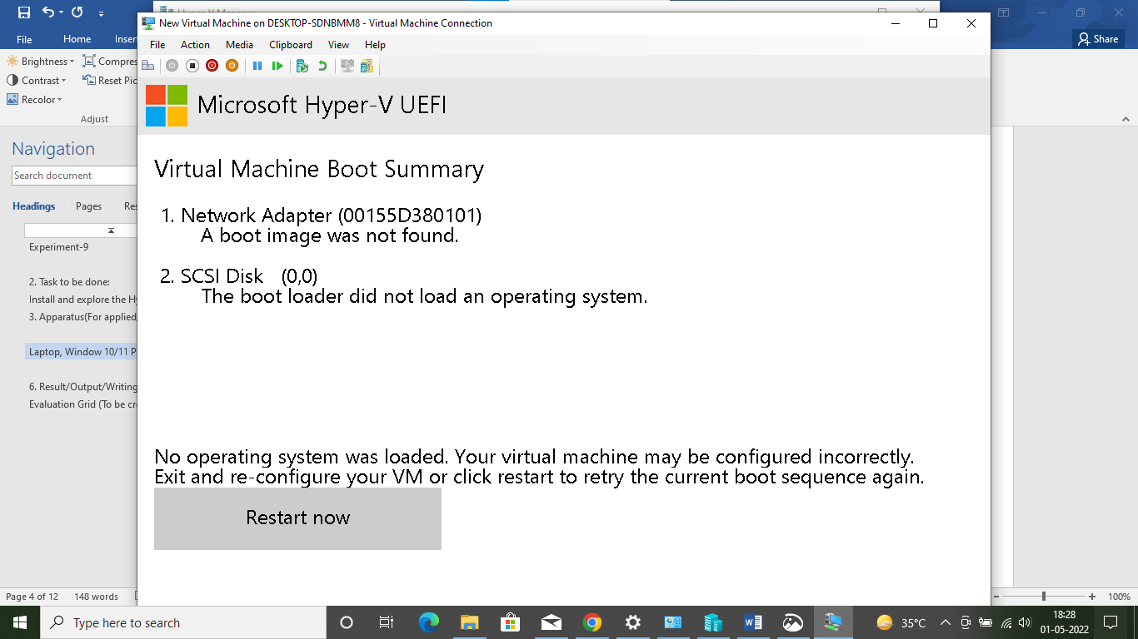

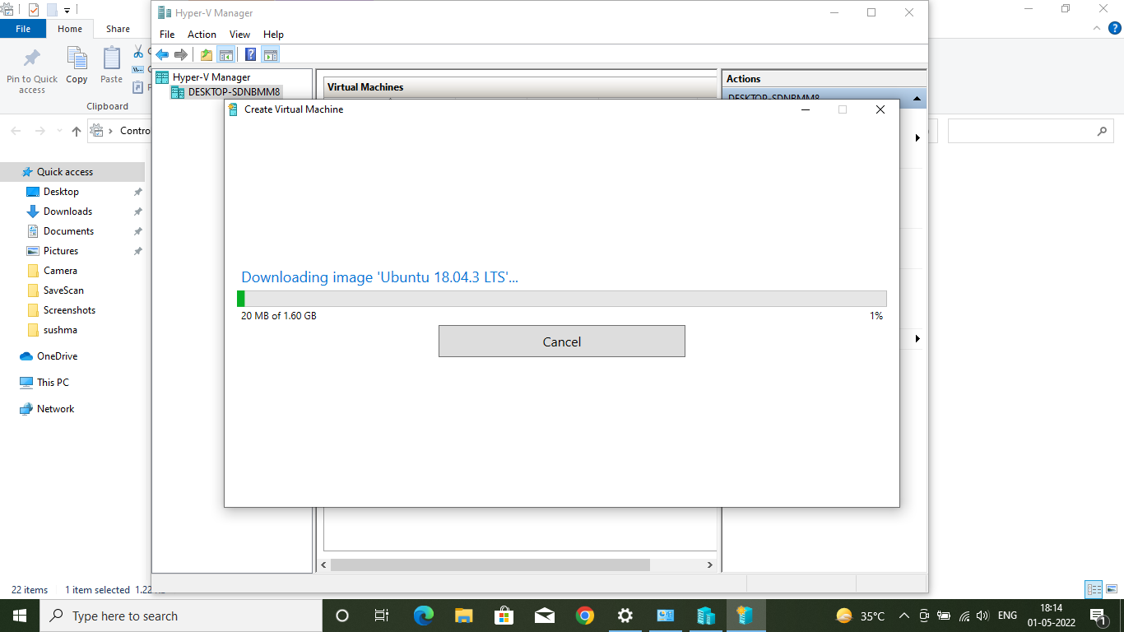

Learning outcomes (What I have learnt):
1. How to upgrade window 10 Home to pro edition
2. How to enable Hyper V
3. How to create a quick virtual Machine
4. How to manually create a Virtual Machine.

Evaluation Grid (To be created as per the SOP and Assessment guidelines by the faculty):
Sr. No. | Parameters | Marks Obtained | Maximum Marks
1.
2.
3.

