The Wise and Foolish Builders

MEMORY VERSE

"The LORD is my rock." — Psalm 18:2 (ESV)
THE BIG IDEA
Jesus told a parable about two builders. One built his house on the sand; the other built on solid rock. When the storm came, the house on the sand washed away, but the house on the rock stood firm. Jesus said He is our rock — when we hear His words and do them, our lives are built on something that lasts.
WHAT WE DID TODAY  We played a "Build-It Relay" and discovered that a strong base holds everything up. Then we heard the parable of the two builders from Matthew 7 and watched it come to life in a water demonstration — a Lego house on sand washed away while the house on rock stood strong. Each child decorated a "Jesus is my Rock" stone to bring home. | JESUS CONNECTION  Jesus is the rock. Storms still come — hard days, sad days, scary days — but the person whose life is built on Jesus stays standing, held safe by Him. We don't build a strong life on our own; we build it by listening to Jesus and trusting Him, day by day.
FOLLOW UP AT HOME
TALK ABOUT IT  Chat together about what it means to build your life on Jesus — praying, reading the Bible, and trusting Him when life is hard. Ask each other: "What storm did you face this week, and how could Jesus be your rock in it?" | TRY AT HOME  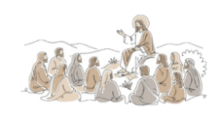  Put the decorated "Jesus is my Rock" stone somewhere you'll see it every day. When you notice it, say the memory verse together: "The LORD is my rock." Let it be a little reminder that God is strong, safe, and always holding us up.
P
A
R
A
B
L
E
S

O
F

J
E
S
U
S

