The Prodigal Son

MEMORY VERSE

"He was lost, and is found." — Luke 15:24 (ESV)

THE BIG IDEA
Jesus told a parable about a father and his two sons. The younger
son took his money, left home, and wasted it all. When he had
nothing left, he headed home to say sorry. While he was still a long
way off, his father saw him, ran to him, and welcomed him home
with a party. Jesus tells this story to show us what God is like.
WHAT WE DID TODAY  We walked a winding tape road from "Lost" all the way to "Found" - home! Then we heard the parable of the prodigal son from Luke 15 and watched it come to life on video. Each child made a "Running Father" slider — the father slides across the village and runs all the way to welcome his son home. | JESUS CONNECTION  The father is like God. No matter how far the son had wandered, the father was watching and ready to run to him. That is how God feels about us. Because Jesus died and rose again, God runs to welcome us home and forgives us completely when we come back to Him.
FOLLOW UP AT HOME
TALK ABOUT IT  Chat together about a time your  family forgave one another. Ask  each other: "How did the father  feel when he saw his son coming  home?" and "How does it feel that  God runs to welcome us, no matter  what?" | TRY AT HOME  Slide the "Running Father"  across the village at home and  retell the story together. When  you do, say the memory verse:  "He was lost, and is found." Let  it remind you that God’s arms  are always open wide for you.
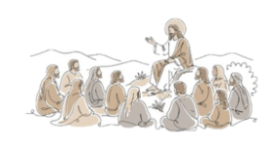
P
A
R
A
B
L
E
S

O
F

J
E
S
U
S

