The Lost Sheep

MEMORY VERSE

"The Son of Man came to seek and to save the lost." — Luke 19:10 (ESV)
THE BIG IDEA
Jesus told a parable about a shepherd with a hundred sheep. When one wandered off and got lost, he left the ninety-nine and searched until he found it. Then he carried it home on his shoulders, full of joy, and called everyone to celebrate. Jesus said heaven is just like that: God loves every single person and rejoices when even one comes home to Him.
WHAT WE DID TODAY  We played the "Lost Sheep Hunt" and searched the room until every hidden sheep was found — cheering when the one lost sheep came home to the pen. Then we watched the parable, played a true-or-false game to recap it, and each child made a fluffy "found sheep" to bring home. | JESUS CONNECTION  Jesus is the Good Shepherd. He came to seek and to save the lost — and He gave His own life to bring us home. You are so precious to God that He would search until He found you, and all of heaven celebrates when even one person turns back to Him.
FOLLOW UP AT HOME
TALK ABOUT IT  Chat together about a time you lost something precious — and how happy you were to find it. Ask each other: "How does it feel to know God loves us so much that He comes looking for us?" | TRY AT HOME  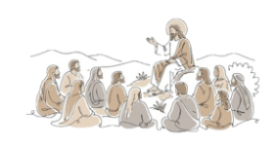  Stand the little "found sheep" somewhere you'll see it. When you notice it, say the memory verse together: "The Son of Man came to seek and to save the lost." Let it remind you that Jesus always comes to find us.
P
A
R
A
B
L
E
S

O
F

J
E
S
U
S

