**New Era University**

College of Computer Studies

Computer Science Department

In Partial Fulfillment of the Requirements in

CS 314 Intelligent System

**Reports Management for Product Sales Development Using Data Mining**

Submitted by:

Antonio, Glydel

Caballero, Robert Russel

Parcia, Mark Anthony S.

Pegollo, Angel III C.

**CLASS SCHEDULE**

WED(5:00pm-7:00pm)

Submitted to:

**Prof. Yumie M. Pasiol**

Instructor

1. **Introduction**

Enterprise report management supports handling and storage of reports and documents. Purchasing of a customer has its pattern. Collecting information from previous record would help the management to increase profit and customers. Sale Forecast is likely to be used as an analysis to determine a strategy to figure out the complimentary products to sell. Companies need a system that provides foundation to make a development of company’s sales.

The system provides an output of reports in graphs and offer recommendation from the given input of the user. Recording the number of products sold in a day that can be viewed in days, weeks, and months.

1. **Statement of the Problem**

1. How will statistical computing, data mining & graphical representation be implemented?

2. How will the existing inventory system determine the data results?

3. How will the data be collected?

1. **Objectives of the Study**

The main objective of the study is to develop, design and evaluate a system using R / Java Programming and Data Mining for a sales report.

Specific Objectives:

1. To integrate a Reports Management for Product Sales Development.

2. To develop product analysis system to an existing inventory system.

3. To evaluate a sales report using Data Mining.

1. **Significance of the Study**

Below are the ones who will benefit on the system and the study.

**Companies** – the company will know the best and worst items to sell on their business.

**Future Researchers** – researchers can make the system as basis of their study and can further improve the system.

1. **Scope and Limitation**

The system generates reports in line graph and offer recommendation from the input. Comparing the products sold in days, weeks, months and years depending on the choice of the owner. It also highlights the products that are in-demand and gets out of stock quickly.

1. 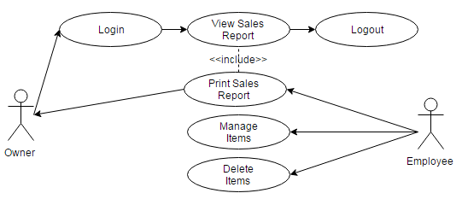**Use-case Diagram**

**Figure 1 Use Case Diagram**

1. **Conceptual Framework**

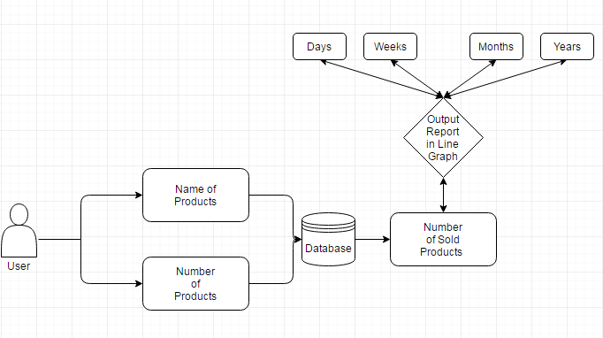

**Figure 1.1 The process of the system**

As shown in the Figure 1.1 which is the flow/ process of how the system will work. First proponent’s are aiming to used an existing system that focused on product management, ordering system or any existing system that is realated to inventory system. The system works as a monitoring system that has the objectives to prevent, produce, increase the production of the products and also to manage those in demand items so the company can maintain the sales of the company.

In every products that is purchased and stored to the database of an inventory system as the history of the transaction. This system will extract all the data from the database of the existing application which is an inventory system. The system will analyze those product that is in demand to the customer, those data will stored to its own database and calculate those number of sold products and provides a graphical representation of the sales which is analyzes the highest & lowest percentage of the numbers of sold product. It can also identify the sales report from the past days, weeks and years.

1. **User-Interface Design Draft**

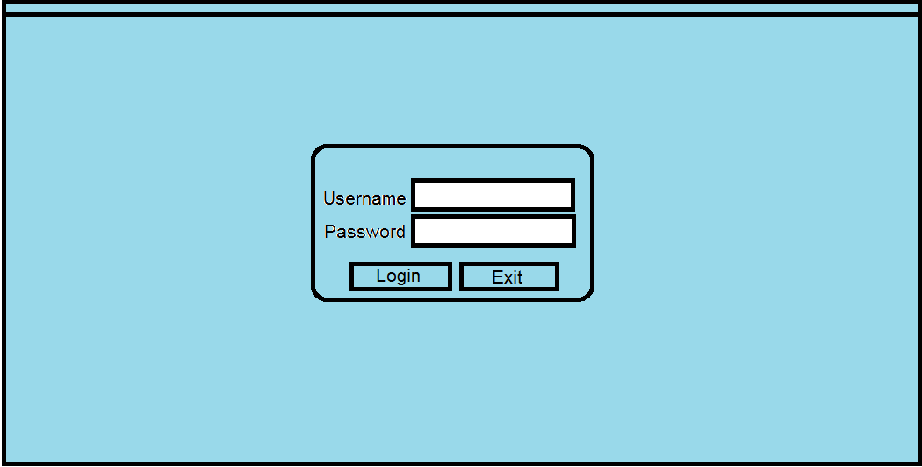Login Frame

Graph Frame

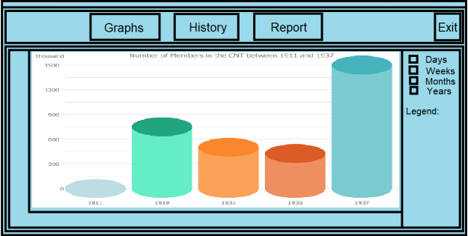

**Report Frame**

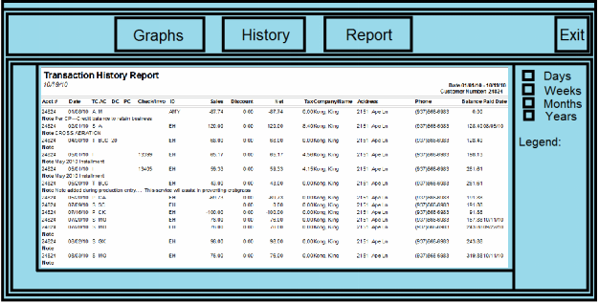

**History Frame**

