**New Era University**

College of Computer Studies

Computer Science Department

In Partial Fulfillment of the Requirements in

CS 314 Intelligent System

**Reports Management for Product Sales Development Using Data Mining**

Submitted by:

Antonio, Glydel

Caballero, Robert Russel

Parcia, Mark Anthony S.

Pegollo, Angel III C.

**CLASS SCHEDULE**

WED(5:00pm-7:00pm)

Submitted to:

**Prof. Yumie M. Pasiol**

Instructor

1. **Introduction**

Enterprise report management supports handling and storage of reports and documents. Purchasing of a customer has its pattern. Collecting information from previous record would help the management to increase profit and customers. Sale Forecast is likely to be used as an analysis to determine a strategy to figure out the complimentary products to sell. Companies need a system that provides foundation to make a development of company’s sales.

The system provides an output of reports in graphs and offer recommendation from the given input of the user. Recording the number of products sold in a day that can be viewed in days, weeks, and months.

1. **Statement of the Problem**

1. How will statistical computing, data mining & graphical representation be implemented?

2. How will the existing inventory system determine the data results?

3. How will the data be collected?

1. **Objectives of the Study**

The main objective of the study is to develop, design and evaluate a system using R / Java Programming and Data Mining for a sales report.

Specific Objectives:

1. To integrate a Reports Management for Product Sales Development.

2. To develop product analysis system to an existing inventory system.

3. To evaluate a sales report using Data Mining.

1. **Significance of the Study**

Below are the ones who will benefit on the system and the study.

**Companies** – the company will know the best and worst items to sell on their business.

**Future Researchers** – researchers can make the system as basis of their study and can further improve the system.

1. **Scope and Limitation**

The system generates reports in line graph and offer recommendation from the input. Comparing the products sold in days, weeks, months and years depending on the choice of the owner. It also highlights the products that are in-demand and gets out of stock quickly.

1. **Use-case Diagram**

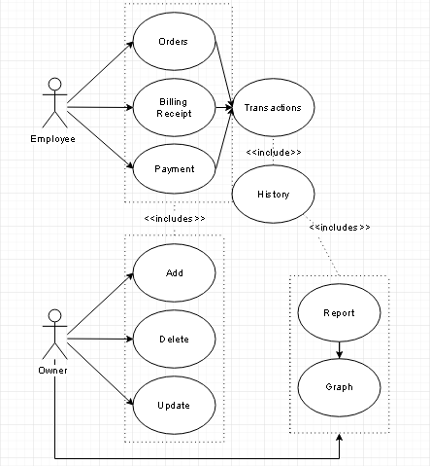

**Figure 1 Use Case Diagram**

1. **Conceptual Framework**

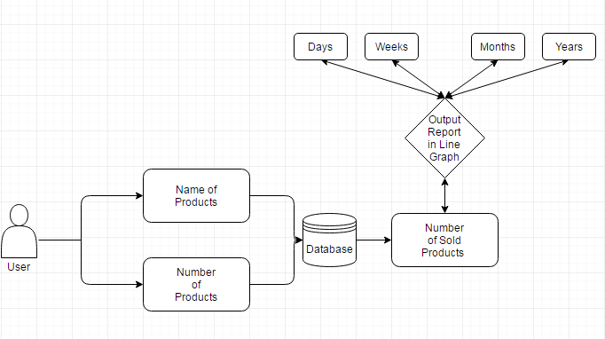

**Figure 1.1 The process of the system**

As shown in the Figure 1.1 which is the flow/ process of how the system will work. First proponents are aiming to use an existing system that focused on product management, ordering system or any existing system that is related to inventory system. The system works as a monitoring system that has the objectives to prevent, produce, increase the production of the products and also to manage those in demand items so the company can maintain the sales of the company.

In every products that is purchased and stored to the database of an inventory system as the history of the transaction. This system will extract all the data from the database of the existing application which is an inventory system. The system will analyze those product that is in demand to the customer, those data will stored to its own database and calculate those number of sold products and provides a graphical representation of the sales which is analyzes the highest & lowest percentage of the numbers of sold product. It can also identify the sales report from the past days, weeks and years.

1. **User-Interface Design Draft**

**A.**

**(1) Employee/ Manager Login**

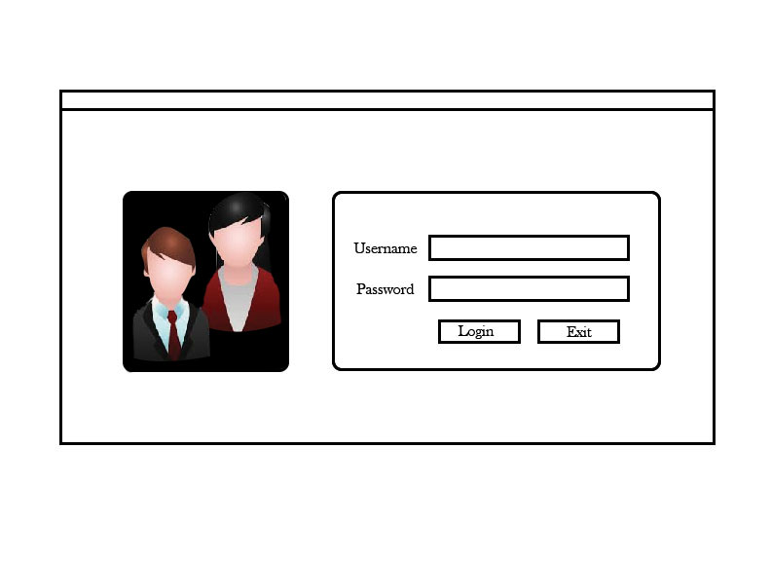

**(2) Ordering System**

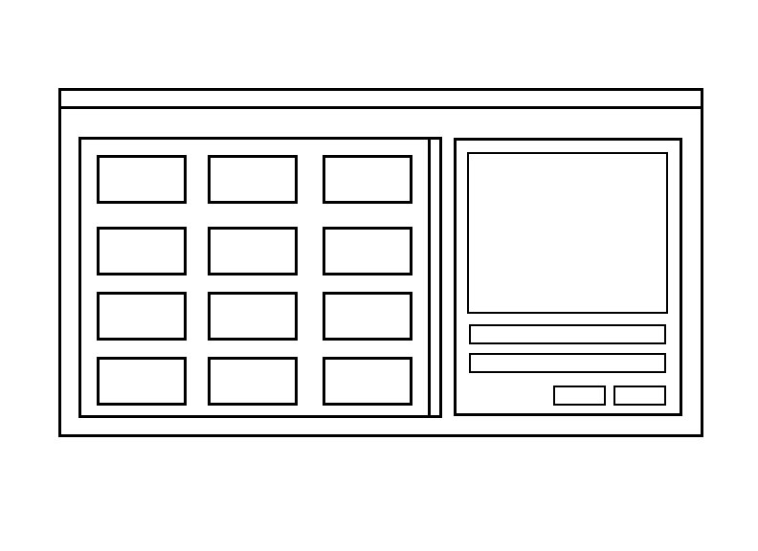

**B.**

**(3). Inventory System**

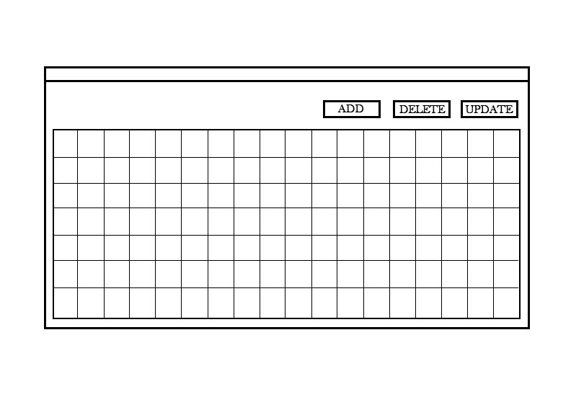

**C.**

**)(1) Owner Login Frame**

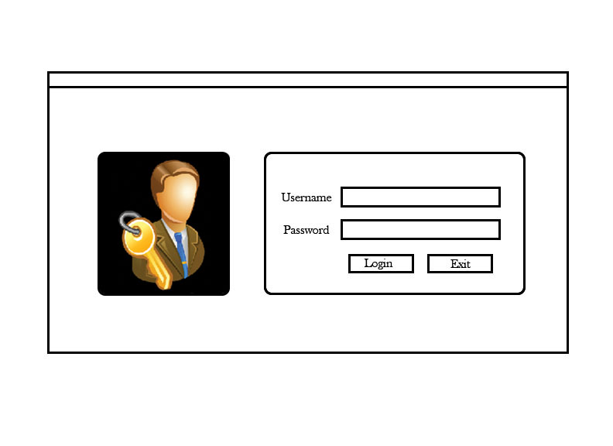

**(2) Graph Frame**

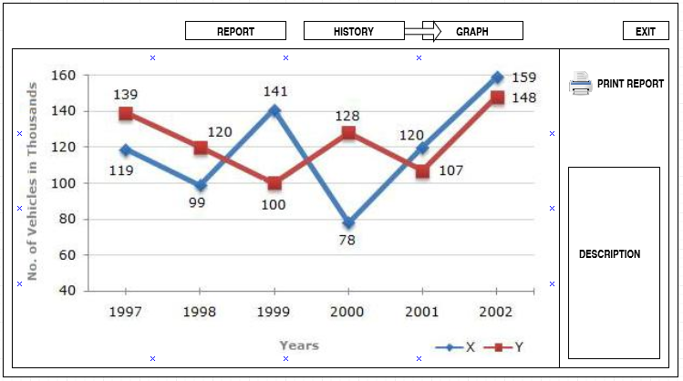

1. **Report Frame**

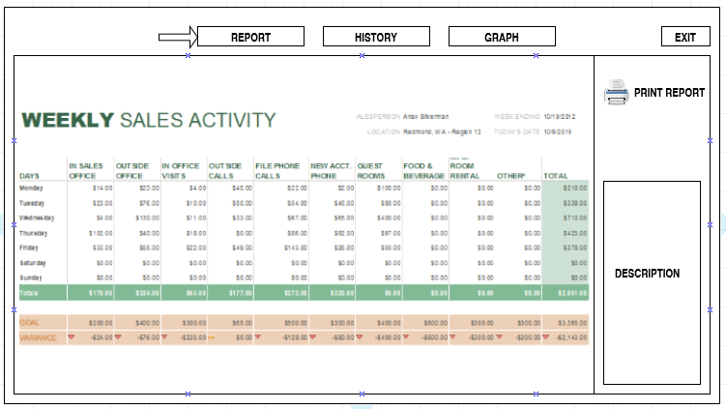

**4) History Frame**

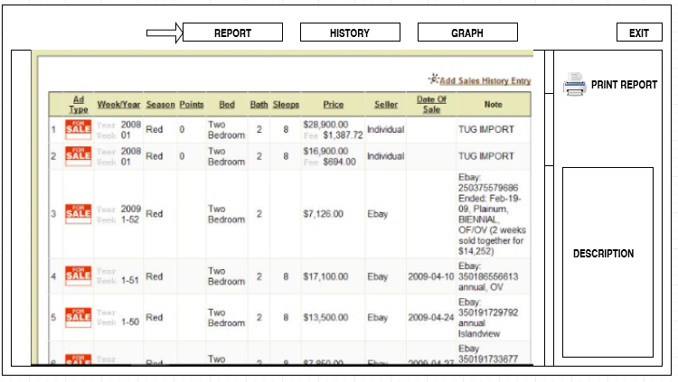

1. **Functional Requirements**

Each function of the system or the specific screen can do are will e identify below. This is typically the things that are needed to analyse.

1. Interface Requirements
   * 1. (1) Screen 1 Employee/Manager Login Frame
2. Screen 2 Ordering System - where data request are enter
   * 1. (1) Inventory System Frame- where items are able to add, update and delete.
     2. (1)Screen 1 Login System accept employee accounts

(2)Screen 2 Graph display data diversity.

(3)Screen 3 Report can print data

(4)Screen 4 sales report stored in the history

1. Business Requirements
   * 1. Data must be entered before a request can be approved.
     2. All employee’s will be trained to use the system
     3. Changes from the item products must be approved by clicking the request approval.
2. Regulatory/ Compliance Requirements
   * 1. The database will have a functional relationship to all process.
     2. The system will limit access to authorized users.
     3. Administrator must secured the daily reports of the products
3. Security Requirements
   * 1. Members of the Employee’s Group can enter request but cannot approved or delete requests
     2. Members of the Manager’s Group cannot enter request but can manage data from data base can add, update, and delete of an item and it also can not approved the request.
     3. Members of the Administrators Group or the owner cannot enter request but can manage data from the database. The one who as privilege to approved, delete, or update the requests.
4. **User Requirements**

The proponents will provide a guide on how the user will understand the flow of the system in the easiest way. The system itself must have the best possible design on the User Interface, the functionality of each part of the system must be analyse and well-tested that affects user’s interest in using the software application.

* User can transfer the results of transactions in 24 hours to the administrators.
* User can ADD an item to the inventory system which they can add new item with a specific information.
* User can DELETE an item to the inventory system which they can remove item from the database.
* User can UPDATE the data from the inventory system which automatically update data from the Point of Sale System.
* User can generate a graphical representation of sales report in every transaction.
* Provides a printed output of the sales report.

1. **System Requirements**

**System Requirements Specification**

1. On each end of the day, a summary of each sold products and their overall sales percentage shall be generated.
2. A graphical representation of the report will be generated and shall automatically be stored in a database for future use.
3. The graph report can be viewed depending on the user in day, week, month or year.
4. On each last working day of the month, a summary of the most sold product, least sold product and most demanded product shall be generated.
5. The system shall suggest a certain product on what to buy and least to buy after a summary is generated.
6. The access to all generated reports shall be restricted to unauthorized users, and can only be accessed by authorized users listed or known by the system.

