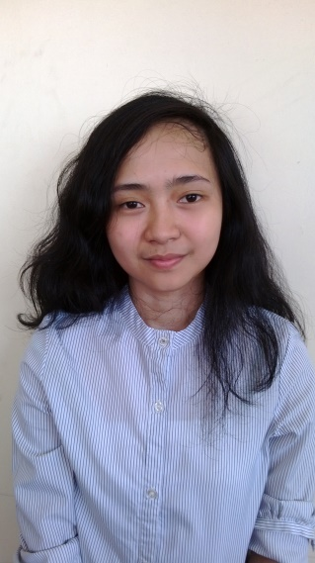**Glydel Camacho ANTONIO**

New Era Ladies Dorm 2, Brgy Culiat, Quezon City

Mobile: 09057065981

Email: bglydelantonio@yahoo.com

CAREER OBJECTIVES

To be able to employ my skills and education in working in an environment where proficiency is practiced.

EDUCATIONAL BACKGROUND

**Tertiary Education** New Era University

BS Computer Science

Batch 2013-present

**Secondary Education** Mahayag School of Arts and Trade

Batch 2009-2013

**Elementary Education** Mahayag Central School

Batch 2003-2009

PROJECTS

**Case Study (ATM)**

2014

PERSONAL DATA

Date of Birth : October 13, 1998

Place of Birth : Mahayag, Zamboanga del Sur

Civil Status : Single

Citizenship : Filipino

Height : 5’1”

Religion : Iglesia Ni Cristo

Language/Dialects: Filipino/English

**Glydel C. Antonio**

***Applicant***