System Architecture & Implementation
This chapter describes how the mathematical model of Chapter 3 becomes running Python code. The implementation translates the Markov Decision Process (MDP) into a modular execution system built on Gymnasium and PyTorch, separating market state handling, policy evaluation, transaction verification, and performance evaluation. Everything here is verifiable on the public orphan branch simple-modelling-clean of https://github.com/TheFinix13/dissertation-project.

Overview of system design
Figure 1.1 shows the single loop everything else plugs into. The policy network $π_{θ}(a∣s)$ proposes a discrete action $a_{t}$; the trading environment (a Gymnasium gym.Env subclass) executes the action against the market data stream and returns the next state $s_{t+1}$ and reward $R_{t}$. Training is running this cycle many times and adjusting $θ$ so actions that increased wealth become more probable.
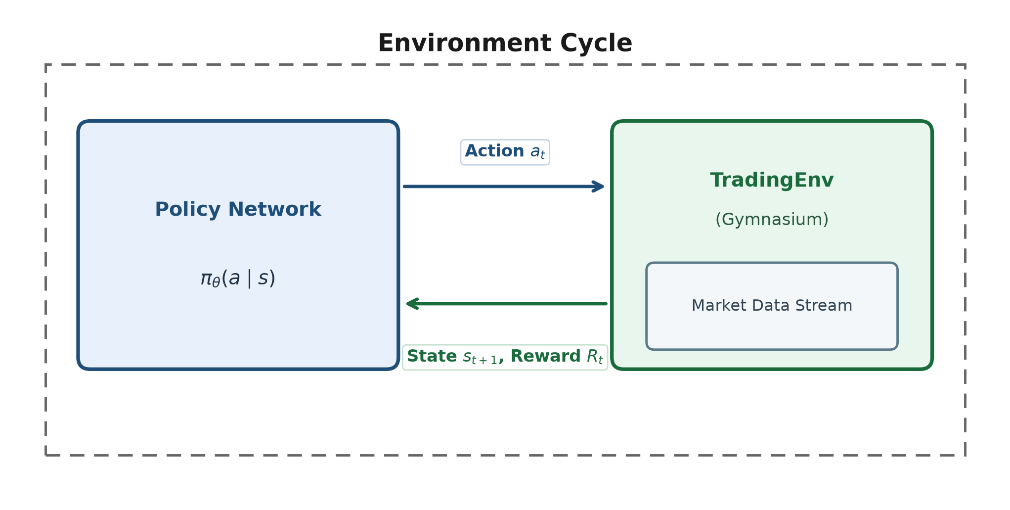
Environment cycle: the policy network exchanges actions for states and rewards with the Gymnasium trading environment wrapping the market data stream.
Figure 1.2 places the same loop in the actor–critic architecture used by A2C and PPO: a shared observation feeds a policy head (actor) and a value head (critic). The actor proposes $a_{t}$; the critic estimates $V(s_{t})$ so the policy update can be written as an advantage rather than a raw Monte-Carlo return.
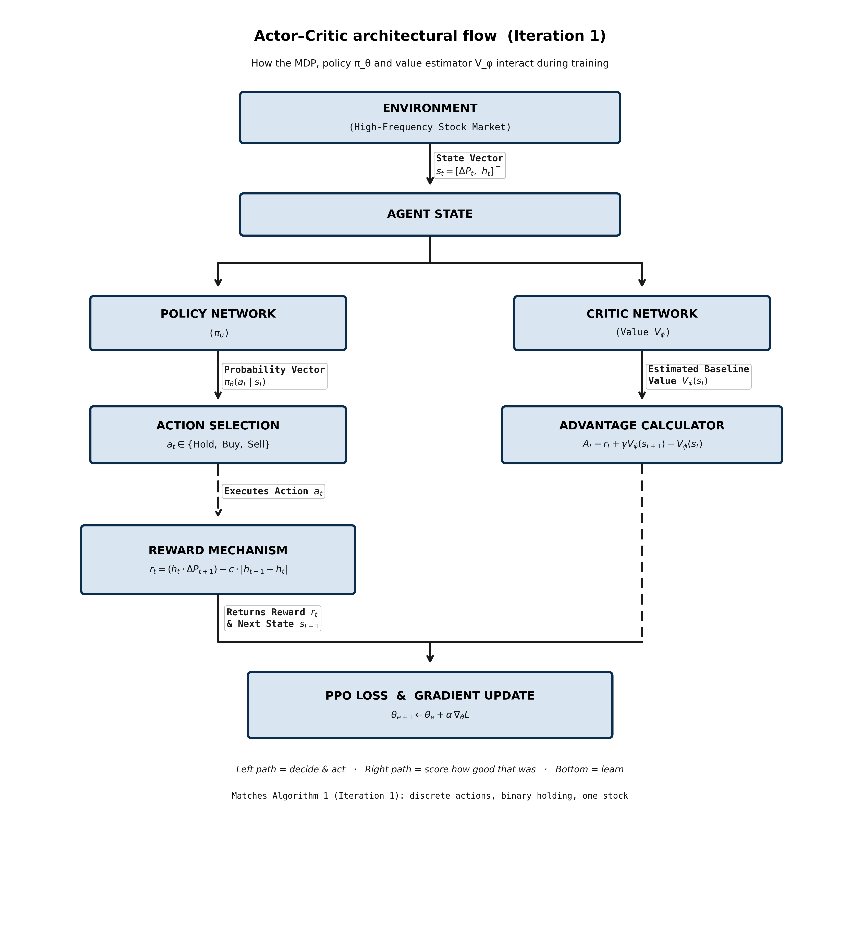
Actor–critic architecture used by A2C and PPO. The actor is the trading policy; the critic supplies the baseline for the advantage estimate.

Environment engine (TradingEnv)
The core environment subclasses gym.Env and handles market data loading, position tracking, order checks, and state formulation. Experimental progression scales incrementally from the Iteration 1 baseline to Iteration 2.

Iteration 1 baseline engine (TradingEnv-v0)
Implemented in experiments/iteration1/env.py. State:
$$s_{t}=[ ΔP_{t}, C_{t}, n_{t} ]^{⊤}.$$
Action set $A=\{0:\text{Hold}, 1:\text{Buy one}, 2:\text{Sell one}\}$ with a feasibility mask. Wealth $W_{t}=C_{t}+n_{t}P_{t}$; reward $r_{t}=W_{t+1}−W_{t}$.

Iteration 2 extended engine (TradingEnv-v1)
The 3-D state leaves three gaps identified in the Iteration-2 methodology notes: (A) the network cannot multiply $n_{t}×P_{t}$ on the fly to judge dollar exposure; (B) once holding, there is no memory of the purchase price; (C) without episode progress, a Buy at bar 1 looks identical to a Buy at bar $T$.
TradingEnv-v1 (experiments/iteration1/env_v1.py) closes the gaps with a scaled 5-D state:
$$s_{t}=[ ΔP_{t}, {PnL}_{t}, τ_{t}, {C_{t}}/{C_{0}}, {n_{t}P_{t}}/{C_{0}} ]^{⊤},$$
where ${PnL}_{t}$ is unrealized return vs average entry price (zero when flat) and $τ_{t}=t/T∈[0,1]$. Actions, fees, masking and reward are identical to Iteration 1, so performance differences are attributable to the state alone.

State transition mechanics
With transaction cost $c=0.0005$ (5 bps):
- Buy ($a_{t}=1$): valid if $C_{t}≥P_{t}(1+c)$; then $C←C−P(1+c)$, $n←n+1$.
- Sell ($a_{t}=2$): valid if $n≥1$; then $C←C+P(1−c)$, $n←n−1$; entry-cost reset when flat.
- Hold ($a_{t}=0$): balances unchanged.
Infeasible requests are masked and, if issued anyway, executed as Hold. The rate of illegal requests after training is reported in Chapter 5 as a constraint-awareness diagnostic.

Algorithm implementations
Five algorithms span value-based and policy-based families so that the choice of policy-gradient methods for trading is evidenced, not asserted.
- Tabular Q-learning (run_cartpole_qlearning.py). Bellman update on a lookup table after hand-binning CartPole ($6×6×12×12$). Demonstrates why tables cannot scale to continuous trading states.
- DQN (Stable-Baselines3). Network $Q_{ϕ}$ trained by MSE to the Bellman target with replay and a frozen target net.
- REINFORCE — from scratch in PyTorch (experiments/phase0_games/reinforce.py): L(θ)=−t​logπθ(at∣st) Gt. Auditable; not an API black box.
- A2C (Stable-Baselines3). Actor–critic advantage replaces the Monte-Carlo return.
- PPO (Stable-Baselines3). Clipped ratio $min(ρ_{t}A_{t}, clip(ρ_{t},1±ϵ)A_{t})$ with $ϵ=0.2$. Carried into trading.
Figure 1.3 places the supervised training template next to the PPO update so the viva mapping (predict $→$ score $→$ backward $→$ step) is explicit.
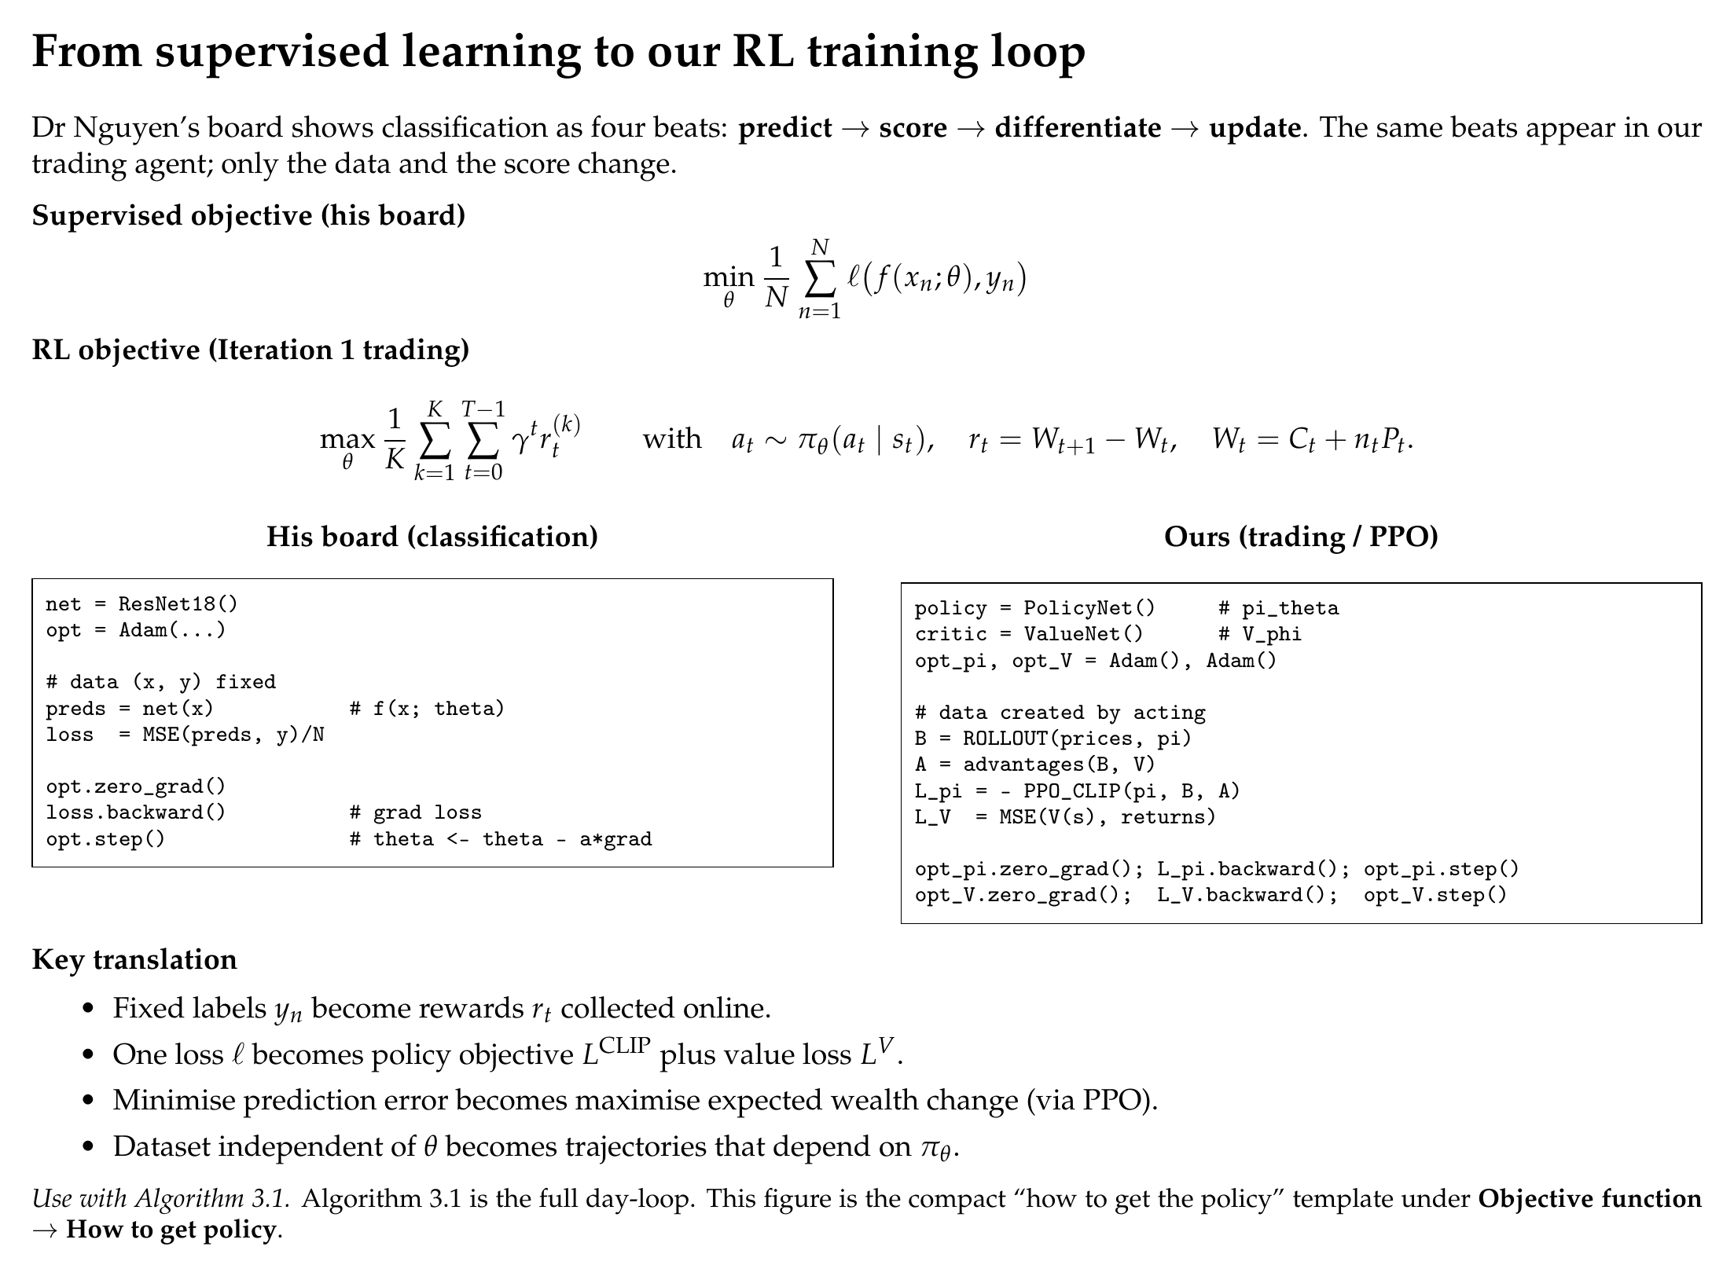
Supervised loss board (left) mapped onto the PPO policy / value loop (right).

Phase 0: game correctness sandbox
A trading agent that loses money is ambiguous: the market may be unlearnable, or the code may be wrong. Games remove the ambiguity because the correct outcome is known. Phase 0 validates every algorithm on three Gymnasium environments of increasing difficulty before any market data is used:
- CartPole-v1: 4-D state, 2 actions, $+1$/step upright (cap 500; solved $≈475$).
- FlappyBird-v0: 12-feature state, 2 actions, sparse pipe rewards.
- LunarLander-v3: 8-D state, 4 discrete engines, shaped landing reward (solved $≈200$).
Suites live under experiments/phase0_games/. Results are in Chapter 5.

Data pipeline and episode construction
Market data is SPY daily adjusted close, 2018–2024, fetched by fetch_spy_daily.py and frozen on disk. One episode $=$ one calendar month of daily closes ($T≈18$–$23$). This is stated honestly: it is not the 390-minute intraday session of the idealised Chapter 3 episode; the environment API is horizon-agnostic, so minute bars are a drop-in upgrade. Months split chronologically — 58 train, 26 test (Nov 2022 – Dec 2024) — and are never shuffled.

Testing and reproducibility
Unit tests (experiments/iteration1/test_env.py) enforce on both engines: (i) accounting identity — summed rewards equal total $ΔW$ within ${10}^{−6}$; (ii) mask correctness — Buy/Sell illegality and forced Hold; (iii) v1 feature correctness — analytic $PnL$ and $τ$ on a hand-built price path. Every training run pins seed, budget, fee and split inside its results JSON; charts regenerate from those JSONs via reports/builders/.

Empirical Results & Analysis
This chapter reports every experiment on the simple-modelling track in the order the methodology builds: Phase 0 validates the learning algorithms on games with known outcomes; Phase 1 applies the validated PPO loop to real SPY data under Iteration 1 (3-D state) and Iteration 2 (5-D state). All numbers are produced by committed scripts; none are illustrative placeholders.

Experimental setup and evaluation metrics

Phase 0 (games).
Fixed seed 42. Budgets: 50,000 environment timesteps on CartPole; 150,000 on Flappy Bird and LunarLander; REINFORCE uses an equivalent episode budget. Evaluation: 30 greedy episodes. Metric: mean evaluation return.

Phase 1 (trading).
SPY daily closes 2018–2024, chronological 58 / 26 month split (test $=$ Nov 2022 – Dec 2024). $C_{0}=\$10,000$, $c=5$ bps, PPO 80,000 timesteps, seed 42. Metrics: wealth change $ΔW$ ($), trades per month, win rate vs the strongest passive baseline. Standing diagnostics: accounting identity (tolerance ${10}^{−6}$) and illegal-action request rate.

Phase 0: algorithm validation on games
Table 2.1 and Figures 2.1–2.4 summarise the three-game suite.
Phase 0 mean evaluation return (30 greedy episodes, seed 42). CartPole solved $≈475$; LunarLander $≈200$. Tabular Q-learning only on discretized CartPole.
Algorithm | CartPole-v1 | FlappyBird-v0 | LunarLander-v3
Random | 28.8 | $−7.4$ | $−183.4$
Tabular Q-learning | 500.0 | — | —
DQN | 500.0 | 7.0 | 177.6
REINFORCE (scratch) | 292.2 | 7.1 | 15.3
A2C | 500.0 | 4.6 | $−41.2$
PPO | 500.0 | 12.6 | 176.4
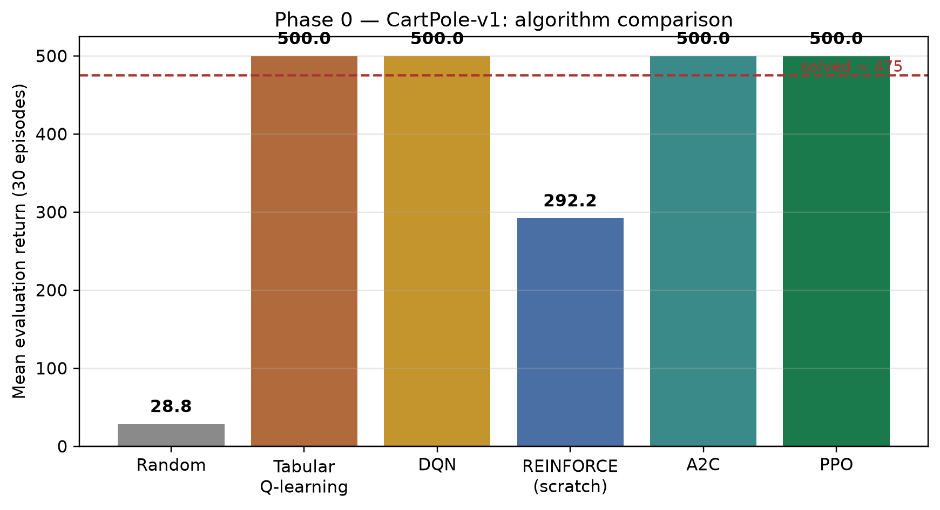
CartPole algorithm comparison. Learning methods clear the random floor; Q-table / DQN / A2C / PPO hit the 500-step cap.
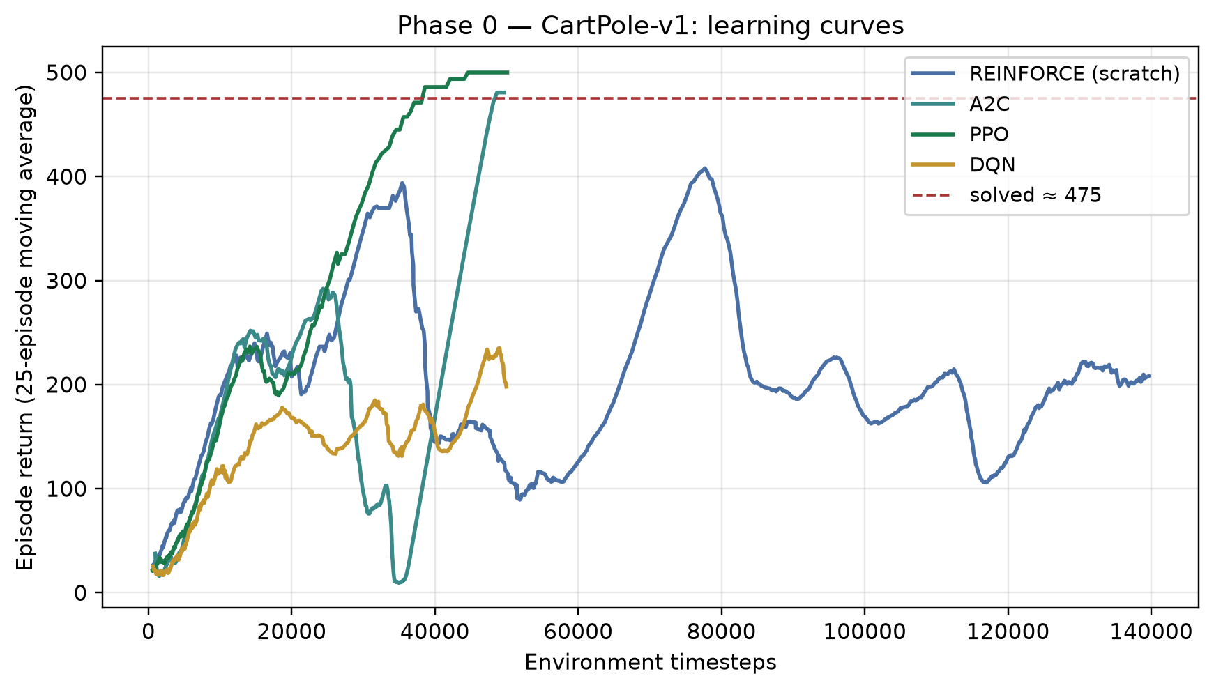
CartPole learning curves (25-episode moving average). Scratch REINFORCE learns but plateaus below the clipped / actor–critic methods.
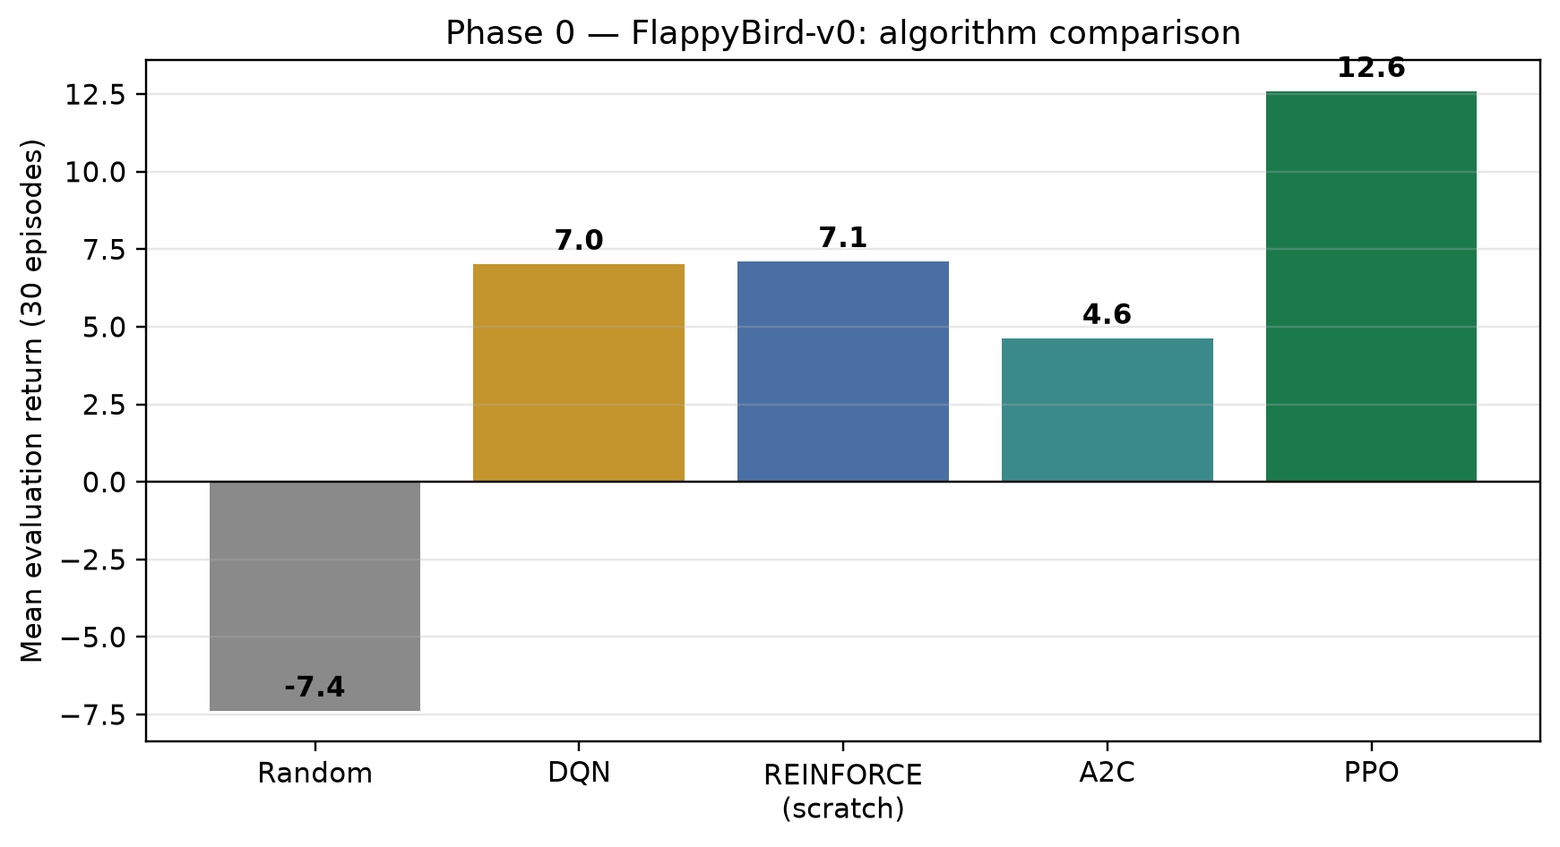
Flappy Bird comparison. PPO is the strongest learner under the fixed budget.
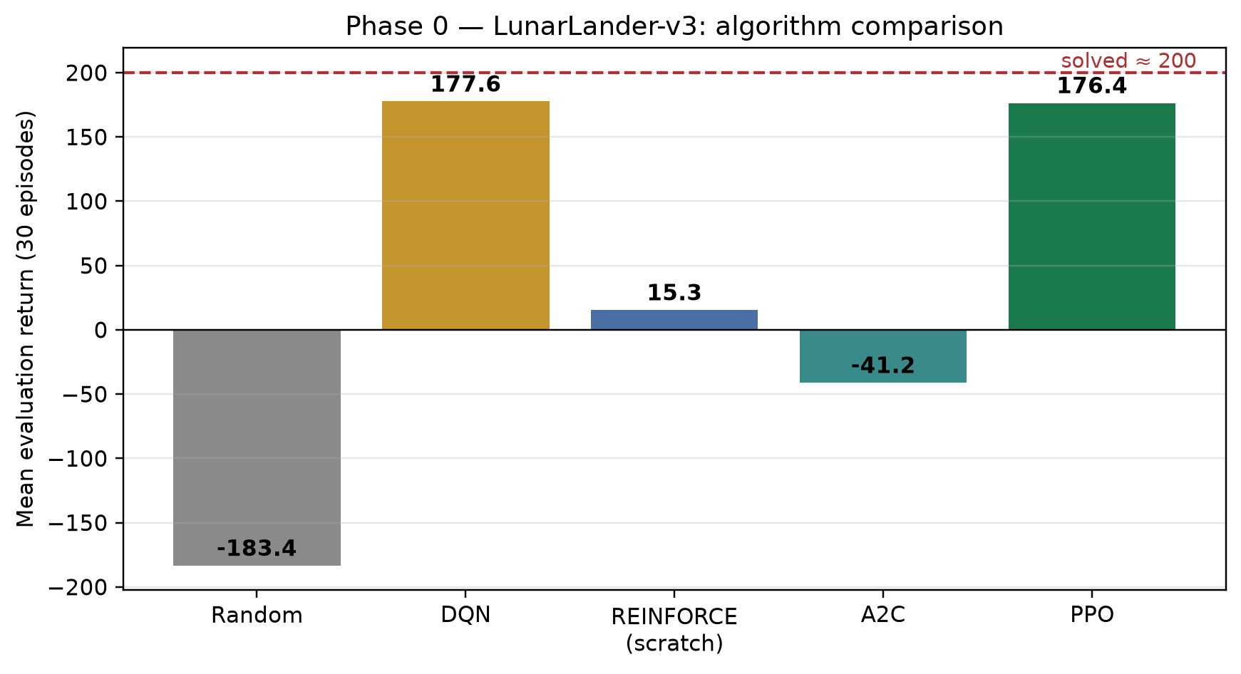
LunarLander-v3 comparison. PPO and DQN approach the solved threshold ($≈200$).

Carry-forward.
Every implementation clears its random floor. Scratch REINFORCE works but is noisy — the textbook motivation for actor–critic and clipping. Tabular Q-learning reaches 500 on CartPole only after hand-binning; trading states with continuous cash and prices make that table explode, so Phase 1 uses policy-gradient methods with function approximation. PPO is the most consistent learner across games and is therefore the trading algorithm.

Phase 1, Iteration 1: the 3-D state agent
Table 2.2 and Figure 2.5 compare PPO on TradingEnv-v0 against four baselines with explicit objectives.
Iteration 1 on 26 held-out SPY test months. $ΔW$ in dollars; fee 5 bps; PPO 80k steps.
Method | Mean $ΔW$ | Std | Trades/mo | Win vs B1b
B0 do-nothing | 0.00 | 0.00 | 0.0 | 31%
B1 buy-one-hold | 7.97 | 16.67 | 1.0 | 31%
B1b buy-max-hold | 76.91 | 178.68 | 19.1 | —
B2 random (masked) | 14.14 | 32.93 | 12.8 | 31%
A1 PPO (3-D state) | 76.91 | 178.68 | 19.1 | 0%
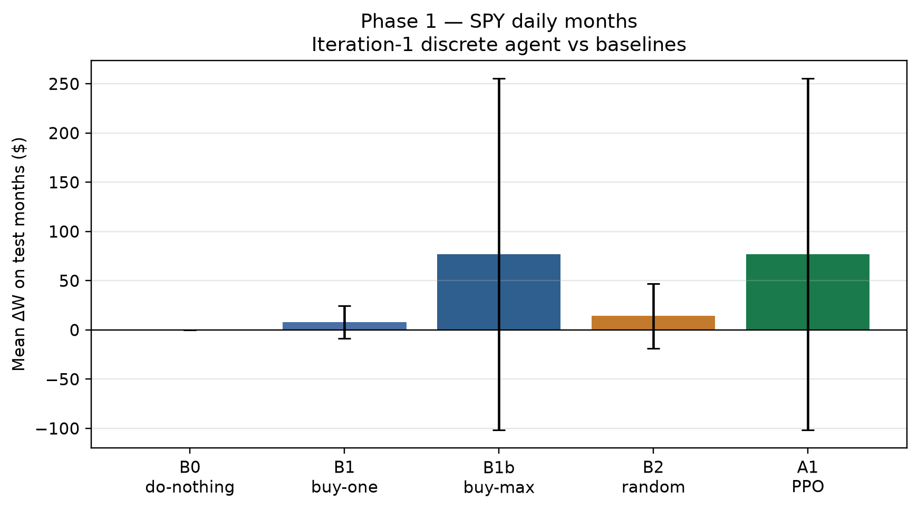
Iteration 1 mean $ΔW$ on test months. A1 matches B1b exactly once the fair fully-invested baseline is included.
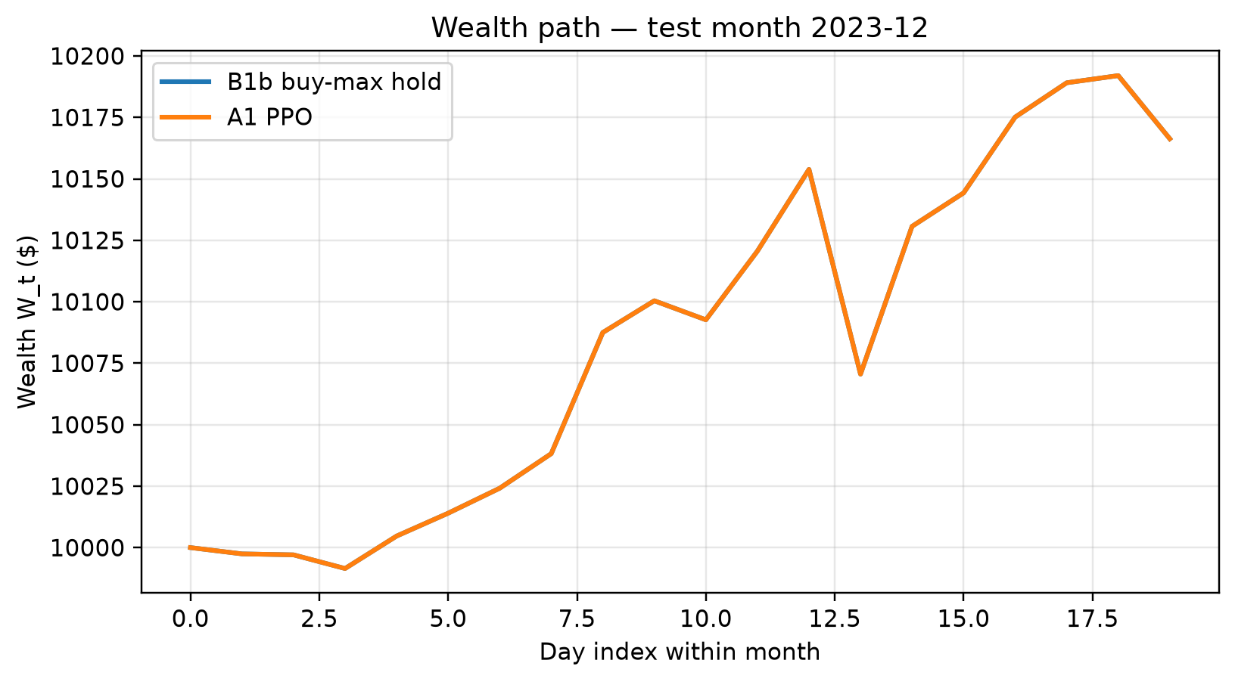
Wealth path for a representative test month: B1b buy-max hold vs A1 PPO (identical after collapse).

Honest headline.
Deterministic PPO matched B1b on all 26 test months: under pure $ΔW$ with a 3-D state, the learned policy is “get fully invested and stay there.” Against the one-share baseline B1 this would look like a $10×$ win; against fair B1b it is rediscovered buy-and-hold. Accounting identity held exactly; illegal-action request rate was 3.9%.

Phase 1, Iteration 2: the 5-D state agent
Iteration 2 re-trains the identical PPO configuration on TradingEnv-v1, changing only the state. Table 2.3 and Figure 2.7 report the comparison.
Iteration 2 vs Iteration 1 on the same 26 test months, budget, fee and seed.
Method | Mean $ΔW$ | Trades/mo | Months identical to B1b
A1 PPO, 3-D (Iter. 1) | 76.91 | 19.1 | 26 / 26
A2 PPO, 5-D (Iter. 2) | 0.00 | 0.0 | 0 / 26
B1b buy-max-hold | 76.91 | 19.1 | —
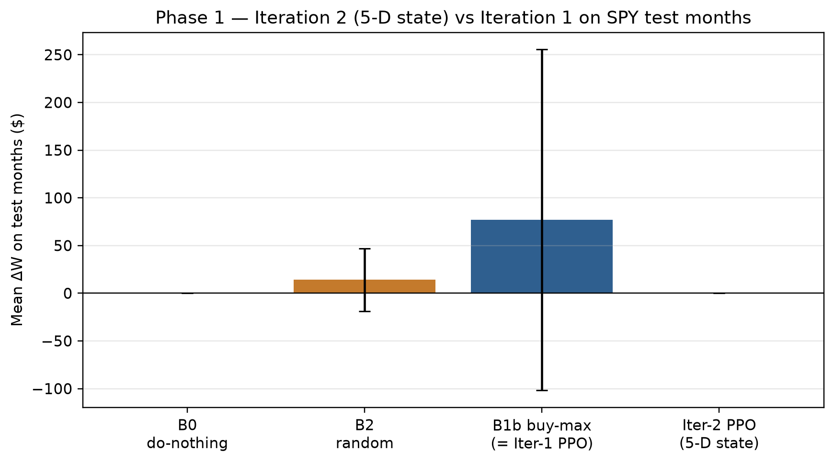
Iteration 2 (5-D) vs Iteration 1 / buy-max. Richer state breaks the collapse but converges mostly-flat under deterministic evaluation.
The richer state did break the buy-and-hold collapse (0/26 months identical to B1b) but converged to the opposite corner: a cautious, mostly-flat policy. Mean action probabilities on a representative test month: Hold 0.66, Buy 0.12, Sell 0.22 — so argmax evaluation never trades. Sampling actions stochastically yields mean $ΔW=+\$1.87$. Month-by-month, the flat agent still beats fully-invested B1b in 8 of 26 months (the falling ones).

Master comparison across iterations
Master results table for the simple-modelling track (Phase 1, SPY test months).
Metric | B1b buy-max | Iter. 1 PPO (3-D) | Iter. 2 PPO (5-D)
State dimension | — | 3 | 5
Mean $ΔW$ ($) | 76.91 | 76.91 | 0.00
Mean trades / month | 19.1 | 19.1 | 0.0
Identical to B1b (months) | — | 26/26 | 0/26
Accounting identity | pass | pass | pass

Analysis and key findings

1. The reward, not the state, sets the incentive.
Under $r_{t}=ΔW_{t}$ in a mostly-rising test window, full investment is near-optimal and Iteration 1 found exactly that. Adding entry and time context moved the policy along the exposure axis (always-invested $→$ almost-never-invested) without creating selective timing. Both extremes are rational responses to a risk-neutral reward estimated from noisy monthly episodes whose training window includes the COVID crash and the 2022 bear market.

2. Baseline design is itself a result.
Without fair B1b, Iteration 1 would have been reported as “PPO beats buy-and-hold by $10×$.” With it, the correct statement is “PPO rediscovered buy-and-hold.”

3. What Iteration 3 must change.
Because the state upgrade only shifted exposure, the next iteration targets the objective: $r_{t}=ΔW_{t}−λD_{t}$ (drawdown penalty) gives a reason to hold selectively. The masked-action rate and accounting identity carry forward as standing diagnostics.

Scope.
Single-seed, fixed budget, monthly daily-bar episodes. Multi-seed confidence intervals, minute-bar episodes ($T=390$), and the drawdown-penalised reward are the planned extensions, in that order.

