System Architecture & Implementation
This chapter describes how the mathematical model of Chapter 3 becomes running Python code. The implementation translates the Markov Decision Process (MDP) into a modular execution system built on Gymnasium and PyTorch, separating market state handling, policy evaluation, transaction verification, and performance evaluation. Everything here is verifiable on the public orphan branch simple-modelling-clean of https://github.com/TheFinix13/dissertation-project.

Overview of system design
Figure 1.1 shows the single loop everything else plugs into. The policy network $π_{θ}(a∣s)$ proposes a discrete action $a_{t}$; the trading environment (a Gymnasium gym.Env subclass) executes the action against the market data stream and returns the next state $s_{t+1}$ and reward $R_{t}$. Training is running this cycle many times and adjusting $θ$ so actions that increased wealth become more probable.
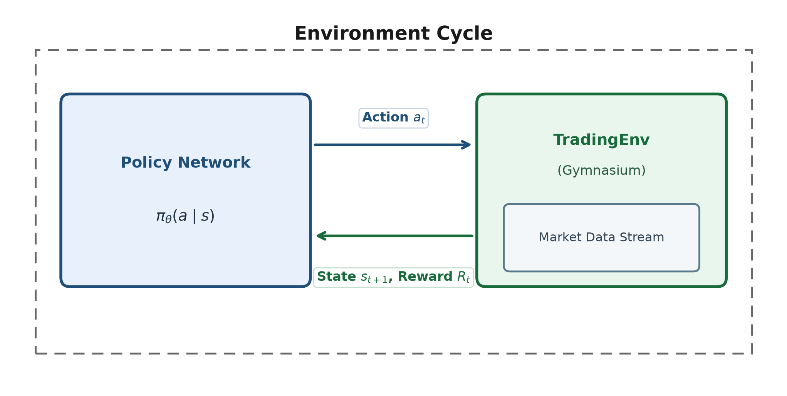
Environment cycle: the policy network exchanges actions for states and rewards with the Gymnasium trading environment wrapping the market data stream.
Figure 1.2 places the same loop in the actor–critic architecture used by A2C and PPO: a shared observation feeds a policy head (actor) and a value head (critic). The actor proposes $a_{t}$; the critic estimates $V(s_{t})$ so the policy update can be written as an advantage rather than a raw Monte-Carlo return.
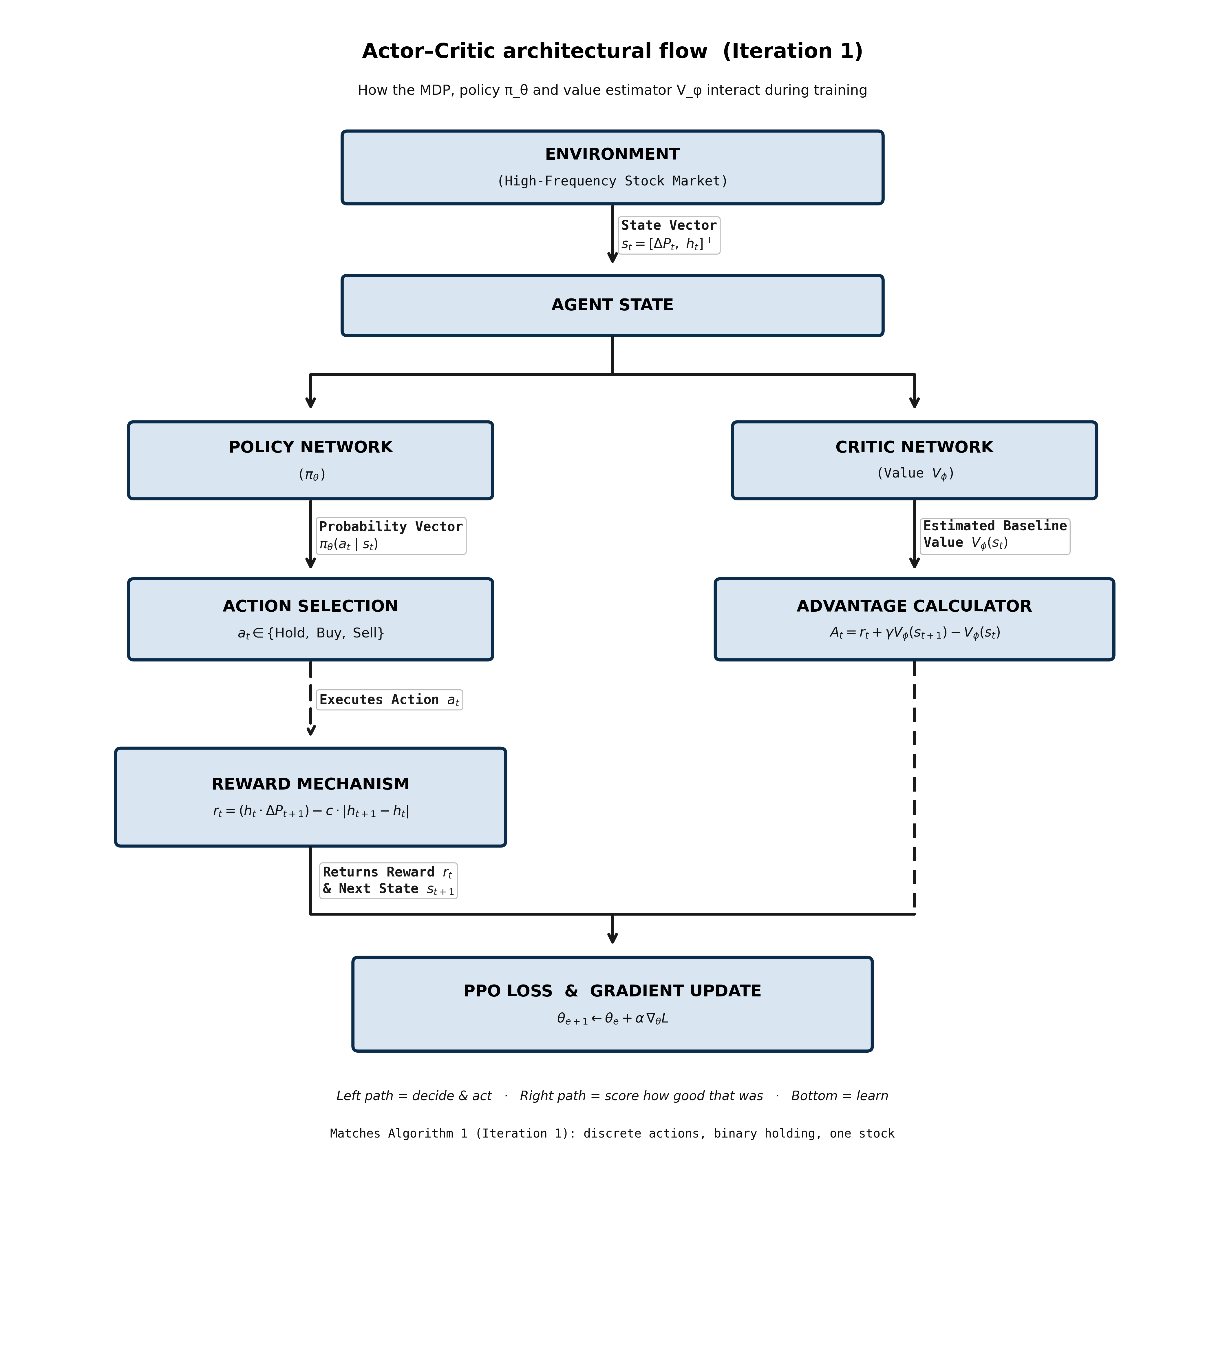
Actor–critic architecture used by A2C and PPO. The actor is the trading policy; the critic supplies the baseline for the advantage estimate.

Environment engine (TradingEnv)
The core environment subclasses gym.Env and handles market data loading, position tracking, order checks, and state formulation. Experimental progression scales incrementally from the Iteration 1 baseline to Iteration 2.

Iteration 1 baseline engine (TradingEnv-v0)
Implemented in experiments/iteration1/env.py. State:
$$s_{t}=[ ΔP_{t}, C_{t}, n_{t} ]^{⊤}.$$
Action set $A=\{0:\text{Hold}, 1:\text{Buy one}, 2:\text{Sell one}\}$ with a feasibility mask. Wealth $W_{t}=C_{t}+n_{t}P_{t}$; reward $r_{t}=W_{t+1}−W_{t}$.

Iteration 2 extended engine (TradingEnv-v1)
The 3-D state leaves three gaps identified in the Iteration-2 methodology notes: (A) the network cannot multiply $n_{t}×P_{t}$ on the fly to judge dollar exposure; (B) once holding, there is no memory of the purchase price; (C) without episode progress, a Buy at bar 1 looks identical to a Buy at bar $T$.
TradingEnv-v1 (experiments/iteration1/env_v1.py) closes the gaps with a scaled 5-D state:
$$s_{t}=[ ΔP_{t}, {PnL}_{t}, τ_{t}, {C_{t}}/{C_{0}}, {n_{t}P_{t}}/{C_{0}} ]^{⊤},$$
where ${PnL}_{t}$ is unrealized return vs average entry price (zero when flat) and $τ_{t}=t/T∈[0,1]$. Actions, fees, masking and reward are identical to Iteration 1, so performance differences are attributable to the state alone.

State transition mechanics
With transaction cost $c=0.0005$ (5 bps):
- Buy ($a_{t}=1$): valid if $C_{t}≥P_{t}(1+c)$; then $C←C−P(1+c)$, $n←n+1$.
- Sell ($a_{t}=2$): valid if $n≥1$; then $C←C+P(1−c)$, $n←n−1$; entry-cost reset when flat.
- Hold ($a_{t}=0$): balances unchanged.
Infeasible requests are masked and, if issued anyway, executed as Hold. The rate of illegal requests after training is reported in Chapter 5 as a constraint-awareness diagnostic.

Algorithm implementations
Five algorithms span value-based and policy-based families so that the choice of policy-gradient methods for trading is evidenced, not asserted.
- Tabular Q-learning (run_cartpole_qlearning.py). Bellman update on a lookup table after hand-binning CartPole ($6×6×12×12$). Demonstrates why tables cannot scale to continuous trading states.
- DQN (Stable-Baselines3). Network $Q_{ϕ}$ trained by MSE to the Bellman target with replay and a frozen target net.
- REINFORCE — from scratch in PyTorch (experiments/phase0_games/reinforce.py): L(θ)=−t​logπθ(at∣st) Gt. Auditable; not an API black box.
- A2C (Stable-Baselines3). Actor–critic advantage replaces the Monte-Carlo return.
- PPO (Stable-Baselines3). Clipped ratio $min(ρ_{t}A_{t}, clip(ρ_{t},1±ϵ)A_{t})$ with $ϵ=0.2$. Carried into trading.
Figure 1.3 places the supervised training template next to the PPO update so the viva mapping (predict $→$ score $→$ backward $→$ step) is explicit.
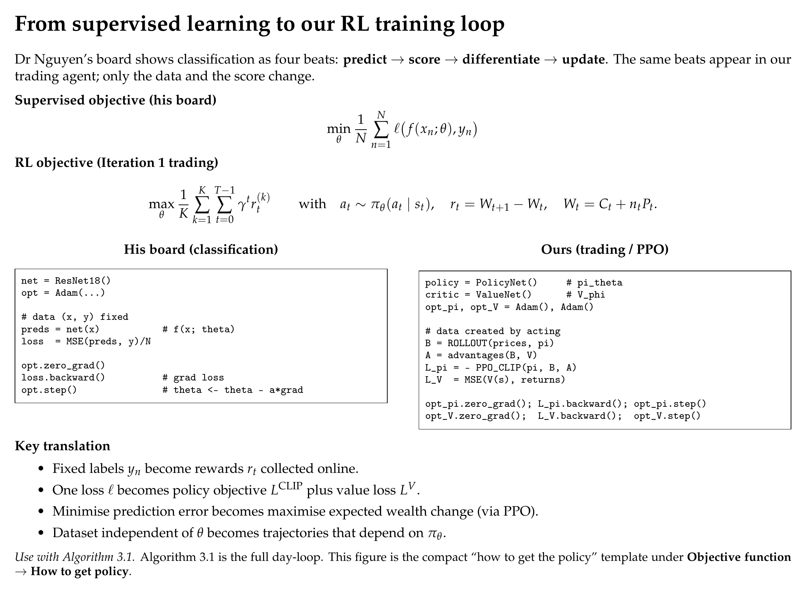
Supervised loss board (left) mapped onto the PPO policy / value loop (right).

Phase 0: game correctness sandbox
A trading agent that loses money is ambiguous: the market may be unlearnable, or the code may be wrong. Games remove the ambiguity because the correct outcome is known. Phase 0 validates every algorithm on three Gymnasium environments of increasing difficulty before any market data is used:
- CartPole-v1: 4-D state, 2 actions, $+1$/step upright (cap 500; solved $≈475$).
- FlappyBird-v0: 12-feature state, 2 actions, sparse pipe rewards.
- LunarLander-v3: 8-D state, 4 discrete engines, shaped landing reward (solved $≈200$).
Suites live under experiments/phase0_games/. Results are in Chapter 5.

Data pipeline and episode construction
Market data is SPY daily adjusted close, 2018–2024, fetched by fetch_spy_daily.py and frozen on disk. One episode $=$ one calendar month of daily closes ($T≈18$–$23$). This is stated honestly: it is not the 390-minute intraday session of the idealised Chapter 3 episode; the environment API is horizon-agnostic, so minute bars are a drop-in upgrade. Months split chronologically — 58 train, 26 test (Nov 2022 – Dec 2024) — and are never shuffled.

Testing and reproducibility
Unit tests (experiments/iteration1/test_env.py) enforce on both engines: (i) accounting identity — summed rewards equal total $ΔW$ within ${10}^{−6}$; (ii) mask correctness — Buy/Sell illegality and forced Hold; (iii) v1 feature correctness — analytic $PnL$ and $τ$ on a hand-built price path. Every training run pins seed, budget, fee and split inside its results JSON; charts regenerate from those JSONs via reports/builders/.

