Empirical Results & Analysis
This chapter reports every experiment on the simple-modelling track in the order the methodology builds: Phase 0 validates the learning algorithms on games with known outcomes; Phase 1 applies the validated PPO loop to real SPY data under Iteration 1 (3-D state) and Iteration 2 (5-D state). All numbers are produced by committed scripts; none are illustrative placeholders.

Experimental setup and evaluation metrics

Phase 0 (games).
Fixed seed 42. Budgets: 50,000 environment timesteps on CartPole; 150,000 on Flappy Bird and LunarLander; REINFORCE uses an equivalent episode budget. Evaluation: 30 greedy episodes. Metric: mean evaluation return.

Phase 1 (trading).
SPY daily closes 2018–2024, chronological 58 / 26 month split (test $=$ Nov 2022 – Dec 2024). $C_{0}=\$10,000$, $c=5$ bps, PPO 80,000 timesteps, seed 42. Metrics: wealth change $ΔW$ ($), trades per month, win rate vs the strongest passive baseline. Standing diagnostics: accounting identity (tolerance ${10}^{−6}$) and illegal-action request rate.

Phase 0: algorithm validation on games
Table 1.1 and Figures 1.1–1.4 summarise the three-game suite.
Phase 0 mean evaluation return (30 greedy episodes, seed 42). CartPole solved $≈475$; LunarLander $≈200$. Tabular Q-learning only on discretized CartPole.
Algorithm | CartPole-v1 | FlappyBird-v0 | LunarLander-v3
Random | 28.8 | $−7.4$ | $−183.4$
Tabular Q-learning | 500.0 | — | —
DQN | 500.0 | 7.0 | 177.6
REINFORCE (scratch) | 292.2 | 7.1 | 15.3
A2C | 500.0 | 4.6 | $−41.2$
PPO | 500.0 | 12.6 | 176.4
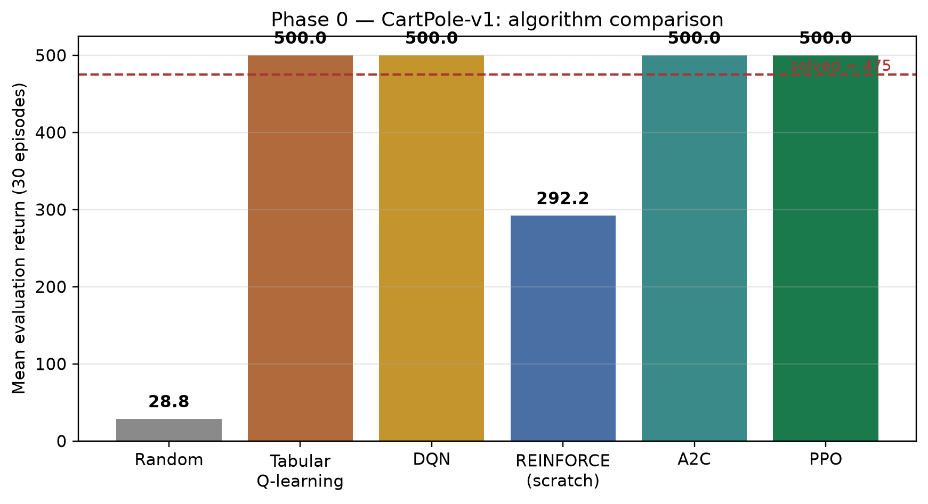
CartPole algorithm comparison. Learning methods clear the random floor; Q-table / DQN / A2C / PPO hit the 500-step cap.
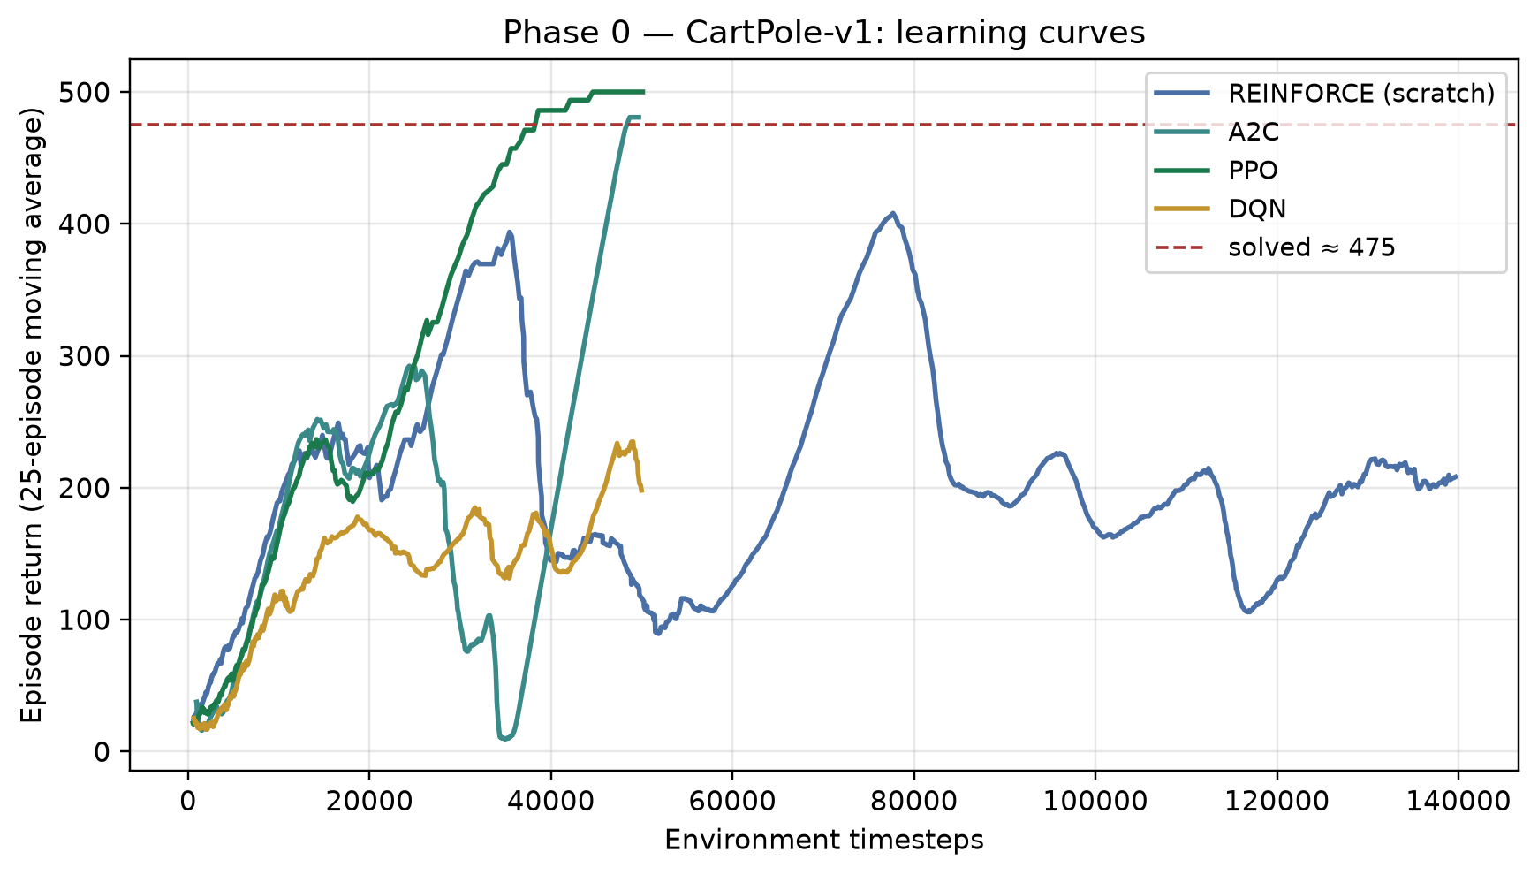
CartPole learning curves (25-episode moving average). Scratch REINFORCE learns but plateaus below the clipped / actor–critic methods.
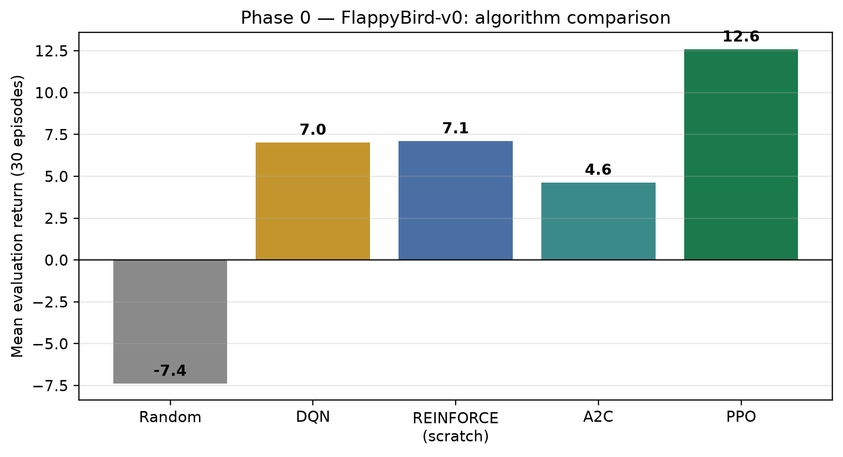
Flappy Bird comparison. PPO is the strongest learner under the fixed budget.
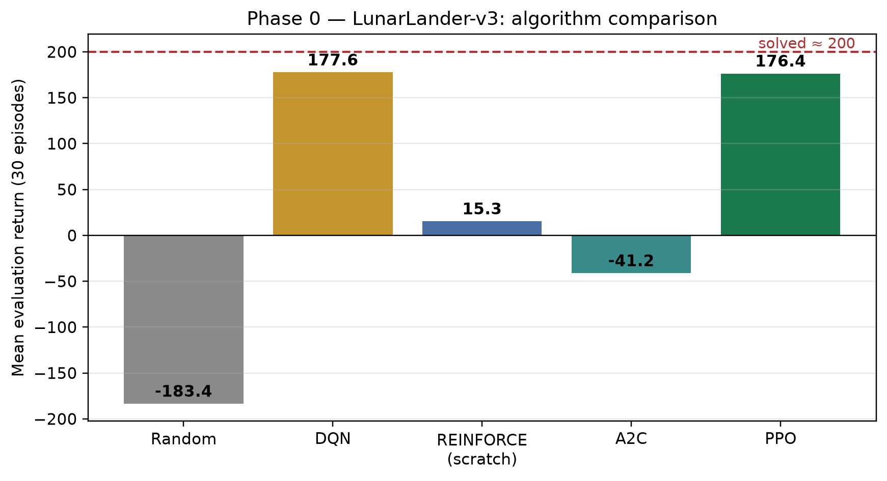
LunarLander-v3 comparison. PPO and DQN approach the solved threshold ($≈200$).

Carry-forward.
Every implementation clears its random floor. Scratch REINFORCE works but is noisy — the textbook motivation for actor–critic and clipping. Tabular Q-learning reaches 500 on CartPole only after hand-binning; trading states with continuous cash and prices make that table explode, so Phase 1 uses policy-gradient methods with function approximation. PPO is the most consistent learner across games and is therefore the trading algorithm.

Phase 1, Iteration 1: the 3-D state agent
Table 1.2 and Figure 1.5 compare PPO on TradingEnv-v0 against four baselines with explicit objectives.
Iteration 1 on 26 held-out SPY test months. $ΔW$ in dollars; fee 5 bps; PPO 80k steps.
Method | Mean $ΔW$ | Std | Trades/mo | Win vs B1b
B0 do-nothing | 0.00 | 0.00 | 0.0 | 31%
B1 buy-one-hold | 7.97 | 16.67 | 1.0 | 31%
B1b buy-max-hold | 76.91 | 178.68 | 19.1 | —
B2 random (masked) | 14.14 | 32.93 | 12.8 | 31%
A1 PPO (3-D state) | 76.91 | 178.68 | 19.1 | 0%
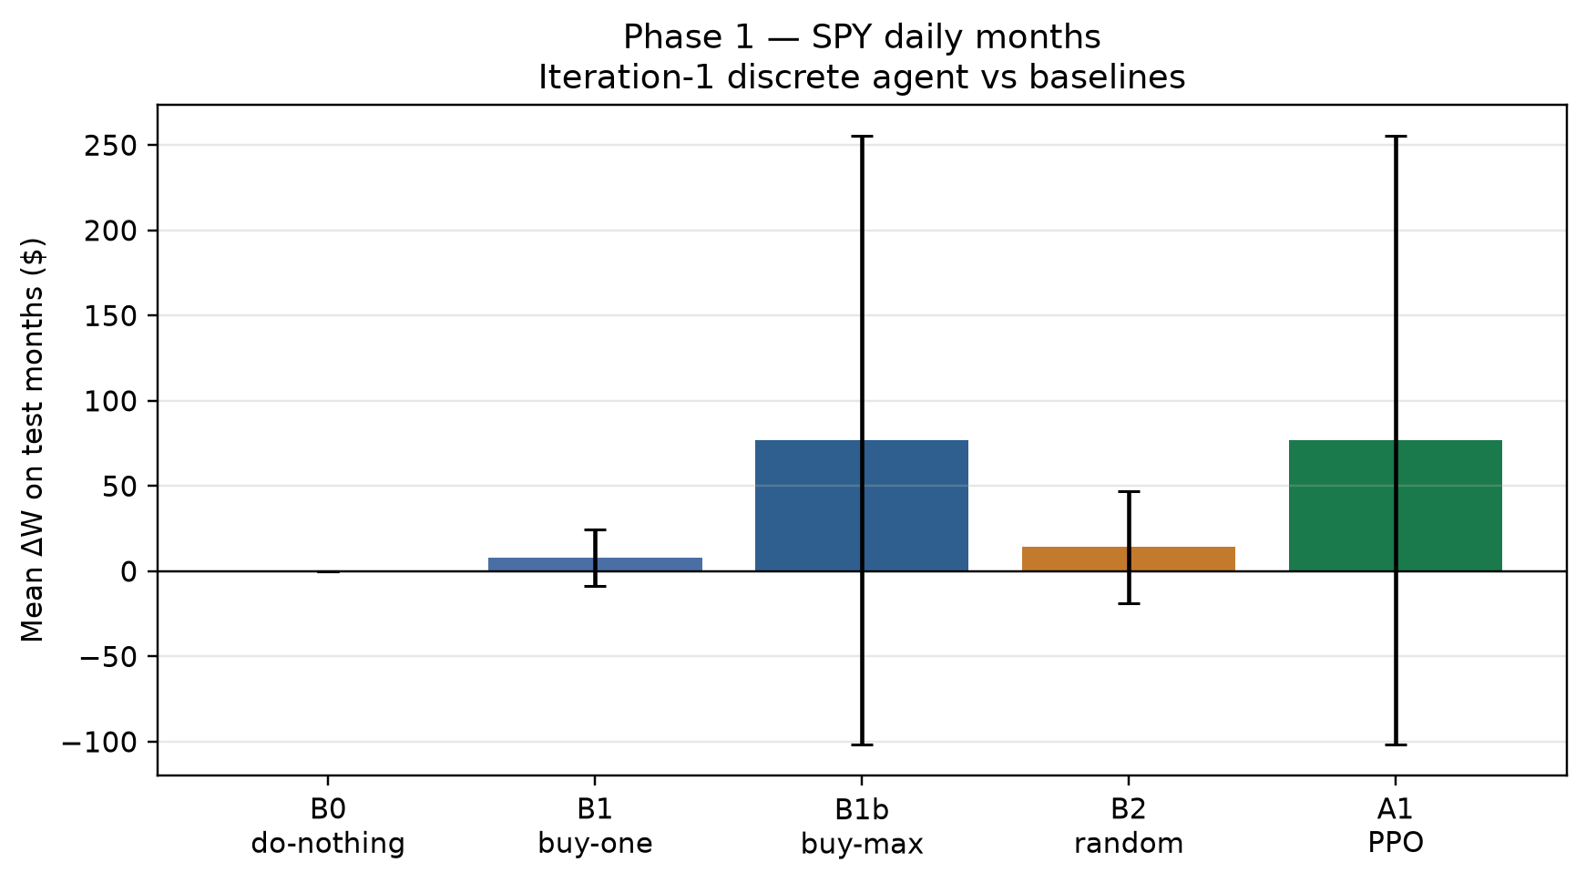
Iteration 1 mean $ΔW$ on test months. A1 matches B1b exactly once the fair fully-invested baseline is included.
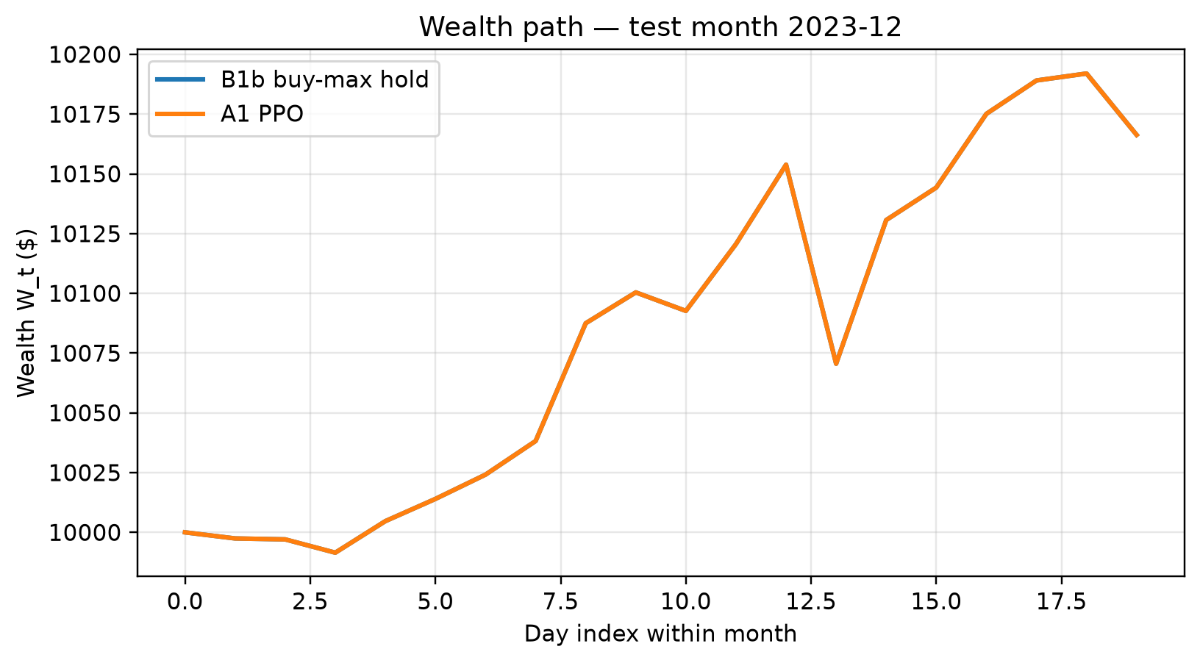
Wealth path for a representative test month: B1b buy-max hold vs A1 PPO (identical after collapse).

Honest headline.
Deterministic PPO matched B1b on all 26 test months: under pure $ΔW$ with a 3-D state, the learned policy is “get fully invested and stay there.” Against the one-share baseline B1 this would look like a $10×$ win; against fair B1b it is rediscovered buy-and-hold. Accounting identity held exactly; illegal-action request rate was 3.9%.

Phase 1, Iteration 2: the 5-D state agent
Iteration 2 re-trains the identical PPO configuration on TradingEnv-v1, changing only the state. Table 1.3 and Figure 1.7 report the comparison.
Iteration 2 vs Iteration 1 on the same 26 test months, budget, fee and seed.
Method | Mean $ΔW$ | Trades/mo | Months identical to B1b
A1 PPO, 3-D (Iter. 1) | 76.91 | 19.1 | 26 / 26
A2 PPO, 5-D (Iter. 2) | 0.00 | 0.0 | 0 / 26
B1b buy-max-hold | 76.91 | 19.1 | —
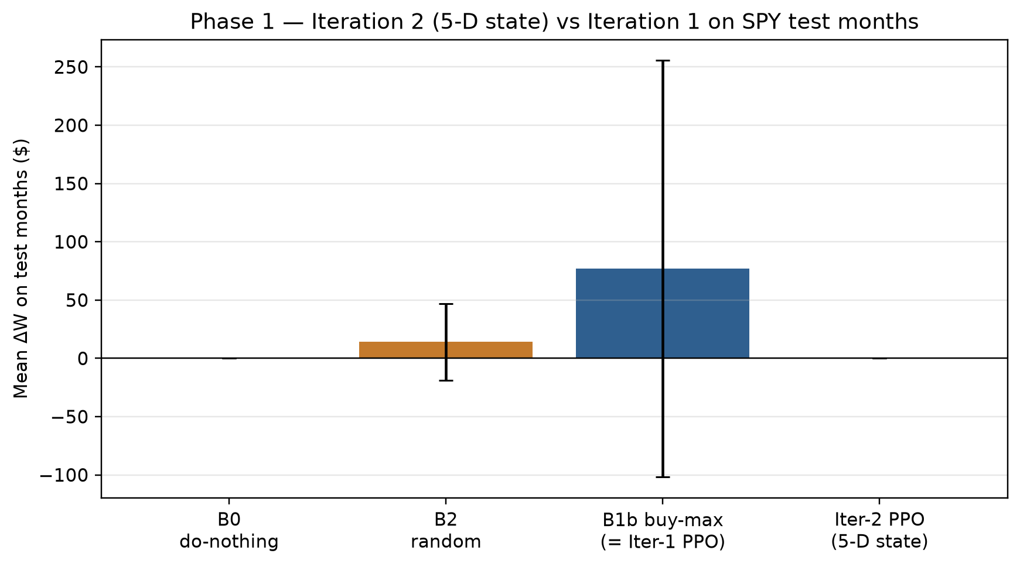
Iteration 2 (5-D) vs Iteration 1 / buy-max. Richer state breaks the collapse but converges mostly-flat under deterministic evaluation.
The richer state did break the buy-and-hold collapse (0/26 months identical to B1b) but converged to the opposite corner: a cautious, mostly-flat policy. Mean action probabilities on a representative test month: Hold 0.66, Buy 0.12, Sell 0.22 — so argmax evaluation never trades. Sampling actions stochastically yields mean $ΔW=+\$1.87$. Month-by-month, the flat agent still beats fully-invested B1b in 8 of 26 months (the falling ones).

Master comparison across iterations
Master results table for the simple-modelling track (Phase 1, SPY test months).
Metric | B1b buy-max | Iter. 1 PPO (3-D) | Iter. 2 PPO (5-D)
State dimension | — | 3 | 5
Mean $ΔW$ ($) | 76.91 | 76.91 | 0.00
Mean trades / month | 19.1 | 19.1 | 0.0
Identical to B1b (months) | — | 26/26 | 0/26
Accounting identity | pass | pass | pass

Analysis and key findings

1. The reward, not the state, sets the incentive.
Under $r_{t}=ΔW_{t}$ in a mostly-rising test window, full investment is near-optimal and Iteration 1 found exactly that. Adding entry and time context moved the policy along the exposure axis (always-invested $→$ almost-never-invested) without creating selective timing. Both extremes are rational responses to a risk-neutral reward estimated from noisy monthly episodes whose training window includes the COVID crash and the 2022 bear market.

2. Baseline design is itself a result.
Without fair B1b, Iteration 1 would have been reported as “PPO beats buy-and-hold by $10×$.” With it, the correct statement is “PPO rediscovered buy-and-hold.”

3. What Iteration 3 must change.
Because the state upgrade only shifted exposure, the next iteration targets the objective: $r_{t}=ΔW_{t}−λD_{t}$ (drawdown penalty) gives a reason to hold selectively. The masked-action rate and accounting identity carry forward as standing diagnostics.

Scope.
Single-seed, fixed budget, monthly daily-bar episodes. Multi-seed confidence intervals, minute-bar episodes ($T=390$), and the drawdown-penalised reward are the planned extensions, in that order.

