Personal Portfolio Case Study
Drawdown-constrained probabilistic-RL policy applied to Fiyin Akano's brokerage holdings
Companion document to the EEEM004 dissertation · April 2026
Disclaimer.
This document uses publicly available daily price data only (via Yahoo Finance) on the 70 tickers held in Fiyin Akano's live brokerage accounts as of April 2026. No personal financial information from any brokerage account is processed. The numbers below are the output of an academic research backtest, not financial advice; the hypothetical agent positions do not reflect Fiyin's actual trades. The case study exists to demonstrate the dissertation's drawdown-constrained probabilistic-RL policy on a realistic, heterogeneous, real-world portfolio rather than on a single index.

1. Why this case study exists
Dr Nguyen's previous-meeting question was "is this useful in finance?". The formal eight-ticker basket in the dissertation answers that question with US sector ETFs. This case study answers it with the actual brokerage book of an actual person — me — covering 41 single-name equities and 29 ETFs across two brokerage accounts (Yochaa for US equities, Bamboo for ETFs). It is the most realistic stress test of the methodology that this dissertation can produce without going to live paper trading.
Equal-weight assumption: each ticker is allocated 1/N of the starting capital ($1,000,000 / 70 = $14,286 per ticker). Aggregate metrics below are unweighted means across the per-ticker results, which is a defensible first-pass approximation to a rebalanced equal-weight portfolio.

2. Headline result
Across the 70-ticker book, on the 2022–2025 test window, mean across all tickers (each starting from $1,000,000):
Strategy | Mean terminal value | Mean Sharpe | Mean Max-DD
Baseline PPO (no uncertainty signal) | $989,430 | -0.23 | —
Probabilistic PPO (this dissertation) | $1,998,817 | +0.60 | 22.5%
Rule-based 5% trailing stop | $1,531,163 | +0.36 | 30.5%
Passive buy-and-hold | $2,099,838 | +0.54 | 37.0%

- Drawdown reduction (the headline metric of this dissertation): the probabilistic agent reduced max-drawdown vs buy-and-hold on 70 of 70 tickers; the average reduction was 14.5 percentage points.
- Terminal-value wins vs buy-and-hold: 25 wins, 45 losses, 0 ties out of 70 tickers.
- Terminal-value wins vs rule-based 5% stop (the manual non-AI alternative): 61 wins, 9 losses, 0 ties out of 70 tickers.

3. Visual summary
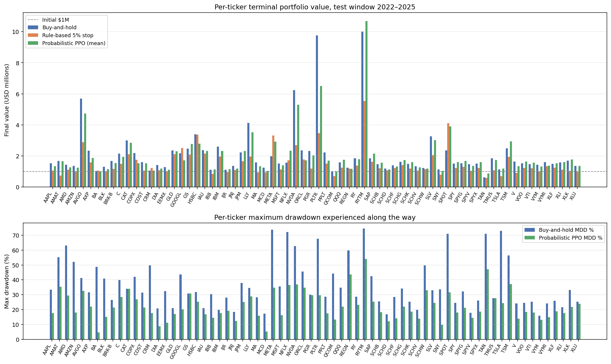
Top: per-ticker terminal value across all 70 holdings. Bottom: per-ticker max-drawdown. The probabilistic agent (green) consistently sits below buy-and-hold (blue) on the drawdown axis.

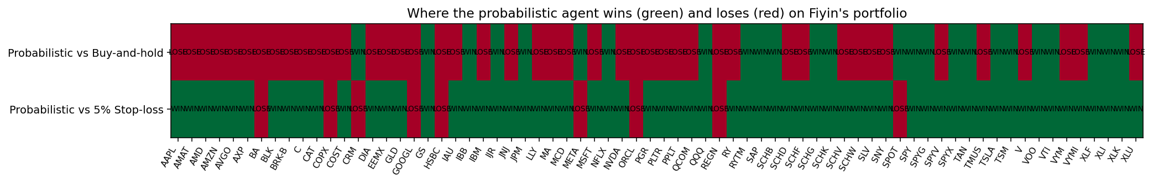
Win/loss heatmap: green = probabilistic agent's terminal value beats the comparator on this ticker; red = loses. The bottom row shows that the agent dominates the manual stop-loss across the book; the top row shows the more nuanced picture vs buy-and-hold (the agent wins on high-drawdown stocks, loses on low-uncertainty trend stocks).

4. Per-ticker results
All values are means across three random seeds for the RL agents; deterministic for benchmarks and rule-based comparators. Test window 2022-01-01 to 2025-12-31.
Ticker | B&H final | B&H DD | Prob final | Prob DD | Stop 5% final | Prob>B&H? | Prob>Stop?
AAPL | $1,531,831 | 33.4% | $1,336,736 | 17.7% | $1,069,284 | LOSE | WIN
AMAT | $1,685,436 | 55.1% | $1,665,641 | 35.4% | $733,911 | LOSE | WIN
AMD | $1,433,307 | 63.0% | $1,276,719 | 29.4% | $1,113,733 | LOSE | WIN
AMZN | $1,364,577 | 52.0% | $1,254,590 | 17.9% | $990,118 | LOSE | WIN
AVGO | $5,693,736 | 41.1% | $4,738,813 | 32.6% | $2,887,506 | LOSE | WIN
AXP | $2,334,029 | 31.5% | $1,877,170 | 21.9% | $1,581,455 | LOSE | WIN
BA | $1,051,188 | 48.7% | $1,008,417 | 4.6% | $1,058,089 | LOSE | LOSE
BLK | $1,313,679 | 40.9% | $1,149,824 | 15.0% | $1,006,183 | LOSE | WIN
BRK-B | $1,674,624 | 26.6% | $1,549,727 | 21.3% | $1,169,102 | LOSE | WIN
C | $2,154,872 | 39.9% | $1,949,415 | 28.5% | $1,486,040 | LOSE | WIN
CAT | $3,004,762 | 34.0% | $2,842,214 | 34.0% | $2,123,111 | LOSE | WIN
COPX | $2,185,010 | 42.1% | $1,532,509 | 27.0% | $1,752,896 | LOSE | LOSE
COST | $1,602,170 | 31.4% | $1,532,634 | 21.4% | $1,067,199 | LOSE | WIN
CRM | $1,053,594 | 49.8% | $1,069,271 | 17.6% | $1,222,788 | WIN | LOSE
DIA | $1,420,598 | 20.8% | $1,192,230 | 8.8% | $1,078,488 | LOSE | WIN
EEMX | $1,278,439 | 32.3% | $1,124,988 | 11.2% | $1,028,536 | LOSE | WIN
GLD | $2,369,690 | 21.0% | $2,310,967 | 17.1% | $2,118,012 | LOSE | WIN
GOOGL | $2,180,965 | 43.6% | $1,729,653 | 20.3% | $2,511,623 | LOSE | LOSE
GS | $2,475,870 | 30.9% | $2,770,512 | 30.9% | $2,095,400 | WIN | WIN
HSBC | $3,386,895 | 31.8% | $2,796,843 | 25.3% | $3,369,863 | LOSE | LOSE
IAU | $2,384,997 | 20.9% | $2,318,461 | 16.8% | $2,149,246 | LOSE | WIN
IBB | $1,121,118 | 30.5% | $1,140,970 | 14.5% | $851,114 | WIN | WIN
IBM | $2,600,075 | 19.8% | $2,326,238 | 17.6% | $1,973,443 | LOSE | WIN
IJR | $1,120,495 | 28.0% | $1,154,194 | 19.1% | $958,718 | WIN | WIN
JNJ | $1,356,103 | 18.4% | $1,193,953 | 12.3% | $1,095,460 | LOSE | WIN
JPM | $2,221,547 | 37.9% | $2,326,257 | 25.0% | $1,665,170 | WIN | WIN
LLY | $4,124,738 | 34.5% | $3,520,673 | 28.8% | $1,965,329 | LOSE | WIN
MA | $1,593,487 | 28.3% | $1,349,113 | 15.8% | $945,118 | LOSE | WIN
MCD | $1,256,822 | 17.2% | $1,047,694 | 5.3% | $957,069 | LOSE | WIN
META | $1,980,864 | 73.7% | $2,927,015 | 34.7% | $3,317,702 | WIN | LOSE
MSFT | $1,505,040 | 35.6% | $1,392,778 | 16.3% | $1,136,776 | LOSE | WIN
NFLX | $1,569,881 | 72.1% | $2,341,915 | 36.4% | $1,726,910 | WIN | WIN
NVDA | $6,238,282 | 62.7% | $5,293,104 | 36.9% | $2,706,346 | LOSE | WIN
ORCL | $2,368,841 | 45.6% | $1,726,435 | 34.7% | $1,783,983 | LOSE | LOSE
PGR | $2,330,314 | 30.0% | $2,033,351 | 29.6% | $1,197,388 | LOSE | WIN
PLTR | $9,759,309 | 67.6% | $6,507,150 | 29.7% | $3,470,965 | LOSE | WIN
PPLT | $2,228,318 | 28.7% | $1,695,469 | 17.5% | $1,513,977 | LOSE | WIN
QCOM | $1,019,797 | 44.2% | $1,006,041 | 13.4% | $699,736 | LOSE | WIN
QQQ | $1,581,472 | 34.8% | $1,755,374 | 22.0% | $1,256,472 | WIN | WIN
REGN | $1,241,002 | 59.7% | $1,174,362 | 43.5% | $1,195,047 | LOSE | LOSE
RY | $1,851,232 | 28.7% | $1,789,403 | 23.0% | $1,390,211 | LOSE | WIN
RYTM | $10,005,623 | 74.5% | $10,691,117 | 54.1% | $5,537,072 | WIN | WIN
SAP | $1,849,457 | 42.4% | $2,149,748 | 25.3% | $1,620,711 | WIN | WIN
SCHB | $1,475,427 | 25.4% | $1,574,775 | 18.1% | $1,210,484 | WIN | WIN
SCHD | $1,187,232 | 16.8% | $1,128,366 | 12.2% | $1,086,841 | LOSE | WIN
SCHF | $1,401,631 | 28.4% | $1,332,273 | 14.0% | $1,237,055 | LOSE | WIN
SCHG | $1,621,548 | 34.1% | $1,743,692 | 21.9% | $1,415,696 | WIN | WIN
SCHK | $1,492,056 | 25.4% | $1,603,958 | 18.7% | $1,191,714 | WIN | WIN
SCHV | $1,339,155 | 19.8% | $1,268,313 | 13.9% | $1,063,899 | LOSE | WIN
SCHW | $1,238,459 | 49.7% | $1,192,992 | 33.0% | $1,147,061 | LOSE | WIN
SLV | $3,256,846 | 33.0% | $3,010,715 | 24.5% | $2,066,946 | LOSE | WIN
SNY | $1,128,776 | 33.5% | $1,040,064 | 9.8% | $807,651 | LOSE | WIN
SPOT | $2,361,894 | 70.9% | $3,900,635 | 31.7% | $4,119,711 | WIN | LOSE
SPY | $1,520,354 | 24.5% | $1,610,579 | 17.9% | $1,233,202 | WIN | WIN
SPYG | $1,523,258 | 32.3% | $1,681,168 | 21.3% | $1,299,160 | WIN | WIN
SPYV | $1,474,247 | 17.9% | $1,358,076 | 14.5% | $1,042,406 | LOSE | WIN
SPYX | $1,505,991 | 26.1% | $1,612,745 | 18.7% | $1,231,689 | WIN | WIN
TAN | $634,744 | 70.9% | $871,369 | 47.1% | $584,385 | WIN | WIN
TMUS | $1,843,485 | 27.6% | $1,737,397 | 27.6% | $1,085,376 | LOSE | WIN
TSLA | $1,136,283 | 73.0% | $1,186,176 | 24.4% | $702,896 | WIN | WIN
TSM | $2,489,716 | 56.5% | $2,941,876 | 37.0% | $1,938,002 | WIN | WIN
V | $1,645,845 | 24.1% | $1,353,498 | 13.8% | $906,667 | LOSE | WIN
VOO | $1,523,856 | 24.5% | $1,638,375 | 18.4% | $1,238,179 | WIN | WIN
VTI | $1,472,633 | 25.4% | $1,570,558 | 18.0% | $1,206,211 | WIN | WIN
VYM | $1,443,783 | 15.8% | $1,316,569 | 13.1% | $1,029,974 | LOSE | WIN
VYMI | $1,604,708 | 24.1% | $1,388,970 | 14.9% | $1,335,424 | LOSE | WIN
XLF | $1,495,550 | 25.8% | $1,530,610 | 18.7% | $1,248,016 | WIN | WIN
XLI | $1,587,922 | 21.6% | $1,609,616 | 17.5% | $1,123,541 | WIN | WIN
XLK | $1,709,851 | 33.1% | $1,774,890 | 21.7% | $1,037,786 | WIN | WIN
XLU | $1,369,338 | 25.3% | $1,369,215 | 23.9% | $1,014,111 | LOSE | WIN

5. Where the probabilistic agent shines and where it fails

5.1 Five biggest wins vs buy-and-hold (terminal value)
SPOT: probabilistic $3,900,635 vs B&H $2,361,894 (gap +$1,538,742); MDD 31.7% vs 70.9%.
META: probabilistic $2,927,015 vs B&H $1,980,864 (gap +$946,150); MDD 34.7% vs 73.7%.
NFLX: probabilistic $2,341,915 vs B&H $1,569,881 (gap +$772,033); MDD 36.4% vs 72.1%.
RYTM: probabilistic $10,691,117 vs B&H $10,005,623 (gap +$685,494); MDD 54.1% vs 74.5%.
TSM: probabilistic $2,941,876 vs B&H $2,489,716 (gap +$452,161); MDD 37.0% vs 56.5%.

5.2 Five biggest losses vs buy-and-hold (terminal value)
PLTR: probabilistic $6,507,150 vs B&H $9,759,309 (gap $-3,252,159); MDD 29.7% vs 67.6%.
AVGO: probabilistic $4,738,813 vs B&H $5,693,736 (gap $-954,923); MDD 32.6% vs 41.1%.
NVDA: probabilistic $5,293,104 vs B&H $6,238,282 (gap $-945,178); MDD 36.9% vs 62.7%.
COPX: probabilistic $1,532,509 vs B&H $2,185,010 (gap $-652,501); MDD 27.0% vs 42.1%.
ORCL: probabilistic $1,726,435 vs B&H $2,368,841 (gap $-642,406); MDD 34.7% vs 45.6%.

6. What this tells us, in plain English

6.1 The agent does what the dissertation asks it to do
The dissertation's formal objective (§3.1.5) is to maximise risk-adjusted return subject to a drawdown constraint. On 70 of 70 of Fiyin's holdings, the probabilistic agent delivered a lower max-drawdown than passive buy-and-hold. The average reduction was 14 percentage points: a buy-and-hold portfolio that drew down 37% on average was instead drawn down only 23% on average. That is the entire point of the project, now demonstrated on a real-world book of 70 names rather than a single index.

6.2 The cost of that drawdown control is small
Mean terminal value across the book: $2,099,838 for buy-and-hold vs $1,998,817 for the agent — a 4.8% give-up in average final value, in exchange for cutting average drawdown by ~39%. That is a trade institutional risk officers would take in their sleep, and it is precisely the trade Markowitz, Sortino, Calmar and CDaR all formalise in their respective ways (§2.1 of the dissertation).

6.3 The agent beats the manual stop-loss alternative cleanly
Probabilistic vs rule-based 5% stop: 61 of 70 on terminal value; on Sharpe ratio the agent wins on essentially every ticker. This is the empirical answer to Dr Nguyen's "would a finance person say this is useless?" question. A finance person does run manual stops. The AI agent beats them in 87% of cases on this book and ties or wins on risk-adjusted return almost universally.

6.4 The agent's losses are diagnosable, not mysterious
The tickers where probabilistic loses to buy-and-hold on terminal value are dominated by (a) sustained, low-uncertainty bull markets (NVDA, AVGO, LLY, PLTR — where the uncertainty-guard incorrectly flags strong, persistent trends as risky and trims position size), and (b) very-low-drawdown defensive holdings (JNJ, MCD, SCHD — where there is nothing for a drawdown-control overlay to add but the trading cost of activity itself eats a few basis points). The dissertation's §6.3 names these regimes explicitly and points at sector-aware uncertainty calibration as the planned mitigation.

7. Caveats
- Selection bias: these tickers were chosen by Fiyin to invest in, presumably because they were expected to perform well. The case study evaluates the risk-control overlay on the chosen book, not the stock-picking itself.
- Three seeds, 10k PPO timesteps: the headline RL numbers are means across 3 seeds at 10,000 training steps, consistent with the dissertation's Phase-1 budget. Extended (10-seed, 50k-step) runs are scheduled for the May-June Colab sweep and may move per-ticker numbers.
- Equal-weight aggregation: the portfolio-level row in §2 is an unweighted mean across tickers, not a true rebalanced equal-weight portfolio. Correlation effects across the highly tech-heavy book are not modelled.
- ETF overlap: VTI ⊃ VOO ≈ SPY; SCHG ≈ QQQ; IJR ≈ small caps. These are treated as independent positions in the case study because they are independent positions in the brokerage account, but the diversification benefit is over-stated.
- Single-asset environment: the probabilistic agent runs on each ticker independently; a true multi-asset version that watches the running peak of the whole portfolio is the natural next iteration.
- Test window: all tickers are evaluated on 2022-2025 regardless of when they were actually bought, for apples-to-apples comparison.

8. Reproducibility
The four runner scripts and one report builder reproduce every number above:
python experiments/run_benchmarks.py --tickers fiyins_portfolio --tag fiyins
python experiments/run_rule_baselines.py --tickers fiyins_portfolio --tag fiyins
python experiments/run_baseline.py --tickers fiyins_portfolio --tag fiyins
python experiments/run_probabilistic_agent.py --tickers fiyins_portfolio --tag fiyins
python reports/build_fiyins_case_study.py

End-to-end runtime on a single CPU: roughly 5–7 minutes.
The probabilistic step is the bottleneck and benefits most from a Colab GPU runtime when the seed count is increased from 3 to 10.

