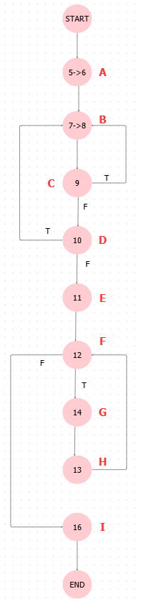
#include <iostream>
- #include <cmath>
- using namespace std;
- int main() {
- int n;
- do {
- cout << "Nhap n (10 < n < 50): ";
- cin >> n;
- } while (n <= 10
- || n >= 50);
- double S = 0;
- for (int i = 1; i <= n;
- i++) {
- S += 1.0 / sqrt(i * (i + 1));
- }
- cout << "Tong S = " << S << endl;
- return 0;
- }

