All status of an OSMBC blog
Status | How do I recognise the status of a blog? | What can I do? | What should I don't do?
OPEN |  | Collect new articles, Edit articles  note: all collects are dedicated to the OPEN blog
EDIT |  | Edit articles  The button – button Set Ready to Review is pressed, after EXPORT | Normally you shoudn t collect even it is possible with at detour
REVIEW | 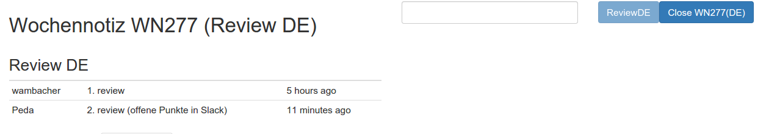 | This button indicates, that the blog is in WordPress to review.  You should not edit! (although technically it's still possible!  The button Close WN2XX is pressed after PUBLISHING. | You should no edit neither review in OSMBC anymore, because the text has been exported and is in REVIEW in WordPress.  After reviewing in WordPress, write a free text into the box in front of the REVIEW button, and click REVIEW. Everybody can see the number of reviews before the text is published.
CLOSE |  | This blog is published. You find the blog in  WN, closed

