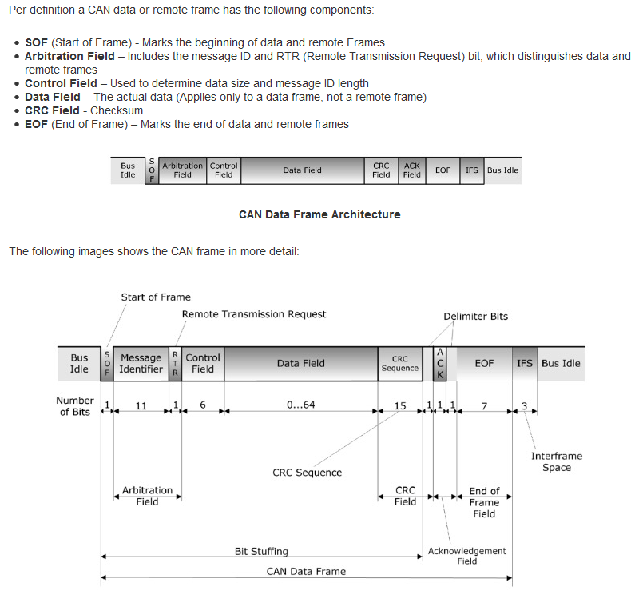
CAN DATA

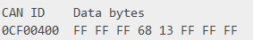
We need to convert RAW CAN data to data the UI can use.
DBC
RAW CAN data look like,
It is in MDF4 Format

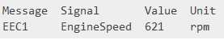
The rules on how to convert it are in a .dbc file

IMPLEMENTATION
NEEDED
Pip install canmatrix
Pip install can_decoder
Pip install pandas

You need the MF4 file and the .dbc file
TEST CODE IN OTHER FILE

USEFUL LINKS
https://pypi.org/project/can-decoder/
https://copperhilltech.com/blog/controller-area-network-can-bus-message-frame-architecture/
https://www.csselectronics.com/screen/page/mdf4-measurement-data-format/language/en
https://www.csselectronics.com/screen/page/can-dbc-file-database-intro/language/en

