UI –
NEED DISPLAYED ? – no info on regulations

Displayed

Buttons
Left above button – Create arrow, every time is pressed, it rotates it 90 degrees.(Perhaps keep the driver driving straight?)

Middle left button - Sensor values( not yet binded. Which sensors?)
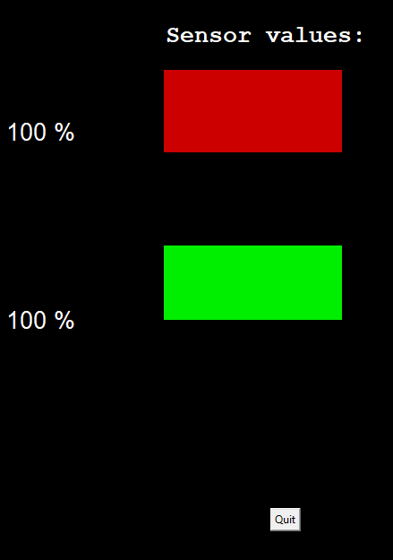

Under left button : not binded

Right above button – starts timer
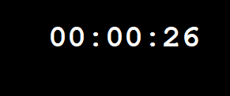
Right mid button – clears timer

Right under button – shows sensor data/ temperature data. Yellow-red = temp up/down

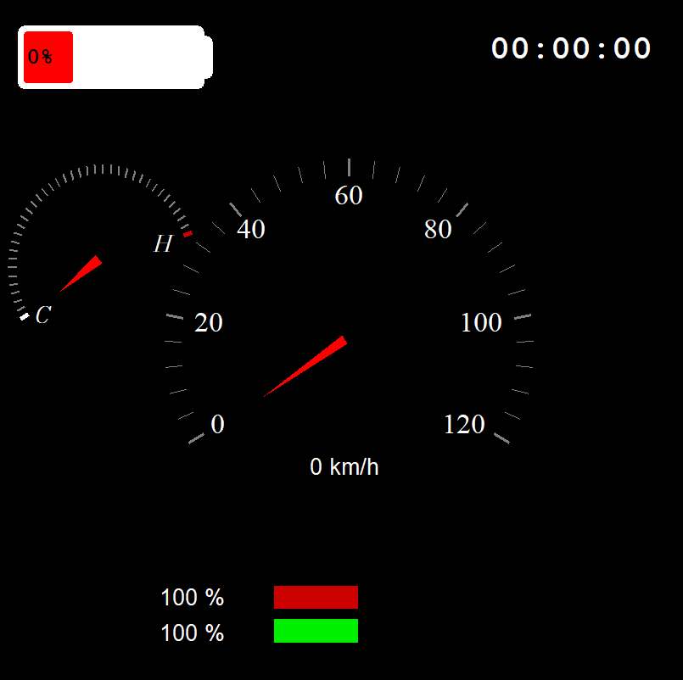
Quit button – quits program

- Gas pressed/acceleration

It is compatible with what we have now. Only window size change.

V2 – V3
Use physical buttons -done
Bind the unfuntctional buttons to the right sensor data
Use the spi/datalogger functions

