OPENVALS

Platform Architecture Flow
Application boundaries · Backend services · Data · External integrations

1. Architecture Objective
This document describes the logical architecture and the interactions between the OpenVals public website, Customer Application, Admin Console, FastAPI backend, PostgreSQL, background processing, and external providers. It is a logical view; deployment topology, network boundaries, and exact service ownership should be confirmed against the deployed environment.

2. High-Level Architecture
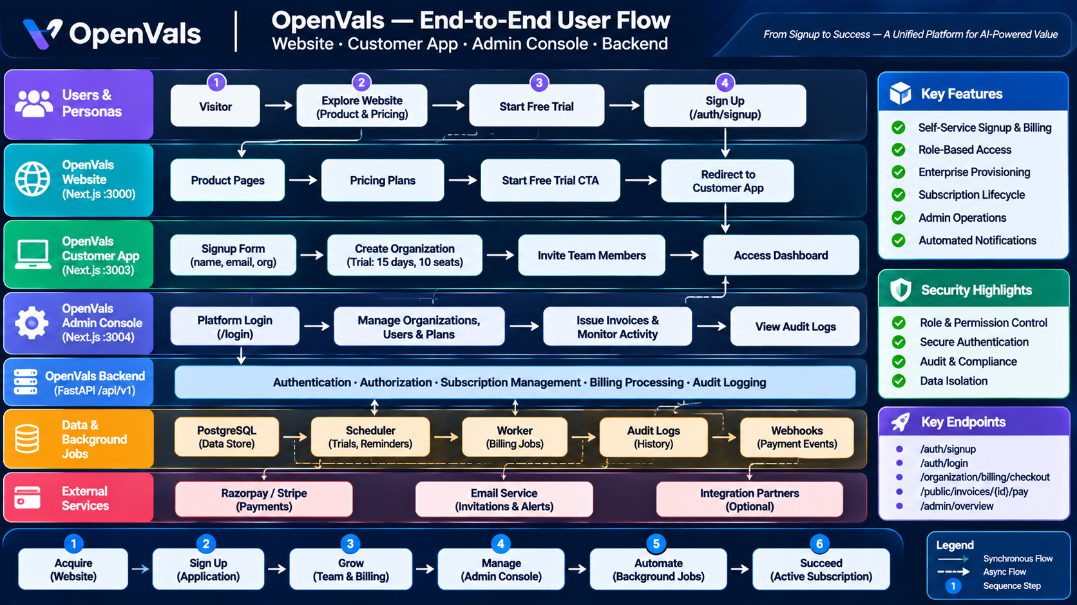
Figure 1. OpenVals platform flow overview
Layer | Component | Primary responsibilities
Presentation | Website — Next.js :3000 | Public pages, pricing, acquisition, signup CTA
Presentation | Customer App — Next.js :3003 | Tenant workspace, team, roles, billing, customer journeys
Presentation | Admin Console — Next.js :3004 | Platform operations, organizations, subscriptions, invoices, governance
API / business | FastAPI /api/v1 | Authentication, authorization, tenant boundaries, business rules, billing and admin APIs
Persistence | PostgreSQL | Organizations, users, roles, permissions, plans, subscriptions, invoices, payment orders, audit and event records
Async processing | Scheduler + worker | Trial reminders, billing sweep, invoice reminders, suspension, email delivery, webhook processing
External | Razorpay / Stripe / Email | Payment checkout, provider callbacks, email invitations and notifications

3. Main Request Flows

3.1 Public Acquisition and Signup
- Visitor requests public website pages.
- Website CTA redirects to Customer App signup with source context.
- Customer App submits signup request to FastAPI.
- Backend validates and transactionally creates tenant, owner, role, and trial subscription.
- Backend issues session credentials; Customer App opens the command center.

3.2 Authenticated Customer Requests
- Customer App sends API requests with the authenticated session.
- Backend authenticates the user and resolves organization membership.
- Authorization checks role and permission.
- Entitlement service checks subscription state, plan limits, and seat capacity where relevant.
- Business service reads or writes tenant-scoped PostgreSQL records.
- Response returns to Customer App; UI reflects authorized state.

3.3 Admin Console Requests
- Staff authenticates through the Admin Console login.
- Backend verifies credentials and requires at least one `platform.*` permission.
- Admin session is established using protected cookies.
- Admin Console loads profile and permission-filtered navigation.
- Each administrative API independently verifies platform permission.
- Successful writes persist business changes and an audit event.

3.4 Payment and Webhook Flow
- Customer starts checkout or public invoice payment.
- Backend creates or retrieves a payment order and returns the provider checkout context.
- Payment provider processes the transaction.
- Browser result and provider webhook reach backend verification paths.
- Backend verifies signature, event identity, amount, currency, and payment state as applicable.
- Idempotent reconciliation updates payment, invoice, subscription, and entitlement records.
- Audit and notification events are recorded.

3.5 Background Billing Flow
- Scheduler triggers the billing sweep.
- Worker claims eligible work and evaluates trial, subscription, and invoice dates.
- Worker applies state transitions and creates notification work.
- Deduplication key is checked before sending.
- Email provider receives the message.
- Delivery result and provider webhook are recorded.

4. Logical Backend Service Boundaries
Logical service area | Responsibilities
Authentication | Signup, login, current user, refresh, logout, password reset, invitation token validation
Tenant and membership | Organization lifecycle, membership, invitations, seat checks, tenant isolation
RBAC | Role assignment, permission resolution, platform permission gate, organization permission checks
Plans and subscriptions | Plan catalog, subscription lifecycle, contract data, entitlement calculation
Billing and payments | Checkout, payment order, provider verification, webhook reconciliation, cancellation, resume, seat changes
Invoices | Drafting, issuing, public invoice access, payment reconciliation, PDF/link delivery
Administration | Overview, organization/user management, plan/role management, subscription operations
Audit and delivery | Audit trail, webhook event history, notification and email delivery records
Background processing | Scheduled billing sweep, reminder generation, suspension, retry and deduplication

5. Data and Trust Boundaries
- Browser clients are untrusted: validate all inputs and authorization on the backend.
- Customer tenant data must be scoped by the authenticated organization context.
- Admin APIs require platform permissions; hiding a navigation item is not authorization.
- Payment provider callbacks are untrusted until signature and event validation succeed.
- Public invoice pages expose only the minimum invoice data authorized by the public token or link policy.
- Secrets, provider credentials, and reset/invitation tokens must not be exposed in client-side storage or logs.
- Background jobs must be safe to retry and must not create duplicate financial or notification effects.

6. Resilience and Observability
- Use correlation IDs across frontend requests, backend logs, worker tasks, and provider callbacks.
- Record webhook event IDs and processing outcomes to support idempotency and replay investigation.
- Use bounded retries with backoff for transient provider/email failures; avoid retrying permanent validation errors.
- Track worker queue depth, job age, failure count, email delivery status, payment reconciliation failures, and billing transition counts.
- Ensure critical multi-entity updates use database transactions.
- Alert on repeated payment verification failures, stuck billing jobs, and failed notification delivery.

7. Architecture Decisions to Validate
- Confirm whether the three Next.js applications share a domain, use separate domains, or sit behind a reverse proxy.
- Confirm cookie domain, SameSite, CSRF, and CORS settings for cross-application authentication.
- Confirm whether webhook handlers run in the API process or a dedicated worker.
- Confirm scheduler technology, worker concurrency, locking strategy, and retry policy.
- Confirm PostgreSQL transaction boundaries and uniqueness constraints for payment and webhook idempotency.
- Confirm storage location and retention policy for invoice PDFs and audit records.

