# Introduction

This website is a place to share and sell my photography. It aims to target people who have seen my work on other sites and want to view it in higher quality or buy prints.

# GitHub – must be included in order to mark your web project

GitHub URL to open your website on a browser

<https://thefree-man.github.io/index>

URL of your GitHub Repository

<https://github.com/TheFree-Man/TheFree-Man.github.io>

# Original Mock-up Sketch of Website home page

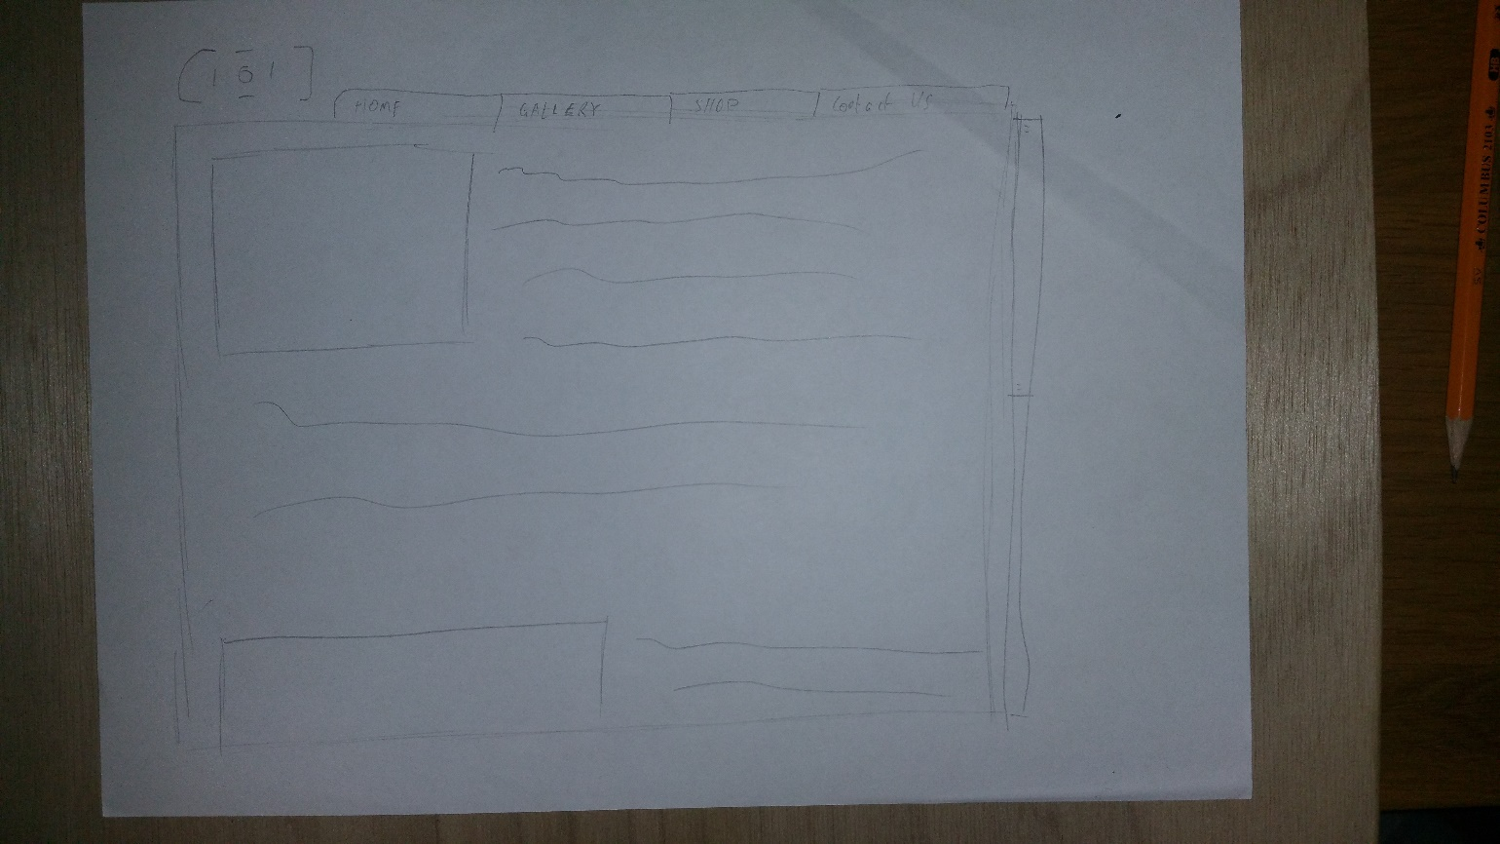

# Website Described

Page 1 – this page is the default home page that says a little bit about myself and my hobby, images from www.freeimages.com

Page 2 – this page is a gallery of images, images from [www.pixabay.com](http://www.pixabay.com)

Page 3 – this page is a store in which to buy items, images from [www.flickr.com](http://www.flickr.com), [www.istock.com](http://www.istock.com)

Page 4 – this page is where you can find my contact information and fill out an inquiry

# HTML5 Validation Results for each Webpage

Page 1 – –Validations result (with the majority of the errors resolved)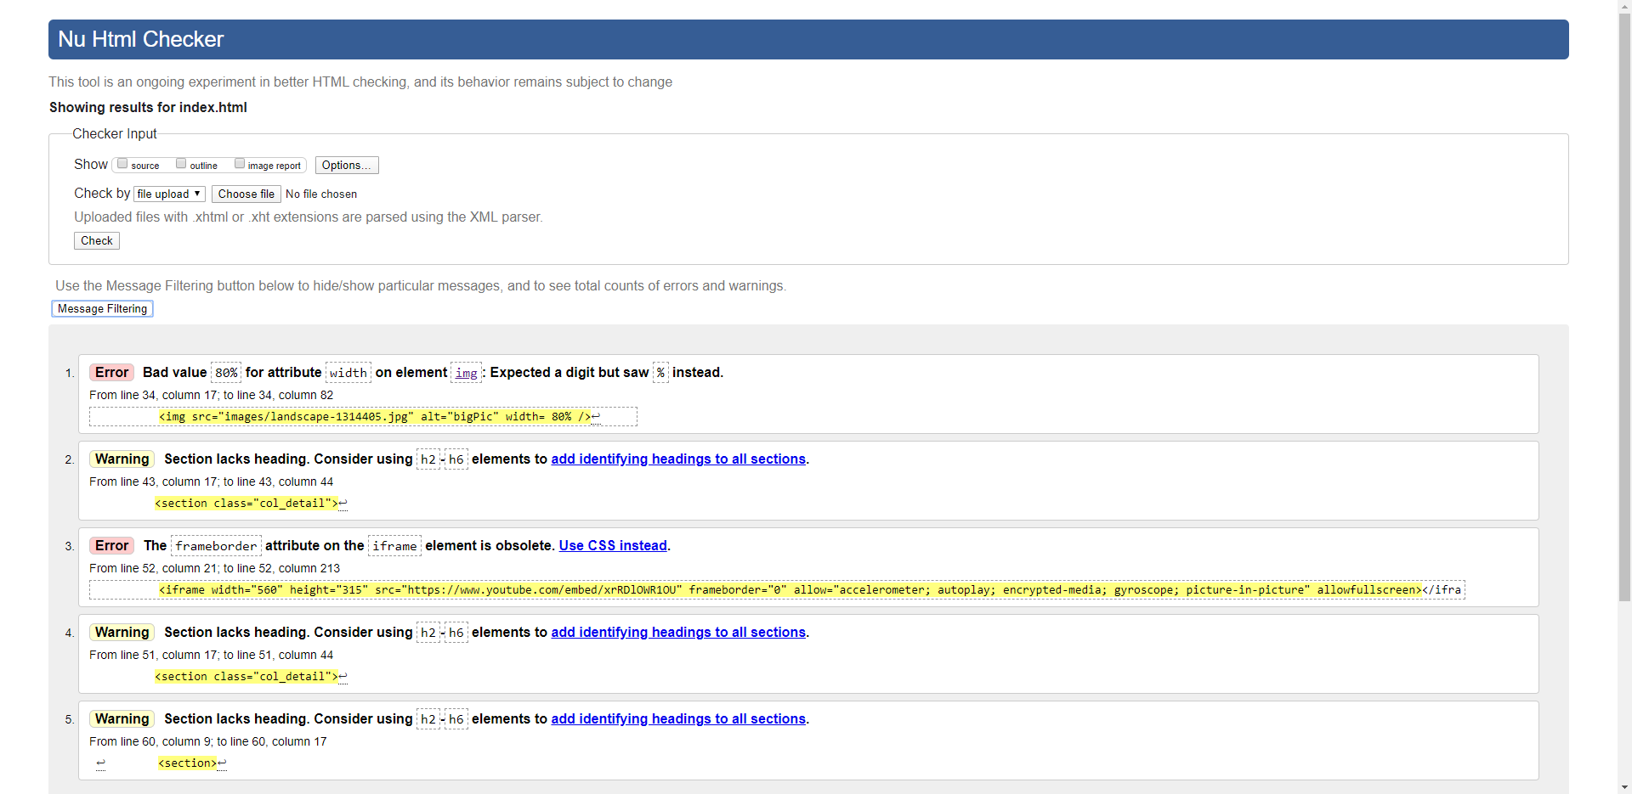

Page 2 – Validation result

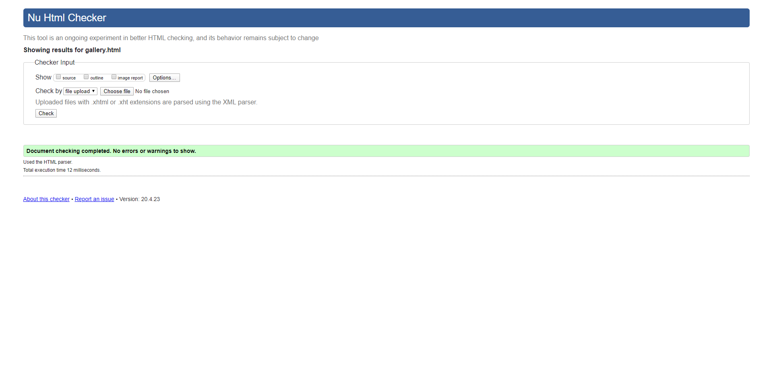

Page 3 – Validation result

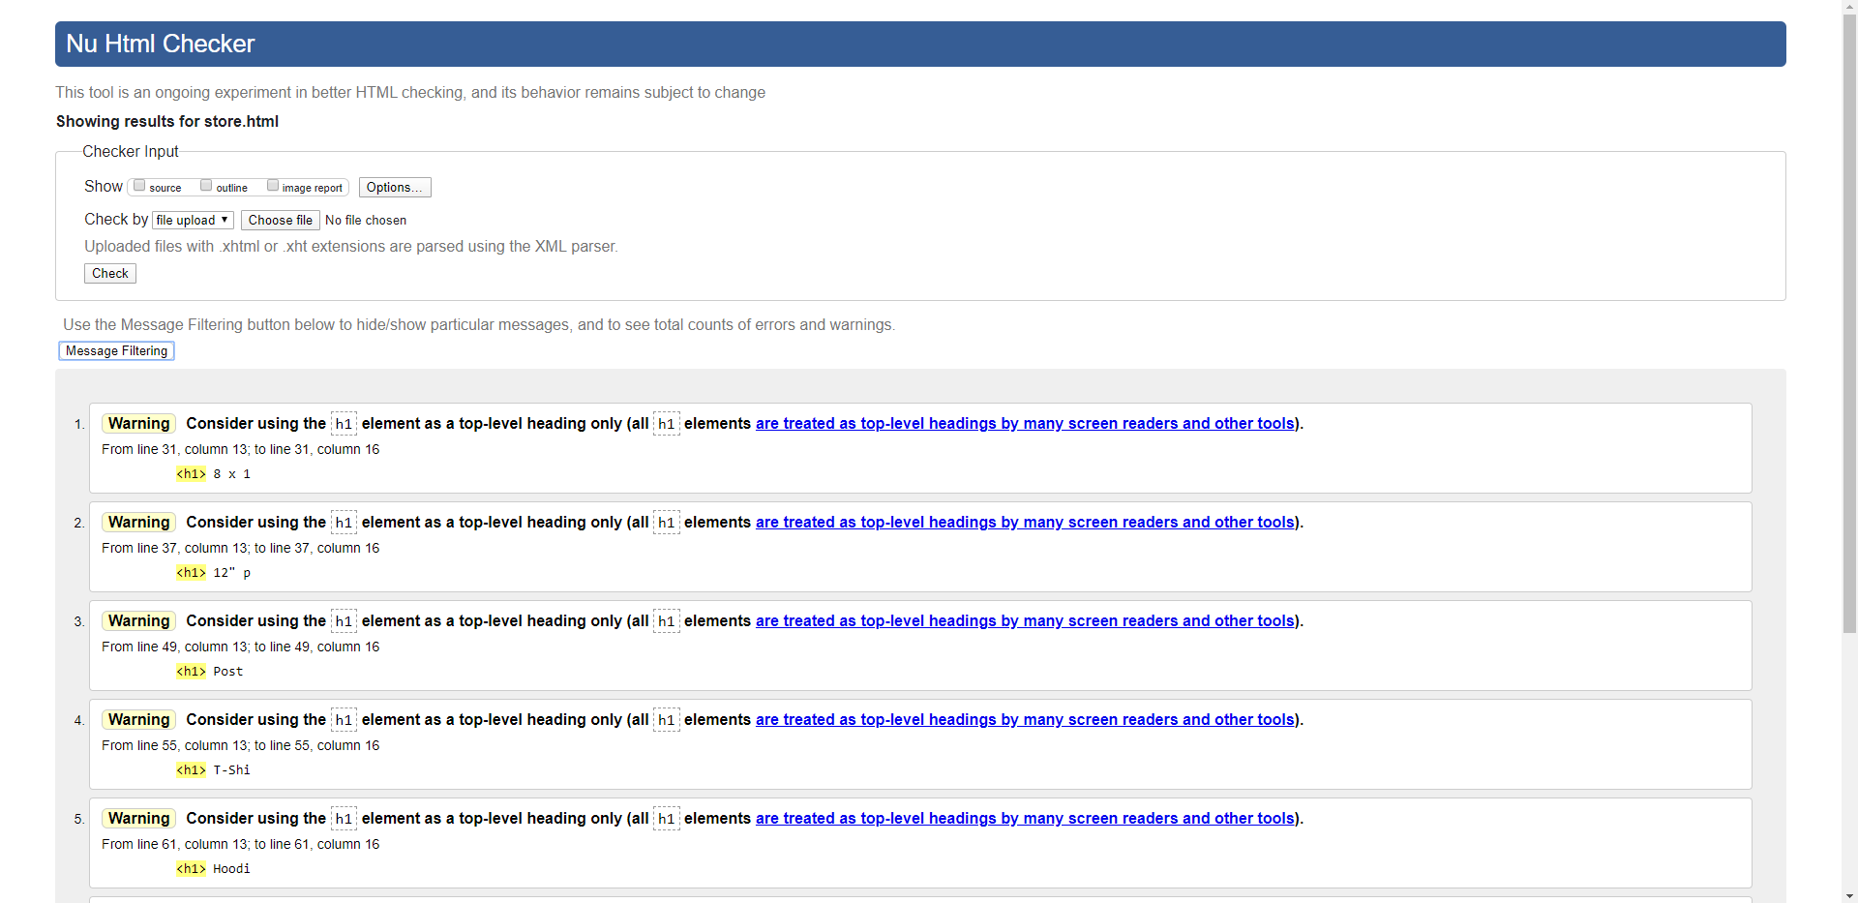

Page 4 Validation results

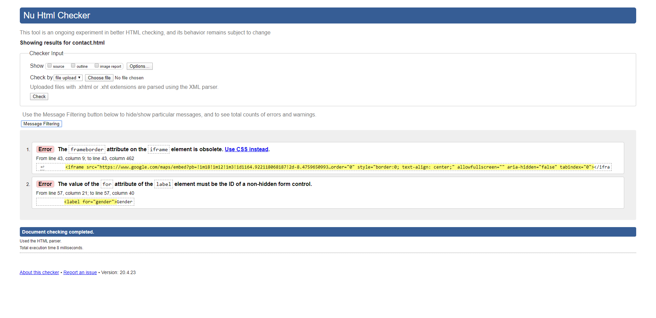

# CSS Validation Results

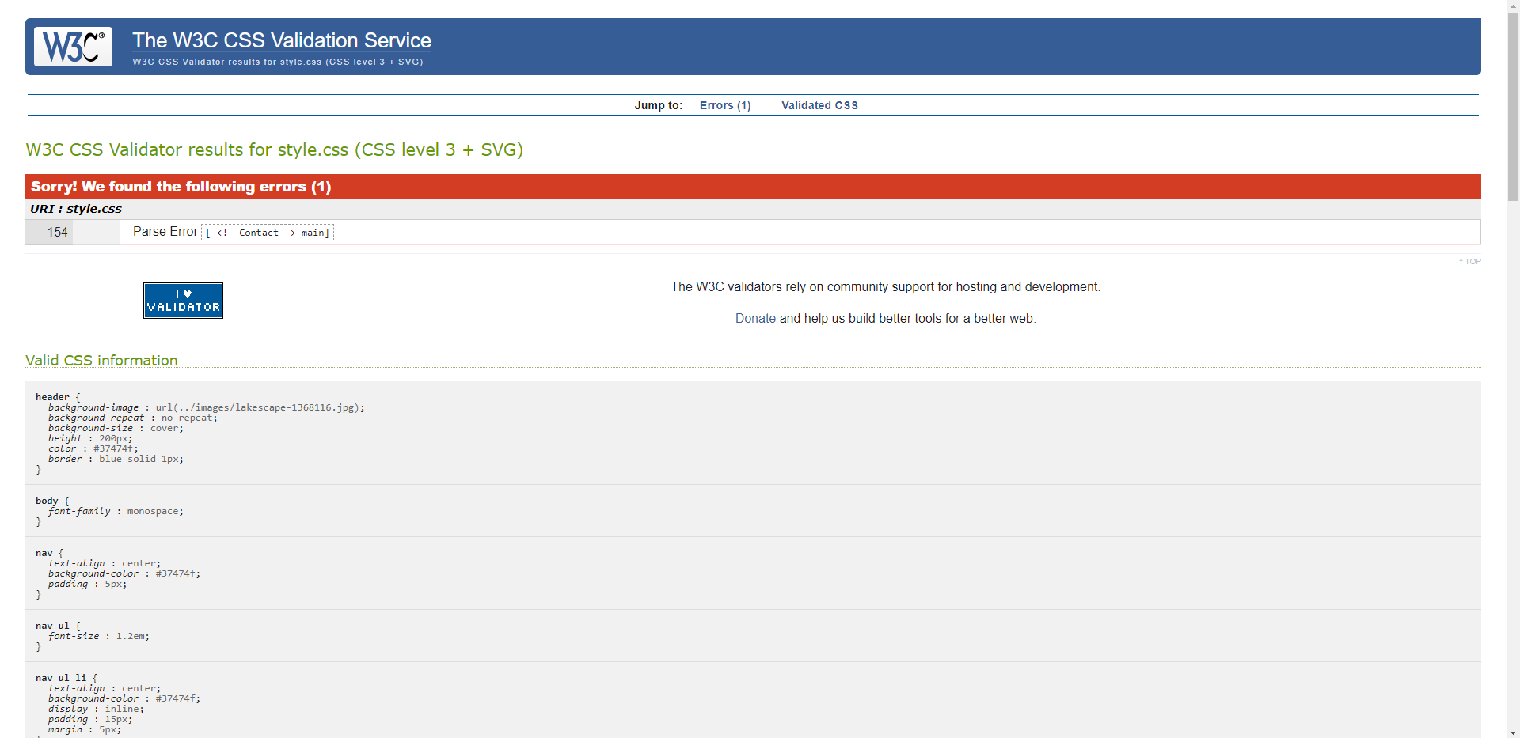

# Include Project Checklist – outline where feature are on Website to ensure they are found and marked

**You are asked to complete an original website of your own work; the website should contain the features listed below.**

Create a website using html5/CSS that will include the below Project Check List elements: if features are not obvious outline where they are located on the web page below. In order to mark the project, the student will present the website and explain the code, declaration of own work submitted.

|  |
| --- |
| **\*\*\*\*Must include Report including purpose and intended audience of the website and sources of images and information of each web page and HTML & CSS validation results. Upload completed project include url in report** |
| **Minimum of 4 HTML Pages with navigation menu not dummy text, use text and hyper link from appropriate website** (outline college project on landing page, do not include any personal or college information in the content of the pages) |
| **Upload progress and completed website to your GitHub account** |
| **HTML5 standards and recommended page layout structure** (header, main, aside, article, footer, etc) |
| **Include appropriate Meta data – description & appropriate keywords etc to improve pages SEO** |
| **Include font family for web page body** |
| **Appropriate use of External Style Sheet – Recommended CSS** (standard for majority of your CSS) |
| **Appropriate use of Internal & Inline Styling on HTML page** (one example of each) |
| **Home page content aligned to each other and visually attractive** |
| **Include navigation above fold and bottom of web pages- Indicate on navigation the current page** |
| **Include both Class and ID as CSS Selectors** |
| **Consistency of design on all pages, use of fonts, colour etc** |
| **Appropriate use of Headings (h1, h2, h3, h4)** |
| **Appropriate use of Colours (test for colour blind users)** |
| **Include an article or section with 2 or 3 columns** (by using appropriate CSS) |
| **Include logo and display in header of page** |
| **Clear, consistent and align content on all pages** (reference all sources) |
| **Include images (with at least one image floated with text alongside)** |
| **Use of background image** |
| **Include table of data/information only for statistical data** |
| **Include lists ordered or unordered (different shaped bullet points)** |
| **Include a link to a suitable video and google map –** use iframe code from YouTube or google maps from share, embed, copy iframe into your html page |
| **Include a contact me form and include red * beside required/mandatory input fields** |
| **Verify data collected on contact form, using get and data attached to URL** (Use the method get to display values entered on form will be appended to URL and passed to server <form action=" [http://year1.ccpdev.me/FormTest.php](http://year1.ccpdev.me/FormTest.php?fdf=fdsaf&fdsfs=hfdsahfkjhfa)" method="get"> |
| **Footer information including Copyright© 2020 and navigation** |
| **Internal anchor Links on one of the webpages** |
| **External Link to external website** |
| **Any Additional Features included __________________** |
| **Results included in report of HTML5 Validation (with majority of issues addressed)** |
| **Results included in report of CSS Validation (with majority of issues addressed)** |
| **Include Favicon on the Title tab** | |
| **Guide line on Website appearance, design and Content** [**https://webdesignledger.com/10-signs-of-a-user-focused-design/**](https://webdesignledger.com/10-signs-of-a-user-focused-design/) | |
| **Guidelines on Website overall appearance & design** [**https://webdesignledger.com/20-dos-and-donts-of-effective-web-design/**](https://webdesignledger.com/20-dos-and-donts-of-effective-web-design/) | |