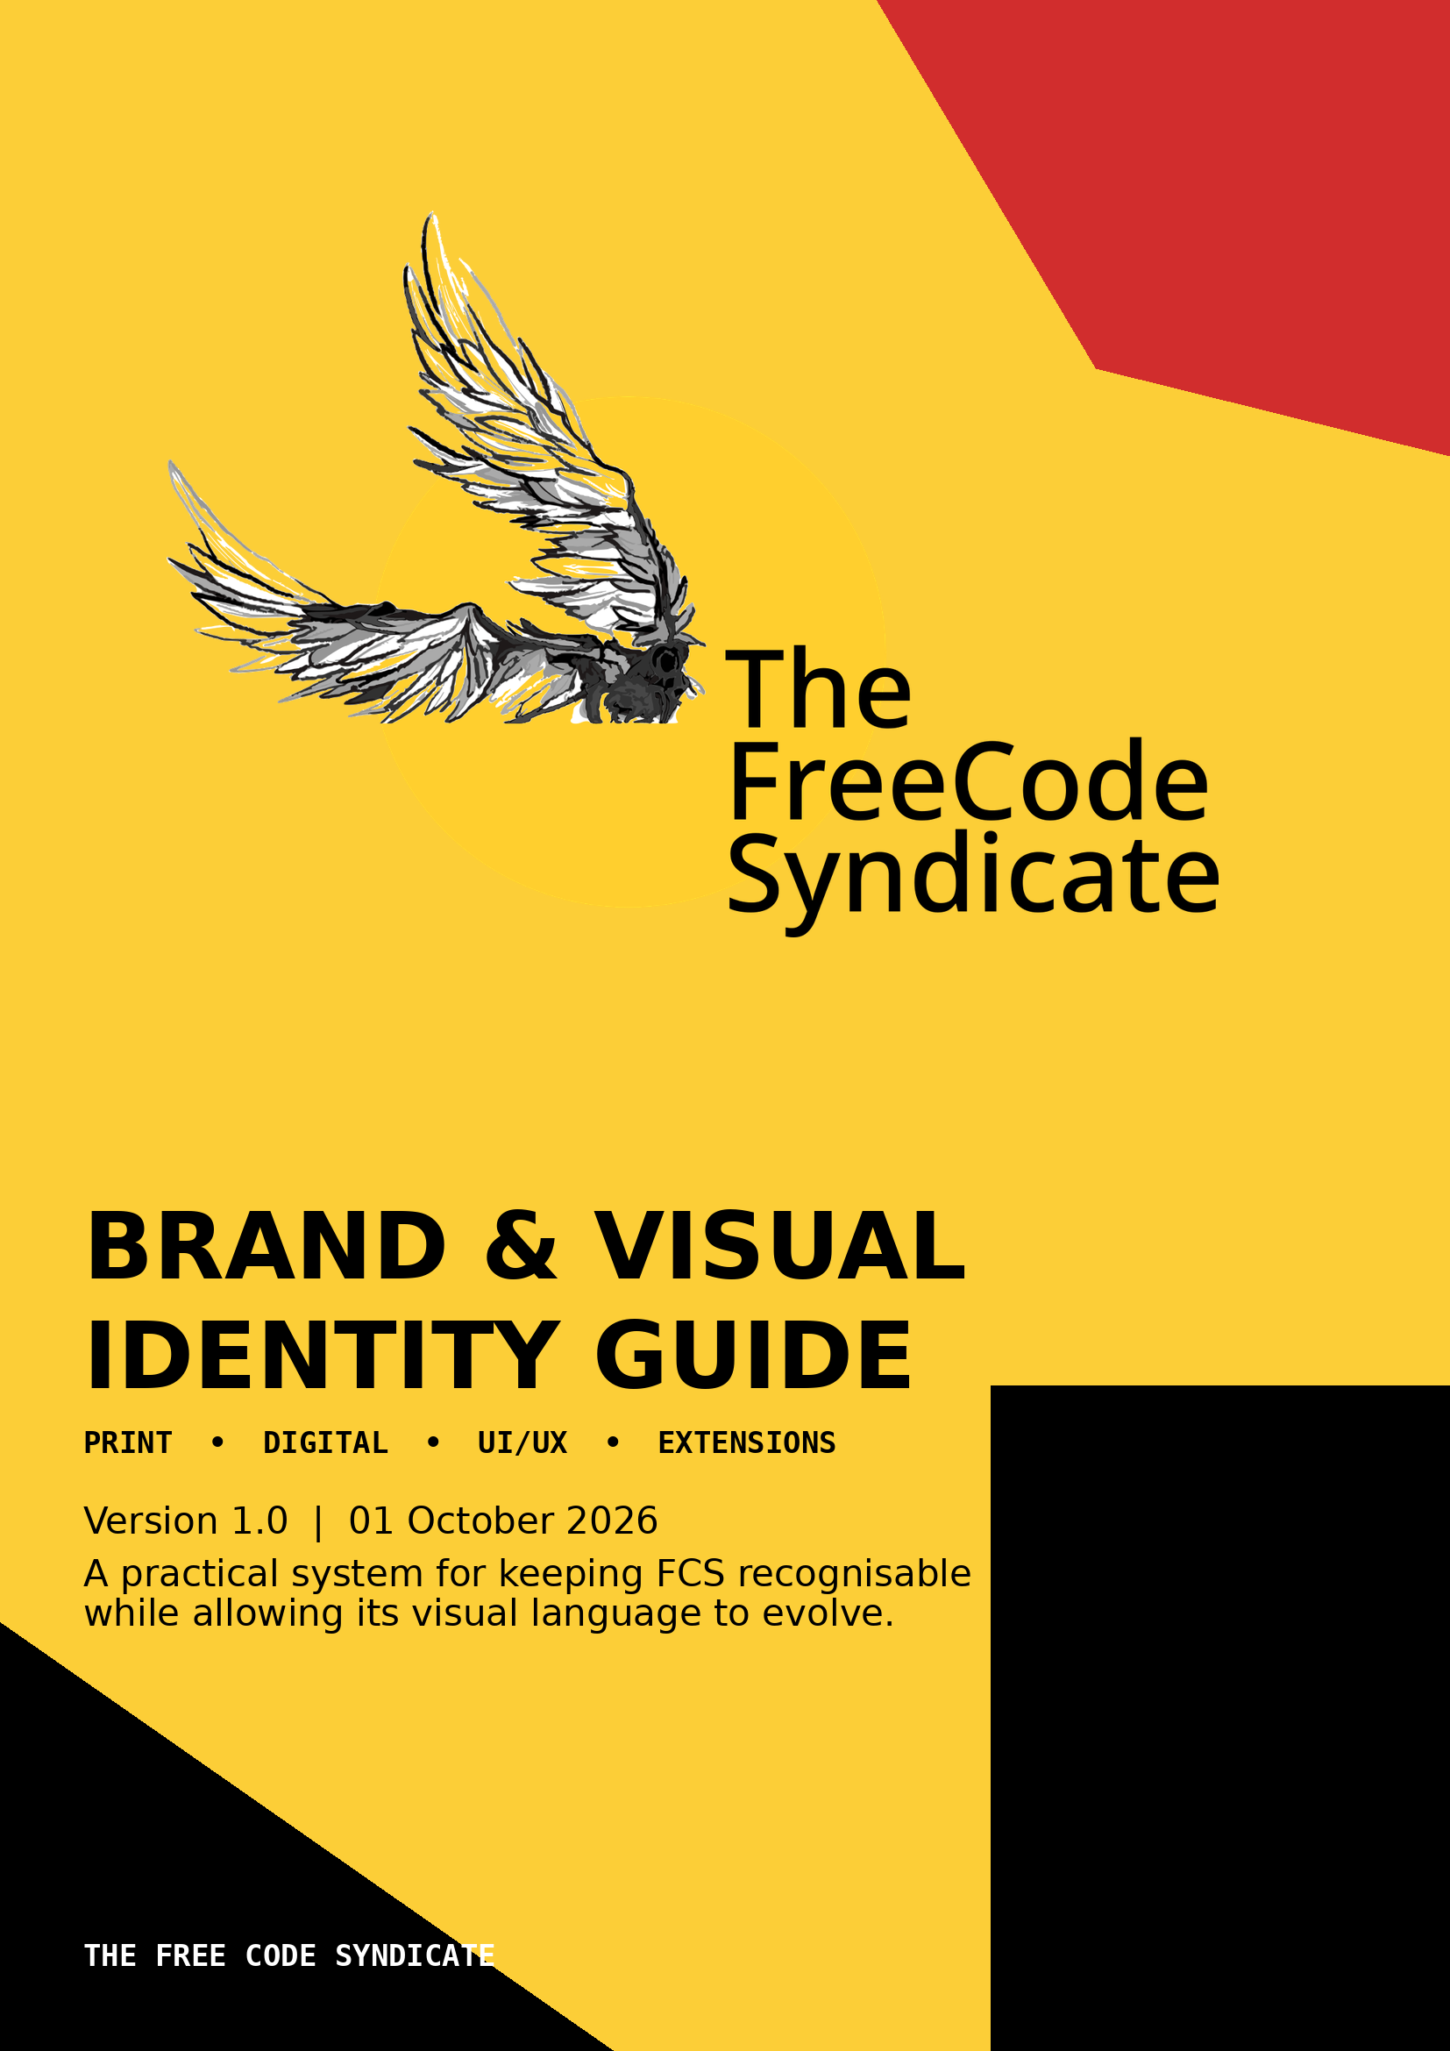

01 DOCUMENT CONTROL
What this guide governs, what it preserves, and what remains to be resolved.

FIELD | SPECIFICATION
Brand | The Free Code Syndicate (FCS)
Identity concept | Icarus v2 / wings, sun, ascent and free movement
Primary website context | Public learning/community website; current page uses a technical, RFC-like editorial language [R13]
Brand fonts (current brief) | Archivo Mono + Latin Modern Mono
Primary colors | FCS Yellow #FCCE37; Black #000000; FCS Cream #FFF7E4; FCS Red #D12D2D
Logo asset formats supplied | SVG icon + SVG logotype; PNG/raster visual boards supplied
Guide status | Recommended system; exact production templates should be version-controlled
Evidence standard | Each actionable guideline is paired with research/standards references

HOW TO USE THIS DOCUMENT
Treat this guide as a system rather than a catalogue of finished graphics. Designers may invent new compositions, but the logo, palette, typography hierarchy, accessibility thresholds, spacing logic and visual grammar should remain stable.

GUIDELINE Evidence versus brand rule
A WCAG threshold or print-production requirement is a standard. A recommendation such as “reserve red for emphasis” is a system rule derived from the supplied FCS identity and supported by research on consistency, legibility and recognition. The distinction is intentional.
RESEARCH BASIS Brand guides work by documenting repeatable rules for logo, colour, typography, imagery and layout; consistency should not mean freezing the identity so tightly that it cannot evolve. [R6, R7, R12]
02 BRAND FOUNDATION
The identity should feel public, technical, experimental and open without becoming visually chaotic.

2.1 The FCS visual proposition
- Public-first: information should look readable, inspectable and shareable rather than promotional. [R13, R5]
- Technical: monospace typography, RFC-like labels, structured cards and system language are legitimate identity elements, not decoration. [R13]
- Ascent: the Icarus mark introduces motion, ambition and experimentation; compositions should allow elements to exceed or cross expected boundaries. [R13]
- Controlled contrast: FCS is built from a deliberately small palette. The power comes from scale, proportion and placement—not from continually adding new colours. [R6, R12]

2.2 Brand character
DIMENSION | FCS SHOULD FEEL LIKE | AVOID
Tone | Plain, direct, technical, curious | Corporate, sales-heavy, motivational cliché
Structure | Editorial, modular, system-oriented | Random collage with no hierarchy
Energy | Bold, asymmetric, experimental | Chaotic, noisy, decorative for its own sake
Community | Open, participatory, public | Exclusive, gatekept, opaque
Technology | Human-readable and practical | Technological ornament without information

2.3 Identity principle: freedom inside constraints
GUIDELINE Keep the system small; vary the composition
Use a fixed core of logo, four principal colours, two monospace families, recurring geometry and a small set of layout behaviours. Change scale, crop, overlap, orientation and density rather than inventing a new visual vocabulary for every campaign.
RESEARCH BASIS Consistent visual elements help establish a recognisable identity, while Adobe explicitly frames brand guides as systems that can evolve rather than remain static. [R6, R12]

03 LOGO SYSTEM
The Icarus mark is the primary visual identifier; the wordmark is the verbal identifier.


Primary Icarus mark supplied as SVG and shown here as a high-resolution raster preview.
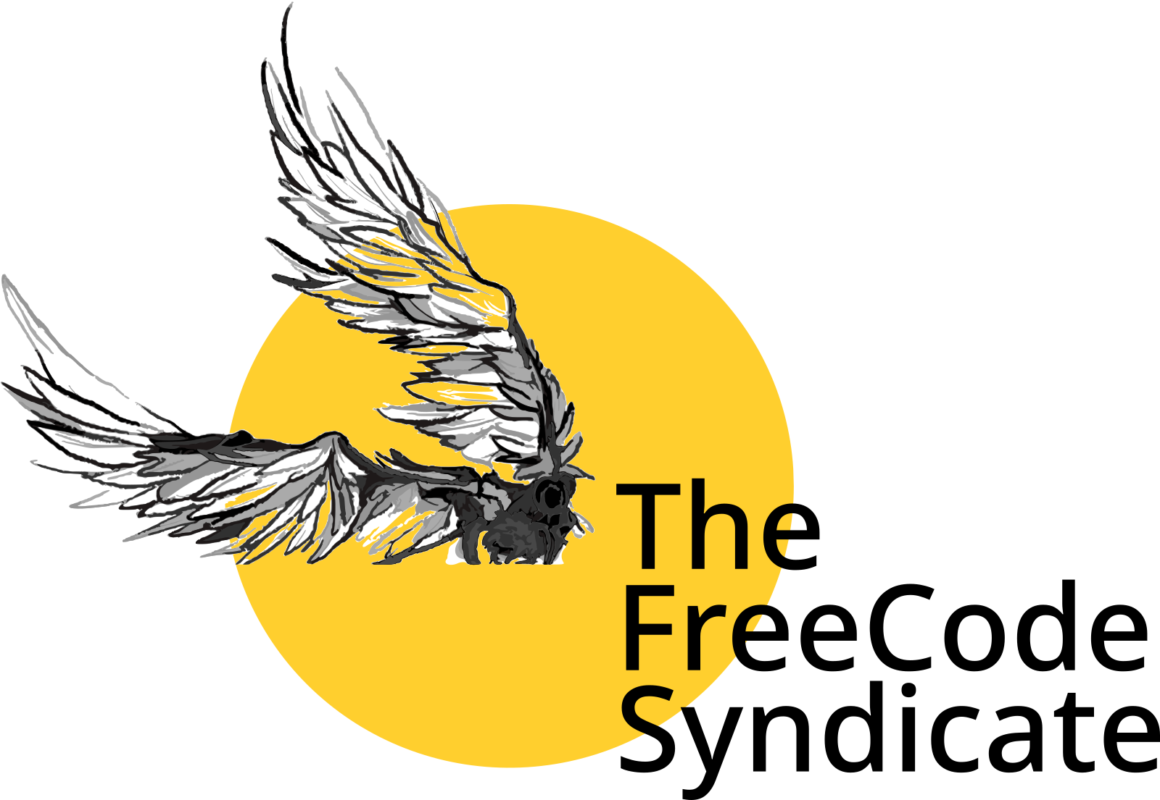
Supplied combined mark + logotype. The SVG is exported using its drawing bounds to preserve all artwork.
GUIDELINE Primary logo
Use the supplied vector SVG as the master asset. Use the icon alone where the brand name is already obvious or space is constrained; use the combined mark + logotype for formal documents, website mastheads, posters, certificates and first-contact communications.
RESEARCH BASIS Professional brand systems commonly define primary and secondary logo variations and explicitly document where each is appropriate; this protects recognition across sizes and contexts. [R6, R12]
GUIDELINE Clear space
Recommended production rule: reserve a minimum clear area around the logo equal to the diameter of the sun circle at the mark's smallest visible scale. Never allow text, UI controls, photography or decorative geometry to touch the wings or wordmark.
RESEARCH BASIS Clear space prevents neighbouring content from competing with the logo and is a standard component of mature identity systems. The supplied artwork does not define a formal clear-space unit, so this is a recommended FCS rule rather than an inherited measurement. [R6]
GUIDELINE Minimum size
Do not establish one universal pixel number for every medium. Instead, test the logo at the actual output size and require that the smallest text and wing details remain visually intact. For digital UI, prefer the icon-only mark below the point where the full lock-up becomes crowded.
RESEARCH BASIS Logo systems need minimum-size rules because fine details and small type can become illegible; Adobe recommends explicit minimum sizing and testing across real-world contexts. [R6, R12]
GUIDELINE Do not alter the mark
Do not stretch, rotate, redraw, add shadows, apply gradients, recolour individual feathers, outline the wordmark, place the mark inside an arbitrary badge, or substitute a different typeface for the supplied logotype.
RESEARCH BASIS Brand consistency depends on preserving the approved mark and documenting prohibited treatments; Adobe explicitly recommends examples of stretching, recolouring and effects as misuse cases. [R6, R12]
GUIDELINE Backgrounds
Preferred backgrounds are FCS Cream, white, black, or FCS Yellow where contrast is adequate. On photographic or complex backgrounds, place the mark on a clean field rather than relying on effects to force legibility.
RESEARCH BASIS Logo guidance recommends testing against light/dark backgrounds and using approved variants rather than compensating with ad-hoc effects. [R6, R12]
CORRECT | INCORRECT
Icon-only mark in a constrained avatar | Full lock-up squeezed into a tiny square
Full lock-up on a quiet background | Logo over busy photography
Original proportions | Horizontal/vertical stretching
Approved monochrome use when necessary | Random colour substitution
Generous clear space | Typography touching wings or wordmark

04 COLOUR SYSTEM
A compact four-colour core creates recognition; accessibility determines pairings.

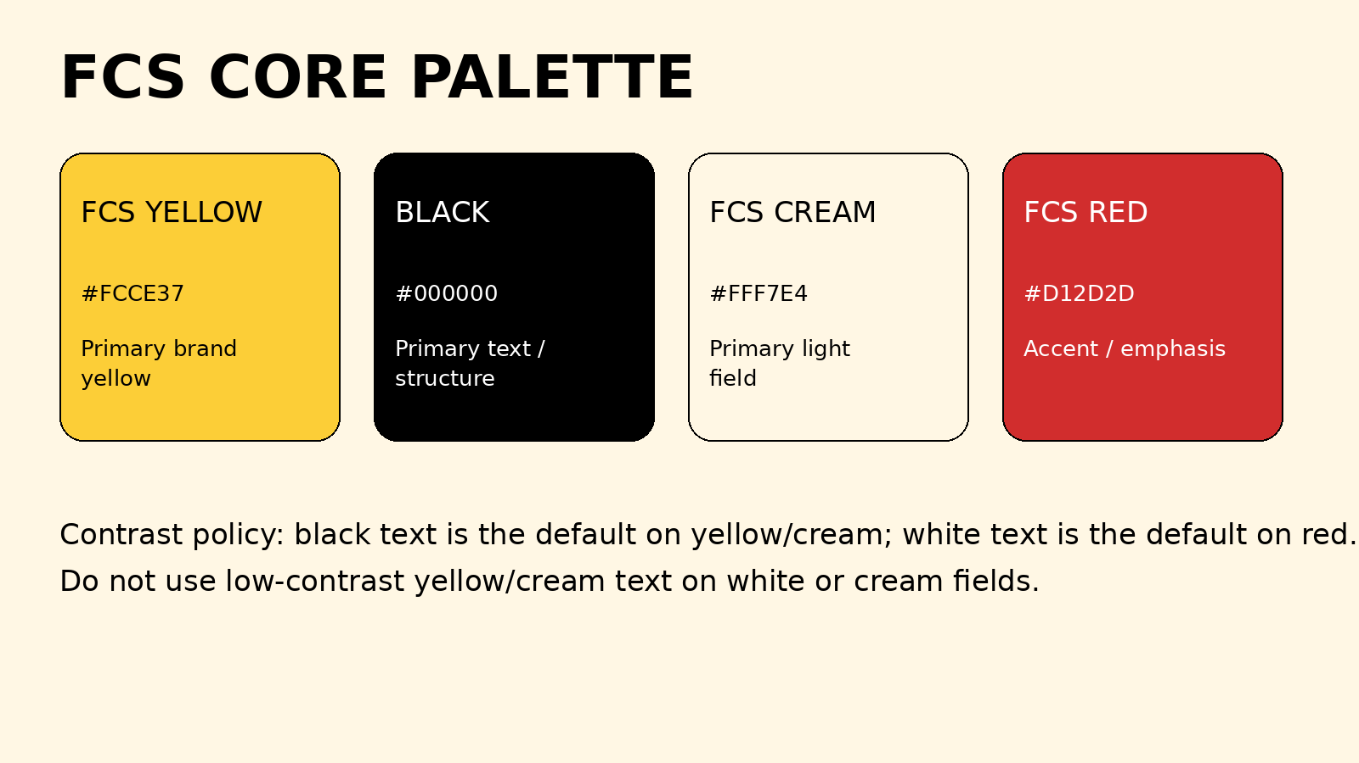
Core palette extracted from the supplied branding board. The guide preserves the supplied values rather than silently correcting them.
TOKEN | HEX | PRIMARY ROLE | PREFERRED PAIRINGS
FCS Yellow | #FCCE37 | Primary field, highlights, calls to action, large blocks | Black
Black | #000000 | Text, structure, dark field, borders | Yellow, Cream, White
FCS Cream | #FFF7E4 | Light field, paper-like surfaces, secondary background | Black
FCS Red | #D12D2D | Accent, warnings, emphasis, selected states, campaign moments | White / Cream

GUIDELINE Use yellow as a field, not as body text
Use FCS Yellow for large areas, panels, highlights, buttons and visual anchors. Use black for ordinary text placed on yellow. Do not use yellow as small text on white or cream.
RESEARCH BASIS WCAG requires at least 4.5:1 contrast for normal text and 3:1 for large text. FCS Yellow #FCCE37 with black is approximately 14:1; yellow with white is approximately 1.5:1. [R2]
GUIDELINE Use red deliberately
Treat FCS Red as a high-salience accent rather than a second background colour that competes with yellow. White or cream text is the default on red; black text on red should not be used for ordinary UI text.
RESEARCH BASIS The approximate contrast of #D12D2D against white is 5.1:1, while against black it is about 4.1:1, which is below the 4.5:1 normal-text threshold. [R2]
GUIDELINE Colour must never carry meaning alone
If red means danger, yellow means emphasis, or a colour denotes a category, pair the colour with text, iconography, shape, position or another redundant cue.
RESEARCH BASIS WCAG includes a requirement against using colour as the only means of conveying information because users may perceive colour differently or not at all. [R1]
GUIDELINE Do not expand the palette casually
New colours require a system-level reason: accessibility, data visualisation, semantic state, or a clearly documented campaign. Do not introduce a new hue simply because a poster “needs more colour.”
RESEARCH BASIS Brand guides establish a defined palette so assets remain recognisable and consistent across touchpoints. [R6, R12]
PALETTE DISCREPANCY TO RESOLVE
The supplied palette board labels the red block as “#08C4FF”, although the block itself is visibly red. The logo SVG also uses #FFCF2E while the palette board specifies FCS Yellow #FCCE37. This guide preserves both source facts; the production team should declare one canonical digital yellow and one canonical red before publishing a locked brand-kit file.

05 TYPOGRAPHY SYSTEM
Monospace typography is not an ornament here; it is part of the FCS voice.

5.1 Approved type families
FAMILY | ROLE | RECOMMENDED USE | DO NOT USE FOR
Archivo Mono | Primary display / UI monospace | Headings, navigation labels, metadata, cards, poster typography, buttons | Long continuous body copy when a conventional proportional face would be more readable
Latin Modern Mono | Secondary technical / editorial monospace | Code, citations, RFC labels, technical notes, data-like content, diagrams | Large expressive display text where the more geometric Archivo Mono is intended

GUIDELINE One hierarchy, two families
Use Archivo Mono as the dominant branded voice. Use Latin Modern Mono to signal technical detail, source material, code, references or a secondary information layer. Do not alternate them randomly line by line.
RESEARCH BASIS Typography is a core identity element, and consistent type application is a standard component of brand systems. The FCS website already uses a technical monospace/editorial language, so the two-family split should clarify hierarchy rather than add decoration. [R12, R13]
GUIDELINE Scale by role, not by device
Define type tokens by semantic role: Display, H1, H2, Body, Meta, Code, Caption. Let responsive layouts change the actual size, but preserve the relationship between roles.
RESEARCH BASIS Responsive design requires content to reflow while remaining readable; WCAG also requires text to remain usable when resized. Semantic hierarchy improves scanning. [R1, R5]
GUIDELINE Body text must remain comfortable
For prose, prefer generous line spacing and moderate line length. Avoid setting paragraphs entirely in uppercase or in extremely heavy display weights. Use monospace deliberately and test long Assamese/English mixed strings before publishing.
RESEARCH BASIS NN/g research shows web users scan rather than read word-for-word; scannable headings, short paragraphs and lists improve information access. WCAG requires text to remain readable and reflowable. [R5, R1]
GUIDELINE Code and technical text
Use Latin Modern Mono for code blocks, command snippets, RFC identifiers and machine-like metadata. Keep code visually distinct from ordinary prose through a surface, border or indentation—not by reducing the text to tiny sizes.
RESEARCH BASIS Accessibility guidance treats text as content that must remain perceivable; differentiation should come from structure as well as typeface. [R1, R12]
06 LAYOUT & GRAPHIC GRAMMAR
FCS should look engineered without becoming rigid.

6.1 Core layout behaviours
BEHAVIOUR | RULE | USE
Modularity | Use rectangular modules, cards and labelled fields. | Information-heavy posters, event cards, dashboards
Asymmetry | Permit controlled imbalance; keep one dominant anchor. | Campaign art, posters, hero sections
Overlap | Let wings, circles, blocks and type cross boundaries sparingly. | Brand moments and covers
Edge tension | Large forms may approach or exceed the frame; critical text should not. | Posters, social graphics
Quiet space | A bold composition must contain calm zones. | Reading areas, UI, documents
System labels | Use small monospace metadata labels above or beside content. | Dates, RFC numbers, categories, statuses

GUIDELINE Use an underlying grid
Build print and screen compositions on a repeatable grid. A 12-column digital grid and a simple modular print grid are recommended starting points; the grid may be broken intentionally when a brand gesture is needed.
RESEARCH BASIS Structured layout and meaningful headings improve scanning; mature brand guides also specify layout and spacing standards to keep applications cohesive. [R5, R12]
GUIDELINE Create hierarchy before decoration
Every composition should have one primary focal point, a secondary information layer and tertiary metadata. If removing a decorative element makes the hierarchy clearer, remove it.
RESEARCH BASIS NN/g's scanning research supports clear headings, short sections and front-loaded information; brand consistency depends on repeatable hierarchy. [R5, R12]
GUIDELINE Use geometry as a language
Circles represent the sun/field; angular blocks suggest structure; dotted or perforated separators suggest system interfaces; wing contours provide organic motion. Do not introduce unrelated geometric motifs without a reason.
RESEARCH BASIS A visual identity becomes coherent when recurring graphic elements, layout and imagery are documented as a system rather than treated as isolated artwork. [R12]

07 PRINT DESIGN GUIDELINES
Production rules for posters, certificates, stationery, brochures, stickers and other physical outputs.

GUIDELINE Design in the final physical size
Set the document to the intended trim size before composing. Do not design a poster at an arbitrary digital canvas and scale it at the end.
RESEARCH BASIS Print production workflows depend on explicit document dimensions, output profiles and preflight; Adobe recommends configuring the document for the intended production output. [R7, R9]
GUIDELINE Use CMYK for production unless the printer specifies otherwise
For conventional commercial print, prepare colour using the printer's required CMYK/output profile. If a printer provides a profile, use it rather than guessing a generic conversion.
RESEARCH BASIS Adobe's current print-ready guidance recommends suitable print colour handling and converting to the printer's specified destination. ISO 12647 defines process-control parameters for characterised print production. [R7, R9, R10]
GUIDELINE Use 300 ppi for raster imagery
Place photographs and raster textures at approximately 300 ppi at final output size. Prefer vector SVG/PDF artwork for the logo, icons and geometric elements.
RESEARCH BASIS Adobe's current print-template requirements specify 300 ppi for embedded raster imagery and recommend vector-safe workflows for print artwork. [R7]
GUIDELINE Use bleed for edge-to-edge artwork
Use 3 mm bleed as the FCS default for conventional print unless the print provider specifies another value. Extend backgrounds and edge graphics into the bleed; keep essential text inside the safe area.
RESEARCH BASIS Adobe identifies 0.125 inch / 3 mm as a typical industry-standard bleed and explains that bleed compensates for trim misalignment. [R8]
GUIDELINE Export a print PDF, not a screenshot
For professional handoff, export a print PDF using the printer's requested PDF/X or equivalent preset. Embed fonts or convert display artwork to outlines where the workflow requires it.
RESEARCH BASIS Adobe recommends print PDF export and preflight; ISO and the PDF Association document PDF/X as a family of standards intended for predictable print exchange. [R7, R10, R11]
GUIDELINE Preflight every final print file
Check links, missing fonts, image resolution, colour spaces, bleed, overprint, page size, transparency and unintended crop marks before delivery.
RESEARCH BASIS Adobe's print-ready workflow explicitly recommends preflight and checking missing resources, low-resolution images and export settings. [R7]
GUIDELINE Proof colour-critical work
For a poster, certificate or large campaign print, obtain a proof when colour consistency matters. Judge the proof under controlled lighting and against the intended output.
RESEARCH BASIS ISO 12647-7 and related print standards address proofing processes intended to simulate a defined printing condition. [R9, R10]

7.1 FCS print specification card
ITEM | FCS DEFAULT | EXCEPTION / NOTE
Document size | Final trim size | Printer template overrides
Bleed | 3 mm | Confirm with printer
Safe margin | Keep essential content away from trim | Increase for small-format finishing
Raster resolution | 300 ppi at final size | Lower only when output/viewing distance justifies it
Logo | Vector SVG | High-resolution raster only when necessary
Colour | CMYK / printer profile | Use spot/Pantone only when specified
PDF | Print PDF; PDF/X when requested | Follow printer's accepted standard
Proof | Recommended for colour-critical jobs | Especially campaign materials

08 SOCIAL MEDIA & DIGITAL PUBLISHING
Fast-scanning, recognisable and platform-adaptive.

GUIDELINE Design for the feed before the detail
Make the first visual read understandable without opening the caption. Put the subject, event name or action in the strongest area of the composition; move supporting detail into a second layer.
RESEARCH BASIS NN/g research found that users scan web content and recommended meaningful subheadings, short paragraphs, lists and front-loaded information. [R5]
GUIDELINE Build platform templates, not one-off posts
Maintain master templates for portrait, square, landscape, story/reel cover and announcement formats. The exact platform dimensions should be refreshed against the platform's current specifications before publishing.
RESEARCH BASIS Responsive/reflow principles favour adaptable layouts, while brand-guide practice recommends documenting layout variations and templates. [R1, R12]
GUIDELINE Keep critical text inside a safe zone
Reserve an internal margin around the edges of social graphics for names, dates, URLs and calls to action. Keep edge-to-edge colour and imagery outside the safe zone.
RESEARCH BASIS The same principle used in print—protecting critical content from trim—has a digital analogue in unpredictable crops, UI overlays and responsive containers. [R8, R12]
GUIDELINE Use a strong first-frame hierarchy
For video and motion, the first frame should communicate identity and subject without requiring motion to understand it. Keep logo placement stable across a series.
RESEARCH BASIS Users scan rather than read every element, so stable hierarchy and recognisable repeated cues reduce search cost. [R5, R12]
GUIDELINE Accessible contrast is mandatory
Use the approved contrast pairings: black on yellow/cream; white/cream on red; black or white on black/white respectively. Do not rely on transparency or thin outlined type for essential information.
RESEARCH BASIS WCAG 2.2 requires 4.5:1 for normal text and 3:1 for large text; non-text UI indicators also have contrast requirements. [R2, R1]
GUIDELINE Captions and alt text are part of the design system
Every public graphic should have an accessible text equivalent where the platform supports it. Captions should communicate the essential information rather than simply repeating decorative text.
RESEARCH BASIS WCAG's information-perceivability model requires meaningful information not to depend on a single sensory channel. [R1]
GUIDELINE Use repetition to build recognition
Repeat the same corner labels, colour roles, type hierarchy and logo treatment across a campaign. Change imagery or headline content, not the identity system.
RESEARCH BASIS Consistency across logo, colour, typography and imagery is a core brand-guide principle. [R6, R12]

8.1 Suggested FCS content families
FAMILY | VISUAL TREATMENT | INFORMATION PRIORITY
Event | Yellow field + black type + small red status accent | Event > date/time > CTA > metadata
Study group | Cream/black base + yellow module + technical labels | Topic > session > output > join
Project | Black field + yellow/cream type + diagram/image | Project > problem > link
Public note | Cream paper-like field + mono editorial hierarchy | Title > thesis > excerpt > source
Announcement | Red accent used as the dominant signal; white type | Action > deadline > details

09 UI/UX DESIGN GUIDELINES
Translate the FCS visual language into a usable interface rather than a poster pasted onto a screen.

GUIDELINE Accessibility is part of brand quality
Treat WCAG 2.2 AA as the minimum design target for public FCS interfaces. Brand expression must not reduce readability, keyboard access or interaction clarity.
RESEARCH BASIS WCAG 2.2 defines requirements for contrast, keyboard access, focus visibility, reflow, text resizing and target sizes. These are functional constraints, not optional visual polish. [R1, R2, R4]
GUIDELINE Target size
Design pointer targets at least 24×24 CSS px with adequate separation as the minimum AA baseline; for important touch controls, prefer approximately 44×44 CSS px.
RESEARCH BASIS WCAG 2.2 SC 2.5.8 establishes a 24×24 CSS-pixel minimum or equivalent spacing; SC 2.5.5 provides a 44×44 enhanced target-size criterion. [R3]
GUIDELINE Keyboard focus must be visible
Every interactive component must expose a clearly visible focus state. Do not remove the browser outline without replacing it with a stronger, accessible indicator.
RESEARCH BASIS WCAG requires focus to be visible and separately specifies stronger focus-appearance guidance; focus indicators must remain perceivable. [R4, R1]
GUIDELINE Contrast for UI components
Text uses the 4.5:1 normal-text / 3:1 large-text threshold. Non-text controls and state indicators should also meet the relevant WCAG contrast requirements.
RESEARCH BASIS WCAG 2.2 defines minimum contrast for text and non-text UI information and explicitly exempts logos from the text-contrast requirement; this exemption does not extend to ordinary interface text. [R2, R1]
GUIDELINE Do not use red and yellow as the only state system
Error, warning, success and selection should combine colour with labels, icons, borders, position or shape. The FCS palette can support states, but it should not become a colour-only semantic code.
RESEARCH BASIS WCAG's use-of-colour principle requires that information and distinctions not depend on colour alone. [R1]
GUIDELINE Responsive reflow
The layout must remain usable when text is enlarged and when the viewport narrows. Avoid horizontally scrolling prose, clipped controls and fixed-height cards that cut off content.
RESEARCH BASIS WCAG 2.2 includes reflow and text-resizing requirements; responsive layouts reduce the need for simultaneous horizontal and vertical scrolling. [R1, R3]
GUIDELINE Scannable information architecture
Use descriptive headings, short paragraphs, lists, status labels and progressive disclosure. Do not make the UI look “technical” by forcing users to decode the interface.
RESEARCH BASIS NN/g's web-reading research directly recommends meaningful subheadings, bullets, short paragraphs and front-loaded conclusions. [R5]
GUIDELINE Systemise components
Define reusable tokens for colour, spacing, radius, border weight, typography, states and elevation. A new page should be assembled from the system before introducing a new component.
RESEARCH BASIS A brand guide becomes operational when rules are repeatable across touchpoints; component systems provide that repeatability in digital products. [R12, R1]

9.1 FCS UI token proposal
TOKEN | DEFAULT | USE
surface.base | #FFF7E4 | Primary light background
surface.dark | #000000 | Dark sections / technical panels
accent.primary | #FCCE37 | Primary action / highlight
accent.alert | #D12D2D | Error / emphasis / campaign alert
text.primary | #000000 | Body and headings on light surfaces
text.inverse | #FFFFFF | Text on black or sufficiently dark red
border.default | #000000 | Structural boundaries; keep weight restrained
focus | Black or white high-contrast ring | Visible keyboard focus; test against actual surface

9.2 Component rules
- Buttons: use a filled FCS Yellow + black label for primary actions on light interfaces; use black/cream variants when yellow would be visually repetitive. [R2, R12]
- Cards: prefer thin structural borders, generous internal spacing and a clear title/meta/body hierarchy over heavy shadows. [R5, R12]
- Navigation: keep labels literal and predictable. FCS can use RFC-like numbering as a secondary layer, not as a substitute for understandable labels. [R5]
- Forms: pair labels with fields; show validation text and iconography, not colour alone. [R1]
- Data visualisation: reserve the core palette for brand emphasis; introduce additional colours only when data categories require them and document the mapping. [R1, R12]

10 WEBSITE APPLICATION
The current FCS site is the reference environment for the digital identity.

The current public site presents FCS through an RFC-like editorial system: “PUBLIC RECORD”, numbered sections, terse labels, project/study-group navigation and the Icarus mark. The page describes the community as public, source-readable and oriented toward study/work. Open the current FCS site
RESEARCH BASIS The current site explicitly uses a technical/editorial language and describes its source as readable, changeable and reviewable. [R13]
GUIDELINE Make the website the canonical digital expression
New digital properties should inherit the site's vocabulary—structured sections, short labels, public notes, technical metadata and clear navigation—rather than creating a separate “marketing” personality.
RESEARCH BASIS Brand consistency is strengthened when identity elements and tone are carried across touchpoints; the FCS site itself establishes this editorial vocabulary. [R12, R13]
GUIDELINE Resolve the typography declaration
The supplied brief for this guide specifies Archivo Mono + Latin Modern Mono. The current public site states that it is set in Archivo and Fira Code. Decide which pair is canonical, then update CSS, documentation and asset packages together.
RESEARCH BASIS Brand systems require explicit type rules; conflicting declarations create implementation drift even when individual designs look correct. [R12, R13]
GUIDELINE Preserve the public-record aesthetic
Use source-like labels, section numbers, status markers, compact metadata and plain language as interface motifs. Avoid adding decorative gradients, glossy cards or generic startup patterns that compete with the Icarus identity.
RESEARCH BASIS The site's existing information architecture is itself a brand asset; consistency across visual and editorial systems supports recognition. [R13]

11 BRAND IDENTITY & EXTENSION GUIDELINES
How FCS can grow into programs, study groups, events, products and sub-brands without fragmenting.

GUIDELINE Use an endorsed-extension model
The parent identity remains visible. A programme may receive its own name, accent treatment or graphic motif, but the FCS logo and core palette should establish provenance.
RESEARCH BASIS Brand systems commonly distinguish core identity from applications while preserving shared logo, colour, typography and imagery rules. [R6, R12]
GUIDELINE Create sub-identities through one variable at a time
When creating a study group, programme or initiative, vary one or two dimensions—secondary graphic motif, campaign accent, naming pattern or layout density. Do not replace all four core identity elements.
RESEARCH BASIS Consistent elements support recognition; controlled variation permits evolution without making each initiative look like a different organisation. [R12]
GUIDELINE Naming architecture
Prefer names that can be prefixed or endorsed cleanly: “FCS / [Programme]”, “FCS Study Group / [Topic]”, “FCS Labs / [Project]”, “FCS Notes / [Series]”.
RESEARCH BASIS Clear, repeatable naming and hierarchy reduce ambiguity in multi-product or multi-programme systems; the FCS site already groups content into projects, resources, study groups and events. [R12, R13]
GUIDELINE Event identity
Events may become visually louder than ordinary FCS content, but must retain at least two fixed anchors: the FCS logo/mark and the core typographic/palette system.
RESEARCH BASIS Brand guides recommend documenting application examples so external or internal creators can extend an identity consistently. [R6, R12]
GUIDELINE Campaign identity
A campaign may introduce a temporary visual motif, but define its start/end date, approved assets, palette additions and relationship to the parent system. Archive the campaign kit when the campaign ends.
RESEARCH BASIS Adobe describes brand identity as something that should evolve while remaining coherent; documenting rules prevents temporary experiments from becoming accidental permanent standards. [R12]
GUIDELINE Merchandise and physical objects
Use the icon mark when embroidery, engraving, stickers or small-format production makes the full lock-up too detailed. Test one-colour production before committing to multi-colour manufacturing.
RESEARCH BASIS Logo systems require variants for small applications and should be tested in real-world contexts and one-colour forms. [R6]

11.1 Extension matrix
APPLICATION | MUST RETAIN | MAY VARY
Study group | FCS provenance, typography, core palette | Topic-specific imagery / secondary motif
Project | FCS provenance + technical typography | Diagram language / campaign layout
Event | FCS logo + core palette + hierarchy | Hero image / temporary accent
Publication | FCS logo + editorial typography | Cover composition / illustration
Merchandise | Recognisable mark | Production method / one-colour treatment
Partner collaboration | FCS mark + clear attribution | Partner's identity in a defined secondary zone

12 IMAGERY, ILLUSTRATION & ICONOGRAPHY
The Icarus illustration is detailed; surrounding graphics should give it room to breathe.

GUIDELINE Use the Icarus mark as the hero, not as texture
Do not repeatedly tile or pattern the full bird illustration. When the mark is used decoratively, crop it intentionally and preserve enough recognizable structure that it remains identifiable.
RESEARCH BASIS A logo is a primary identifier; brand guides recommend clear space, minimum size and context testing rather than uncontrolled decorative use. [R6]
GUIDELINE Prefer high-contrast, editorial imagery
Photography and illustrations should support the subject. FCS can use documentary, workshop, code, laboratory, campus and maker imagery; avoid generic corporate stock that conflicts with the public/technical character.
RESEARCH BASIS Visual identity systems include imagery and photography rules because imagery contributes to the overall identity alongside logo, colour and type. [R12]
GUIDELINE Pixel / grid motifs are secondary
The supplied boards use pixel-like icons, grids and technical frames. Use them as secondary interface language; never allow them to overpower the subject or reduce legibility.
RESEARCH BASIS Scannability and hierarchy research supports prioritising meaningful content over decorative density. [R5]
GUIDELINE Icons should be functional
Use a consistent stroke/shape logic for UI icons. The current website uses 24px icon assets for known services; keep icon size and alignment systematic rather than mixing arbitrary icon families.
RESEARCH BASIS The website documents a 24px icon system, and accessibility standards require non-text UI indicators to remain perceivable. [R13, R1]
13 MOTION & INTERACTION LANGUAGE
Motion should communicate state, sequence or energy—not compensate for weak hierarchy.

GUIDELINE Animate the wings sparingly
Wing motion may be used for loading, reveal or event transitions, but should not be a perpetual decorative animation. Prefer short, purposeful motion with an immediate static equivalent.
RESEARCH BASIS WCAG 2.2 includes requirements concerning animation from interactions and physical reactions; interaction design should also preserve usability when motion is reduced. [R1]
GUIDELINE Use motion to reveal hierarchy
When content enters, animate the structural order: section → title → detail. Avoid animating every element independently.
RESEARCH BASIS Scannability depends on clear hierarchy; motion should reinforce rather than obscure that hierarchy. [R5]
GUIDELINE Respect reduced-motion preferences
Provide a reduced-motion mode that removes non-essential animation while retaining functional state changes.
RESEARCH BASIS WCAG 2.2 addresses animation and user safety/comfort; respecting reduced-motion preferences is a practical accessibility implementation. [R1]

14 BRAND VOICE & EDITORIAL SYSTEM
The visual identity becomes stronger when the language behaves like the graphics.

GUIDELINE Write plainly
Prefer short declarative sentences, concrete verbs and direct labels. Use technical terminology when it is useful, but do not use jargon merely to sound technical.
RESEARCH BASIS NN/g's web research recommends concise, scannable writing, meaningful headings and front-loaded information. [R5]
GUIDELINE Use the public-record voice
FCS copy should sound like a maintained technical record: what happened, what was built, what failed, what was learned, what is next.
RESEARCH BASIS This rule follows the editorial voice already established by the current FCS site, which frames its work as public records and study/work artifacts. [R13]
GUIDELINE Do not oversell community work
Prefer evidence of activity—notes, repositories, events, study groups, outputs and experiments—over generic claims about being “the best”, “revolutionary” or “world-class”.
RESEARCH BASIS The current site is structured around public work and evidence; scannable, concrete content is also easier for users to evaluate. [R5, R13]
GUIDELINE Metadata is a feature
Dates, status, version numbers, authorship, links and source labels should be visible when useful. Use monospace metadata as a recognisable FCS device.
RESEARCH BASIS The current website already uses labels such as RFC numbers, status, sections and public-record terminology. [R13]
15 GOVERNANCE & PRODUCTION WORKFLOW
The system stays healthy only if assets and decisions are version-controlled.

GUIDELINE Maintain a single source of truth
Keep the master logo SVGs, canonical colour tokens, font files/licensing notes, templates and current brand guide in one version-controlled location. Do not let designers work from screenshots as the source asset.
RESEARCH BASIS Brand kits and guidelines exist to centralise approved assets and usage rules; current print workflows also depend on correct, linked resources. [R6, R7, R12]
GUIDELINE Version every change
Use semantic or date-based versions for the brand kit. Record what changed: logo, colour, typography, layout, accessibility or production rules.
RESEARCH BASIS Consistent brand systems require documented rules, while evolving systems benefit from explicit change management rather than silent drift. [R12]
GUIDELINE Pre-publication checklist
Every published asset should pass a short checklist: logo integrity, colour token correctness, typography, contrast, hierarchy, accessibility text, export format and file naming.
RESEARCH BASIS Brand consistency and accessible publishing both benefit from explicit verification; Adobe's print workflow uses preflight for production errors. [R6, R7, R1]

15.1 FCS designer checklist
□ Is the correct master logo used, with original proportions?
□ Is the logo given adequate clear space?
□ Are the four canonical core colours used correctly?
□ Is any new colour documented and justified?
□ Is Archivo Mono / Latin Modern Mono used according to role?
□ Is the hierarchy understandable in a three-second scan?
□ Does ordinary text meet the 4.5:1 contrast target?
□ Are controls large enough and separated sufficiently?
□ Is keyboard focus visible for digital work?
□ Does the composition still work in monochrome where necessary?
□ For print: final size, bleed, 300 ppi and print profile checked?
□ For digital: safe zones, captions/alt text and platform crop checked?
□ Has the final file been named and stored according to the asset system?

16 RESEARCH BASIS & REFERENCES
Standards, usability research and brand-system references used to support the guidelines.

The evidence model in this guide is deliberately mixed. WCAG and ISO material provides formal technical requirements or process standards. NN/g provides usability research on scanning behaviour. Adobe's brand/production material documents established professional workflows. FCS's own website and supplied identity boards define the brand-specific source material. Where this guide makes a brand-specific recommendation that is not a formal standard, it is labelled as a recommended FCS rule rather than presented as universal law.
R1 W3C — Understanding WCAG 2.2 — Accessibility requirements covering perceivability, keyboard access, reflow, focus, use of colour and more. https://www.w3.org/WAI/WCAG22/Understanding/
R2 W3C — Understanding Contrast Minimum — 4.5:1 normal text and 3:1 large text contrast thresholds. https://www.w3.org/WAI/WCAG21/Understanding/contrast-minimum
R3 W3C — Understanding Target Size Minimum / Enhanced — 24×24 CSS-pixel minimum target-size criterion and spacing exceptions; related enhanced criterion uses 44×44. https://www.w3.org/WAI/WCAG22/Understanding/target-size-minimum
R4 W3C — Understanding Focus Visible — Visible keyboard focus as a usability/accessibility requirement. https://www.w3.org/WAI/WCAG22/Understanding/focus-visible
R5 Nielsen Norman Group — How Users Read on the Web — Scanning behaviour and recommendations for headings, bullets, short paragraphs and front-loaded information. https://www.nngroup.com/articles/how-users-read-on-the-web/
R6 Adobe Express — How to Design a Logo / Usage Guidelines — Logo variants, clear space, minimum size, colour values and misuse examples. https://www.adobe.com/express/learn/blog/how-to-design-a-logo
R7 Adobe InDesign — Produce Print-Ready PDF Files — Preflight, 300 ppi checks, print colour handling and PDF export. https://helpx.adobe.com/indesign/desktop/print/print-production-and-file-creation/produce-print-ready-pdf-files.html
R8 Adobe InDesign — Print Bleed and Slug Areas — 3 mm typical industry bleed and explanation of trim compensation. https://helpx.adobe.com/indesign/desktop/print/page-set-up-and-printer-marks/print-bleed-and-slug-areas.html
R9 ISO 12647-1:2013 — Graphic Technology — Process-control parameters and measurement methods for characterised production printing. https://www.iso.org/standard/57816.html
R10 ISO Committee — Guidelines for Using Print Production Standards — Print-production standards and recommendation to use PDF/X data for reliable exchange. https://committee.iso.org/files/live/sites/tc130/files/Resources/Guidelines%20for%20using%20print%20production%20standards%20v2%20Jan%202024.pdf
R11 PDF Association — Technical Side and Requirements of PDF/X — PDF/X as a strict subset of PDF for predictable print exchange. https://pdfa.org/technical-side-and-requirements-of-pdfx
R12 Adobe — Visual Identity / Brand Guide Practice — Identity systems: logo, colour, typography, imagery, icons, layout, do/don't examples and consistency. https://www.adobe.com/uk/creativecloud/design/discover/visual-identity.html
R13 The Free Code Syndicate — Current Public Site — FCS's current public editorial, RFC-like, technical and open-learning language. https://thefreecodesyndicate.github.io/fcs-site/
R14 The Free Code Syndicate — fcs-site repository — Implementation context and current site architecture; useful for maintaining digital consistency. https://github.com/TheFreeCodeSyndicate/fcs-site

17 ASSET INVENTORY & HANDOFF
What should be distributed with the brand guide.

ASSET | MASTER FORMAT | PURPOSE | STATUS / ACTION
Icarus icon | SVG | Primary mark / favicon / avatar / small-format applications | Supplied; keep as vector master
Icarus + logotype | SVG | Formal identity lock-up | Supplied; use drawing-bounds export for production until SVG viewBox is verified
Palette tokens | HEX + RGB + CMYK profiles | Digital + print colour control | Core values supplied; resolve discrepancies
Archivo Mono | Font files / webfont | Primary brand/display monospace | Current brief; verify licensing and distribution package
Latin Modern Mono | Font files / webfont | Technical/editorial monospace | Current brief; verify licensing and distribution package
Social templates | Editable source | Recurring content families | To be created from this guide
Print templates | INDD/AI/SVG/PDF | Poster/certificate/stationery production | To be created per print vendor
UI tokens | CSS variables / design tokens | Website and app consistency | To be implemented in site/component system
Brand guide | DOCX + PDF | Governance and onboarding | This document is v1.0

IMPORTANT PRODUCTION NOTE
The supplied combined SVG should be checked in Inkscape/Illustrator/Figma before being distributed as the canonical wordmark. Its artwork extends beyond the declared viewBox, so exports should use the drawing bounds until the source SVG is normalised.

18 ONE-PAGE QUICK RULES
The condensed sheet a designer can keep beside the canvas.

RULE | INSTRUCTION
LOGO | Use supplied SVG. Preserve proportions. Clear space. No effects or arbitrary recolours.
COLOUR | Yellow #FCCE37 + black is the primary high-contrast pair. Red #D12D2D + white/cream is the alert/emphasis pair. Cream #FFF7E4 is the paper-like field.
TYPE | Archivo Mono = primary voice. Latin Modern Mono = technical secondary voice. Hierarchy first; decoration second.
LAYOUT | Grid + modular cards + controlled asymmetry + quiet space. One focal point per composition.
PRINT | Final size. 3 mm bleed default. 300 ppi raster. CMYK/profile as printer requires. Preflight. Print PDF/PDF-X when requested.
DIGITAL | Design for scanning. Keep critical content away from edges. Stable templates. Captions/alt text. Contrast first.
UI | WCAG 2.2 AA baseline. 4.5:1 normal text. 24×24 minimum pointer target; 44×44 preferred for important controls. Visible focus.
EXTENSIONS | Keep FCS provenance. Vary one or two dimensions at a time. Document temporary campaign systems.
VOICE | Plain. Technical. Public. Concrete. Evidence over hype.

THE FREE CODE SYNDICATE
Fly freely. Build publicly. Keep the system readable.

