**Air Hockey**

**CS 480 - Graphics**

**PA9**

Nov 3, 2015

Matt Berger & Matt Fredrickson

# Controls

**Player 1**

Player 1 may be controlled via the mouse. Mouse movements shall be translated into movements for the puck that is closest to the camera.

**Player 2**

Player 2 may be controlled via the WASD keys (see Technical Issues, #3).

# Gameplay

Initially, the game starts with the puck in the center of the table and Players’ 1 and 2 paddles on the far sides of the table. Player score and opponent score are displayed on the bottom of the screen.

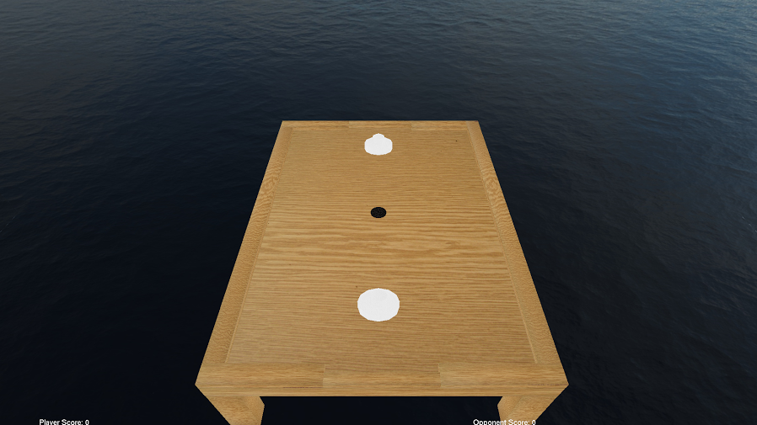

# Extra Credit

* We implemented two Text2D displays to show the player and opponent score.

# Compile and Run Instructions

From the bin directory:

make –C ../build/

./AirHockey

# Technical Issues

1. SDL vs GLUT

Our code utilized SDL for previous projects--however, we determined that this would be insufficient for fulfilling the requirements of the project compared to GLUT. This is specifically due to the fact that GLUT handles menus much more easily than SDL. Therefore we decided to re-implement GLUT for this project, and remove SDL as a dependency.

1. Mouse Lock in Menu

For purposes of movement, we tied the mouse to the center of the screen, so there would be no unforeseeable out-of- bounds issues with mouse movements. However, we were unable to turn this feature off when the user right-clicks to create a menu. This makes it so that it is very difficult to select a menu option.

1. Player 2 Movement

We implemented movement controls for Player 2 (i.e. the far side paddle), but these stop working after the first few key-presses. We were unable to determine the origin of this bug in the time we had to complete this project.

1. Scoring

Due to an issue with the collision boundaries for the table, it is not possible to actually score points.