Labyrinth
CS 480 - Graphics
PA11
Dec 7, 2015

Matt Berger & Matt Fredrickson

Controls
Player 1
Arrow keys are used to tilt the game board (by altering the gravity vector). (See Technical Issues #2).

Gameplay
Initially, the game starts with the ball falling into the open area of the table, with the goal point in the bottom right corner of the board. Player score is displayed on the bottom of the screen, and time elapsed is displayed in the upper right corner.
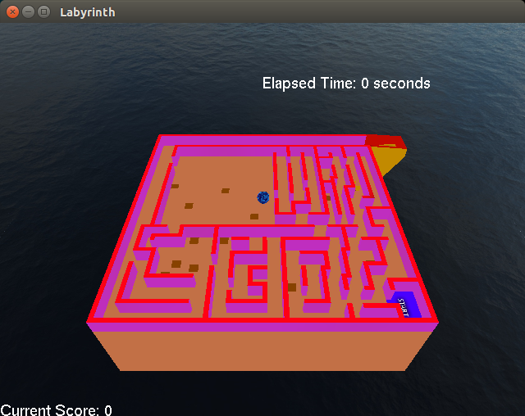

Extra Credit
- A triangle mesh was used for the labyrinth (as a static object) and the gravity vector was altered to “tilt” the board.

Compile and Run Instructions
From the bin directory:
make –C ../build/
./Labyrinth

Technical Issues
- SDL vs GLUT
Our code utilized SDL for previous projects--however, we determined that this would be insufficient for fulfilling the requirements of the project compared to GLUT. This is specifically due to the fact that GLUT handles menus much more easily than SDL. Therefore we decided to re-implement GLUT for this project, and remove SDL as a dependency.

- Movement
We experienced a multitude of bugs regarding movement in this project, mostly due to the fact that we had to alter the gravity vector to move the ball around instead of moving it via user input. The ball would consistently exhibit strange behavior, including jerking and clipping through walls, flying off the board, and occasionally extreme acceleration off-screen. Due to the extreme nature of these glitches, we decided to remove

- Clock time
For the implementation of the clock used to count time elapsed, we used the standard library clock. However, we noticed that on some machines the clock does not count time properly, instead going very slowly. This only occurs on some machines and was not deemed a priority to fix for this release.

