Compiled by
Petra Andraschko
Jatin Patel
Taylor Addington
Alegna M. Medina Rodriguez

SLAY

Last updated: June 22, 2019

Overview - Executive summary

Elevator Pitch / High Concept
SLAY is a top down hack and slash set in the dark medieval Queendom of Runoz where the player, assuming the role of the knight-in-training Azael, fights hordes of evil creatures, in order to defeat the big bad evil alongside your trusty animal companion.

Genre
Fantasy, Action, Hack/Slash, Adventure, Retro

Key/Exotic Features
- Animal Companion
  - Provides multiple different benefits to the player, multiple different companions available to equip.
- Hidden Rooms
- New Game +
- Optional Dungeon Levels

Target Audience
Primary:
Nostalgic older gamers
Secondary:
Newer/Younger gamers

Play Action and Cadence
Overwhelming combat against hordes of enemies. Fast paced. Rewarding and tense combat. Breaks between areas with optional exploration and shops to buy upgrades.

Win Condition / Player Goal
Collect all the fragments of Pandora’s Box to seal away a great evil terrorizing the land! To collect these pieces, you will have to defeat the powerful monsters guarding them!

Loss Condition / Continuation
The player has a finite amount of lives. If they run out of lives then it is game over!
You continue at a previously gained checkpoint if you have remaining lives, spread out among the beginnings of the various levels.

Comparable products

The Legend of zelda (original)
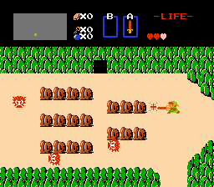
Camera Perspective, Map style, Combat Style, Story.

The Binding of isaac
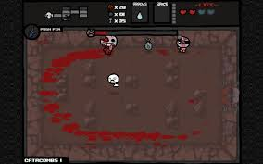
Camera perspective, combat style.

Original Castlevania
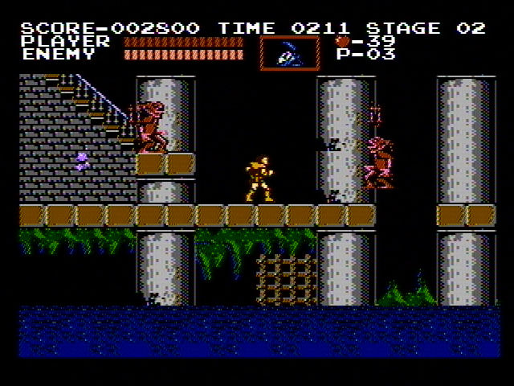
UI inspiration, genre, story

Crawl
< 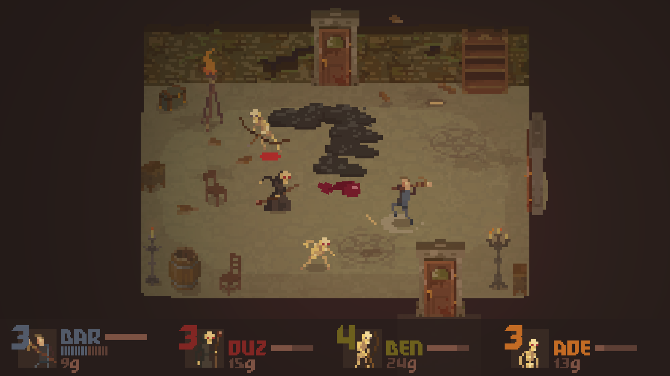>
Similar color scheme/ palette, UI

Enter the Gungeon
< 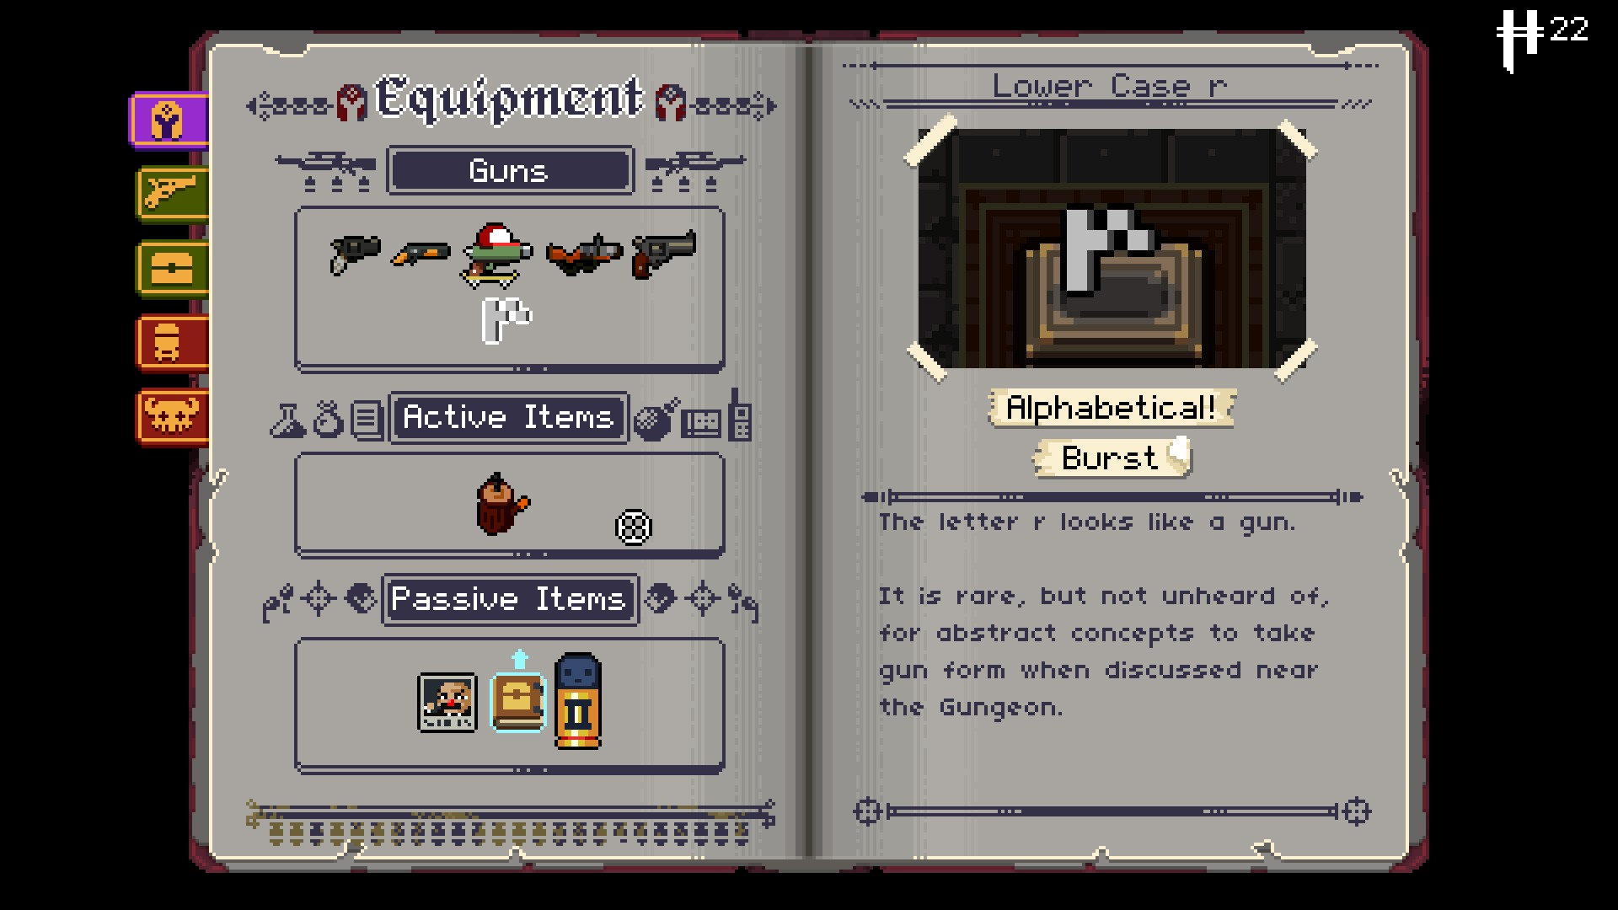 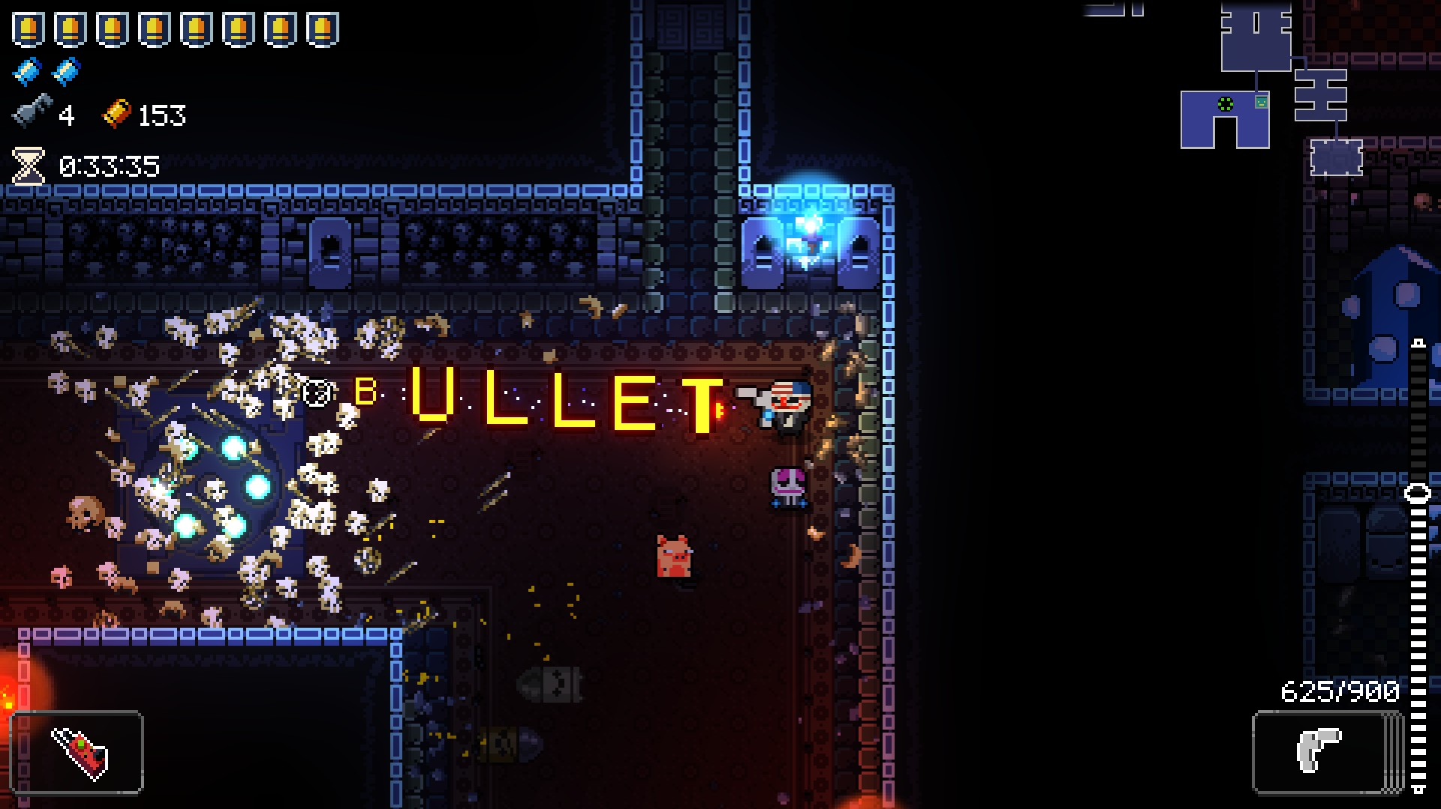>
Silly weapons

<Product Name>
<Picture of comparable portion>
<Description of comparable portion>

Art and Production Design

Art / visual Style
Pixelate, dark/dull color pallet, simple sprites/visual design, clean/readable screen.
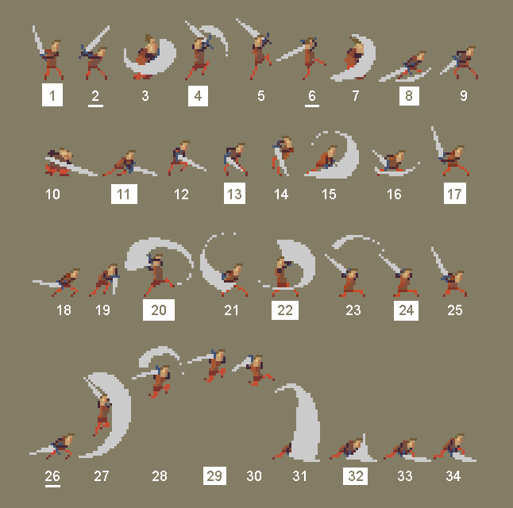

Music Style
Classic arcade/8 bit/16 bit video game music, tense, focusing

https://westarmusic.sourceaudio.com/#!details?id=19037852
https://patrickdearteaga.com/audio/Heroic%20Intrusion.ogg

SFX Style
8 Bit, retro, electronic SFX
https://opengameart.org/content/rpg-sound-pack

Interactivity

Camera Logic
Stay centered on player, edge snapping.
Quick camera mockup below
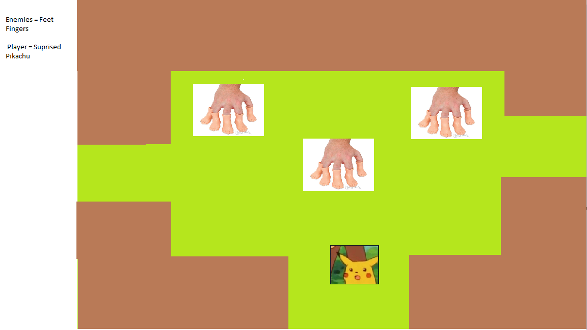
Room transitions Legend of Zelda style, seamless transitions in extended backlog.

Controls

PC Controls

- WASD or Arrows
- Left Click – Attack 1
- Right Click - Attack 2
- 1,2 Inventory controls
- <Control>
- <Control>
- <Control>
- <Control>
- <Control>
- <Control>

WebPlayer Controls

- WASD or Arrows
- Left Click – Attack 1
- Control - Attack 2 (if right mouse conflict)
- 1,2 Inventory controls
- <Control>
- <Control>
- <Control>
- <Control>
- <Control>
- <Control

Scope

Game Progress – Player Milestones
- Release the Town from enemies(unlock shop/crafting system) gain a box piece
- Head to any of the 3 environments and Defeat the environments Semi boss to gain a box piece
- Unlock animal companion
- Continue to defeat other Semi-bosses in their environment and gain their pieces
- Reconstruct box
- Defeat Final Boss

Worlds/Levels
Town, Forest, Beach, Plains, Castle, Optional Dungeons
~4-6 minutes per level
~30 minutes.

Mechanics

Combat
Room locks down when enemies spawn (no separate screen)
Combat starts when enemies ambush you, ends when all enemies are dead, or you die.

Leveling system
Killing enemies gains experience
Enemies stats scaling based on player level
Static stat boost per level.

Gold
Enemies drop gold and XP
Gold can be spent in shop, XP works towards increasing level

Shop/Inventory
Player can journey to the physical shop to spend gold on new/upgraded weapons, consumables, animal companions.
Weapons can be switched mid-combat, only two items are equipped at a time, one of which is a locked in weapon.

Player abilities
- Blocking
- Magic attacks
- Wield different weapon types

Enemy types
- Seekers
  - Seek out the players
- Slimes
  - Split in half on death
- Skeletons
  - Ranged Attacks
- Fire Mage
  - Fire Magic attacks
- Ice Mage
  - Ice Magic attacks
- 90* turners
  - Rotates 90* on colliding with an obstacle
- Spawners
  - Spawns enemies when left alone too long
- Wolves
  - Attacks the players in short leaps, moves quickly.
- Armored Knight
  - Moves slowly, attacks the player with sudden lunges, can only be damaged from behind.

Boss encounters
- 1 End boss
  - Hope
    - Phase 1: Scythe
    - Phase 2: Magic
      - Bullet Hell
    - Final Phase: Gun
      - Aim
      - Pause
      - Hitscan attack

- 3 Mid-Bosses
  - Siren
    - Summons enemies. Temporarily steals your animal companion with her song.
  - Minotaur
    - Bullfight style charges with boss vulnerability stuns on failed attacks
  - Cyclops
    - Throws sheep at you, eye lasers

Item Types
- Health potions
- Attack potions
- Speed potions
- Love Potion
- Bottled Fire
- Tar Bottle
- Dagger
- Sword
- Broadsword
- Axe
- Trident
- Throwing Knives
- Short Bow
- Longbow
- Gun
- Fireball
- Lightning Bolt
- Cone of Cold
- Hex
- Deathly Aura
- Currency
- Experience Pickup

Unlockables
- Animal Companion
- Different Weapon Types
- Different Magic Types
- Box Pieces (Story Items)

Animal Companion
- Magic Attacker Friend
- Melee Attacker Friend
- Ranged Attacker Friend
- Stunner Friend
- Item Grabber Friend
- Healing Magic Friend
- Stat Buffing Friend
- Bonus Gold Friend
- Bonus XP Friend
- Scavenger Friend

