**Show what differences there are between the forks:**

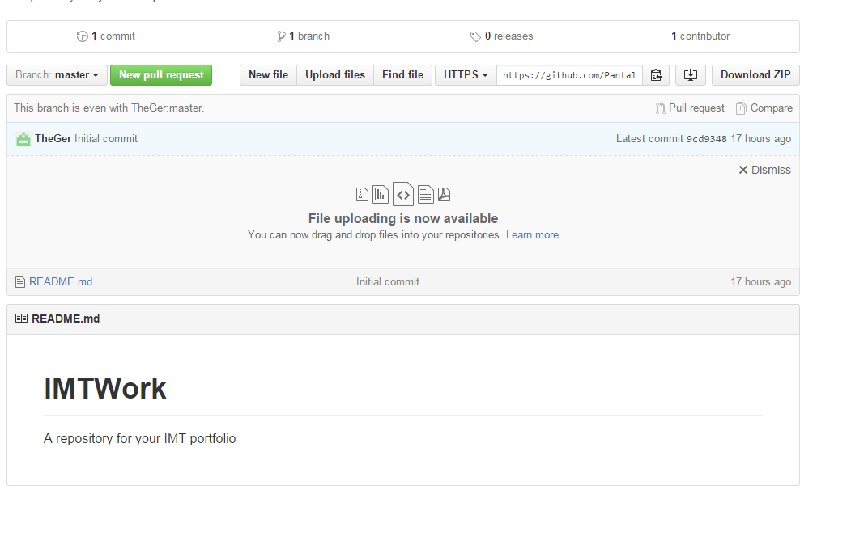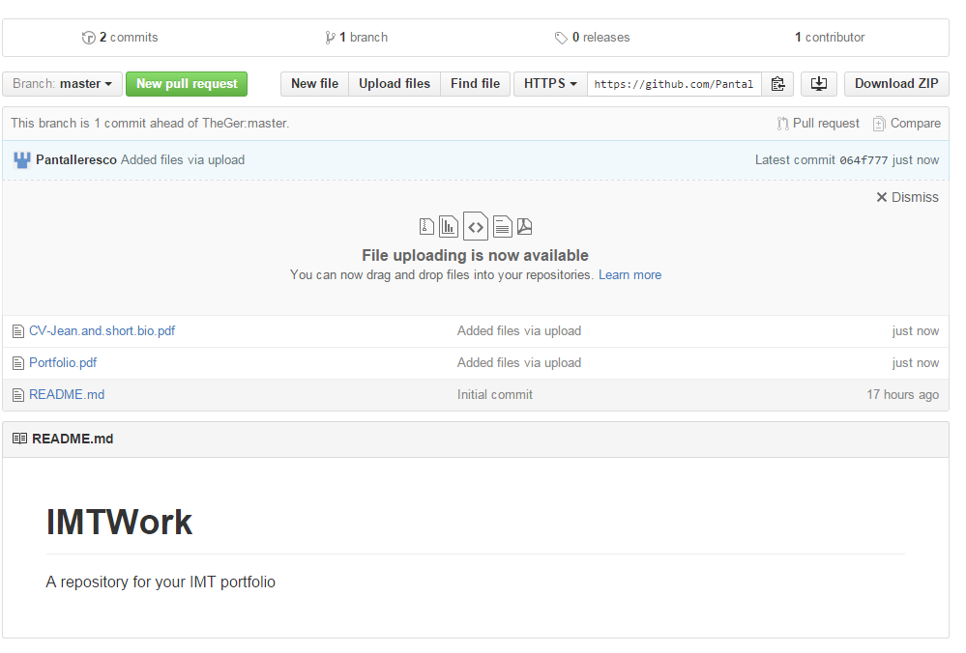

**Explain what the .gitignore file is used for:**

It's usually used to avoid committing transient files from your working directory that aren't useful to other collaborators, such as compilation products, temporary files.