1. Fork the repository available at the following URL: <https://github.com/TheGer/IMTWork>

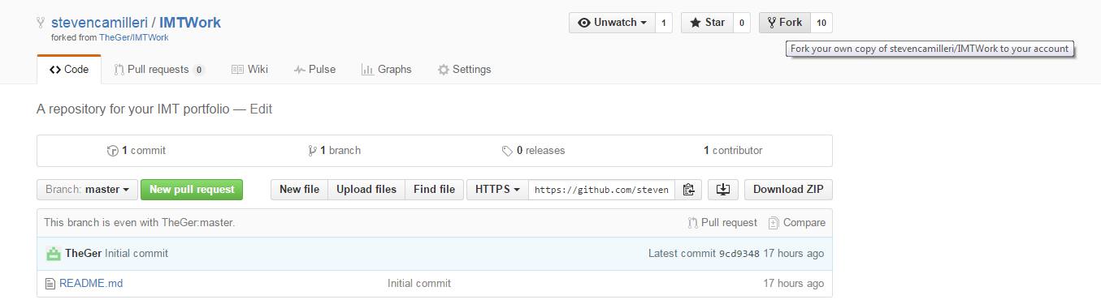

1. Add a CV, short bio and portfolio as PDF documents to your forked repository

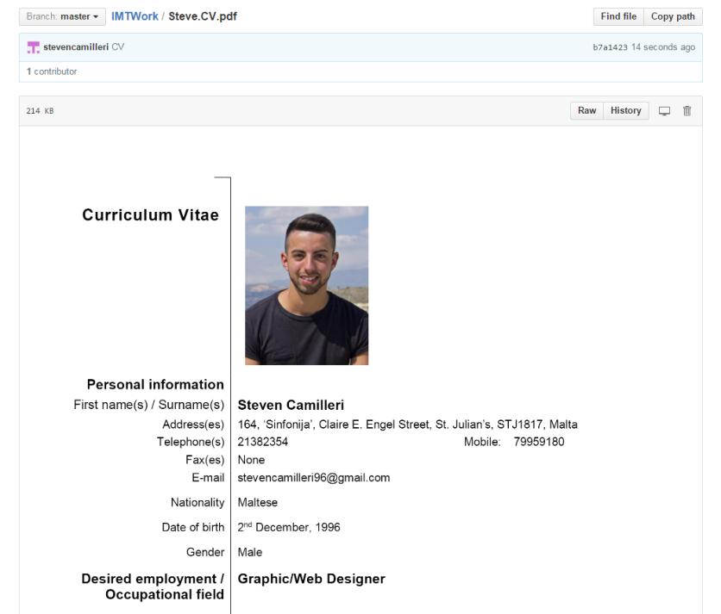

1. Create a pull request to the original master fork. Take a screenshot of the diff between the different forks, to show what differences there are between the forks.

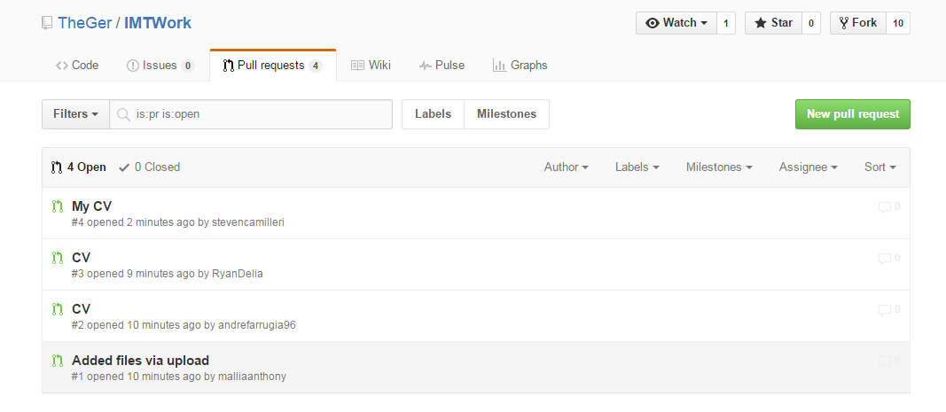

1. View the other pull requests to the original master fork and note the differences between the other pull requests.

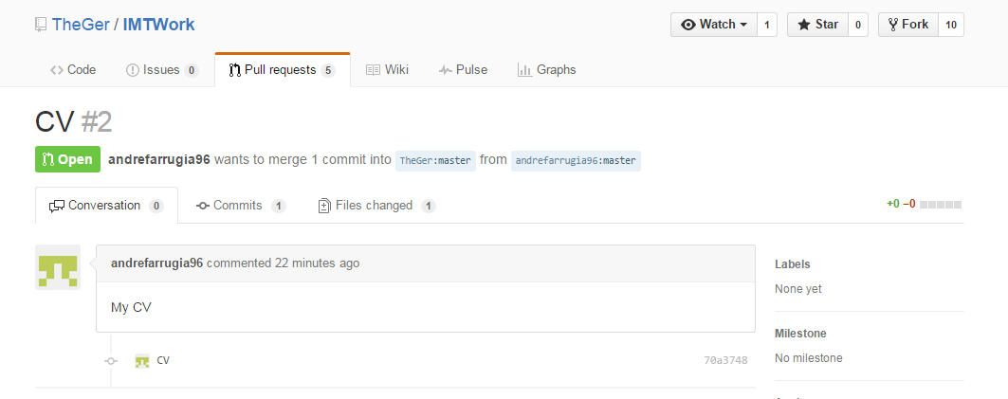

1. Explain what the .gitignore file is used for.

The file .gitignore is a file that shows Git which files or paths to ignore, these files would be files that are not changeable or editable by the user therefore Git does not need to synchronize them. An example of these files would be temporary project files or operating system files that update automatically by the system and not by the user.