Fork the repository available at the following URL: <https://github.com/TheGer/IMTWork>

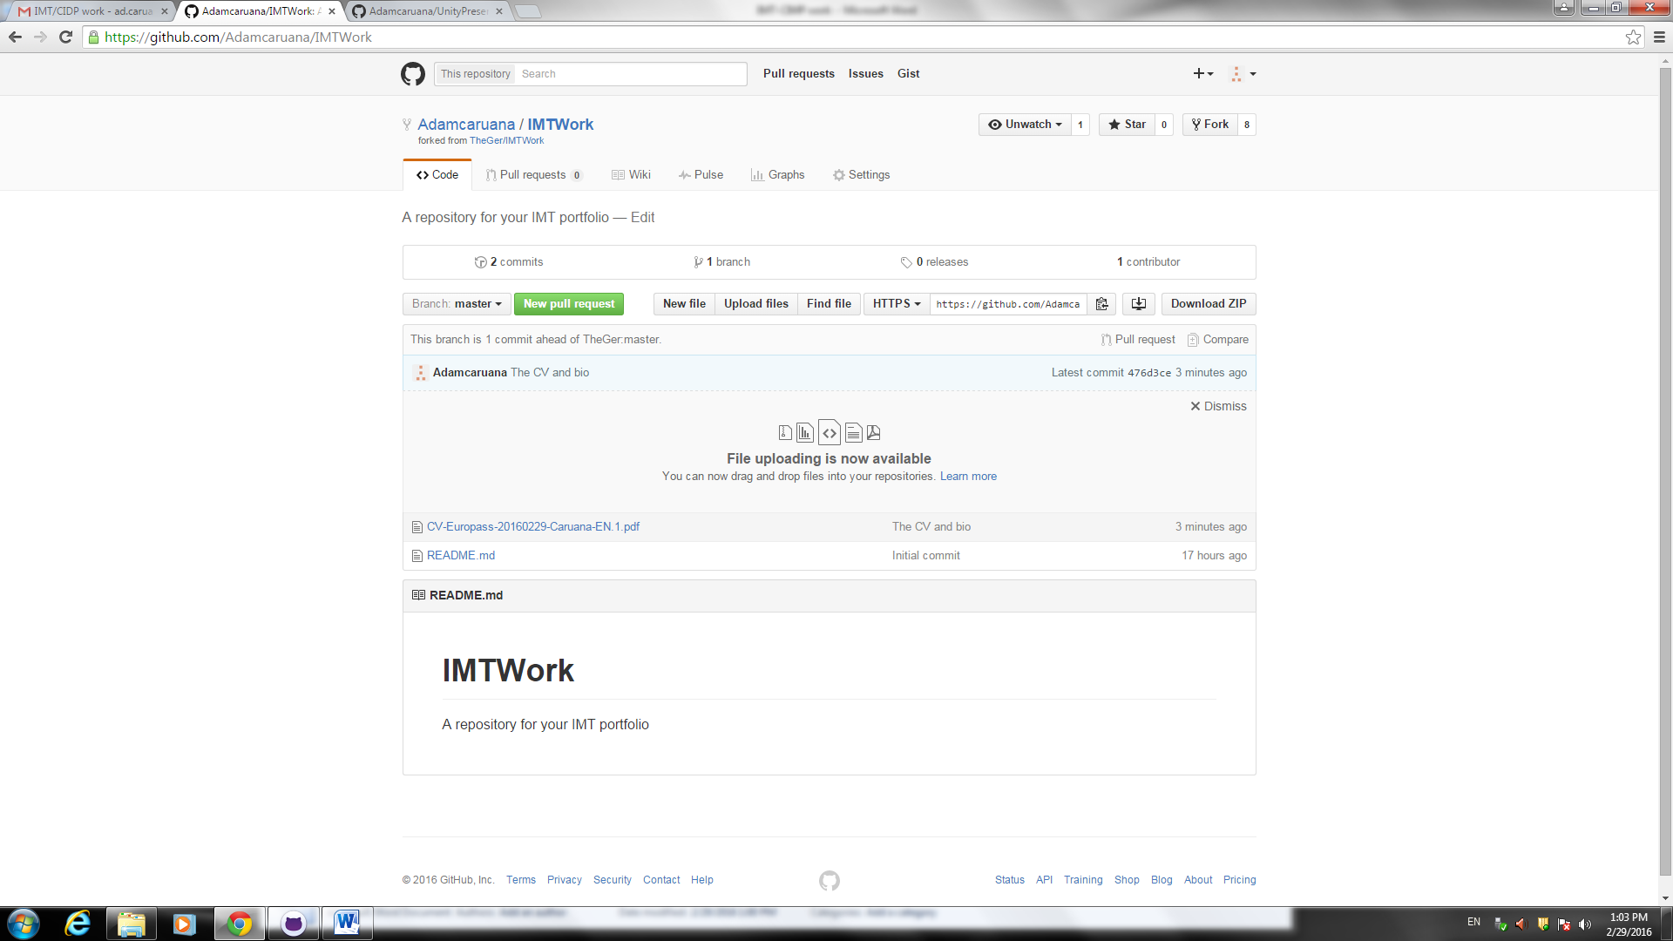

Add a CV, short bio and portfolio as PDF documents to your forked repository

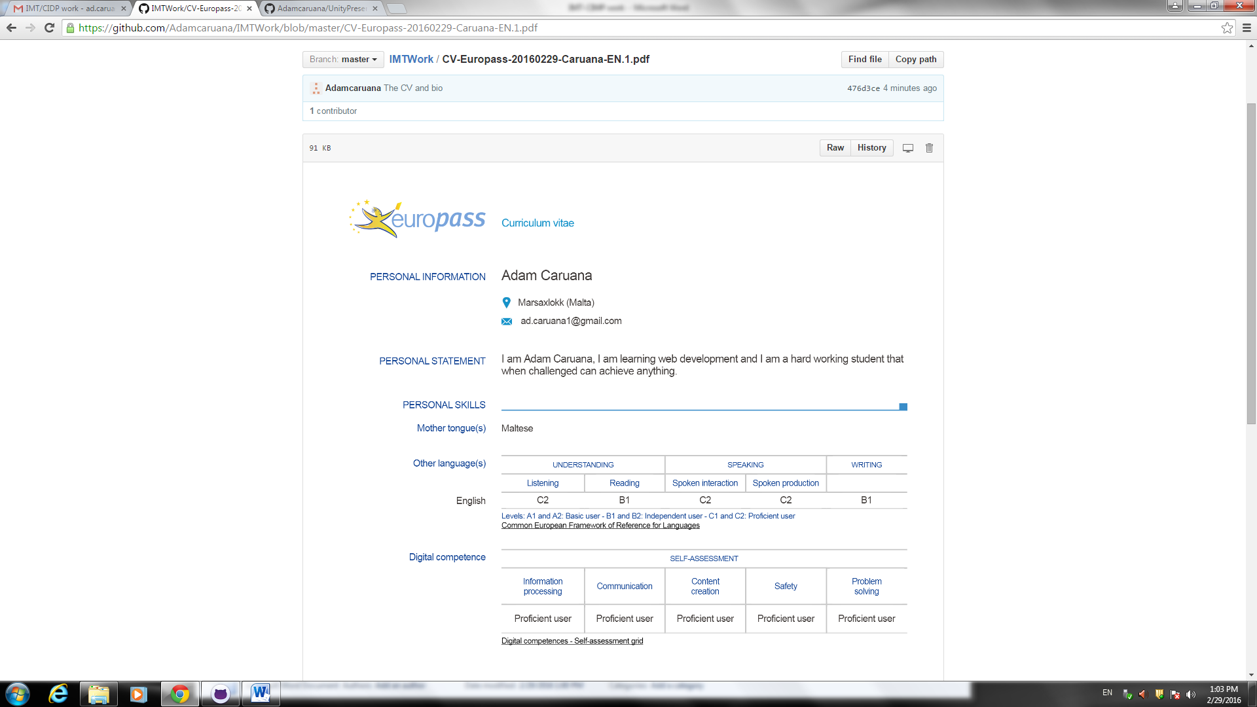

Create a pull request to the original master fork.  Take a screenshot of the diff between the different forks, to show what differences there are between the forks (which should be the documents you have added)

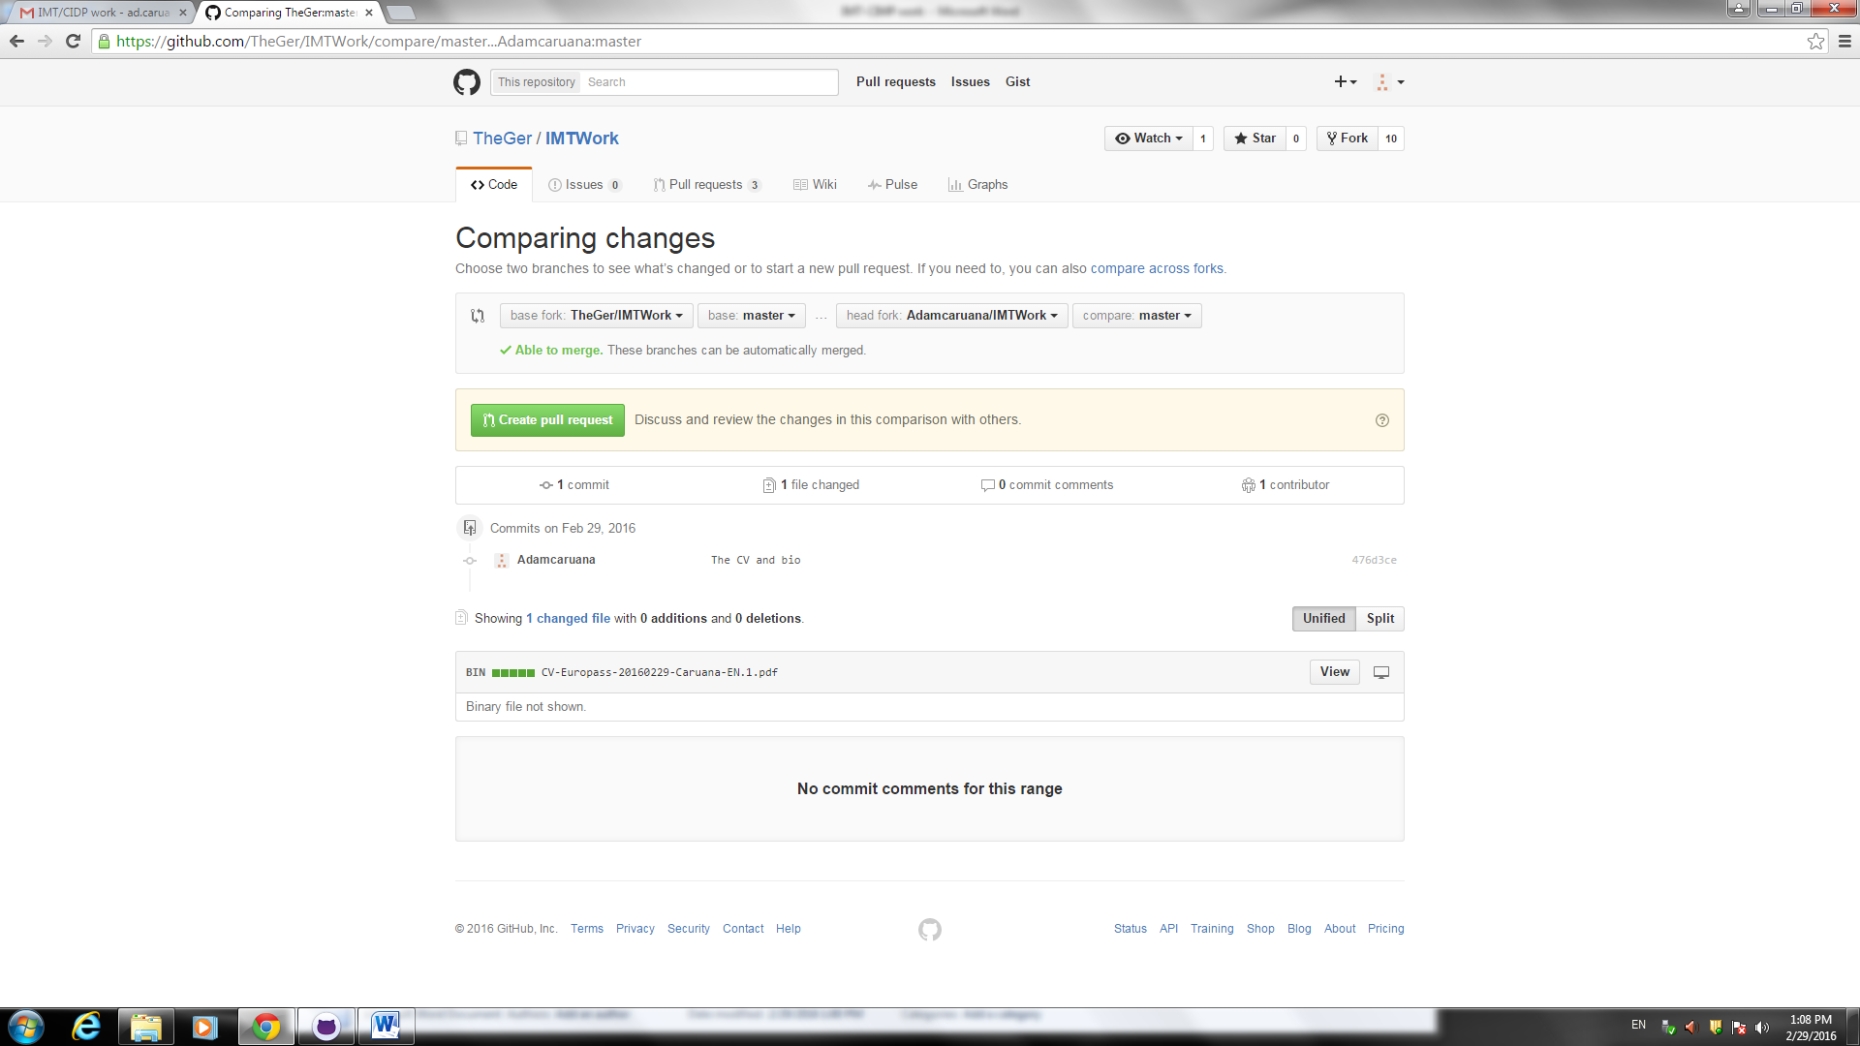

The user can see other cv.

View the other pull requests to the original master fork and note the differences between the other pull requests.

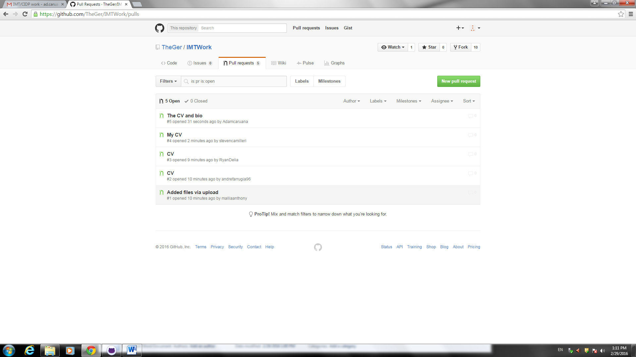

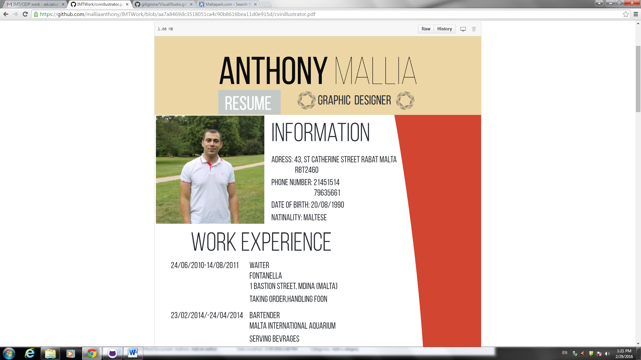

Explain what the .gitignore file is used for

The file .gitignore is a file that shows Git which files to ignore. This files which will not change are usually used in other programs this is done to reduce data duplication and the time taken to upload.