Appendix A Table Descriptions

Mining Tenure (spatial)
el_appl | Exploration Licence Applications
el_grnt | Granted Exploration Licences
el_cess | Ceased Exploration Licences awaiting gazettal or moratorium period to end
emel_app | Extractive Mineral Exploration Licence Applications
emel_grn | Granted Extractive Mineral Exploration Licences
ten_appl | Mining Tenement Applications
ten_grnt | Granted Mining Tenements
mel_curr | All current Offshore Mineral Exploration Licences

Petroleum Tenure (spatial)
pet_appl | Exploration Licence Applications
pet_grnt | Granted Exploration Licences

Mining Reserves (spatial)
res_curr | Proposed and Current Mining Reserves

ALRA Moratorium (spatial)
alra_mora | Areas in Moratorium under the Aboriginal Land Rights Act

Graticular Blocks (spatial)- See Appendix C
OneMiniuteGraticularBlock_GDA94 | 1’ x 1’ graticular blocks for mining applications
FiveMiniuteGraticularBlock_AGD84 | 5’ x 5’ graticular blocks for petroleum applications

Title Holders (textual)
el_hold | Current Exploration Licence Holders
ten_hold | Current mining Tenement Holders
gep_hold | Current Geothermal Exploration Permit Holders
grl_hold | Current Geothermal Retention Licence Holders
gpl_hold | Current Geothermal Production Lease Holders

Geothermal Tenure (spatial)
gep_appl | Geothermal Exploration Permit Applications
gep_grnt | Granted Geothermal Exploration Permit
grl_appl | Geothermal Retention Licence Applications
grl_grnt | Granted Geothermal Retention Licence
gpl_appl | Geothermal Production Lease Applications
gpl_grnt | Granted Geothermal Production Lease

Geothermal Reserves from Occupation (spatial)
gro_curr | Proposed and Current Geothermal Reserves from Occupation

Appendix B Tenure Type Descriptions
Mining Tenure
EL | Exploration Licence
SEL | Substitution Exploration Licence
ERL | Exploration Retention License
ML | Mineral Lease
MLN | Mineral Lease Northern
MLC | Mineral Lease Central
MLS | Mineral Lease Southern
MC | Mineral Claim
MCN | Mineral Claim Northern
MCC | Mineral Claim Central
MCS | Mineral Claim Southern
EMP | Extractive Mineral Permit
EMPN | Extractive Mineral Permit Northern
EMPC | Extractive Mineral Permit Central
EMPS | Extractive Mineral Permit Southern
EML | Extractive Mineral Lease
EMLN | Extractive Mineral Lease Northern
EMLC | Extractive Mineral Lease Central
EMLS | Extractive Mineral Lease Southern
A | Authorisation
AN | Authorisation Northern
AC | Authorisation Central
AS | Authorisation Southern
HLDN | Holding Northern
HLDC | Holding Central
HLDS | Holding Southern
OEL | Offshore Exploration Licence
OML | Offshore Mining Licence
ORL | Offshore Retention Licence
OSPC | Offshore Special Purpose Consents
OWL | Offshore Work Licence

Mining Reserve
RE | Reservation from Exploration
RO | Reservation from Occupation
FA | Fossicking Area
MR | Petroleum Reserve

Petroleum Tenure
AC/ | Ashmore Cartier Release Area
AC/L | Ashmore Cartier Offshore Production Licence
AC/P | Ashmore Cartier Offshore Exploration Permit
AC/RL | Ashmore Cartier Offshore Retention Lease
NT/ | NT Release Area
NT/L | NT Offshore Production Licence
NT/P | NT Offshore Exploration Permit
NT/RL | NT Offshore Retention Lease
EP | Onshore Exploration Permit
L | Onshore Production Licence
OL | Onshore Production Lease
RL | Onshore Retention Licence
PP | Pipeline Permit
PL | Pipeline Licence
Well | Well

Geothermal Tenure
GEP | Geothermal Exploration Permit
GRL | Geothermal Retention Licence
GPL | Geothermal Production Lease

Geothermal Reserve
GRO | Geothermal Reserves from Occupation

Appendix C Graticular Blocks
For the purposes of the Mining Act, the Territory is divided:
“(a) by the meridian of longitude 129 degrees east and by meridians that are east of that meridian at increasing distances from that meridian of one minute of longitude; and
(b) by the parallel of latitude 26 degrees south, and by parallels of latitude that are north of that parallel of latitude at increasing distances from that parallel of latitude of one minute of latitude,” – Sec 14(1) Mining Act.

A graticular block is bounded:
“(c) by portions of 2 of those meridians that are at a distance from each other of one minute of longitude; and
(d) by portions of 2 of those parallels of latitude that are at a distance from each other of one minute of latitude” – Sec 14(1) Mining Act.

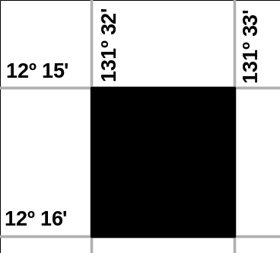

The average size of these graticular blocks is approximately 3.22 square kilometres.

Discrete Areas

An application can only be made over 1 discrete area.

A discrete area can be a single block, or a number of blocks that are joined by a side or a point. Applications made over 2 or more discrete areas cannot be accepted.

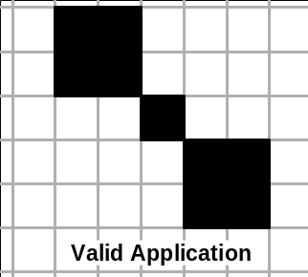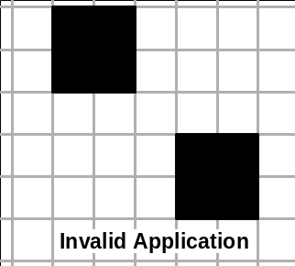

Block Identification Method

The Block Identification Method (BIM) is based on the 1:1,000,000 national mapping series (SD52 Darwin).

Each map is divided into 5 minute by 5 minute blocks. There are 3456 five-minute blocks (numbered 1 to 3456) on each 1:1,000,000 map sheet.

Since a graticular block is 1 minute by 1 minute, the above mentioned five-minute blocks were further divided into graticular blocks called sub-blocks. Each of these sub-blocks is identified by a letter of the alphabet, excluding the letter “i”. Therefore the reference “SD52 1507 A” identifies sub-block “A” on the 1507th block of the SD52 map

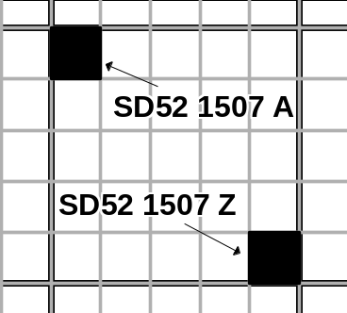
Sub-blocks are hatched.

Written description by sub-blocks
SD52 1435 z | Application area is hatched.  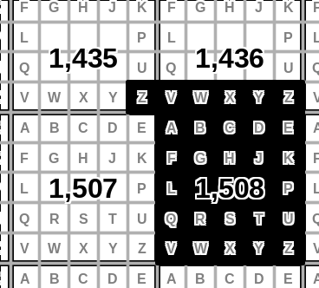  1:1,000,000 map sheet reference number is SD52.
SD52 1436 v,w,x,y,z
SD52 1508 all

