** MINISTRY OF EDUCATION AND TRAINING**

**FPT UNIVERSITY**

Capstone Project Document

Outsourcing HRM

|  |  |
| --- | --- |
| **Group 7** | |
| **Group members** | Nguyen Thi Xuan Mai – Team Leader – SE60910  Le Minh Hoang– Team Member - SE60937  Nguyen Huu Phuoc– Team Member - SE61138  Ngo Trac Kien– Team Member - SE61016 |
| **Supervisor** | Mr. Lai Duc Hung |
| **Ext. Supervisor** | N/A |
| **Capstone Project code** | OHRM |

-Ho Chi Minh City, 05/2015-

*This page is intentionally left blank*

***ACKNOWLEDGEMENTS***

We wish to thank various people for their contribution to this project: Our teachers for their advice and participation in the final review, our friends for their valuable technical support.

Special thanks should be given to Mr. Lai Duc Hung, our research supervisor for his professional guidance and the useful, constructive recommendations throughout the course of this project.

# Table of Contents

[Table of Contents 4](#_Toc421088357)

[List of Tables 5](#_Toc421088358)

[Report No. 1 Introduction 6](#_Toc421088359)

[1. Project Information 6](#_Toc421088360)

[2. Introduction 6](#_Toc421088361)

[3. Current Situation 6](#_Toc421088362)

[4. Problem Definition 6](#_Toc421088363)

[5. Proposed Solution 6](#_Toc421088364)

[5.1 Feature functions 6](#_Toc421088365)

[5.2 Advantages and disadvantages 7](#_Toc421088366)

[6. Functional Requirements 7](#_Toc421088367)

[6.1 Project Management 7](#_Toc421088368)

[6.2 System Management 7](#_Toc421088369)

[6.3 Assessment Management 7](#_Toc421088370)

[6.4 Recruitment Management 7](#_Toc421088371)

[6.5 Knowledge Management 8](#_Toc421088372)

[6.6 Suggestion System 8](#_Toc421088373)

[7. Role and Responsibility 8](#_Toc421088374)

[Report No.2 Software Project Management Plan 9](#_Toc421088375)

[1. Problem Definition 9](#_Toc421088376)

[1.1 Name of this Capstone Project 9](#_Toc421088377)

[1.2 Problem Abstract 9](#_Toc421088378)

[1.3 Project Overview 9](#_Toc421088379)

[2. Project organization 11](#_Toc421088380)

[2.1 Software Process Model 11](#_Toc421088381)

[2.2 Roles and responsibilities 11](#_Toc421088382)

[2.3 Tools and Techniques 12](#_Toc421088383)

[3. Project Management Plan 12](#_Toc421088384)

[3.1 Software Development Life Cycle 12](#_Toc421088385)

[3.2 Phase Detail 14](#_Toc421088386)

[3.3 All Meeting Minutes 15](#_Toc421088387)

[4. Coding Convention 15](#_Toc421088388)

# List of Tables

[Table 1: Definitions 6](#_Toc421089209)

[Table 2: Roles and Responsibilities 9](#_Toc421089210)

[Table 3: Hardware Requirement for Server 11](#_Toc421089211)

[Table 4: Roles and Responsibilities Details 13](#_Toc421089212)

[Table 5: Development Phases 14](#_Toc421089213)

[Table 6: Phase 1: Requirement Analysis 15](#_Toc421089214)

[Table 7: Phase 2: Design 15](#_Toc421089215)

[Table 8: Phase 3: Implementation 15](#_Toc421089216)

[Table 9: Phase 4: Testing 15](#_Toc421089217)

[Table 10: Phase 5: Deployment 16](#_Toc421089218)

# List of Figures

[Figure 1: Waterfall Development Model 12](#_Toc421089219)

# Definitions, Acronyms, and Abbreviations

|  |  |
| --- | --- |
| **Name** | **Definition** |
| OHRM | Outsourcing Human Resource Management |
| Admin | Administrator |
| HR | Human Resource |

Table 1: Definitions

# Report No. 1 Introduction

## Project Information

* Project name: **Outsourcing HRM**
* Project Code: **OHRM**
* Product Type: **Website**
* Start Date: **May 11th, 2015**
* End Date:

## Introduction

Along with the development and growing size of the outsourcing company, human resource management for each project is important.

Human resource management in an outsourcing software firm isn’t simply as manage staff but also ensure to assign work for staff with right skills and interests for the appropriate projects.

Thus the development of specialized management system for human resource involve in specific projects are needed.

OHRM is a system like that. It helps to reduce the pressure management for managers and improve the productivity of works of employee’s project.

## Current Situation

Below are some human resource managements:

* Nowadays, there are a lot human resource management systems in different fields are available on internet and users can easily use it but for outsourcing field it still may not have it yet.
* Some companies develop management system but only internal employees can use it like Fsoft company... The systems provide management specialized functions in outsourcing HRM software such as employee records and assign employees into projects … But there are still some limitations.

## Problem Definition

Below are the disadvantages of current OHRM system:

* The request recruitment for a project or receive the evaluation from customer … Still be done through email.
* System can’t suggest employees with right skills and interests for appropriate project.

## Proposed Solution

System will provide functions that focus on outsourcing resource management‘s efficiency, manage resource for each specific project, sharing experience system …..

### **Feature functions**

* System suggest people that criteria consistent with specific conditions of the project.
* Manager can establish human resource for project that they are involved.
* Director can approve the request from manager.
* Human resource department can select employees and assign them base on the request of manager.
* Manager, Leader, Engineers could hand down experiences of projects as a reference documents to support future projects.
* Admin can manage employee and customer’s account.
* Customer can feedback

### Advantages and disadvantages

The advantages and disadvantages of the proposed solution:

* Advantages:
* With system suggest
  + - Saving energy and time for manager to easily select employees for each project base on automatic system suggest.
    - Each employee will be assigned on projects matching their skills and interests.
    - Productivity of project will be increased.
* With experiences from storage system
* The employee can refer experiences from previous projects.
* With application form management system
* Manager, Director can review the stored application form for hiring.
* System matching the data in order to create new employee profile.
* Disadvantages:
* System only suggests these criteria: skill and interest. It can’t control in term of specific staff’s time.
* Storage system experiences can only save each project under text form. It can’t support text of project content to be searched.
* System can’t manage over time works.

## Functional Requirements

Function requirements of the system are listed as below:

### Project Management

* Director can create new projects and update projects.
* Manager can choose engineers for project which they have been assigned to.

### System Management

* Admin can manage company account.
* Admin can manage criteria for assessment system.
* Engineer can change their profile.

### Assessment Management

* System can provide assessment form for users.
* Manager can appraise project engineer.
* Manager, Director can perform period evaluation for their employes
* Customers can make feedback project after project ends.

### Recruitment Management

* Director can post new recruitment’s need.
* Human Resource Management can reply director hire post.

### Knowledge Management

* Engineer, Manager, Director can post experience knowledge from existing projects and comment on the post.

### Suggestion System

* System can find and suggest engineer with skills and interests that fit the project.

## Role and Responsibility

|  |  |  |  |  |
| --- | --- | --- | --- | --- |
| No | Full Name | Role | Position | Contact |
| 1 | Lai Duc Hung | Project Manager | Instructor | hungld@fpt.edu.vn |
| 2 | Nguyen Thi Xuan Mai | Developer | Leader | Maintxse60910@fpt.edu.vn |
| 3 | Le Minh Hoang | Developer | Member | HoangLMSE60937@fpt.edu.vn |
| 4 | Nguyen Huu Phuoc | Developer | Member | PhuocNHSE61138@fpt.edu.vn |
| 5 | Ngo Trac Kien | Developer | Member | KienNTSE61016@fpt.edu.vn |

Table 2: Roles and Responsibilities

# Report No.2 Software Project Management Plan

## Problem Definition

### Name of this Capstone Project

Outsourcing HRM (OHRM)

### Problem Abstract

Human resource management is always a complex problem for enterprises. Especially for Software Outsourcing company.

Managing human resource efficiently will help software projects complete on time with high quality.

To manage that resource outsourcing, we can build a system that supports human resource management in the projects. Supporting the assessment of employee based on multiple criteria and store experience knowledge from projects.

In addition, system supports management of employee‘s task and assigns them to appropriate position which will not only optimizes the performance of outsourcing resource but also increases the quality of software projects.

### Project Overview

#### Current Situation

Here are some current workflows:

* Communicating via mail:
  + Director establishes recruitment’s need and send mail to Human Resource Department. Simultaneously receive the result list form Human Resource Department also via email
  + Enterprises receive feedback about project from customer via email.
  + The feedback criteria are sent to manager in order to perform the appraisal.
* Mainly, recruit new employee through interview. Employee information is stored does not include employee’s skills and interests.
* Appraise employee based on criteria and the assessment results are written on paper.
* The experiences, tips from previous projects mainly obtained through training from manager are not stored.

The limitations of current workflows:

* Communicating via email require user to manually formatting text, drawing table … It’s consuming time, easy to make mistakes and has no standard format.
* Employee’s skills and interests aren’t store will make manager harder to choose appropriate employee for suitable project, time-consuming for interview….
* The assessment results aren’t stored in system will make it difficult for director to review the assessment results, and it takes a lot of time to plan and pay salary for employee.
* The experience from existing projects are saved that won’t support similar projects in the future. At the same time, new managers will take time to learn from experience manager, it’s wasting resources.

#### The Proposed System

This System is a web application that can solve these problem by helping users manage outsourcing human resource with following functions:

* Director can establish recruitment’s need, project management and review employee’s assessment result.
* Manager can manage their own project, arrange engineer on project and appraise engineers.....
* Engineer can view and edit their personal information, view project information which they are assigned to, post experience knowledge anf log timesheet….
* Human Resource Department can view and respond to recruitment post.
* Admin can manage account, manage assessment criteria and routine evaluation.
* Customer can make feedback for project after project is completed.
* System can suggest engineers in accordance with project, notify users about the changes of human resource, project.....

#### Boundaries of the System

* This system operation requires users to have a computer/laptop with Internet connection.
* Language that system uses is English.
* This system is web application with function for director, manager, engineer, admin, human resource department.

#### Development Environment

##### Hardware requirements

**For server**

|  |  |  |
| --- | --- | --- |
| Windows | Minimum Requirements | Recommended |
| Internet Connection | Cable, Wifi (4 Mbps) | Cable, Wifi (8 Mbps) |
| Operating System | XP, Vista, 7, 8 | XP, Vista, 7, 8 |
| Computer Processor | Intel® Core 2 Duo | Intel® Core(TM) i5 CPU , M 460 @ 2.53GHz |
| Computer Memory | 1GB RAM | 3GB or more |

Table 3: Hardware Requirement for Server

##### Software requirements

* Microsoft Windows 7 Ultimate: operating system and platform for development.
* SQL Server 2008 Enterprise R2: used to create and manage the database for system.
* StarUML 5.0: used to create models and diagrams.
* Skype: used for communication and meeting.
* Microsoft Visio: used to draw models and diagrams.
* NetBeans IDE 7.4 JDK 7u51: used to implement website.
* GitHub & TortoiseSVN: used for source control.

## Project organization

### Software Process Model

Project is developed under waterfall model.

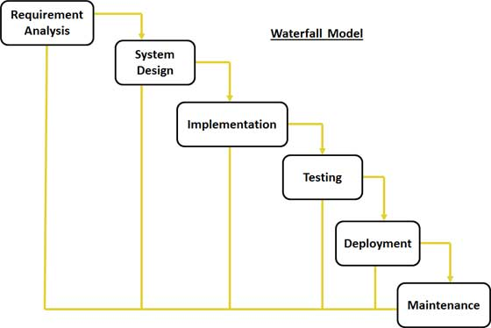

Figure 1: Waterfall Development Model

For more information: <http://www.tutorialspoint.com/sdlc/sdlc_waterfall_model.htm>

(Owner tutorialspoint.com. Tutorials Point)

### Roles and responsibilities

|  |  |  |  |
| --- | --- | --- | --- |
| **No** | **Full name** | **Role in Group** | **Responsibilities** |
| **1** | Lai Duc Hung | Project manager | * Specify user requirement * Control the development process * Give out technique and business analysis support |
| **2** | Nguyen Thi Xuan Mai | Team Leader, BA, DEV, Tester | * Managing process * Designing database * Clarifying requirements * Prepare documents * GUI Design * Create test plan * Coding * Testing |
| **3** | Le Minh Hoang | Team Member, BA, DEV, Tester | * Designing database * Clarifying requirements * Prepare documents * GUI Design * Create test plan * Coding * Testing |
| **4** | Nguyen Huu Phuoc | Team Member, BA, DEV, Tester | * Designing database * Clarifying requirements * Prepare documents * GUI Design * Create test plan * Coding * Testing |
| **5** | Ngo Trac Kien | Team Member, BA, DEV, Tester | * Designing database * Clarifying requirements * Prepare documents * GUI Design * Create test plan * Coding * Testing |

Table 4: Roles and Responsibilities Details

### Tools and Techniques

- Front-end technologies: HTML5, CSS3, JavaScript, jQuery, AJAX.

- Back-end: Website: Website: NetBeans IDE 7.4 JDK 1.7.

- Web Server: Microsoft IIS.

- Database Management System: MS SQL Server 2008 Enterprise R2.

## Project Management Plan

### Software Development Life Cycle

|  |  |  |  |  |  |
| --- | --- | --- | --- | --- | --- |
| **Phase** | **Description** | **Deliverables** | **Resource needed** | **Dependencies and Constrains** | **Risks** |
| **Preliminary Investigation or Analysis** | - Collect requirements from customer.  - Identify and clarify requirements for the system in general. | - Introduction of proposed system.  - Software requirement specification  - Project Task Plan.  - Prototypes. | 20 man-days | N/A | - Missing requirement- Unclear scope of project.  - Lack of member share of understand. |
| **Design** | - Architecture design for the system.  - Detail design using top-down.  - Choose Architecture style. | - Software Design Document  - Base code structure. | 20 man-days | Depend on “Requirement Analysis”. | - Lack of experience.  - Not fulfil requirement |
| **Implementation** | - Coding system core functions and other feature with GUI.  - Unit test | - Main user’s functions on web. | 40 man-days | Depend on “Design”. | - Lack of experience and knowledge.  - Human’s mistake. |
| **Testing** | - Integration test the system.  - Alpha test.  - Correct bugs.  - Beta test.  - Acceptance test. | - Test document. | 20 man-days | Depend on “Implementation”. | - Lack of experience.  - Missing test case. |
| **Deployment** | N/A | - Installation guide.  - User Manual. | 10 man-days | Depend on “Testing”. | - Lack of experience. |
| **Maintenance** | N/A | N/A | N/A | N/A | N/A |

Table 5: Development Phases

### Phase Detail

#### Phase 1: Requirement Analysis

|  |  |  |
| --- | --- | --- |
| **Task** | **Description** | **Author** |
| **1. Collect requirements** | Find which systems currently provide similar service, their strengths and weakness. | MaiNTX, HoangLM, PhuocNH, KienNT |
| **2. Identify and clarify main functions** | Define which main functions system should provide. | MaiNTX, HoangLM, PhuocNH, KienNT |
| **3.** **Create System Introduction** | Complete Introduction Report. | MaiNTX |
| **4. Software Project Management Plan** | Prepare Project Management Plan. | MaiNTX |
| **5. Prototype** | Build a prototype of proposed system (Website). | MaiNTX, HoangLM, PhuocNH, KienNT |
| **6. SRS** | Create SRS document. | MaiNTX, HoangLM, PhuocNH, KienNT |

Table 6: Phase 1: Requirement Analysis

#### Phase 2: Design

|  |  |  |
| --- | --- | --- |
| **Task** | **Description** | **Author** |
| **1. Detailed Design** | Which feature this function should have and how to implement. | MaiNTX, HoangLM, PhuocNH, KienNT |
| **2. Database Design** | Design a database which contains all entities information. | MaiNTX, HoangLM, PhuocNH, KienNT |
| **3. Design Document** | Create software design document. | MaiNTX, HoangLM, PhuocNH, KienNT |

Table 7: Phase 2: Design

#### Phase 3: Implementation

|  |  |  |
| --- | --- | --- |
| **Task** | **Description** | **Author** |
| **1. Front-end web functions** | Implement front-end functions on web. | MaiNTX, HoangLM, PhuocNH, KienNT |
| **2. Back-end web functions** | Implement back-end functions on web. | MaiNTX, HoangLM, PhuocNH, KienNT |
| **3. Unit testing** | Write test case and testing for web functions. | MaiNTX, HoangLM, PhuocNH, KienNT |

Table 8: Phase 3: Implementation

#### Phase 4: Testing

|  |  |  |
| --- | --- | --- |
| **Task** | **Description** | **Author** |
| **1. Integration testing** | Write test case and testing systems. | MaiNTX, HoangLM, PhuocNH, KienNT |
| **2. Alpha testing** | Do alpha test with customer. | MaiNTX, HoangLM, PhuocNH, KienNT |

Table 9: Phase 4: Testing

#### Phase 5: Deployment

|  |  |  |
| --- | --- | --- |
| **Task** | **Description** | **Author** |
| **1. Installation guide** | Write installation guide. | MaiNTX |
| **2. User Manual** | Write user manual. | HoangLM, PhuocNH, KienNT |

Table 10: Phase 5: Deployment

#### Phase 6: Maintenance

N/A

### All Meeting Minutes

Refer to Meeting Minutes folder.

## Coding Convention

Use Java coding convention to develop website.

Summary:

* Naming Convention.
  + Use camel case for both variable and function name.
  + Use Pascal case for class name.
* Indentation.
  + Avoid lines longer than 80 characters, since they are not handled well by many terminals and tools.
* Declaration.
  + One declaration per line is recommended since it encourages commenting.
  + In absolutely no case should variables and functions be declared on the same line.
  + Do not put different types on the same line.
* Code Examples

Follow “Code Conventions for the Java TM Programming Language, by Sun Microsystems, rev April 20, 1999”.

<http://www.oracle.com/technetwork/java/codeconventions-150003.pdf>

# Report No. 3 Software Requirement Specification

## User Requirement Specification

### Guest Requirement

Guest is a person who does not have access to the system. The function guest can use:

* Login.

### Engineer Requirement

Admin is the person who manages the system. Admin is super user who cans you following function:

* View evaluation.
* View appraisal.
* Edit Profile.
* Search knowledge.
* View knowledge detail.
* Edit knowledge.
* Close knowledge.
* Comment knowledge.
* Edit comment.
* Remove comment.
* Search projects.
* View projects detail.
* Search timesheets.
* Write timesheet.
* Edit timesheet.
* Remove timesheet.

### Manager Requirement

StoreOwner is the person who uses our service to create order and print it. StoreOwner account will be created when Guest register as StoreOwner. StoreOwner can use these functions:

* Search employees
* View employee profile.
* Review timesheets.
* Appraise project engineers.
* Edit appraisal.
* Edit evaluation.
* Evaluate engineers in period time.
* Assign engineers to project
* Remove engineers from project

### Director Requirement

Employee is the person who works for StoreOwner. Employee can use the following functions:

* Search recruitment
* View recruitments detail.
* Create recruitment
* Edit recruitment.
* Reply recruitment.
* Create project.
* Edit project.
* Review assigned engineers.
* Review evaluation.

### Customer Requirement

Employee is the person who works for StoreOwner. Employee can use the following functions:

* Make feedback.

### Admin Requirement

Employee is the person who works for StoreOwner. Employee can use the following functions:

* Search account.
* View account.
* Create account.
* Edit account.
* Print order.

### HR Requirement

HR is a department that reply recruitment’s need. HR can use the following functions:

* Search recruitment
* View recruitments detail.
* Reply recruitment.

## System Requirement Specification

### External Interface Requirement

#### User Interface

* General requirement for graphics user interface is the GUI should be simple, clear, intuitive, and reminiscent.
* The interface design is an iterate process includes design, sketching, prototyping, user assessment.
* Some design principles will be taken into consideration:
  + UI for business web applications - Janko Jovanovic [Ref: <http://www.smashingmagazine.com/2010/02/25/designing-user-interfaces-for-business-web-applications/>]
  + Ten principles of effective web design – Vitaly Friedman [Ref: <http://www.smashingmagazine.com/2008/01/31/10-principles-of-effective-web-design/>]
  + Principles of mobile interface design – Jonathan Stark [Ref: <http://www.oreilly.com/pub/e/2144>]

#### Hardware Interface

* N/A

#### Software Interface

* Run with FireFox (version 37.0.1), Chrome (version 42.0.2311.90 m) browser and must support Javascript and HTML5.

#### Communication Protocol

* Using HTTP/HTTPS protocol
* Using Bluetooth protocol

### System Overview Use Case

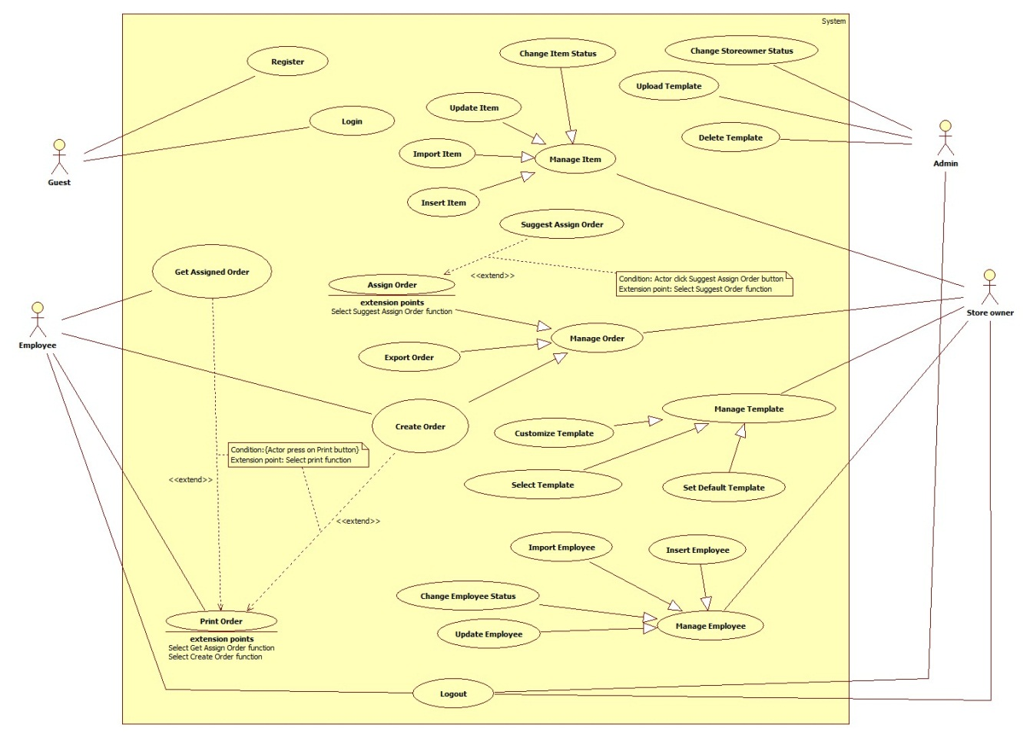

Figure 2: System Overview Use Case



### List of Use Case

#### <Guest> Overview Use Case

**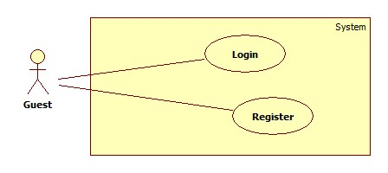**

**Figure 3: <Guest> Overview Use Case**



##### <Guest> Login Use Case Diagram

**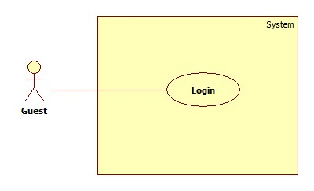**

**Figure 4: <Guest> Login use case diagram**

**Use Case Specification**

|  |  |  |  |
| --- | --- | --- | --- |
| **USE CASE -1 SPECIFICATION** | | | |
| **Use-case No.** | EPS001 | **Use-case Version** | 2.0 |
| **Use-case Name** | Login | | |
| **Author** | Chau Chieu Nguyen | | |
| **Date** | 22/01/15 | **Priority** | High |
| **Actor:**  Guest  **Summary:**  This use case allows guest to login to the system.  **Goal:**  Allow guest login to the system.  **Triggers**   * Guest press login button on Login screen.   **Preconditions:**   * N/A   **Post Conditions:**   * **On Success**: Guest logged in to the system. * **On Failure**: Show error message.   **Main Success Scenario:**   |  |  |  | | --- | --- | --- | | Step | Actor Action | System Response | | 1 |  | System will display Login screen:  - “Tài khoản”: textbox, min length 4, max length 50.  - “Mật khẩu”: textbox, min length: 6, max length 50.  -“Đăng nhập”: button.  - “Quên mật khẩu”: Link  [Alternative 1] | | 2 | Guest input username and password |  | | 3 | Press “Đăng nhập” button | System will navigate to Home screen.  [Exceptions 2, 3, 4, 5, 6] |   **Alternative Scenario:**   * -N/A   **Exceptions:**   |  |  |  | | --- | --- | --- | | No | Actor Action | System Response | | 1 | Guest press “Quên mật khẩu” link | System will navigate to Forgot Password screen on web application. | | 2 | Guest lefts “Tài khoản” or “Mật khẩu” textboxes blank. | Show message: “Tên tài khoản hoặc mật khẩu không được để trống”. | | 3 | Guest login to the web application with employee account. | Show message:”Bạn không được phép đăng nhập vào trang web này”. | | 4 | Guest login with wrong username or password. | Show message:”Tên tài khoản hoặc mật khẩu không đúng”. | | 5 | Guest login with non-existed account. | Show message:” Tên tài khoản không hợp lệ”. | | 6 | Guest login fail 5 times | Show message:”Bạn đã bị khóa 15 phút vì đăng nhập sai quá nhiều lần”. |   **Relationships:**   * N/A   **Business Rules:**   * Guest have to login with Admin account or Store Owner account to access the web application. * On mobile application, user name and password will be saved to login without Internet connection next times. * If user changes their password, they still can use the mobile application until they logout. * If guest login fail for 5 times, login function will be disable for 15 minutes. | | | |

##### <Guest> Register Use Case Diagram

**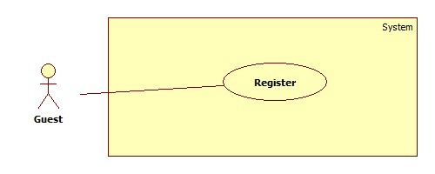**

**Figure 5: <Guest> Register use case diagram**

|  |  |  |  |
| --- | --- | --- | --- |
| **USE CASE -2 SPECIFICATION** | | | |
| **Use-case No.** | EPS002 | **Use-case Version** | 2.0 |
| **Use-case Name** | Register | | |
| **Author** | Duong Le Dinh Khang | | |
| **Date** | 13/04/15 | **Priority** | High |
| **Actor:**  Guest  **Summary:**  This use case allows guest register info system as StoreOwner account.  **Goal:**  Allow guest register to the system.  **Triggers**   * Guest press Register button on Register screen.   **Preconditions:**   * N/A   **Post Conditions:**   * **On Success**: New StoreOwner account will be created. * **On Failure**: Show error message.   **Main Success Scenario:**   |  |  |  | | --- | --- | --- | | Step | Actor Action | System Response | | 1 |  | System will display Register screen:  - “Tài khoản”: textbox, min length 4, max length 50.  -“Địa chỉ Email”: textbox, regurlar expression: “^[a-zA-Z0-9\_.+-]+@[a-zA-Z0-9-]+\.[a-zA-Z0-9-.]+$".  - “Mật khẩu”: textbox, min length: 6, max length: 50, required.  -“Nhập lại mật khẩu”: textbox, min length: 6, max length: 50, required.  -“Tên”: textbox, min length: 5, max length: 100.  -“Số điện thoại”: textbox, min length: 9, max length: 11.  -“Website của bạn”: textbox, min length: 5, max length: 50.  -“Tên cửa hàng”: textbox, min length: 6, max length: 50.  -“Địa chỉ nhà”:  -“Đăng Ký”: button. | | 2 | Guest input personal information into textbox. |  | | 3 | Press “Đăng Ký” button | System will navigate to Register Success screen.  [Exceptions 1, 2, 3]  [Alternative 1] |   **Alternative Scenario:**   |  |  |  | | --- | --- | --- | | No | Actor Action | System Response | | 1 | Guest navigates to another page. | Close “Đăng ký” page and navigate to new page. |   **Exceptions:**   |  |  |  | | --- | --- | --- | | No | Actor Action | System Response | | 1 | Guest not fills all the required texbox. | Show message: “Vui lòng nhập thông tin vào những ô bắt buộc”. | | 2 | “Mật khẩu” and “Nhập lại mật khẩu” not matched. | Show message: “Mật khẩu nhập lại không khớp”. | | 3 | Guest register with a username already existed in system. | Show message:”Tên tài khoản không khả dụng”. |   **Relationships:**   * N/A   **Business Rules:**   * All fill with required attribute must be filled. * “Mật khẩu” and “Nhập lại mật khẩu” must be same. * Exception must not violate. | | | |

#### <StoreOwner> Overview Use Case

**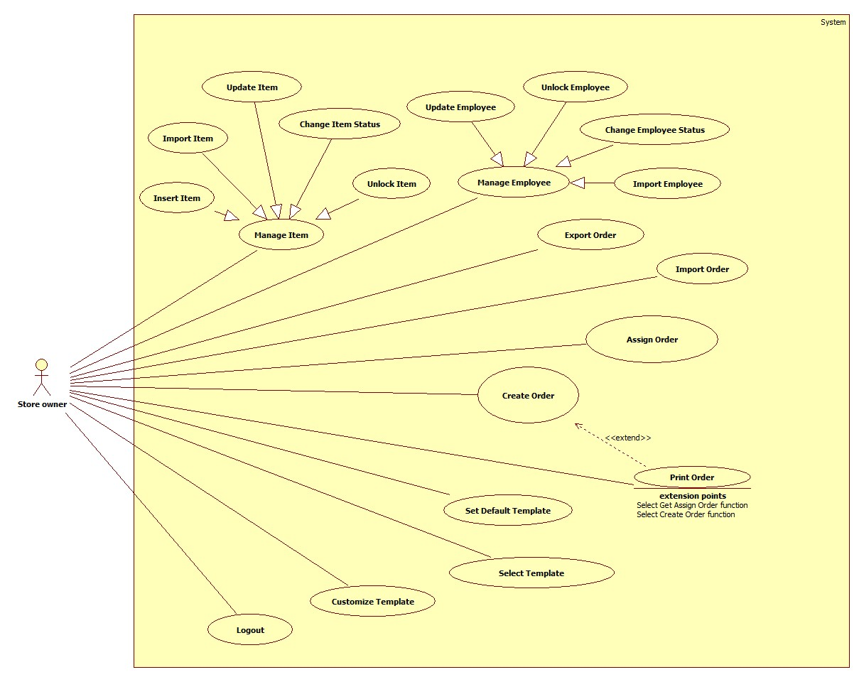**

**Figure 6: <StoreOwner> Overview Use Case**

##### <StoreOwner> Insert Item Use Case Diagram

**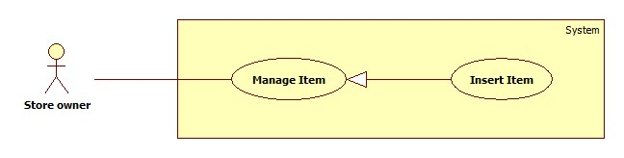**

**Figure 7: <StoreOwner> Insert Item Use Case Diagram**

**Use Case Specification**

|  |  |  |  |
| --- | --- | --- | --- |
| **USE CASE-3 SPECIFICATION** | | | |
| **Use-case No.** | EPS003 | **Use-case Version** | 2.0 |
| **Use-case Name** | Insert Item | | |
| **Author** | Duong Le Dinh Khang | | |
| **Date** | 16/01/15 | **Priority** | Medium |
| **Actor:**  Store owner  **Summary:**  This use case allow StoreOwner insert their product items into our system.  **Goal:**  Add a new item.  **Triggers**   * Store’s owner chooses add item function.   **Preconditions:**   * User must login with role StoreOwner.   **Post Conditions:**   * **On Success**: A new item will be added. * **On Failure**: Show error message.   **Main Success Scenario:**   |  |  |  | | --- | --- | --- | | Step | Actor Action | System Response | | 1 | StoreOwner clicks on “Quản lý sản phẩm” navigator. | System will navigate to “Quản lý sản phẩm” page.  “Thêm sản phẩm”: button.  “Nhập danh sách sản phẩm”: button.  “Danh sách sản phẩm”: table data. List of items. | | 1 | StoreOwner clicks on “Thêm sản phẩm” button. | System will navigate to “Thêm sản phẩm” page.  -“Tên sản phẩm”: textbox, min length: 10, max length: 30, required.  -“Mô tả”: text area, min length: 20, max length: 500.  -“Loại sản phẩm”: texbox, min length: 6, max length: 50.  -“Đơn vị tính”: textbox, min length: min length 6, max length: 50.  -“Số lượng”: textbox, min length: 1, max length: 3 with range [1, 999].  -“Giá”: textbox, regular expression: “\d\* [.]?\d+”, min value: 10, max value: 100.000 with unit are 1000VNĐ, required.  -“Thêm sản phẩm”: button | | 2 | Input fields. |  | | 3 | Click on “Thêm sản phẩm” button. | Item will be added to database and show: “Bạn đã thêm sản phẩm thành công”.  [Exception 1, 2, 3, 4, 5 ,6, 7]  [Alternative 1] |   **Alternative Scenario:**   |  |  |  | | --- | --- | --- | | No | Actor Action | System Response | | 1 | StoreOwner navigates to another page. | Close “Thêm sản phẩm” page and navigate to new page. |     **Exceptions:**   |  |  |  | | --- | --- | --- | | No | Actor Action | System Response | | 1 | Length of item name is not in range. | Show error message: “Độ dài tên sản phẩm phải từ 10-30 ký tự!” | | 2 | Category is not specificed. | Show error message: “Hãy chọn thể loại!” | | 3 | Unit is not specificed. | Show error message: “Hãy chọn đơn vị!” | | 4 | Quantity is “0” | Show error message: “Số lượng của sản phẩm ít nhất là 1!” | | 5 | Price is not in range. | Show error message: “Giá sản phẩm phải từ 10.000 đồng trở lên!” | | 6 | Description is blank. | Show error message: “Mô tả không được để trống!” |   **Relationships:**  N/A  **Business Rules:**   * In main success scenario, a new item with be added to database. * StoreOwner can only use item which they added to database for generate report purpose. * Employee can use item which added by their StoreOwner. * Range of item price is from 10.000VNĐ to 100.000.000VNĐ. * StoreOwner can add two or more item with same name. * New item will be showed in “Danh sách sản phẩm” table. * Exception must not violate. | | | |

##### <Store owner> Update Item Use Case Diagram

**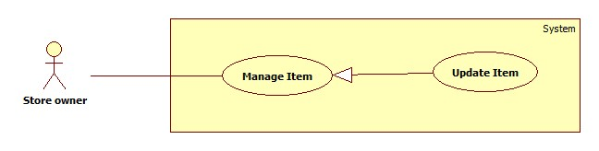**

**Figure 8: <StoreOwner> Update Item Use Case Diagram**

**Use Case Specification**

|  |  |  |  |
| --- | --- | --- | --- |
| **USE CASE-4 SPECIFICATION** | | | |
| **Use-case No.** | EPS004 | **Use-case Version** | 2.0 |
| **Use-case Name** | Update Item | | |
| **Author** | Duong Le Dinh Khang | | |
| **Date** | 16/01/15 | **Priority** | Medium |
| **Actor:**  Store owner  **Summary:**  This use case allow StoreOwner update their product items into our system.  **Goal:**  Update an item.  **Triggers**   * StoreOwner chooses update item function.   **Preconditions:**   * User must login with role StoreOwner.   **Post Conditions:**   * **On Success**: Item will be updated with new information. * **On Failure**: No item will be edited. Show error message.   **Main Success Scenario:**   |  |  |  | | --- | --- | --- | | Step | Actor Action | System Response | | 1 | Choose “Quản lý sản phẩm” in navigator. | System will navigate to “Quản lý sản phẩm” page.  “Thêm sản phẩm”: button.  “Nhập danh sách sản phẩm”: button.  “Danh sách sản phẩm”: table data. List of items. | | 2 | Click on “Cập nhật” button on which item you want to edit. | Navigate to “Cập nhật sản phẩm” page  -“Tên sản phẩm”: textbox, min length: 10, max length: 30, not editable.  -“Mô tả”: text area, min length: 20, max length: 500.  -“Loại sản phẩm”: texbox, min length: 6, max length: 50.  -“Đơn vị tính”: textbox, min length: min length 6, max length: 50.  -“Số lượng”: textbox, min length: 1, max length: 3 with range [1, 999].  -“Giá”: textbox, regular expression: “\d\* [.]?\d+”, min value: 10, max value: 100.000 with unit are 1000VNĐ, required.  -Hoàn tất:button | | 3 | Input field. |  | | 4 | Click on “Hoàn tất” button. | Item will be edited from database and a message will be showed: “Bạn đã sửa sản phẩm thành công”.  [Exception 1, 2, 3] |   **Alternative Scenario:**  N/A  **Exceptions:**   |  |  |  | | --- | --- | --- | | No | Actor Action | System Response | | 1 | Quantity is “0” | Show error message: “Số lượng của sản phẩm ít nhất là 1!” | | 2 | Price is not in range. | Show error message: “Giá sản phẩm phải từ 10.000 VNĐ đến 100.000.000 VNĐ!” | | 3 | Description is blank. | Show error message: “Mô tả không được để trống!” |   **Relationships:**  N/A  **Business Rules:**   * StoreOwner cannot edit name of item. * Item edited will be synchronized with mobile app when it connect to the internet. * Item can only edit by StoreOwner who created it. * Range of item price is from 10.000VNĐ to 100.000.000VNĐ. * Updated Item will be showed new info in “Danh sách sản phẩm” table. * Exception must not violate. | | | |

##### <Store owner> Change Item Status Use Case Diagram

**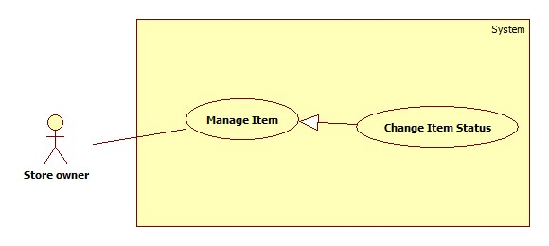**

**Figure 9: <StoreOwner> Change Item Status Use Case Diagram**

**Use Case Specification**

|  |  |  |  |
| --- | --- | --- | --- |
| **USE CASE-5 SPECIFICATION** | | | |
| **Use-case No.** | EPS005 | **Use-case Version** | 2.0 |
| **Use-case Name** | Change Item Status | | |
| **Author** | Duong Le Dinh Khang | | |
| **Date** | 16/01/15 | **Priority** | Medium |
| **Actor:**  StoreOwner  **Summary:**  Make item you want to lock not available for future use and unlock to continue use it.  **Goal:**  Change the item status.  **Triggers**   * StoreOwner chooses lock item or unlock item function.   **Preconditions:**   * User must login with role StoreOwner.   **Post Conditions:**   * **On Success**: Item’s status changed to locked. * **On Failure**: No item will be lock. Show error message.   **Main Success Scenario:**   |  |  |  | | --- | --- | --- | | Step | Actor Action | System Response | | 1 | Choose “Quản lý sản phẩm” in navigation bar | Show “Quản lý sản phẩm” page with table of list items.  “Thêm sản phẩm”: button.  “Nhập danh sách sản phẩm”: button.  “Danh sách sản phẩm”: table data. List of items. | | 2 | Click on “Khoá” button on which item you want to lock. | Show message: “Khoá sản phẩm thành công”.  [Alternative 1] |   **Alternative Scenario:**   |  |  |  | | --- | --- | --- | | No | Actor Action | System Response | | 1 | Click on “Mở khoá” button on which item you want to unlock. | Show message: “Mở khoá thành công”. |   **Exceptions:**   * N/A   **Relationships:**   * N/A   **Business Rules:**   * If item’s status is lock, this use case will show “Mở khoá” button. * If item’s status is available, this use case will show “khoá” button. * Locked item cannot be use to create order in future. * Available item can be use to create order. | | | |

##### <StoreOwner> Import Item Use Case Diagram

**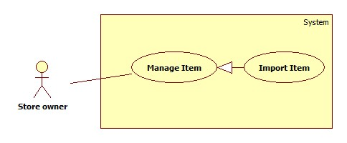**

**Figure 10: <StoreOwner> Import Item Use Case Diagram**

**Use Case Specification**

|  |  |  |  |
| --- | --- | --- | --- |
| **USE CASE-6 SPECIFICATION** | | | |
| **Use-case No.** | EPS006 | **Use-case Version** | 2.0 |
| **Use-case Name** | Import Item | | |
| **Author** | Duong Le Dinh Khang | | |
| **Date** | 14/04/15 | **Priority** | Medium |
| **Actor:**  StoreOwner  **Summary:**  StoreOwner can add multiple item at a time by import a list of item in excel file into system.  **Goal:**  Add multiple item.  **Triggers**   * StoreOwner chooses import item function.   **Preconditions:**   * User must login with role StoreOwner. * StoreOwner must have a list of item in excel file with valid format.   **Post Conditions:**   * **On Success**: Item in excel will be added into system. * **On Failure**: No item will be added. Show error message.   **Main Success Scenario:**   |  |  |  | | --- | --- | --- | | Step | Actor Action | System Response | | 1 | Choose “Quản lý sản phẩm” in navigation bar | Show “Quản lý sản phẩm” page with table of list items.  “Thêm sản phẩm”: button.  “Nhập danh sách sản phẩm”: button.  “Danh sách sản phẩm”: table data. List of items. | | 2 | StoreOwner clicks on “Nhập danh sách sản phẩm”. | Navigate to “Nhập danh sach sản phẩm” page.  -“Tải mẫu file xls”: hyperlink.  -“Browse”: button.  -“Nhập”: button. | | 3 | StoreOwner clicks on “Tải mẫu file xls” hyperlink. | System will response a excel template file to import item data. | | 4 | StoreOwner fill out item information into excel file. |  | | 5 | StoreOwner clicks on “Browse” | System will display an open file dialog for user to choose file.  -“Open”: button.  -“Cancel”: button  [Alternative 1] | | 6 | StoreOwner navigate to the excel file and click “Open”. | Name of excel will be showed right after  “Browse” button. | | 7 | StoreOwner clicks on “Nhập” button. | List of items will be import to system.  [Alternative 2]  [Exceptions 1,2] |   **Alternative Scenario:**   |  |  |  | | --- | --- | --- | | No | Actor Action | System Response | | 1 | StoreOwner clicks on “Cancel” button. | Open file dialog will be closed. | | 2 | StoreOwner navigates to another page. | “Nhập danh sách sản phẩm” page will be close and new page will be open. |   **Exceptions:**   |  |  |  | | --- | --- | --- | | No | Actor Action | System Response | | 1 | StoreOwner not fill data into required cell in excel file. | Show message: “Vui lòng nhập đầy đủ thông tin sản phẩm”. | | 2 | StoreOwner select invalid file | Show message: “File danh sách sản phẩm của bạn không hợp lệ”. |   **Relationships:**   * N/A   **Business Rules:**   * Structure of xls file:      * File type of excel file must be “xls”. * All info of item must be filled. * When import success, item list will be added to database. * “Danh sách sản phẩm” will update new item. * Exceptions must not violate. | | | |

##### <StoreOwner> Insert Employee Use Case Diagram

****

**Figure 11: <StoreOwner> Insert Employee Use Case Diagram**

**Use Case Specification**

|  |  |  |  |
| --- | --- | --- | --- |
| **USE CASE-7 SPECIFICATION** | | | |
| **Use-case No.** | EPS007 | **Use-case Version** | 2.0 |
| **Use-case Name** | Insert Employee | | |
| **Author** | Chau Chieu Nguyen | | |
| **Date** | 15/04/15 | **Priority** | Medium |
| **Actor:**  Store owner  **Summary:**  This use case allow StoreOwner insert their employees into our system.  **Goal:**  Add a new employee.  **Triggers**   * Store’s owner chooses add employee function.   **Preconditions:**   * User must login with role StoreOwner.   **Post Conditions:**   * **On Success**: A new employee will be added. * **On Failure**: Show error message.   **Main Success Scenario:**   |  |  |  | | --- | --- | --- | | Step | Actor Action | System Response | | 1 | Store’s owner chooses add employee function. | System will navigate to “Tạo tài khoản nhân viên” page includes:  -“Tên tài khoản”: textbox, min length: 4, max length: 20, required.  - “Mật khẩu”: password, min length: 4 max length: 10, required.  - “Tên nhân viên”: textbox, min length: 4; max length: 50.  -“Thêm”: button | | 2 | Input fields. |  | | 3 | StoreOwner clicks on “Thêm” button. | Employee will be added to database and system will navigate to manage employee screen.  [Exception 1, 2] |   **Alternative Scenario:**   * N/A   **Exceptions:**   |  |  |  | | --- | --- | --- | | No | Actor Action | System Response | | 1 | “Tên tài khoản” is blank. | Show error message: “Tên tài khoản không được trống”. | | 2 | “Mật khẩu” is blank. | Show error message: “Mật khẩu không được trống”. |   **Relationships:**  N/A  **Business Rules:**   * In main success scenario, a new employee will be added to database. * New employee can login to Android app. * New employee can received order that their StoreOwner assign for them. * Exception must not violate. | | | |

##### <StoreOwner> Update Employee Use Case Diagram

****

**Figure 12: <StoreOwner> Update Employee Use Case Diagram**

**Use Case Specification**

|  |  |  |  |
| --- | --- | --- | --- |
| **USE CASE-8 SPECIFICATION** | | | |
| **Use-case No.** | EPS008 | **Use-case Version** | 2.0 |
| **Use-case Name** | Update Employee | | |
| **Author** | Chau Chieu Nguyen | | |
| **Date** | 15/04/15 | **Priority** | Medium |
| **Actor:**  StoreOwner  **Summary:**  This use case allow StoreOwner update their employees in our system.  **Goal:**  Update an existed employee.  **Triggers**   * Store’s owner chooses update employee function.   **Preconditions:**   * User must login with role StoreOwner.   **Post Conditions:**   * **On Success**: An existed employee will be updated. * **On Failure**: Show error message.   **Main Success Scenario:**   |  |  |  | | --- | --- | --- | | Step | Actor Action | System Response | | 1 | Store’s owner chooses add employee function. | System will navigate to “Cập nhật tài khoản nhân viên” page includes:  -“Tên tài khoản”: textbox, min length: 4, max length: 20, required.  - “Mật khẩu”: password, min length: 4 max length: 10, required.  - “Tên nhân viên”: textbox, min length: 4; max length: 50.  -“Cập nhật”: button | | 2 | Input fields. |  | | 3 | Click on “Cập nhật” button. | Employee will be updated to database and system will navigate to manage employee screen.  [Exception 1] |   **Alternative Scenario:**   * N/A   **Exceptions:**   |  |  |  | | --- | --- | --- | | No | Actor Action | System Response | | 1 | “Mật khẩu” is blank. | Show error message: “Mật khẩu không được trống”. |   **Relationships:**  N/A  **Business Rules:**   * Store Owner cannot edit Employee’s username. * Employee still can use Android app when their StoreOwner already changed the password. * When employee log out, they will need to login with new password. | | | |

##### <StoreOwner> Change Employee Status Use Case Diagram

**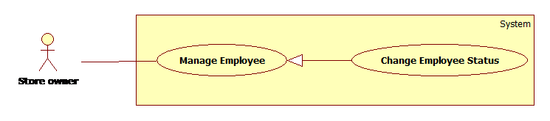**

**Figure 13: <StoreOwner> Change Employee Status Use Case Diagram**

**Use Case Specification**

|  |  |  |  |
| --- | --- | --- | --- |
| **USE CASE-9 SPECIFICATION** | | | |
| **Use-case No.** | EPS009 | **Use-case Version** | 2.0 |
| **Use-case Name** | Change Employee Status | | |
| **Author** | Chau Chieu Nguyen | | |
| **Date** | 15/04/15 | **Priority** | Medium |
| **Actor:**  Store owner  **Summary:**  This use case allow Storeowner lock or unlock their employees in our system.  **Goal:**  Lock/unlock employee.  **Triggers**   * Store’s owner chooses lock/unlock employee function.   **Preconditions:**   * User must login with role StoreOwner.   **Post Conditions:**   * **On Success**: An existed employee will be lock/unlock. * **On Failure**: Show error message.   **Main Success Scenario:**   |  |  |  | | --- | --- | --- | | Step | Actor Action | System Response | | 1 | StoreOwner chooses lock/unlock employee function in manage employee page. | System will lock/unlock employee and navigate to manage employee page. |   **Alternative Scenario:**   * N/A   **Exceptions:**   * N/A   **Relationships:**   * N/A   **Business Rules:**   * Employee has two statuses: active and deactivate. * When being locked, if employee not log out yet then they can open Android app but cannot use any function. * When being locked, if employee already logout, then they cannot login to Android app again. | | | |

##### <StoreOwner> Import Employee Use Case Diagram

**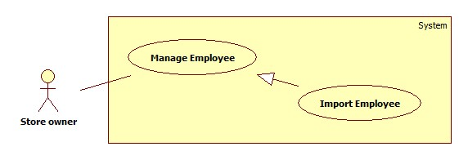**

|  |  |  |  |
| --- | --- | --- | --- |
| **USE CASE-10 SPECIFICATION** | | | |
| **Use-case No.** | EPS010 | **Use-case Version** | 2.0 |
| **Use-case Name** | Import Employee | | |
| **Author** | Chau Chieu Nguyen | | |
| **Date** | 15/04/15 | **Priority** | Medium |
| **Actor:**  StoreOwner  **Summary:**  This use case allow Storeowner import a list of employee.  **Goal:**  Insert new employees with info in excel file.  **Triggers**   * StoreOwner chooses import employee function.   **Preconditions:**   * User must login with role StoreOwner.   **Post Conditions:**   * **On Success**: StoreOwner inserts a list of employee to their store. * **On Failure**: Show error message.   **Main Success Scenario:**   |  |  |  | | --- | --- | --- | | Step | Actor Action | System Response | | 1 | StoreOwner clicks on “Quản lý nhân viên” in navigation bar. | System will navigates to “Quản lý nhân viên” page.  “Thêm nhân viên”: button.  “Nhập danh sách nhân viên”: button.  “Xuất danh sách nhân viên”: button.  “Danh sách nhân viên”: table. | | 2 | StoreOwner clicks on “Nhập danh sách nhân viên” button. | System navigates to “Nhập danh sách nhân viên” page.  “Browse”: button.  “Nhập”: button. | | 3 | StoreOwner clicks on “Browse” button. | System will display open file dialog:  “FileName”: textbox.  “Open”: button.  “Cancel”: button. | | 4 | StoreOwner selects list of Employee excel file and click “OK” button. | [Alternative 1] | | 5 | StoreOwner clicks on “Nhập” button. | System will import list of Employee then redirect StoreOwner to “Trang chủ” page.  [Exception 1] |   **Alternative Scenario:**   |  |  |  | | --- | --- | --- | | No | Actor Action | System Response | | 1 | StoreOwner clicks on “Cancel” button. | Open file dialog will close. |     **Exceptions:**   |  |  |  | | --- | --- | --- | | No | Actor Action | System Response | | 1 | StoreOwner left some column blank | Show error message “Vui lòng điền đầy đủ thông tin của nhân viên!” |   **Relationships:**   * N/A   **Business Rules:**   * Structure of excel file:      * Format of excel file is “xls” (Microsoft Office 2003). * Status of Employee when import success is “active”. * StoreOwner can assign order for theses Employee after import success. * Exception must not violate. | | | |

##### <StoreOwner> Select Template Use Case Diagram

**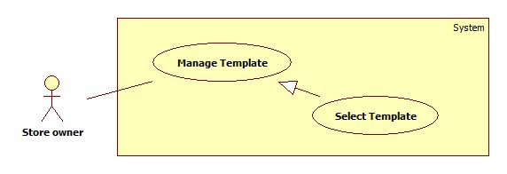**

**Figure 14: <StoreOwner> Select Template Use Case Diagram**

**Use Case Specification**

|  |  |  |  |
| --- | --- | --- | --- |
| **USE CASE-11 SPECIFICATION** | | | |
| **Use-case No.** | EPS011 | **Use-case Version** | 2.0 |
| **Use-case Name** | Select Template | | |
| **Author** | Chau Chieu Nguyen | | |
| **Date** | 06/04/15 | **Priority** | High |
| **Actor:**  Store Owner.  **Summary:**  This use case allows Store Owner to select some templates they want from the system to use.  **Goal:**  Store Owner selected a template.  **Triggers**   * Store Owner log in for the first time.   **Preconditions:**   * User must log in as Store Owner role.   **Post Conditions:**   * **On Success**: Selected templates will be available for use. * **On Failure**: Show error message.   **Main Success Scenario:**   |  |  |  | | --- | --- | --- | | Step | Actor Action | System Response | | 1 | Storeowner log in to the system for the first time. | Navigate to “Chọn Mẫu Hóa Đơn” page to choose a template.  “Danh sách mẫu hóa đơn của hệ thống”: table of system’s templates list which has 5 columns below:   * “STT”: ordinal number of a template. * “Tên mẫu hóa đơn”: Column contains name of a template. * “Hình đại diện”: Column contains a link to view image of template. * “Mẫu hóa đơn”: Column contains a link to download template. * “Loại hóa đơn”: Columns contains type of template. * A check box to select templates.   “Chọn”: button.  [Alternative 1, 2] | | 2 | StoreOwner selects templates | System display “Chọn”: button | | 3 | StoreOwner clicks “Chọn” button | Navigate to manage template page. |   **Alternative Scenario:**   |  |  |  | | --- | --- | --- | | No | Actor Action | System Response | | 1 | StoreOwner clicks on “Hình đại diện” link. | Navigate to show picture page. | | 2 | StoreOwner clicks on “Mẫu hóa đơn” link. | System will download the template to StoreOwner’s computer. |   **Exceptions:**   * N/A   **Relationships:**   * N/A   **Business Rules:**   * When Store Owner log in to the system for the first time, they will be navigate to “Chọn mẫu hóa đơn” page to choose template. * The first chosen template will be the default template. * If storeowner does not choose any template, next time when he/she login, system will navigate to choose template again. * Storeowner can only select templates for their store once. | | | |

##### <StoreOwner> Set Default Template Use Case Diagram

**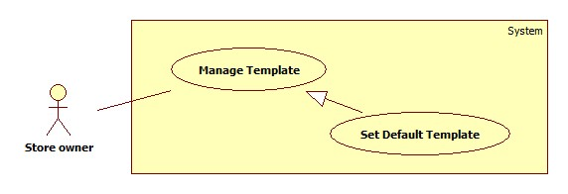**

**Figure 15: <StoreOwner> Set Default Use Case Diagram**

**Use Case Specification**

|  |  |  |  |
| --- | --- | --- | --- |
| **USE CASE-12 SPECIFICATION** | | | |
| **Use-case No.** | EPS012 | **Use-case Version** | 2.0 |
| **Use-case Name** | Set default template | | |
| **Author** | Chau Chieu Nguyen | | |
| **Date** | 06/04/15 | **Priority** | High |
| **Actor:**  StoreOwner  **Summary:**  This use case allows StoreOwner to set the default template of their store.  **Goal:**  A template will be set to default template.  **Triggers**   * StoreOwner clicks on Set default template function.   **Preconditions:**   * User must log in as StoreOwner role.   **Post Conditions:**   * **On Success**: A template is set to default * **On Failure**: Show error message.   **Main Success Scenario:**   |  |  |  | | --- | --- | --- | | Step | Actor Action | System Response | | 1 | Click on “Quản Lý Mẫu Hóa Đơn” button. | Navigate to “Chọn Mẫu Hóa Đơn” page to choose a template.  “Danh sách mẫu hóa đơn đã chọn”: table of template that store owner has chosen list which has 5 columns below:   * “STT”: Column contains ordinal number of a template. * “Chọn”: Column contains combobox to select template. * “Tên mẫu hóa đơn”: Column contains name of a template. * “Hình đại diện”: Column contains a link to view image of template. * “Mẫu hóa đơn”: Column contains a link to download template. * “Loại hóa đơn”: Column contains type of template. * “Tùy chỉnh”: link to navigate to customize page.   “Đặt làm mặc định”: button.  [Alternative 1, 2] | | 2 | Store Owner selects a template and clicks on “Đặt làm mặc định” button | That template is set to default template of store. |   **Alternative Scenario:**   |  |  |  | | --- | --- | --- | | No | Actor Action | System Response | | 1 | Storeowner clicks on “Hình đại diện” link. | Navigate to show picture page. | | 2 | Storeowner clicks on “Mẫu hóa đơn” link. | System will download the template to storeowner’s computer. |   **Exceptions:**   * N/A   **Relationships:**   * N/A   **Business Rules:**   * Storeowner can only have one default template. * Only template Bluetooth can be set as default template. | | | |

##### <StoreOwner> Customize Template Use Case Diagram

**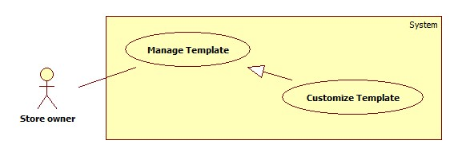**

**Figure 16: <StoreOwner> Customize Template Use Case Diagram**

**Use Case Specification**

|  |  |  |  |
| --- | --- | --- | --- |
| **USE CASE-13 SPECIFICATION** | | | |
| **Use-case No.** | EPS013 | **Use-case Version** | 2.0 |
| **Use-case Name** | Customize Template | | |
| **Author** | Chau Chieu Nguyen | | |
| **Date** | 06/04/15 | **Priority** | High |
| **Actor:**  StoreOwner  **Summary:**  This use case allows StoreOwner to customize their templates.  **Goal:**  An existed template will be redesign.  **Triggers**   * StoreOwner clicks on “Tùy chỉnh” link on manage template page.   **Preconditions:**   * User must log in as StoreOwner role.   **Post Conditions:**   * **On Success**: A template is redesign. * **On Failure**: Show error message.   **Main Success Scenario:**   |  |  |  | | --- | --- | --- | | Step | Actor Action | System Response | | 1 | Click on “Tùy chỉnh” link on manage template page. | Navigate to “Tùy chỉnh mẫu hóa đơn” page includes   * “Thông tin hóa đơn”: list of report’s information, can be draggable. * “Thuộc tính sản phẩm”: list of item’s information, can be draggable. * “Số lượng cột”: combo box, raw source is value: 2, 3, 4 for Bluetooth template and 2, 3, 4, 5, 6 for A4 template; for storeowner to select number of item’s information will be displayed. * A mock-up template for storeowner to drop information. * Image of a trash for storeowner to remove information. * “Lưu” button.   Mock-up template includes:   * Title: textbox with min length: 1 and max length: 20. * Four lines for storeowner to drop report’s information. * A table with number of columns defined by storeowner and let them drop item’s information. * “Số lượng ký tự mỗi cột”: label * “Cột 1”: textbox, max length: 2. * “Cột 2”: textbox, max length: 2. * “Cột 3”: textbox, max length: 2. * … * “Tổng tiền”: label. | | 2 | Store Owner selects the number of item’s information. | System displays item’s table with the number of column relies on storeowner’s selection. | | 3 | Store Owner input title. | System displays title in mock-up template.  [Alternative 1, 2] | | 4 | Store Owner drag information in the mock-up template. | System displays a pop-up required user to input the limit characters includes:   * “Nhập số lượng ký tự tối đa”: textbox; max length: 2. * “OK”: button. * “Hủy”: button. | | 5 | Store Owner input limit characters and clicks “OK” button |  | | 6 | Store Owner clicks on “Lưu” button | System redesigns template relies on Store Owner’s choices.  Navigate to manage template screen. |   **Alternative Scenario:**   |  |  |  | | --- | --- | --- | | No | Actor Action | System Response | | 1 | Store Owner change number of columns. | System display the mock-up template relies on Store Owner’s choice. | | 2 | Store Owner input limit characters of columns with total greater than 37 for Bluetooth template and greater than 80 for A4 template. | System display confirm message includes:   * “Số lượng ký tự bạn chọn nhiều hơn 37 (80), điều này sẽ ảnh hưởng đến định dạng của mẫu hóa đơn. Bạn có muốn tiếp tục?” * “Có”: button. * “Không”: button. |   **Exceptions:**   * **N/A**   **Relationships:**   * N/A   **Business Rules:**   * The maximum columns for template Bluetooth are four and template A4 is six. * The minimum columns of item’s information for both templates are two. * The maximum width of template Bluetooth is 37 characters and template A4 is 80 characters. * Number of columns is relying on storeowner choice in “Số lượng cột” combo box. * When storeowner wants to change item’s information, they will drag the old information to the trash and drag the new one in. | | | |

##### <StoreOwner> Create Order Use Case Diagram

**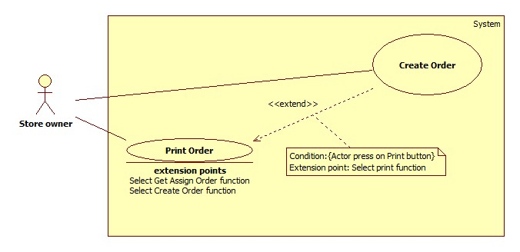**

**Figure 17: <StoreOwner> Create Order Use Case Diagram**

**Use Case Specification**

**Web**

|  |  |  |  |
| --- | --- | --- | --- |
| **USE CASE-14 SPECIFICATION** | | | |
| **Use-case No.** | EPS014 | **Use-case Version** | 2.0 |
| **Use-case Name** | Create Order. | | |
| **Author** | Duong Le Dinh Khang | | |
| **Date** | 14/04/15 | **Priority** | High |
| **Actor:**  StoreOwner.  **Summary:**  This use case allow StoreOwner or their employee make a report using a template from our system combine with their item.  **Goal:**  Create an order from template and define attribute of item.  **Triggers**   * StoreOwner click on create order function.   **Preconditions:**   * StoreOwner must have at least 1 item in system. * User must log in as StoreOwner role.   **Post Conditions:**   * **On Success**: A new order created and ready to print. * **On Failure**: Show error message.   **Main Success Scenario:**   |  |  |  | | --- | --- | --- | | Step | Actor Action | System Response | | 1 | Click on “Tạo Hoá Đơn” in navigator. | Navigate to “Tạo hoá đơn” screen to choose a template.  “Chọn mẫu hoá đơn”: combo box of template list.  “Tiếp tục”: button. | | 2 | StoreOwner selects a template and clicks on “Tiếp tục” button. | Navigate to “Thêm sản phẩm vào hoá đơn” screen.  -“Chọn sản phẩm”: combox box of item list.  -“Số lượng”: textbox, min length: 1, max length: 999.  -“Đơn giá”: textbox, not editable.  -Preview Item list: table.  -“Thêm”: button.  -“Tiếp tục”: button.  [Alternative 1] | | 3 | StoreOwner selects an item from combo box. | “Số lượng” will be set to “1” and “Đơn giá” will be filled with price of item. | | 4 | StoreOwner set the quantity of item by change “Số lượng” textbox value. |  | | 5 | StoreOwner clicks on “Thêm” button. | Preview Item List will show your item.  [Exception 1] | | 6 | StoreOwner clicks on “Tiếp tục” button. | Navigate to “Thông tin khách hàng” screen.  -“Khách hàng”: textbox.  -“Địa chỉ”: textbox.  -“Xác minh địa chỉ”: button.  -“In Hoá Đơn”: button.  -“Lưu Hoá Đơn”: button. | | 7 | StoreOwner fills out “Khách hàng” texbox with customer name, “Địa chỉ” texbox with customer address. |  | | 8 | StoreOwner clicks on “Lưu Hoá Đơn” button | Print dialog will display.  Printer: combo box.  “OK”: button.  “Cancel”: button.  [Alternative 2]  [Exception 2] |   **Alternative Scenario:**   |  |  |  | | --- | --- | --- | | No | Actor Action | System Response | | 1 | StoreOwner clicks on “Tiếp tục” button. | Default template will be applied. | | 2 | StoreOwner clicks on “In Hoá Đơn” | New order will be created, printer will print it and system navigates to “Trang chủ” page. |   **Exceptions:**   |  |  |  | | --- | --- | --- | | No | Actor Action | System Response | | 1 | Quantity is “0” | Show error message: “Số lượng của sản phẩm ít nhất là 1!” | | 2 | Click on “In Hoá đơn” before add item. | Show error message: “Bạn phải nhập ít nhất 1 sản phẩm trước khi in hoá đơn!” |   **Relationships:**   * Extend for Print Order (Select Print function).   **Business Rules:**   * Allow number of item per order is 10. * Default template will be select if StoreOwner does not choose. * Default quantity when input an item is one. * Quantity of item in database will be deduced with the number of item already add to order. * If StoreOwner already create an order and print it, they cannot assign that order for their employee to print again. * If StoreOwner only creates an order without print it, they can assign that order for their employee to print. | | | |

##### <Store owner> Print Order Use Case Diagram

****

**Figure 18: <StoreOwner> Print Order Use Case Diagram**

**Use Case Specification**

**Web**

|  |  |  |  |
| --- | --- | --- | --- |
| **USE CASE-15 SPECIFICATION** | | | |
| **Use-case No.** | EPS015 | **Use-case Version** | 2.0 |
| **Use-case Name** | Print Order | | |
| **Author** | Dương Le Dinh Khang | | |
| **Date** | 15/04/15 | **Priority** | High |
| **Actor:**  StoreOwner.  **Summary:**  This use case allow StoreOwner print an order.  **Goal:**  Print an order and have order’s paper.  **Triggers**   * StoreOwner clicks on print function.   **Preconditions:**   * Already add some item into order. * User must log in as role.   **Post Conditions:**   * **On Success**: Have an order paper. * **On Failure**: Show error message.   **Main Success Scenario:**   |  |  |  | | --- | --- | --- | | Step | Actor Action | System Response | | 1 | Press on “In Hoá Đơn” button. | Print dialog will display.  Printer: combox box (in Firefox) or list (Chrome).  “OK”: button. (In Firefox).  “Print”: button. (In Chrome).  “Cancel”: button.  [Alternative 1]  [Exception 1] | | 2 | StoreOwner selects which printer to use. |  | | 3 | StoreOwner clicks on “Ok” button (Firefox) or “Print” button (Chrome). | New order will be created, printer will print it and system navigates to “Trang chủ” page. |   **Alternative Scenario:**   |  |  |  | | --- | --- | --- | | No | Actor Action | System Response | | 1 | StoreOwner clicks on “Cancel” button | Only order will be created and no order paper will be printed. |   **Exceptions:**   |  |  |  | | --- | --- | --- | | No | Actor Action | System Response | | 1 | StoreOwner clicks on “In hoá đơn” button before add item. | Show message: “Vui lòng thêm ít nhất 1 sản phẩm vào hoá đơn”. |   **Relationships:**   * Extend by Create order (Select create order function), Get Assign Order (Select Get Assign Order function).   **Business Rules:**   * StoreOwner can print with A4 printer or mini Bluetooth printer depends on what type of template they choose for order. * When printing success, StoreOwner will get an order paper and a new order will be added to database. * In main success scenario, StoreOwner or employee will have an order paper. * In case there are no printers installed on StoreOwner computer, they can also save order to file as xps/pdf…file. * Exception must not violate. | | | |

##### <StoreOwner> Assign Order Use Case Diagram

**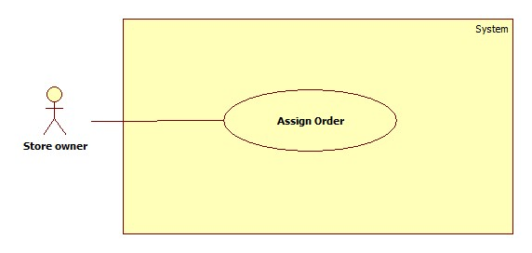**

**Figure 19: <StoreOwner> Assign Order Use Case Diagram**

**Use Case Specification**

|  |  |  |  |
| --- | --- | --- | --- |
| **USE CASE-16 SPECIFICATION** | | | |
| **Use-case No.** | EPS016 | **Use-case Version** | 2.0 |
| **Use-case Name** | Assign Order | | |
| **Author** | Dương Le Dinh Khang | | |
| **Date** | 15/04/15 | **Priority** | High |
| **Actor:**  StoreOwner.  **Summary:**  This use case allow StoreOwner assign an order for employee to print.  **Goal:**  Assign order for employee.  **Triggers**   * StoreOwner clicks on assign order function.   **Preconditions:**   * StoreOwner must have at least 1 order not printed yet. * StoreOwner must have at least 1 employee in idle time.   **Post Conditions:**   * **On Success**: Order will be assigned for employee. * **On Failure**: Show error message.   **Main Success Scenario:**   |  |  |  | | --- | --- | --- | | Step | Actor Action | System Response | | 1 | StoreOwner clicks on “Giao việc” in navigation bar. | System will navigate to “Giao việc” page.  “Danh sách hoá đơn”: table.   * “Chọn”: checkbox. * “Tên”: text. * “Địa chỉ”: text.   “Danh sách nhân viên”: combo box.  “Giao việc”: button. | | 2 | StoreOwner stick on the checkbox of order they want to assign. | [Alternative 1] | | 3 | StoreOwner selects an employee from combo box “Danh sách nhân viên”. | [Alternative 2] | | 4 | StoreOwner clicks on “Giao việc” button | System creates a notification to notify employee about orders assign for them.  [Exception 1] |   **Alternative Scenario:**   |  |  |  | | --- | --- | --- | | No | Actor Action | System Response | | 1 | StoreOwner not creates any order yet. | Show message: “Vui lòng tạo ít nhất 1 hoá đơn để có thể giao cho nhân viên!” | | 2 | StoreOwner not creates any employee yet. | Show message: “Vui lòng tạo ít nhất 1 nhân viên để có thể tiến hành giao việc!” |   **Exceptions:**   |  |  |  | | --- | --- | --- | | No | Actor Action | System Response | | 1 | StoreOwner clicks on “Giao việc” button before select order. | Show message: “Vui lòng chọn ít nhất 1 hoá đơn để giao!”. |   **Relationships:**   * N/A   **Business Rules:**   * On Success scenario, system will make a push notification to notify to employee Android smartphone about assignment. * StoreOwner will receive another notification about the assign status when their employee accept or decline the assignment using our web service. * One order can only assign for one employee, if employee decline the assign ment, orders assign for them will available for assign again. * Exception must not violate. | | | |

##### <StoreOwner> Export Order Use Case Diagram

**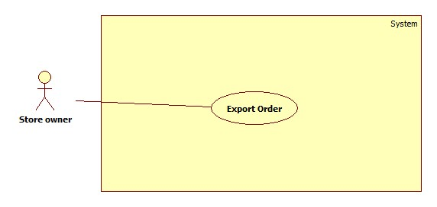**

**Figure 20: <StoreOwner> Assign Order Use Case Diagram**

**Use Case Specification**

**Web**

|  |  |  |  |
| --- | --- | --- | --- |
| **USE CASE-17 SPECIFICATION** | | | |
| **Use-case No.** | EPS017 | **Use-case Version** | 2.0 |
| **Use-case Name** | Export Order | | |
| **Author** | Dương Le Dinh Khang | | |
| **Date** | 15/04/15 | **Priority** | High |
| **Actor:**  StoreOwner.  **Summary:**  This use case allow StoreOwner export their list of order into excel file.  **Goal:**  Export list of order.  **Triggers**   * StoreOwner clicks on export order function.   **Preconditions:**   * StoreOwner must have at least 1 orders.   **Post Conditions:**   * **On Success**: StoreOwner receive an excel file contain their list of order. * **On Failure**: Show error message.   **Main Success Scenario:**   |  |  |  | | --- | --- | --- | | Step | Actor Action | System Response | | 1 | StoreOwner clicks on “Quản lý hoá đơn” in navigation bar. | System will navigate to “Quản lý hoá đơn” page.  “Danh sách hoá đơn”: table.  “Tạo hoá đơn”: button.  “Nhập danh sách hoá đơn”: button.  “Xuất danh sách hoá đơn”: button. | | 2 | StoreOwner clicks on “Xuất danh sách hoá đơn” button. | System response with an excel file contain their list of orders.  [Exception 1] |   **Alternative Scenario:**   * N/A   **Exceptions:**   |  |  |  | | --- | --- | --- | | No | Actor Action | System Response | | 1 | StoreOwner clicks on “Xuất danh sách hoá đơn” button before create atleast one order. | Show message: “Vui lòng tạo ít nhất một hoá đơn trước khi xuất danh sách hoá đơn!”. |   **Relationships:**   * N/A   **Business Rules:**   * Structure of excel file:      * Each order will place as a sheet in excel file. * Excel file version is “.xls” (Microsoft Office 2003). * Output of this use case can use to import it back to system. * Exception must not violate. | | | |

#### <Employee> Overview Use Case

**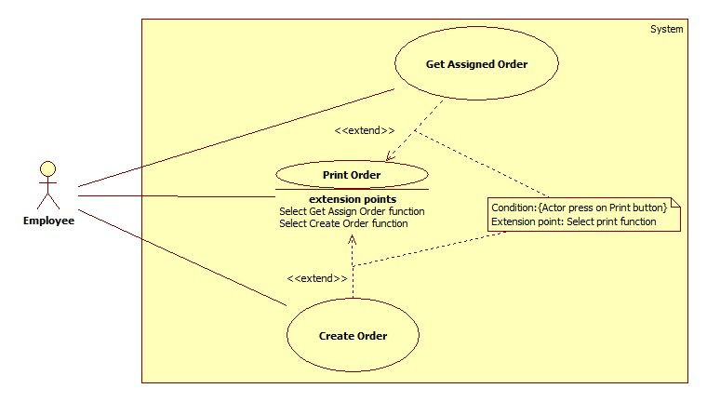**

**Figure 21: <Employee> Overview Use Case Diagram**

##### <Employee> Create Order Use Case Diagram

**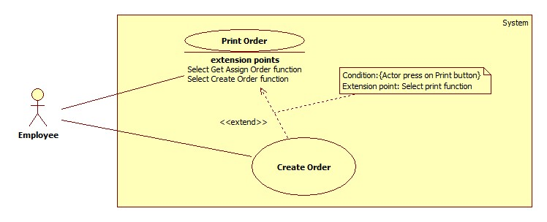**

**Figure 22: <Employee> Create Order Use Case Diagram**

**Use Case Specification**

|  |  |  |  |  |
| --- | --- | --- | --- | --- |
| **USE CASE-18 SPECIFICATION** | | | | |
| **Use-case No.** | EPS018 | **Use-case Version** | | 2.0 |
| **Use-case Name** | Create Order | | | |
| **Author** | Chau Chieu Nguyen | | | |
| **Date** | 14/04/15 | | **Priority** | Medium |
| **Actor:**  Employee  **Summary:**  This use case allow Employee to create an order in Android application.  **Goal:**  Create an order  **Triggers**   * Employee chooses create order function in Android application.   **Preconditions:**   * User must login with role Employee.   **Post Conditions:**   * **On Success**: A new order will be created. * **On Failure**: Show error message.   **Main Success Scenario:**   |  |  |  | | --- | --- | --- | | Step | Actor Action | System Response | | 1 | Employee touches on “Tạo hóa đơn” button on menu screen | System will navigate to choose template screen includes:   * List of templates chosen by storeowner with two cloumns. | | 2 | Employee touches on one template. | System navigate to generate order screen includes:   * “Sản phẩm”: combo box for employee to choose item. Raw sources such as: “máy tính”, “máy in”… * “Số lượng”: textbox for employee to input quantity of item; max length 2. * “Đơn giá”: textbox to show unit price of an item, uneditable * “Thêm sản phẩm”: button. * “Khách hàng”: textbox for employee to input customer’s name, max length 50. * “T.Tính 1”: label. * “T.Tính 2”: label. * “T.Tính 3”: label. * “Tạo hóa đơn”: button.   [Exception 1] | | 3 | Employee chooses an item and input quantity of item. |  | | 4 | Employee touches “Thêm sản phẩm” | System add item to a list an display “Đã thêm” message.  [Alternative 1] | | 5 | Employee touches “Tạo hóa đơn” button. | System will create an order rely on employee choices.  Navigate to preview order screen. |   **Alternative Scenario:**   |  |  |  | | --- | --- | --- | | No | Actor Action | System Response | | 1 | Employee input customer’s name |  | | 2 | Employee touches “T.Tính 1” or “T.Tính 2” or “T.Tính 3” label | System show a dialog includes:   * “ĐVT”: radio button. * “Số lượng”: radio button. * “Đơn giá”: radio button. * “Loại SP”: radio button. * “Thành tiền”: radio button. | | 3 | Employee touches on one radio button | System close dialog and change label. | | 4 | Employee touches “Tạo hóa đơn” button. | System will create an order rely on employee choices.  Navigate to preview order screen. |   **Exceptions:**   |  |  |  | | --- | --- | --- | | No | Actor Action | System Response | | 1 | Employee’s Android phone does not have internet connection | Show message “Vui lòng kết nối mạng và khởi động lại ứng dụng” |   **Relationships:**  Extend for Print Order (Select Print Order function).  **Business Rules:**   * Customer’s name will be “Khách lẻ” if employee does not input in “Khách hàng” textbox. * The maximum number of items to add is 999. * The quantity of items in order will increase if employee adds an item multiple times. * Items of the store will be download every time employee chooses create order function. | | | | |

##### <Employee> Print Order Use Case Diagram

****

**Figure 23: <Employee> Print Order Use Case Diagram**

**Use Case Specification**

|  |  |  |  |
| --- | --- | --- | --- |
| **USE CASE-19 SPECIFICATION** | | | |
| **Use-case No.** | EPS019 | **Use-case Version** | 2.0 |
| **Use-case Name** | Print Order | | |
| **Author** | Dương Le Dinh Khang | | |
| **Date** | 18/01/15 | **Priority** | High |
| **Actor:**  Employee  **Summary:**  This use case allows Employee print an order via Bluetooth printer.  **Goal:**  Print an order and have order’s paper.  **Triggers**   * Employee choose print function button.   **Preconditions:**   * Have a preview report. * User must log in as employee role.   **Post Conditions:**   * **On Success**: Have an order’s paper. * **On Failure**: Show error message.   **Main Success Scenario:**   |  |  |  | | --- | --- | --- | | Step | Actor Action | System Response | | 1 | In main menu, Employee clicks on “In Hoá Đơn” button. | System navigates to “Danh sách hoá đơn” screen.  “Tìm kiếm theo”: combo box with source value is “Tên K.hàng”,”Đ.chỉ K.hàng”.  “Giá trị”: textbox.  “Tìm kiếm”: button.  “Danh sách hoá đơn”: listview.  [Alternative 1] | | 2 | Employee clicks on an order in “Danh sách hoá đơn”. | System navigates to “Chọn mẫu hoá đơn” screen.  [Alternative 2] | | 3 | Employee clicks on a template to select. | System navigates to preview order image.  “Kết nối máy in”: button.  Preview image: imageview. | | 4 | Employee clicks on “Kết nối máy in” button. | System navigates to print settting screen.  “Tìm kiếm máy in”: button.  “Danh sách thiết bị bluetooth”: listview.  [Alternative 3]  [Exception 1] | | 5 | Employee clicks on Bluetooth printer | System navigates to Print screen.  “Số bản in”: textbox.  “In”: button.  [Exception 2] |   **Alternative Scenario:**   |  |  |  | | --- | --- | --- | | No | Actor Action | System Response | | 1 | When Employee do not have any assigned order to print. | Show message “Bạn hiện không có hoá đơn nào để in” | | 2 | Employee input value in “Giá trị” textbox and press “Tìm kiếm” | System updates “Danh sách hoá đơn” with the result matching their search value. |   **Exceptions:**   |  |  |  | | --- | --- | --- | | No | Actor Action | System Response | | 1 | Employees not turn on internet connection on their Android phone. | Show message: “Không thể kết nối đến máy chủ để tạo hoá đơn!” | | 2 | Employee input invalid number of order’s copy | Show error message: “Số bản in từ 1-99 !Xin nhập số hợp lệ” |   **Relationships:**   * Extended by Create Order (Select create order function), Get Assigned Order (Select get assigned order function).   **Business Rules:**   * The phone must have Bluetooth connection to connect to printer. * Input for printer is image file with extension is “.png”. * In main success scenario, Employee will get an order’s paper. * Exception must not violate. | | | |

##### <Employee> Get Assigned Order Use Case Diagram



**Figure 24: <Employee> Get Assigned Order Use Case Diagram**

**Use Case Specification**

**Android**

|  |  |  |  |
| --- | --- | --- | --- |
| **USE CASE-20 SPECIFICATION** | | | |
| **Use-case No.** | EPS020 | **Use-case Version** | 2.0 |
| **Use-case Name** | Get Assign Order | | |
| **Author** | Chau Chieu Nguyen | | |
| **Date** | 15/04/15 | **Priority** | Medium |
| **Actor:**  Employee  **Summary:**  This use case allows Employees to get orders assigned to them.  **Goal:**  Employee will get notify about order which assigned for them.  **Triggers**   * When StoreOwner has assigned orders to employee.   **Preconditions:**   * User must login with role Employee.   **Post Conditions:**   * **On Success**: Employee receive notify about orders and they can accept or decline it. * **On Failure**: Show error message.   **Main Success Scenario:**   |  |  |  | | --- | --- | --- | | Step | Actor Action | System Response | | 1 | Employee scrolls down the notification bar and touch on order notification | Navigate to get assigned order screen and show confirm dialog includes:   * List of order’s information. * “Thôi”: button. * “OK”: button   [Alternative 1] | | 2 | Employee touches “OK” button | Close dialog and download order information to employee’s device.  Send notification back to storeowner.  Show “Tải hóa đơn hoàn tất”. |   **Alternative Scenario:**   |  |  |  | | --- | --- | --- | | No | Actor Action | System Response | | 1 | Employee touches “Thôi” button | Close dialog and send notification back to storeowner. |   **Exceptions:**   * N/A   **Relationships:**   * Extended for Print Order (Select Get Assigned Order function).   **Business Rules:**   * If StoreOwner assigns orders when employee is offline, system will send notification when employee comes online again. * System will send notification back to storeowner after employee accept or decline the assignment. | | | |

#### <Admin> Overview Use Case

**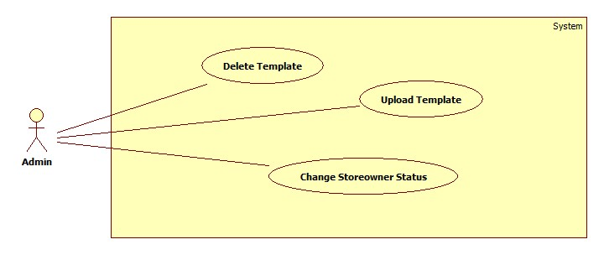**

**Figure 25: <Admin> Overview Use Case Diagram**

##### <Admin> Upload Template Use Case Diagram

**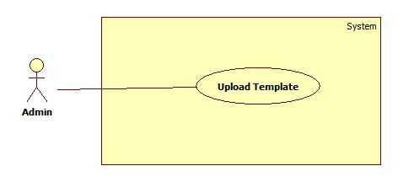**

**Figure 26: <Admin> Upload Template Use Case Diagram**

**Use Case Specification**

|  |  |  |  |
| --- | --- | --- | --- |
| **USE CASE-20 SPECIFICATION** | | | |
| **Use-case No.** | EPS020 | **Use-case Version** | 2.0 |
| **Use-case Name** | Upload Template | | |
| **Author** | Chau Chieu Nguyen | | |
| **Date** | 16/01/15 | **Priority** | Medium |
| **Actor:**  Admin  **Summary:**  This use case allows Admin to upload their template to the system.  **Goal:**  Upload a new template.  **Triggers**   * Admin choose upload template function.   **Preconditions:**   * User must login with role Admin.   **Post Conditions:**   * **On Success**: A new template will be uploaded. * **On Failure**: Show error message.   **Main Success Scenario:**   |  |  |  | | --- | --- | --- | | Step | Actor Action | System Response | | 1 | Admin chooses upload template function. | System will navigate to upload template includes:  -“Tên mẫu hóa đơn”: textbox, min length: 10, max length: 100, required.  - “Mẫu hóa đơn (.xls)”: label  -“Chọn tệp”: button.  - “Hình đại diện (.png)”: label  -“Chọn tệp”: button.  - “Loại hóa đơn”: combobox, raw sources are: Bluetooth, A4.  -“Tải lên”: button. | | 2 | Admin input template’s name. |  | | 2 | Click “Chọn tệp” button. | System will display an open file dialog for user to choose excel file.  -“Open”: button.  - “Close”: button  [Alternative 1] | | 3 | Link to the template and Click “Open” button. | System will display the template file’s name.  [Exception 1] | | 4 | Click “Chọn tệp” button. | System will display an open file dialog for user to choose image file.  -“Open”: button.  - “Close”: button | | 5 | Link to the template and Click “Open” button. | System will display the template image ’s name.  [Exception 1] | | 6 | Admin choose the template’s type |  | | 7 | Click “Tải lên” button | Template’s file and image paths on server will be added to database and a new template will be displayed in list.  [Exception 2, 3, 4] |   **Alternative Scenario:**   |  |  |  | | --- | --- | --- | | No | Actor Action | System Response | | 1 | Admin press “Close” | Close open file dialog |     **Exceptions:**   |  |  |  | | --- | --- | --- | | No | Actor Action | System Response | | 1 | Type of file is not “.xls” | Show error message: “Mẫu hóa đơn phải là file .xls.” | | 2 | Template name with same name already existed. | Show error message: “Mẫu hóa đơn đã có sẵn”. | | 3 | Template’s name is blank | Show error message: “Tên của mẫu hóa đơn không được để trống”. | | 4 | The Excel file is empty | Show error message: “Mẫu hóa đơn không được là file trống” |   **Relationships:**  N/A  **Business Rules:**   * The template’s type must be .xls file with format:   C:\Users\NguyenCCSE60911\Desktop\EPS Template\Template_1.png  Figure 1: Excel format of Bluetooth template.C:\Users\NguyenCCSE60911\Desktop\EPS Template\Template_5.png  Figure 2: Excel format of A4 template.   * Template’s image must be “.png” file. * Template’s name cannot be blank. * When a template is updated, it will be stored at folder Template on server * Length of file path is less or equal to 260 characters. * Template file cannot be empty. * The number of columns is 4 for Template Bluetooth and 6 for Template A4. | | | |

##### <Admin> Delete Template Use Case Diagram

**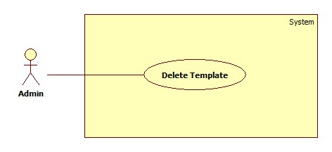**

**Figure 27: <Admin> Delete Template Use Case Diagram**

**Use Case Specification**

|  |  |  |  |
| --- | --- | --- | --- |
| **USE CASE-21 SPECIFICATION** | | | |
| **Use-case No.** | EPS021 | **Use-case Version** | 2.0 |
| **Use-case Name** | Delete Template | | |
| **Author** | Chau Chieu Nguyen | | |
| **Date** | 19/01/15 | **Priority** | Medium |
| **Actor:**  Admin  **Summary:**  This use case allows Admin to delete template.  **Goal:**  Delete an existed template.  **Triggers**   * Admin select delete template function on admin manage template page.   **Preconditions:**   * User must login with role Admin.   **Post Conditions:**   * **On Success**: An existed template will be deleted. * **On Failure**: Show error message.   **Main Success Scenario:**   |  |  |  | | --- | --- | --- | | Step | Actor Action | System Response | | 1 | Admin click “Quản lý mẫu hoá đơn” in navigation bar. | System navigates to “Quản lý mẫu hoá đơn” page. | | 2 | Admin click “Xoá” button | System shows message “Bạn có chắc muốn xoá mẫu hoá đơn này?” | | 3 | Admin click “OK” button | System deletes the selected template.  [Exception 1] |   **Alternative Scenario:**   * N/A   **Exceptions:**   |  |  |  | | --- | --- | --- | | No | Actor Action | System Response | | 1 | Admin click “Cancel” button. | System will cancel delete function. |   **Relationships:**   * N/A   **Business Rules:**  Deleted template will no longer available for use.  StoreOwner already select this template in the past still can use or customize it. | | | |

##### <Admin> Change StoreOwner Status Use Case Diagram

**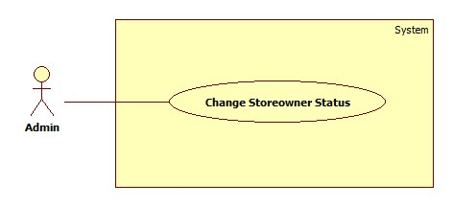**

**Figure 28: <Admin> Change StoreOwner Status Use Case Diagram**

**Use Case Specification**

|  |  |  |  |
| --- | --- | --- | --- |
| **USE CASE-22 SPECIFICATION** | | | |
| **Use-case No.** | EPS022 | **Use-case Version** | 2.0 |
| **Use-case Name** | Change Storeowner Status | | |
| **Author** | Chau Chieu Nguyen | | |
| **Date** | 15/04/15 | **Priority** | Medium |
| **Actor:**  Admin  **Summary:**  This use case allow Admin lock or unlock storeowner.  **Goal:**  Lock/Unlock a Storeowner  **Triggers**   * Admin chooses lock/unlock Storeowner function on manage Storeowner page.   **Preconditions:**   * User must login with role Admin.   **Post Conditions:**   * **On Success**: An existed storeowner and their employees will be lock/unlock. * **On Failure**: Show error message.   **Main Success Scenario:**   |  |  |  | | --- | --- | --- | | Step | Actor Action | System Response | | 1 | Admin chooses lock/unlock storeowner function in manage storeowner page. | System will lock/unlock storeowner and their employees.  Navigate to manage storeowner page. |   **Alternative Scenario:**   * N/A   **Exceptions:**   * N/A   **Relationships:**   * N/A   **Business Rules:**   * Storeowner has two statuses: active and deactivate. * When being locked, storeowner cannot login to the system. * If a storeowner is locked, his/her employee will be locked too. * If locked user not logout yet on Android app, they still can open it but cannot use any function. | | | |

## Software System Attribute

### Usability

#### Graphic User Interface

* + All the texts, labels and should be written in Vietnamese.

#### Usability

* + Admin only need one day of training to use this system.

#### Installation

* + The system must be easy to deploy. Customer can deploy successfully and learn to configure, maintain the system within one day of training.
  + The attached manual guide must be clear. User can read and do themselves without developer’s help.

### Reliability

* + Information about order of StoreOwner can be backup and restore easily using import/export function.

### Availability

* + User need to have an internet connection to use every function of the system in the best way.

### Security

* + Information about employee, item, and order of a StoreOwner only can access by their own. Even Admin cannot do anything.

### Maintainability

* + The system is divided into separated modules.

### Portability

* + The system can be deployed into many type of servers those have Tomcat server.

### Performance

The process of create a printable order only need 10 seconds.

## Conceptual Diagram

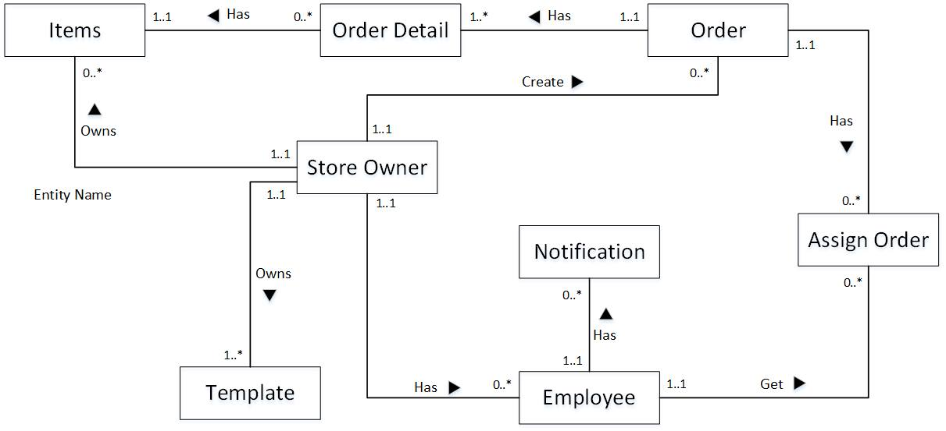

**Data Dictionary**

|  |  |
| --- | --- |
| **Entity Data dictionary: describe content of all entities** | |
| Entity Name | Description |
| Items | Describe all Items in the system. |
| Store Owner | Describe all StoreOwners in the system. |
| Template | Describe all Templates available in the system. |
| Employee | Describe all Employees in the system. |
| Order | Describe all Order in the system. |
| Order Detail | Describe all Order Details in the system. |
| Notification | Describe all Notifications in the system. |
| Assign Order | Describe all templates available in the system. |